Go for Gold

Can you make a medal table look great?

Your challenge!
1. Copy the GoForGold folder into your Dojo files folder.
2. Open the go-for-gold.html file in your editor and in your browser. Also open styles.css in your editor.
3. Look at the two pictures of a HTML table on the other side of this sheet.
4. When you look at the file in your browser the medal table looks like the first picture. Not very pretty! Can you make it look like the second?
In the CSS stylesheet you need to replace each occurance ofthe word ‘elementname’ with the correct element
(HINT: choose from body, article, section, h1, h2, p, table, tr, th, td, img)
And then replace ‘.attributename’ with the name of the attribute that will turn Katie’s line golden!

Feeling brave?
1. Change the background colour of the winner’s row to green.
2. Change the background colour of the second place row to orange.
Tip: You will need to edit both the CSS file and the HTML file for this.
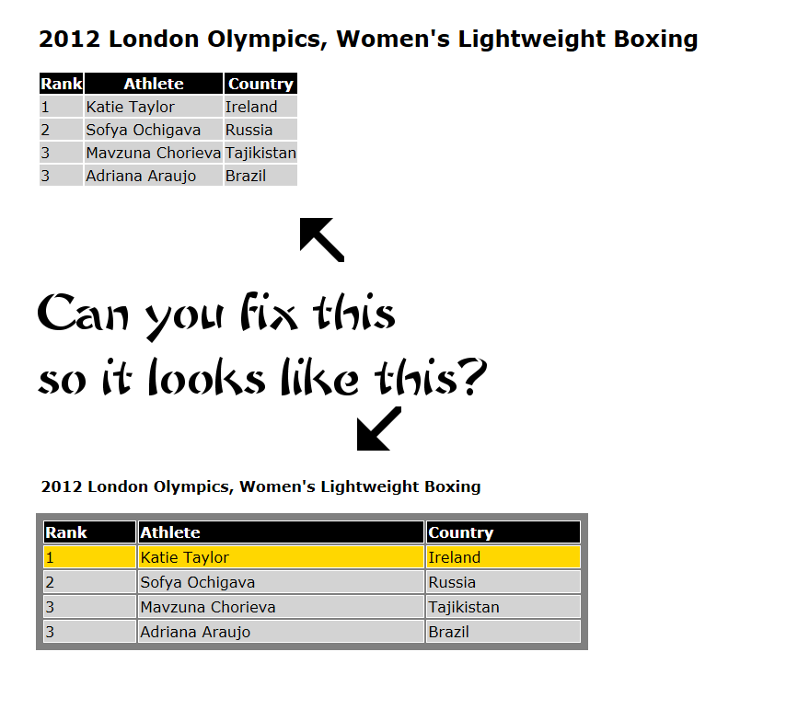
3. Create a table showing your top-four Premier League predictions for the the end of the season.

