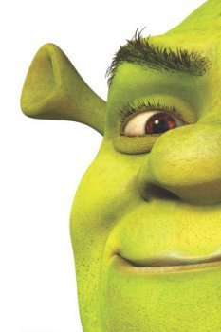
Shrektastic
This challenge brings everything together that we’ve been doing over the previous sessions. You’ll need to create a page giving details of the three Shrek characters. To do this you’ll need to remember:
• how the various HTML elements go together (headings!, lists! images! tables!)
• how CSS allows you to make your web page look great
• how you should organise your files so that your web page ‘sees’ your CSS and image files

Your challenge!
1. Create a new web page with a title of ‘My Shrek Characters by’ followed by your own Shrek identity (we’ll explain!)
2. Create a web page similar to the one shown on the next page. See if you can style it using a CSS file.

Feeling brave?
Create two or three style sheets with different effects (plain, fancy, colourful, or similar) and take turns linking the different stylesheets to the page.
The picture on the next page shows the effect of changing ONLY a stylesheet. In other words, creating a new stylesheet (let’s call it styles-fancy.css) and then changing this...
<link type="text/css" rel="stylesheet" href="styles.css"/>
to this
<link type="text/css" rel="stylesheet" href="styles-fancy.css"/>
