Make the Home page
1 Go into the my-first-website folder, copy the about-me.html file (again!) and this time rename it index.html
index.html will be the Home page for your site.
Home pages are often given a file name of index.html
* Remember: to copy the file, select it, then hold down the Z and c keys at the same time. Then paste it, by holding down the Z and v keys at the same time. Finally, press the " key to rename it.
After you have pasted and renamed the file you should see this —
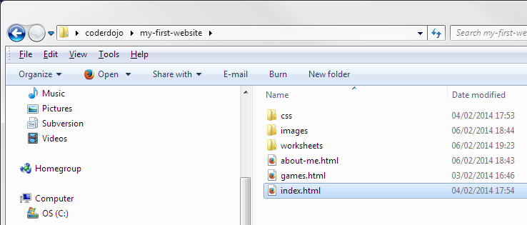
Now edit index.html so that it’s like the one in the screenshot below (except that it has your name in it, not Lee’s)
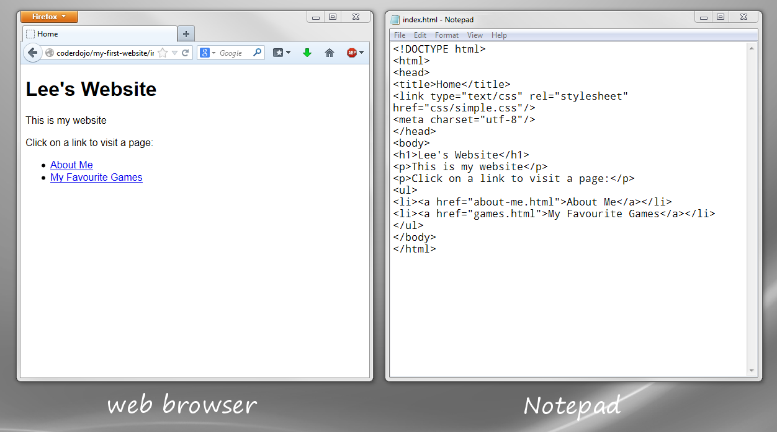
The index.html page has two links on it. If you click one of the links you are taken to one of the pages you made earlier.
A link has two main parts —
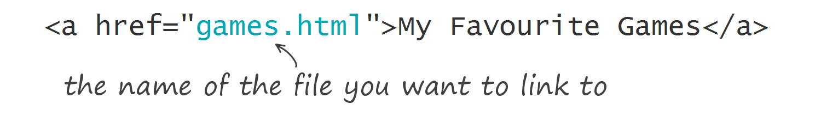

Also, be careful when you’re typing links. You have to get them exactly right!
They always have the same pattern —
start and end a tags — | <a href="filename">Link text</a>
href attribute — | <a href="filename">Link text</a>
filename — | <a href="filename">Link text</a>
link text — | <a href="filename">Link text</a>
Notice how the href attribute puts quote marks " " around the filename and how it comes inside the a start tag.

Your challenge …
Make three more pages and add the links from the Home page.
Some suggestions (your own ideas welcome!) —
Title | File Name
My Family | family.html
My Pets | pets.html
My Top Songs | songs.html
My Sports Teams | teams.html
My Hobbies | hobbies.html
My Heroes | heroes.html

