Add some style
1 The index.html Home page looks a bit boring.
You can change its appearance using a CSS file.
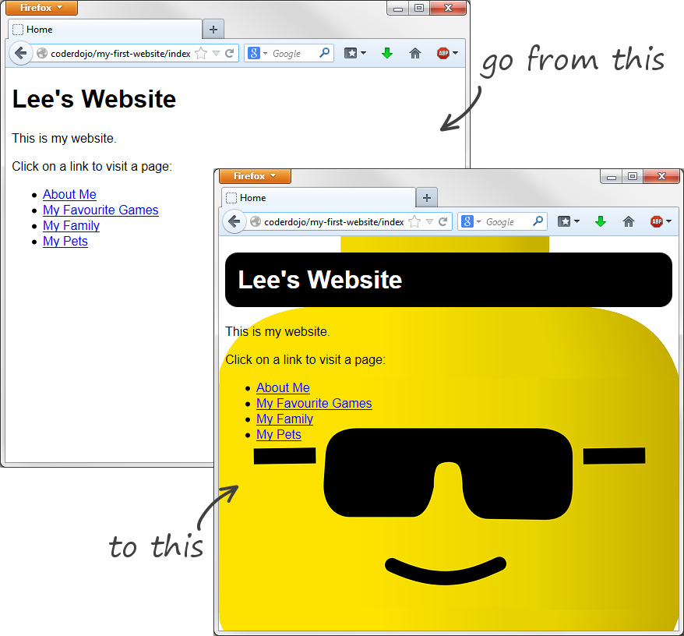
using CSS
A CSS file contains the recipe for how the web page should appear.
It’s a separate file from the HTML file and it’s linked to the HTML file like this:
<link type="text/css" rel="stylesheet" href="css/simple.css"/>
1 Open the index.html file in Notepad and locate the link (it’s the fifth line down).
What this link is telling you is that the appearance of the page is controlled by a stylesheet named simple.css which is located in the css folder.
2 Go into the css folder and locate the file:
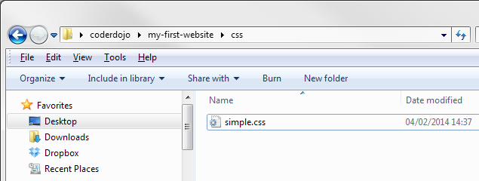
3 Copy simple.css and rename the copy to home.css
4 Now change the link in the index.html file so that it is pointing to home.css —
<link type="text/css" rel="stylesheet" href="css/home.css"/>
5 Save the modified index.html file by pressing Z s
Open index.html in your browser and open home.css alongside it in Notepad, so that you can see them both side-by-side.
The home.css file contains just one statement:
body {
font-family: sans-serif;
}
This statement is called a selector and it tells the browser how to format everything inside the body element of the HTML file. What this selector is saying is ‘set everything in the body element in a sans-serif font’.
6 Modify the body selector by adding a rule to include a background image, and add a new selector which says how to format the h1 element. So the finished home.css file will look like this —
body {
font-family: sans-serif;
background-image: url('../images/cool-lee.png');
}
h1 {
padding: 0.5em;
background-color: black;
color: white;
border-radius: 0.5em;
}
7 Add the rules one at a time, saving as you go. Click refresh in your browser each time you add a new rule so that you understand the difference the new rule makes.
* Notice how the selectors contain a number of individual formatting rules. Each rule is ended by a semi-colon (;) and consists of a property (such as color) followed by a colon (:) and then a value (such as white). Notice, also, that rules are enclosed in curly braces ({ and }).

