Dojo Sushi
“A way of structuring and packaging learning activities, geared to the Dojo environment — helping great ideas to get passed on”

Key aspects
* Two-sided laminated Sushi Cards
* Free to copy, modify and distribute
* One concept per card
* Each card unlocks a new skill
* Proceed at your own pace
* Activity-led, not theory-led
* You can see the beginning and the end — it’s manageable


Problem Sushi addresses
Communicating a great idea is sometimes harder than having the great idea!

Sushi is not …
… a specific curriculum or development method

Why cards?
Everyone loves cards!


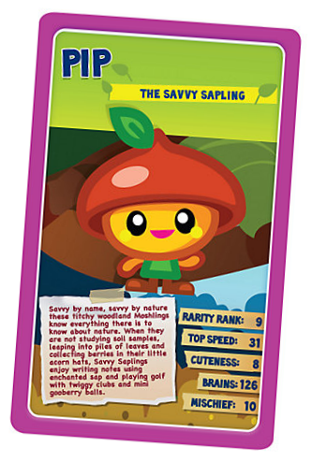
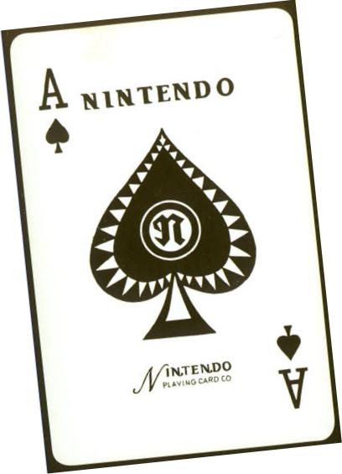

* No internet connection required
* Reduce window-management problems — particularly on small screens
* Deal them out fast — like … well … cards
* You can immediately see what a kid is working on

How make Sushi Cards
1 Decide where you want to go (build a website, make a game, design a robot)
2 Map out how you’ll get there.
3 Divide up the journey into manageable stages based on learning concepts.
4 Describe the stage and the associated concept in two sides of A4.

5 Use pictures rather than words if you can.
6 Test in the Dojo.
7 Iterate.

Inspirations

