
Ogres on the menu
OK, you’ve created your Shrek page, you’ve made it look pretty by linking it to a CSS style sheet.
Now for the biggest challenge yet! (No-one said that CoderDojo would be easy!)
This week you’re going to work in teams to link together the pages you did last week. How? By adding a top menu.

Your challenge!
1 Save last week’s page with a new name based on your Shrek identity (e.g. blindmouseone.html).
Important! Make sure that the name of everyone’s page is different.
2 Also, change the name of your CSS stylesheet so that it matches the name of your page (e.g. blindmouseone.css) AND change the link in your page so that it now links to the renamed stylesheet. For example:
<link type="text/css" rel="stylesheet" href="styles-fancy.css"/>
to this
<link type="text/css" rel="stylesheet" href="blindmouseone.css"/>
3 Write down the names of all the pages. For example:
blindmouseone.html, captainhook.html, princessfiona.html
4 Add links to the other pages at the top of your page, inside the body element, for example:
<body>
<nav>
<ul>
<li>
<a href="blindmousetwo.html">Blind Mouse Two</a>
</li>
<li>
<a href="blindmousethree.html">Blind Mouse Three</a>
</li>
<li>
<a href="princessfiona.html">Princess Fiona</a>
</li>
</ul>
</nav>
5. Now check your page — it probably looks something like this …
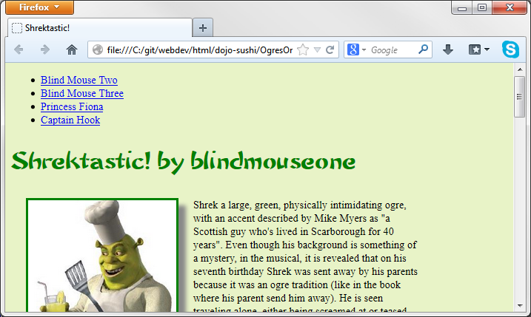
You could make it look like this though …
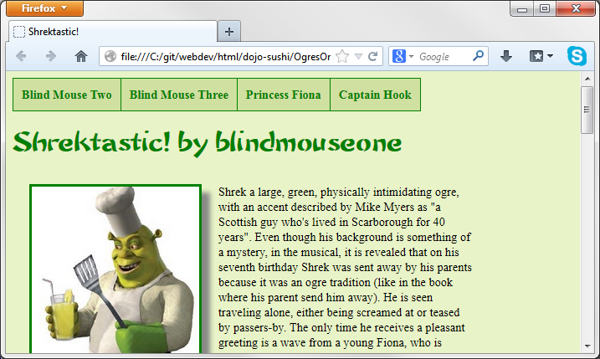
How? By adding some some rules (‘selectors’) to the CSS stylesheet.
So let’s do it!
6. Open the menu.css file and paste the code into your CSS stylesheet.
Refresh the page? How does it look?

Feeling brave?
Change the code you’ve pasted so that the menu background is black and the text is white.

