
Ogres online
We’ve finished our Shrek pages and we have them linked to other pages …
Let’s put them online!
To do this we’ll upload them to the html.coderdojobray.com site.

Your challenge!
1 Install FileZilla on the machine of one of the ninjas in your group.
2 Choose Site Manager from the File menu and create a new site with details shown below.(replace with screenshot containing actual settings)
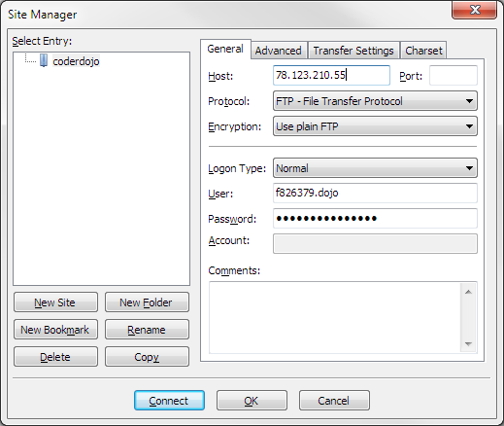
Settings:
Host: [enter connection setting]
Login Type: Normal
User: [enter username]
Password: [enter password]
3. Connect to the server and upload everyone’s files.
Can you figure how to do this?

Hint… find your files and drag them across.
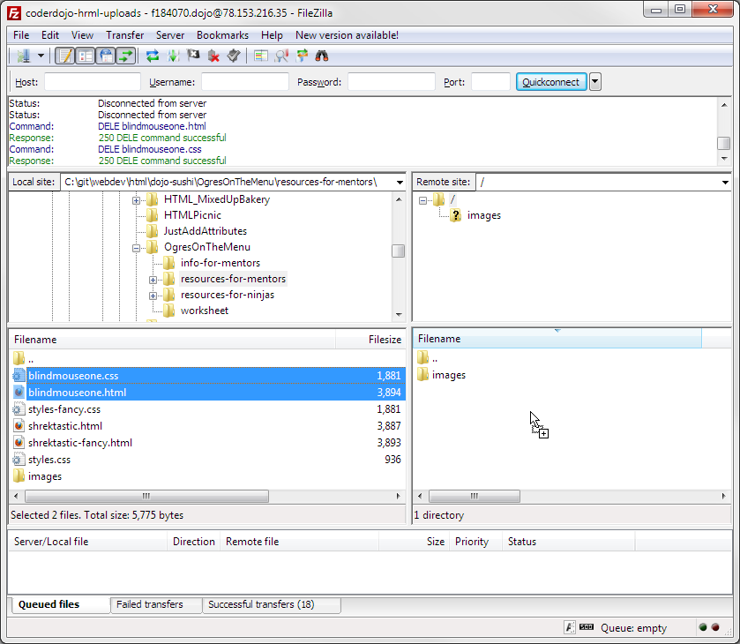
4. Now open your browser and see if you can see your files in
html.coderdojobray.com/uploads/ (followed by your filename) —
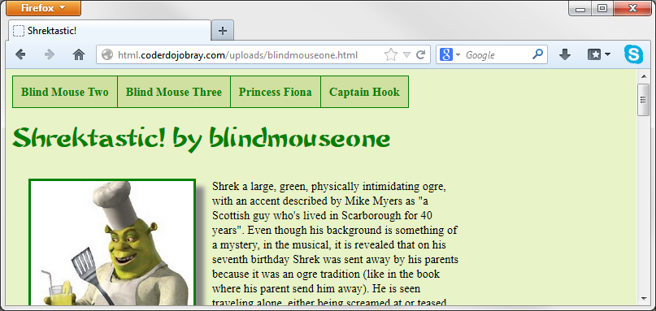

Feeling brave?
It’s Eurovision night — create a table (like the Go For Gold table last week) with your predictions for places 1, 2, 3 and last and upload it to the server.

