HTML picnic
Believe it or not HTML is like a preparing a picnic.
What? Why?
“Everything has to be packed into containers. And you don’t want to mix the wrong things together.”

Here are the rules for your HTML picnic
Rule 1. Everything must be inside a container.
Rule 2. That container can be inside another container.
Which can be inside another, bigger, container.
Which, in turn, can be inside yet another even bigger container.
(And so on).
Some containers may have lots of other smaller containers
inside them.
Others only one or two.
Rule 3. Any single container can only ever be directly inside one other container.
Rule 4. Don’t mix up the wrong containers!

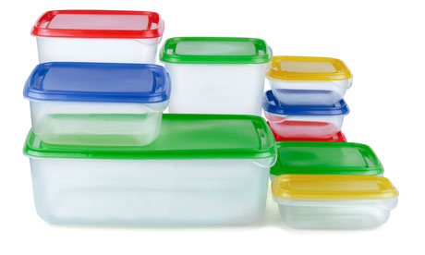
Your challenge!
Fix the picnic.html file that’s on the data key. Look at the examples for clues.

Feeling brave?
Create your own HTML file containing
the recipe for the perfect picnic.
What is the real name for the HTML
‘containers’?

Examples

This is a good HTML picnic

<html>
<head><title>HTML Picnic</title></head>
<body>
<h1>Best things for a picnic!</h1>
<ol>
<li>Dojo Sushi</li>
<li>Cheese sandwiches</li>
<li>Crisps</li>
<li>Jam sandwiches</li>
</ol>
<p>Can <em>you</em> think of anything else?</p>
</body>
</html>

The containers are all mixed up!
<html>
<head><title>HTML Picnic</head></title>
<h1>
<body>Best things for a picnic!</h1>
<li><ol>Dojo Sushi</li>
<li>Cheese sandwiches</li>
<li>Crisps</li>
<li>Jam sandwiches</li>
<p>
</ol>Can <em>you think of anything else?</p></em>
</html>
</body>

Stuff is in the wrong containers!

<html>
<head><p>HTML Picnic</p></head>
<body>
<title>Best things for a picnic!</title>
<p>
<ol>Dojo Sushi</ol>
<ol>Cheese sandwiches</ol>
<ol>Crisps</ol>
<ol>Jam sandwiches</ol>
</p>
<em>Can <h1>you</h1> think of anything else?</em>
</body>
</html>

