Copy and save
This challenge is to make sure you can find your files.
Do you know what a file is?
Do you know what a folder is?
Do you know how to make one on your PC or Mac?
Once you made it, can you find it?
Can your friend?
(Oh … and what’s a file extension?)

Your challenge!
1. Create a folder on your machine your for Dojo files
2. Write down where it is — for example —
C:\Users\Shrek\Documents\Dojo_files
3. Now get the hello,html file (your mentor will tell you where to find it) and copy it to the Dojo files folder
4. Write down the full path to copied file. For example —
C:\Users\Shrek\Documents\Dojo_files\hello.html
5. Can you see the whole of the file name in the folder?
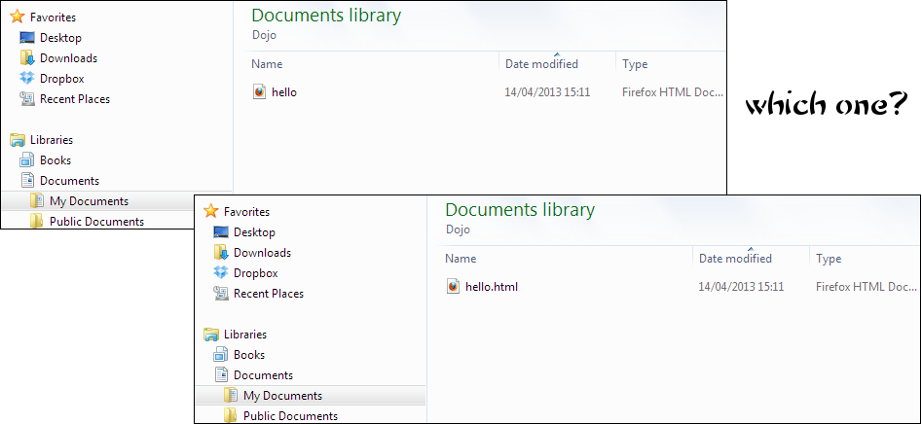

Feeling brave?
Give the path to the Ninja sitting next to you.
Can they find?

