
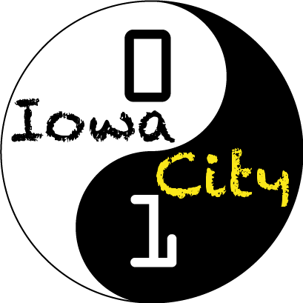

CoderDojo – Iowa City

Teach kids to program. Bring together families. Do some good for the future. It doesn’t take a rocket scientist.

Well, maybe a few…
CoderDojo is an international movement of free coding clubs for kids. Begun in Ireland in 2010, it has exploded in popularity with over 50 chapters in ten countries and growing. With some of the biggest names in technology, such as Google and Twitter, hosting chapters, CoderDojo is creating a brighter future for kids around the world while preparing them to enter an exciting and rewarding career path in programming.
Chapters host free coding sessions where volunteer programmers teach software languages and guide students in exercises and projects where they can “hack” (i.e. experiment with, take apart, reassemble, explore) code and learn in a hands-on, interactive environment.
Students track their progress in a manner similar to a martial arts dojo, using both colored badges and belts. Badges are awarded for many areas, including:
- Game Development
- Social Good
- Mentorship
- Open Source/Free Software
- And much more…
Students work in groups of 2-3, learning from each other and collaborating on challenging tasks. Dojos stress interaction and independent problem solving.
CoderDojo has just one rule: “Above All: Be Cool.” Bullying, lying, wasting people’s time and so on is uncool.
Iowa City is one of the first chapters in the US to start, and we’re excited to help make the Corridor an area that encourages young people to explore technical creativity and avenues of entrepreneurship.
2012
April 21st

Twitter
@CoderDojoIACity

Email
coderdojo-iowa-city@googlegroups.com

Mailing List
http://groups.google.com/group/coderdojo-iowa-city

For more Information:
Dave Welch – Lead Organizer
Email: david.m.welch@gmail.com
Cell: 319-621-1686
www.coderdojo.com
www.zen.coderdojo.com/dojo/68

Web
2-4:30 pm
ITS Conference Center
Old Capital Mall

