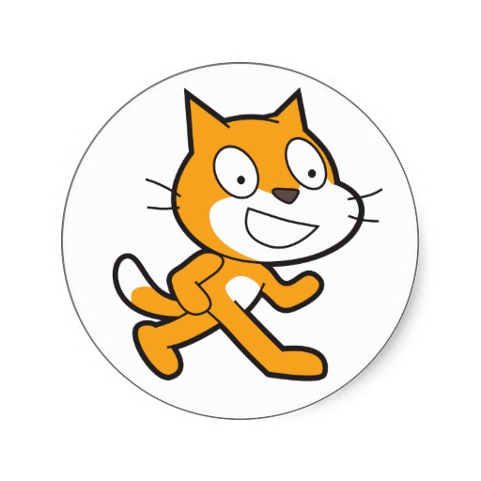

About Scratch

Scratch is a programming language that makes it easy to create your own interactive stories, animations, games, music, and art -- and share your creations on the web.

As young people create and share Scratch projects, they learn important mathematical and computational ideas, while also learning to think creatively, reason systematically, and work collaboratively.



The one rule is…

# **Be cool!**

At CoderDojo Porirua, we expect participants to:

* Have fun
* Ask questions
* Help
* Share
* Be kind and respectful: everyone is here to learn

Kids’ safety comes before everything except common sense.

Parents, please allow your kids to experiment, even if those experiments are not successful. Those are often the best kind.

Anyone who has questions, concerns, or just isn’t having fun should find a Volunteer or Mentor; look for nametags. You can also call:

Event help: 021 271 1844

**Thank you for coming!** CoderDojo Porirua