

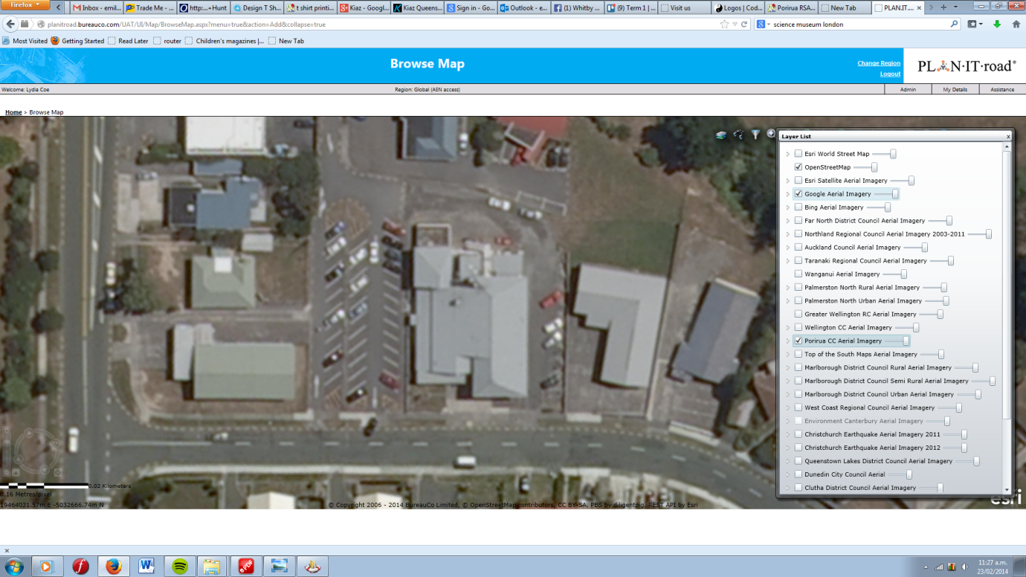

Entrance

Coder Dojo entrance around back of building, at top of stairs.

You are here