# Step by Step **Part 1**:

These are all the types of ‘code’ you can use

Read all of these speech bubbles - they contain helpful hints for you

## The Scratch window/ coding environment

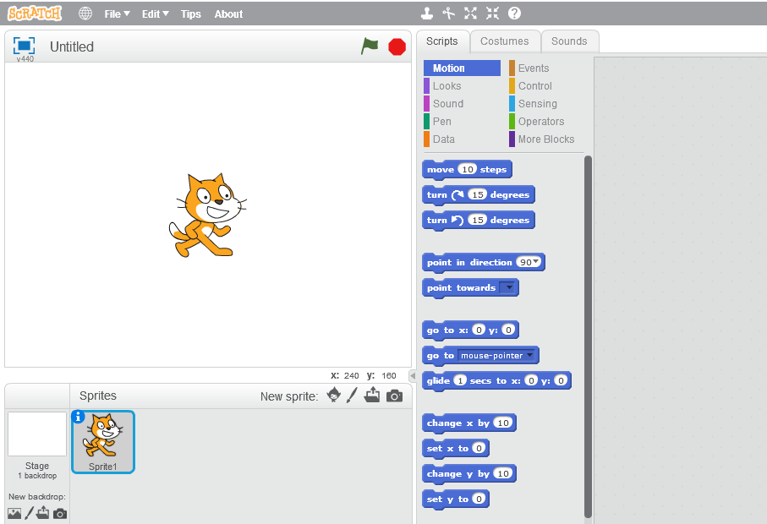

This is a ‘sprite’ or character in your game. Sprites wear ‘costumes’

You can add or paint a new sprite from here

Click the green flag to run your code

This is the ‘stage’ where your game will be played

Drag the code blocks you want into this space. When you run the code, your sprites follow your instructions exactly

## Make a sprite move and bounce off the edges of the stage

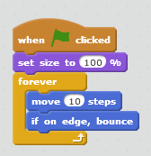

Use your mouse to find and drag blocks with the right colours to add this code for Sprite1. Then run the code using the green flag

## Paint a new sprite

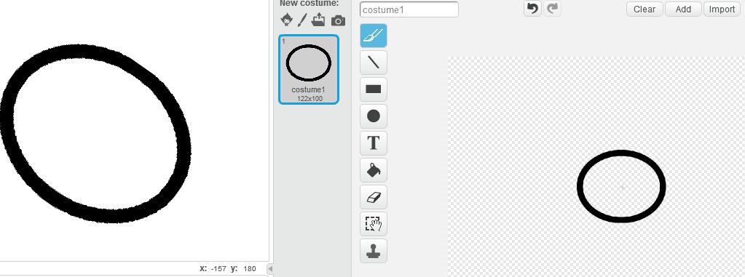

Use the painting tools to make a shape that looks like a track

***Turn the page over >>>***

## Change the code for Sprite1 (the cat) so that it follows the track

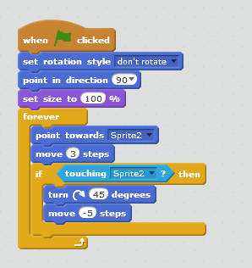

Press the green flag when finished, to run your code

As you drag in the new code, look at all the other options available in Scratch for code blocks you can use

To remove old code you don’t want, pull the block out using your mouse. Then click with your right mouse button to delete it fully

## Save your project in a folder

Use File>Save from the Scratch menu, just above the stage. Pick a folder (e.g. your desktop) and give your file a name

## Enjoy it for a few minutes, then move on

Watch the animation, show it to someone, or playa round with it for a few minutes. Then you’re ready for your next project.

Grab the next handout, which helps you to build a game where a cat plays fetch with a ball thrown by a friendly alien.

