1 Read the Getting Started and C Programming introductions before starting this exercise.

2 First we need to make a simple circuit using the Arduino and a breadboard. The sample Arduino program expects an LED on to be wired on Pin 13.

[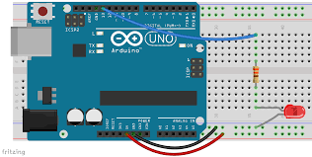](http://www.google.ie/imgres?imgurl=http://highschoolmaker.com/wp-content/uploads/2014/12/Breadboard-with-LED.png&imgrefurl=http://electronics.flosscience.com/Home_LE/unit-3---introduction-to-arduino/breadboard---introduction-to-arduino&h=854&w=1689&tbnid=H7B-ZPEvkp4DZM:&docid=Nra2hxLkv90sCM&ei=xehQVsSzNsHYPKCGvqgL&tbm=isch&ved=0ahUKEwiEqtaewaLJAhVBLA8KHSCDD7UQMwhgKDowOg)

3 Now we can take a look at a simple program to make the LED Blink. For the Arduino programs are called Sketches. Open up the Arduino software and use the Open Icon to look at the sketch Blink in the examples folder

[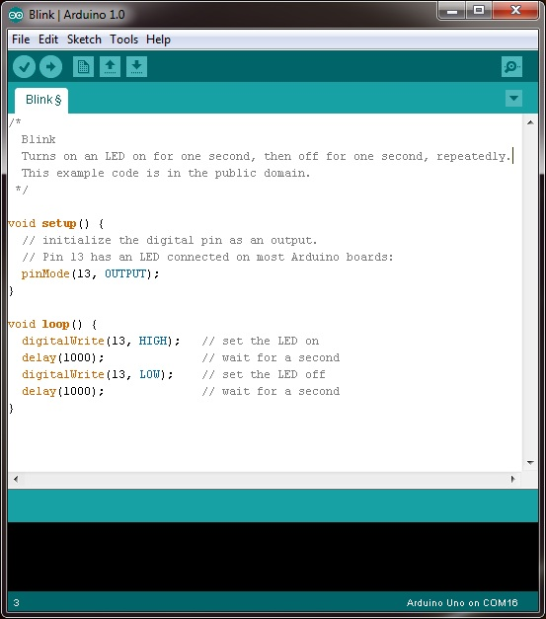](http://www.google.ie/url?sa=i&rct=j&q=&esrc=s&source=images&cd=&cad=rja&uact=8&ved=0ahUKEwjLh67iwqLJAhXHvRQKHaV5By8QjRwIBw&url=http://www.robotshop.com/blog/en/arduino-5-minute-tutorials-lesson-2-basic-code-blink-led-2-3639&psig=AFQjCNEjiMS-wScYgIHYY1tOAIgmjlbwoA&ust=1448229854832405)

4 Now click the Upload icon to load the program to the Arduino. You will see the RX and TX lights on the Arduino flicker and a confirmation message. A few seconds later you should see your program in action!

What’s next?

Try changing

1. The timing interval
2. The Port number (don’t forget to rewire)
3. Add another LED to you board and add code to make that blink
4. Move on to the Dice Game!

For more information and additional lessons try the following useful links:

<http://www.robotshop.com/blog/en/arduino-5-minute-tutorials-lesson-2-basic-code-blink-led-2-3639>