1 Make sure you have mastered the LED Blink exercise before starting this exercise.

2 Check the parts you we need to complete this project

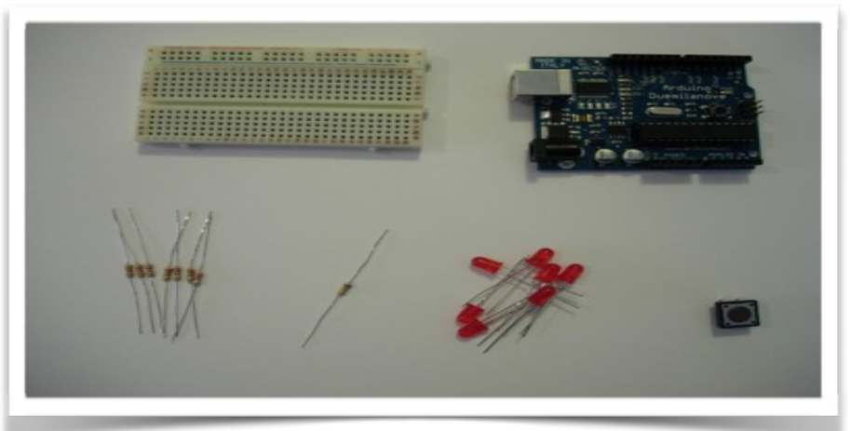

.Parts

* Arduino
* 7x Leds of any kind (I use 5mm Red Leds)
* A 10k Resistor (brown black orange)
* 7x 220 or 330 Resistor (red red brown or orange orange brown)
* A little Push Button
* Breadboard
* Some wires for the breadboard

3 Build the LED dice on your breadboard using this circuit diagram:

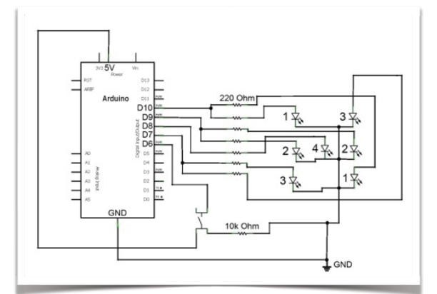

4 Place the 7 LED’s in the pattern of an “H” as shown below:

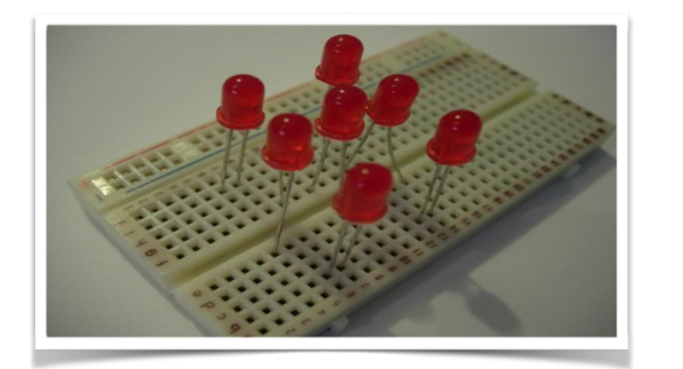

5 Continue to build out the circuit until you use all the components

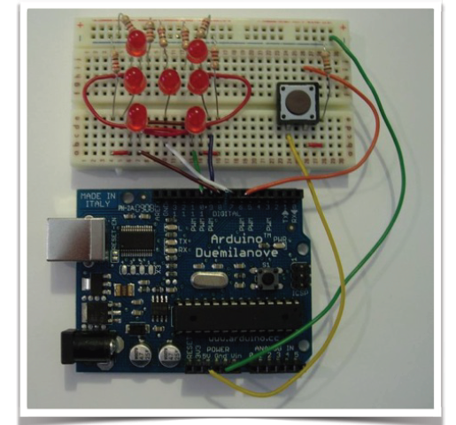

3 Now let populate the Sketch to drive the LED’s

int pinLeds1 = 10;

int pinLeds2 = 9;

int pinLeds3 = 7;

int pinLed4 = 8;

int buttonPin = 6;

int buttonState;

long ran;

int time = 2000;

void setup ()

{

pinMode (pinLeds1, OUTPUT);

pinMode (pinLeds2, OUTPUT);

pinMode (pinLeds3, OUTPUT);

pinMode (pinLed4, OUTPUT);

pinMode (buttonPin, INPUT);

randomSeed(analogRead(0));

}

void loop()

{

buttonState = digitalRead(buttonPin);

if (buttonState == HIGH){

ran = random(1, 7);

if (ran == 1){

digitalWrite (pinLed4, HIGH);

delay (time);

}

if (ran == 2){

digitalWrite (pinLeds1, HIGH);

delay (time);

}

if (ran == 3){

digitalWrite (pinLeds3, HIGH);

digitalWrite (pinLed4, HIGH);

delay (time);

}

if (ran == 4){

digitalWrite (pinLeds1, HIGH);

digitalWrite (pinLeds3, HIGH);

delay (time);

}

if (ran == 5){

digitalWrite (pinLeds1, HIGH);

digitalWrite (pinLeds3, HIGH);

digitalWrite (pinLed4, HIGH);

delay (time);

}

if (ran == 6){

digitalWrite (pinLeds1, HIGH);

digitalWrite (pinLeds2, HIGH);

digitalWrite (pinLeds3, HIGH);

delay (time);

}

}

digitalWrite (pinLeds1, LOW);

digitalWrite (pinLeds2, LOW);

digitalWrite (pinLeds3, LOW);

digitalWrite (pinLed4, LOW);

}[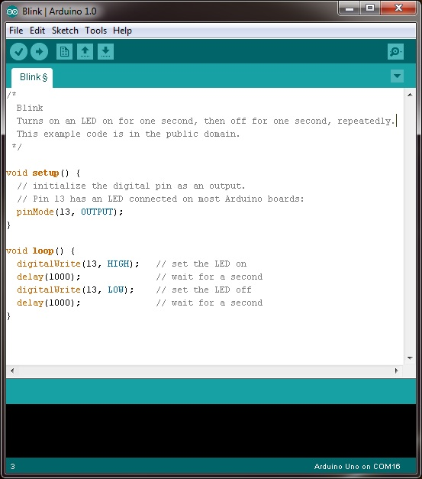](http://www.google.ie/url?sa=i&rct=j&q=&esrc=s&source=images&cd=&cad=rja&uact=8&ved=0ahUKEwjLh67iwqLJAhXHvRQKHaV5By8QjRwIBw&url=http://www.robotshop.com/blog/en/arduino-5-minute-tutorials-lesson-2-basic-code-blink-led-2-3639&psig=AFQjCNEjiMS-wScYgIHYY1tOAIgmjlbwoA&ust=1448229854832405)

4 Now click the Upload icon to load the program to the Arduino. You will see the RX and TX lights on the Arduino flicker and a confirmation message. A few seconds later you should see your program in action!

What’s next?

Try changing

1. The timing interval
2. The Port number (don’t forget to rewire)
3. Add another LED to you board and add code to make that blink
4. Move on to the Dice Game!

For more information and additional lessons try the following useful links:

<http://www.robotshop.com/blog/en/arduino-5-minute-tutorials-lesson-2-basic-code-blink-led-2-3639>