1 A potentiometer is a device that provides variable resistance usually through a knob or slider. In this project, potentiometer values are read in through an 'Analog In' pin. The values could then be used to control the blinking rate of an LED.

[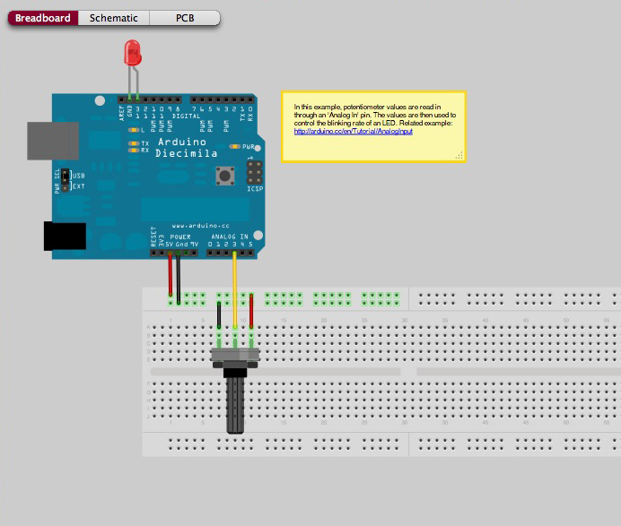](http://www.google.ie/url?sa=i&rct=j&q=&esrc=s&source=images&cd=&cad=rja&uact=8&ved=0ahUKEwixj6LalcHKAhVFwA4KHR--CEsQjRwIBw&url=http%3A%2F%2Ffritzing.org%2Fprojects%2Fanalog-input-potentiometer&psig=AFQjCNHzgzyHazKfs0ASGm-CSIPKMlzwaQ&ust=1453680956511253)

2 Now we can take a look at a simple program to take an analog reading and make the LED Blink. Open up the Arduino software and use the Open Icon to look at the sketch AnalogInput in the examples folder

[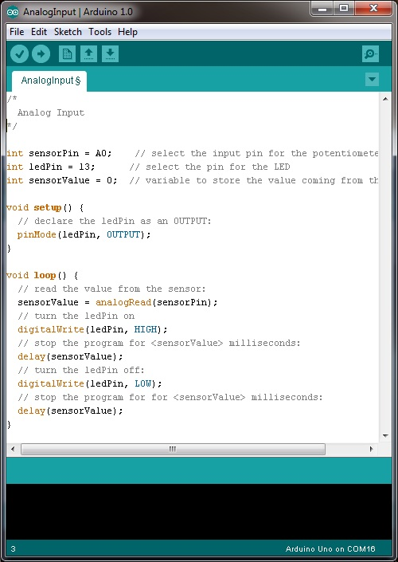](http://www.robotshop.com/blog/en/files/arduino-potentiometer-led-code.jpg)

3 Most Arduino microcontrollers use 10 bit analog (voltage) to digital (numeric) conversion, which is 210 possible numbers = 1024. Therefore a voltage of 0V corresponds to a numeric value of 0. A voltage of 5V corresponds to a numeric value of 1024. Therefore a value of 3V would correspond to a numeric value of:

3/5 =x/1024, x = 3*1024/5 = ~614

4 Now use the Analog output to control the flashing of the LED.

5 We can send the value back to the console using the serial port of the Arduino using the code:

**Serial**.println(sensorValue);

This sends the value contained in the variable “sensorValue” serially via the USB plug and digital pin 1. Verify, then upload this sketch to your Arduino. Once it is done, press on the “magnifying glass” located towards the top right of the window. This is the “Serial monitor” and monitors communications being sent and received by the Arduino

.

[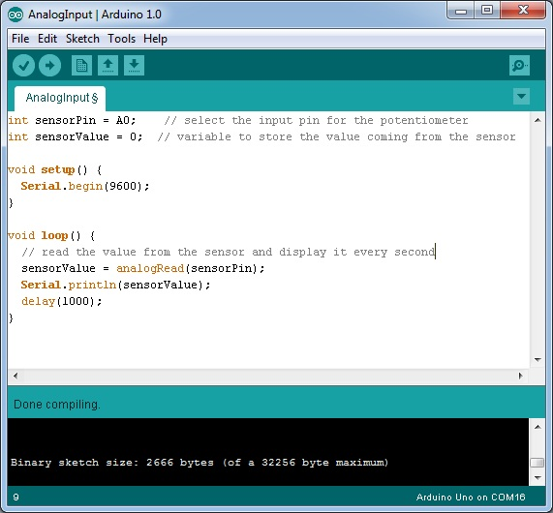](http://www.robotshop.com/blog/en/files/analog-serial.jpg)

Note to use Serial communications you need to set the Baud rate using the command

**Serial**.begin(9600);

For more information and additional lessons try the following useful links:

<http://www.robotshop.com/blog/en/arduino-5-minute-tutorials-lesson-3-potentiometer-3638>

<http://fritzing.org/projects/analog-input-potentiometer>