1 A resistor represents a given amount of resistance in a circuit. Resistance is a measure of how the flow of electric current is resisted.

Think of a circuit as a flow of water driving a water wheel. If too much water enters the water wheel, then it will go too fast and break. So you need to slow down the flow of water. In an electronic circuit this is the job of a resistor.

Resistance is measured in Ohms. The Ohm is often represented by the omega symbol: Ω.

The symbol for resistance is a zigzag line as shown below. The letter "R" is used in equations.

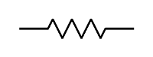

Resistor Symbol

Resistors

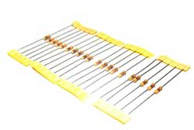

Resistors are usually light brown or blue in colour, but there are basically the same. What is important is the value of the resistor and this is represented by banding on the body of the resistor, and that will vary by the number of bands present. You can use the following diagram to see the value of a resistor:

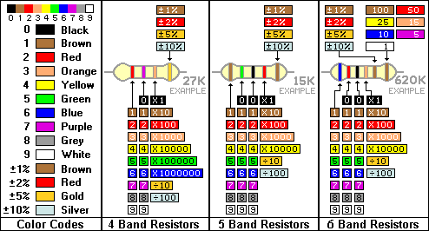

Resistors can also look like this:

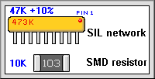

2 To simplify the writing of large resistor values, the abbreviations K and M are used for one thousand and one million. To keep the convention standard, R is used to represent 0. Because of problems in seeing the decimal point in some printed texts, the 3 letters: K M or R are used in place of the decimal point. Thus, a 2,700 Ohm resistor is written 2K7 and a 6.8 Ohm resistor is written 6R8.

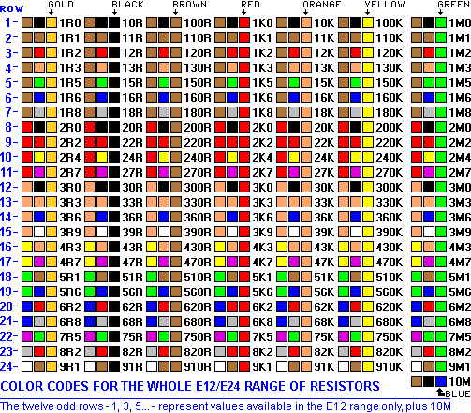

2 Working out what value of resistance you need will depend on the amount of current you want to limit to which in turn is determined by which component the circuit is being connected to. The component will have a tolerance, and it will be up to you to calculate how much resistance is needed!

**Resistance is NOT futile!**

4 To work out how much Resistance you need you need to know some things first!

**Supply voltage** This is how much power you're putting into the circuit. Batteries and wall warts will have the output voltage printed on them somewhere. If you're using multiple batteries*, add the voltage together.

**LED Voltage** Sometimes "Forward Voltage" but usually just abbreviated "V".

**LED Current** Sometimes "Forward Current". This is listed in milliamps or "mA".

Both of these last two can be found on the packaging for your LEDs or on your supplier's web site. If they list a range ("20-30mA") pick a value in the middle (25 in this case). Here are some typical values, but *use your own values to be sure you don't burn out your LEDs!:*

Red LED: 2V 15mA

Green LED: 2.1V 20mA

Blue LED: 3.2V 25mA

While LED: 3.2V 25mA

Having established your Suppl voltage, LED voltage and LED Current then you can work out the value of the resistance needed using Ohms law:

**(Supply Voltage - LED Voltage) / (LED Current / 1000) = Resistance**\*

We divide the LED current by 1000 when the value is listed in milliamps

So for a Supply Voltage of 3.3V (typical of Arduino) and a Red LED of LED Voltage 2V and 15mA LED we need a Resistor of:

3.3-2/(15/1000) = 87 Ohms = 91R

This works just as we for other components – not just LEDs!

4 When current flows through a resistor it will generate heat. The greater the current the more heat will be produced. We therefore have to make sure the Resistor Power Rating is appropriate to the current being generated. The Resistor Power Rating is calculated by the formula

**Power = V2 * R**

So in the above example we P = 152 * 91 = 0.02W = 20mW

For safety reasons the Power Rating is normally doubled to ensure that heat will be properly dissipated.

4 What happens if you want to connect components in series?

Below is another simple LED’s (LED’s Connected in Series) Circuit. In this circuit, we have connected 6 LED’s in Series. Supply Voltage is 18V, The Forward Voltage (VF) of LED’s is 2V and the forward Current (IF) is 20mA each.

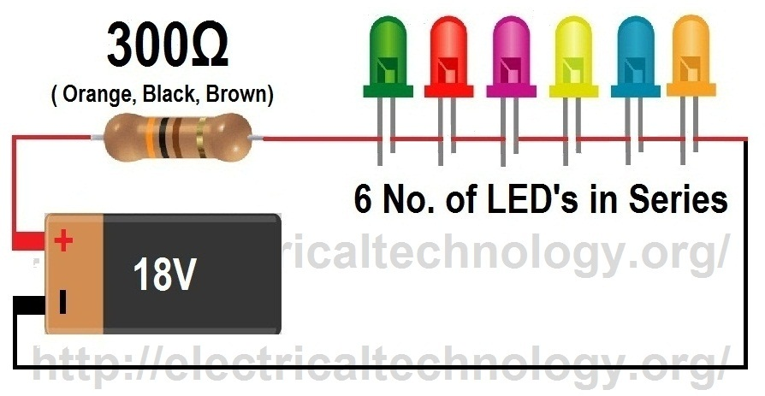

Resistor Value (LED’s in Series) = (Vsupply – (VF x No. of LED’s)) / IF

Here, Total forward voltage (VF) of 6 LED’s = 2 x 6 = 12V

and forward Current (IF) is same (i.e. 20mA)

(**Note:** this is a series circuit, so current in series circuit in each point is same while voltages are additive)Now, the value of resistor (for Series Circuit) would be:

= (Vsupply – (VF x No. of LED’s)) / IF= (18 – (2 x 6)) / 20mA

= (18-12) / 20mA = **300 Ω**

Total Current draw = 20mA

(This is series circuit, so currents are same)Resistor Power Rating

= IF2x Resistor Value= (20mA) 2 x 300Ω = 0.12 = 120mW

**But** This is the minimum required resistor value to ensure that resistor will not overheat, so its recommended that to double the power rating of resistor that you have calculated, Resistor power rating (Value is doubled) = 0.24 W = (240 mW)

5 What happens if you want to connect components in parallel?

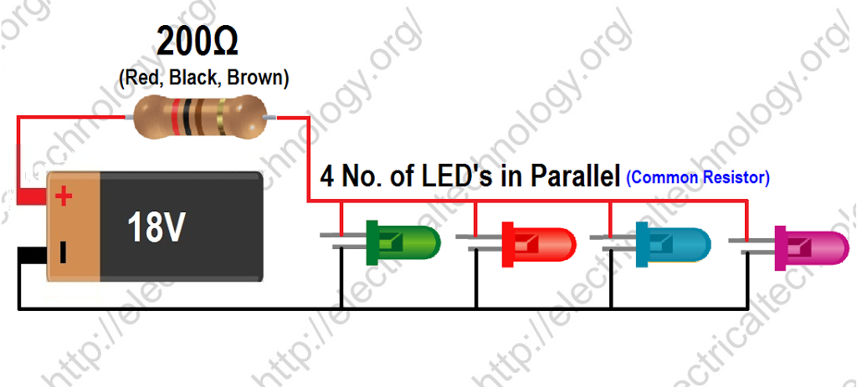

In this circuit, we have connected LED’s in parallel with common resistor. Supply Voltage is 18V, The Forward Voltage (VF) of LED’s is 2V and the forward Current (IF) is 20mA each.

Resistor Value (LED’s in parallel With Common Resistor) = (Vsupply – VF)/ (IF x No. of LED’s)

Here, Total forward Current (IF) of 4 LED’s = 20mA x 4 = 0.08A, and forward Voltage (VF) is same (i.e. 2V)

(**Note:** this is a parallel circuit, so voltage is parallel circuit is same in each point while currents are additive).

Now, the value of resistor (for parallel Circuit with common resistor) would be:

= (Vsupply – VF)/ (IF x No. of LED’s)

= (18 – 2) / 0.08

= **200 Ω**

Total Current draw = 20mA x 4 = 80mA

(This is parallel circuit, so currents are additive)

Resistor Power Rating = IF2x Resistor Value= (20mA) 2 x 200Ω = 0.08 W = 80Mw Resistor power rating (Value is doubled) = 0.16 W = (160 mW)

6 Or you could also connect your resistors in parallel too!

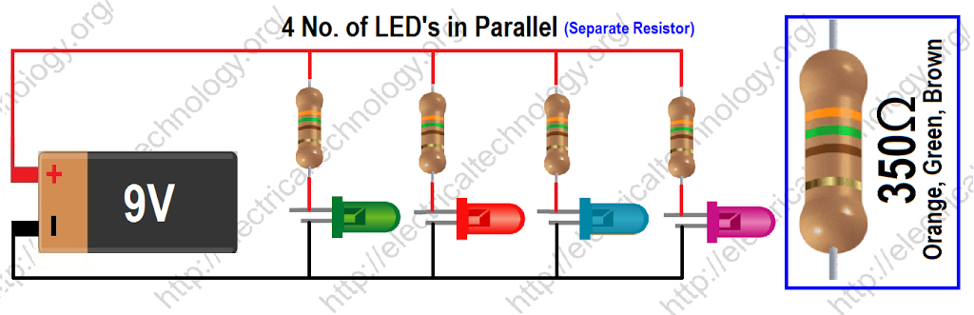

In this circuit, we have connected 4 LED’s in parallel with separate resistors. Supply Voltage is 9V and the Forward Voltage (VF) of LED’s is 2V and the forward Current (IF) is 20mA each.

**Resistor Value** (LED’s in parallel with separate Resistor) = (Vsupply – VF)/ IFHere, Total forward voltage (VF) of LED’s = 2 and forward Current (IF) 20mA (i.e. 20mA)

(**Note:** this is a parallel circuit, but we are finding the value of resistor for each section, not for whole circuit. So in each section, the circuit becomes in Series position (refer to the Series Circuit formula or the 1st simple circuit above, you will find that these are same)

Now, the value of resistor (for parallel Circuit with separate resistors) would be:

= (Vsupply – VF)/ IF= (9 – 2) / 20mA = **350 Ω**

Total Current draw = 20mA x 4 = 80mA (This is parallel circuit, so currents are additive)

Resistor Power Rating = IF2x Resistor Value= (20mA) 2 x 350Ω = 0.14 = 140mW

Resistor power rating (Value is doubled) = 0.28 W (280 mW)

Credit for this material and Other useful links

<http://www.electricaltechnology.org/2013/08/how-to-calculate-value-of-resistor-for-LED-circuits.html>

<http://www.diyaudioandvideo.com/Electronics/ResistorColorCodes/>