1 This sushi card explores the Challenge of creating a Tilt game that can be played on a BBC Microbit.

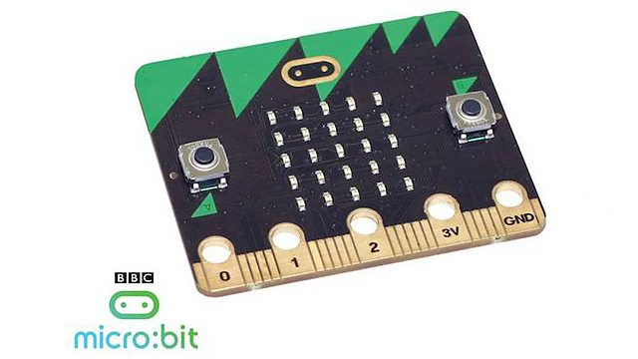

The Micro:bit has an inbuilt accelerometer which allows us to determine if the board is being tilted about its axis.

The design of the game should include some or all of these elements

* Use the LED matrix to simulate rolling a ball across a board
* The ball is represented by one LED on the board
* The ball starts at the same position each time
* Player makes his ball roll by tilting the board
* On each turn other LED’s will light up and be the target
* When the ball touches a target the players score is increased
* When all the targets are touched the game resets to a higher level
* There is a timer, the time taken to clear all levels will be displayed at the end
* If the ball rolls off the board it reverts back to the start position

2 You have a choice of Programming Languages to complete the project. You can even try coding the game in Microsoft Block editor, MicroPython or JavaScript! Here’s some coding hints to get you started: