DALEKS

**Try to kill all the daleks by making them crash into each other before they catch and kill you.**

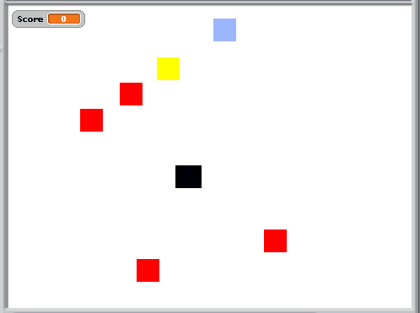

# Rules

* Player (black) is escaping the daleks (red, 4)
* Whenever he moves (arrow keys), they all move too, towards his new position
* If a dalek touches the player, player loses and game starts again (score -1)
* If a dalek touches another dalek, the dalek dies
* If all daleks are dead, the player wins and game starts again (score +1)
* A dead dalek can still kill the player or a live dalek
* Player can teleport to a random location (press 't') but this may land him on a dalek, killing him instantly
* Player can skip a turn with 'space'. Daleks move, player doesn't
* Various power-ups are available, placed randomly at game start and not moving

Note: you want multiple daleks each with its own code (same as other daleks). As Scratch does not allow you to clone a sprite from the code, you should create one dalek with the working code, then duplicate 3 times before starting game.

# Power-ups

* Power-ups are placed at random at each game start
* If the player touches the power-up, its effect begins immediately
* If player touches a power-up in same move as a dalek catches them, the power up still works. Depending on the power-up, this could save their life
* When a power-up is active, the player sprite and stage background should be different
* Power-ups:
  1. Invisibility (blue). If player touches it, for 3s he is invisible and daleks do not move. Player can use this time to reposition himself to kill the daleks or just get out of trouble
  2. Invulnerability (yellow). If player touches it, for 3s he is invulnerable and daleks cannot kill him. Player can use this time to cause daleks to kill each other without worrying about being killed, but can be killed as soon as the effect wears off

# Next challenges

1. Make daleks faster when they're nearer to the player, slower when further away
2. Make the power-ups only usable once per game. Sprite changes when used to show they've been used.
3. Add another power-up that causes the daleks to grow x3 for 3s. This increases the chance they will touch (but also easier for them to reach player)
4. Add another power-up that slows the daleks down for 3s or for 10 player moves
5. Add wraparound teleport: if the player touches the edge of the stage, he appears at the same point on the opposite edge i.e. Move to top means he appears at same x-position on bottom. Daleks can't do this and so the edges become escapes
6. Add difficulty levels. Ideally affects number of daleks but this is not possible in scratch. Instead, make daleks faster/slower speed to difficulty. Auto-increase difficulty as score increases, reduce as falls
7. Add mines. Mines are non-moving areas of a different colour, randomly placed, which kill the player if they walk into it. These need no code so can be programmatically created: an invisible sprite could move across the stage at game start, dropping its pen at random to draw colour blocks. Player code then has "if touching" code to die. Number of mines could be linked to difficulty
8. Use better sprites, backgrounds/effects, sounds

# Bugs

1. Can get a dalek seem to die without touching another one, though one is close. Why? First moved and touched second just before second moved away and lived as it wasn't touching first at that point. Fix by having both die in this case
2. Can get daleks touching in initial random layout. Make sure no sprite is touching another sprite in the random start. If they do, randomise all or just that one again or move the touching one away till not touching

*There is code to make sure that if the player is placed on a dalek in the initial layout, the layout is redone but without any of the usual "lose" logic (score -1). See logic around game-starting variable.*