1 Read the Getting Started and C Programming introductions before starting this exercise or a Mentor will give you a basic introduction to this activity.

2 First we need to make a simple circuit using the Arduino and a breadboard. The sample Arduino program expects an LED on to be wired on Pin 13.

Top Tip: Make sure the long leg (Anode) of the LED is on positive side of the circuit, in this case in line with the resistor.

[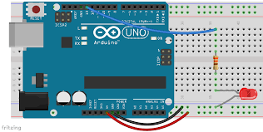](http://www.google.ie/imgres?imgurl=http://highschoolmaker.com/wp-content/uploads/2014/12/Breadboard-with-LED.png&imgrefurl=http://electronics.flosscience.com/Home_LE/unit-3---introduction-to-arduino/breadboard---introduction-to-arduino&h=854&w=1689&tbnid=H7B-ZPEvkp4DZM:&docid=Nra2hxLkv90sCM&ei=xehQVsSzNsHYPKCGvqgL&tbm=isch&ved=0ahUKEwiEqtaewaLJAhVBLA8KHSCDD7UQMwhgKDowOg)

3 Take a look at a simple program to make the LED Blink. For the Arduino programs are called Sketches. Open up the Arduino software and use the Open Icon to look at the sketch “Blink” in the Basics section of the Arduino Examples library.

Examine the code and read the comments. This will help you understand how a simple program can be written for the Arduino. Check that you have the right pin connected according to your program.

4 Now click the Upload icon to load the program to the Arduino. You will see the RX and TX lights on the Arduino flicker and a confirmation message. A few seconds later you should see your program in action!

What’s next?

Try changing

1. The timing interval
2. The Port number (don’t forget to rewire)
3. Add another LED to you board and add code to make that blink
4. Move on to the next Challenge!

For more information and additional lessons try the following useful links:

<http://www.robotshop.com/blog/en/arduino-5-minute-tutorials-lesson-2-basic-code-blink-led-2-3639>

Sample Code:

[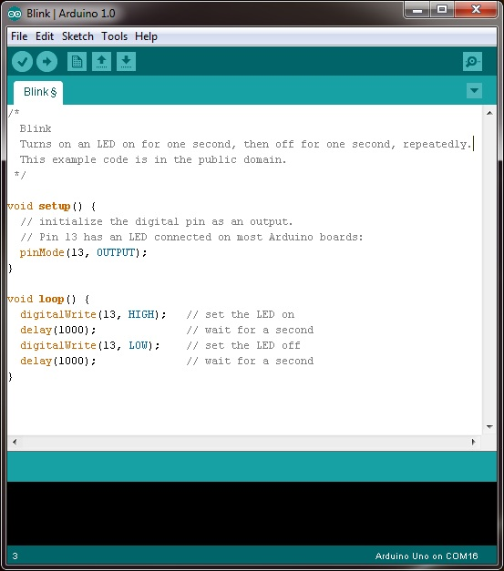](http://www.google.ie/url?sa=i&rct=j&q=&esrc=s&source=images&cd=&cad=rja&uact=8&ved=0ahUKEwjLh67iwqLJAhXHvRQKHaV5By8QjRwIBw&url=http://www.robotshop.com/blog/en/arduino-5-minute-tutorials-lesson-2-basic-code-blink-led-2-3639&psig=AFQjCNEjiMS-wScYgIHYY1tOAIgmjlbwoA&ust=1448229854832405)