1 Make sure you have mastered the LED Blink exercise before starting this exercise.

2 We are going to make this circuit using Resistors, LED’s in the shape of an “H”, a Switch and a Breadboard, wired up to an Arduino

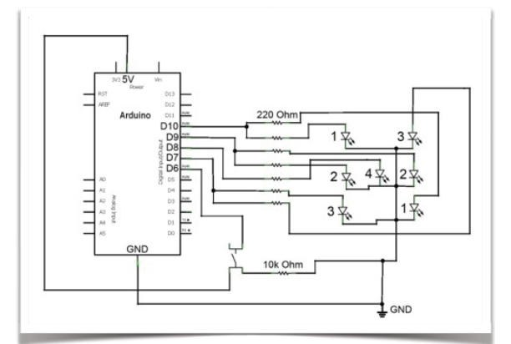

3 Continue to build out the circuit until you use all the components.

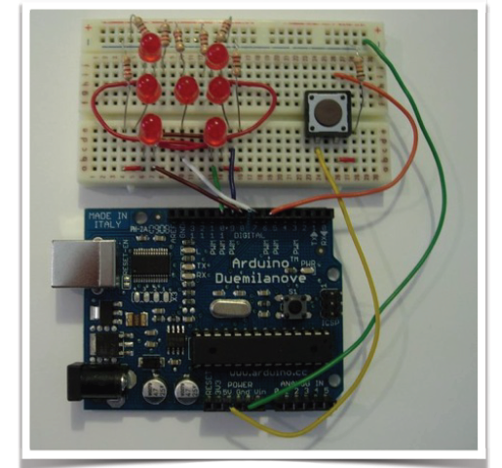4 Now review the code/Sketch (LEDDice.ino) that control the LED’s. Review the code for the Pins Outs that matches the Breadboard Wiring, the detection of the button press, the use of a random number generator to decide which LED to light up and the initialization and de-initialization code!

Don’t Forget! - the LED’s need to be positioned with the longer leg (Anode) on the + side of the circuit.

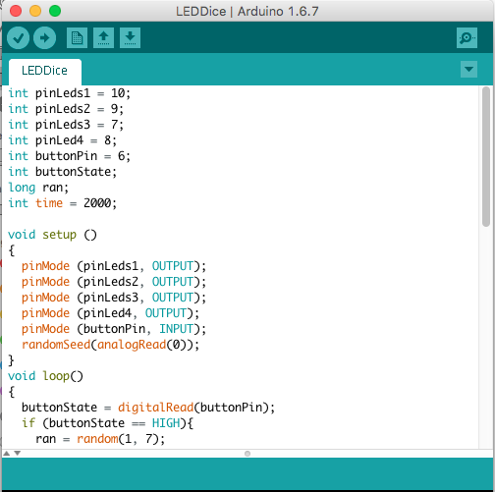

What you could try next…

1. Randomly vary the time interval for the LED to light up
2. Make all the numbers light up after pressing pressing the button