1 When you open the Scratch Program you will see its IDE (Integrated Develop Environment) – this is where you write *your* code that brings *your* idea’s into life! This screen has a few parts you will need to remember.

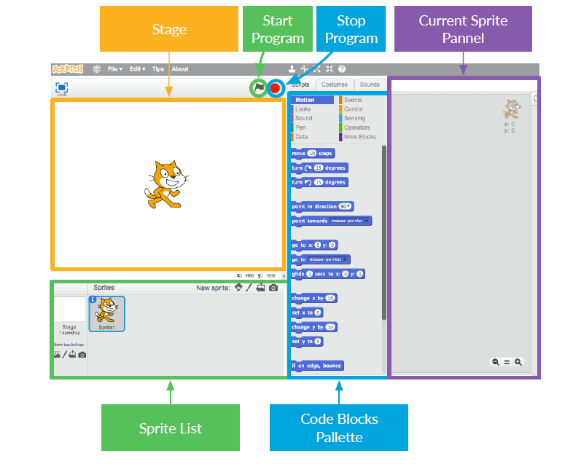

2 There are a few words from that picture that need explaining:

**The Stage**

This is where your Scratch Programs run. It has

• One or more **backgrounds** (images on the background of the screen)

• Any **code blocks** associated with it (we’ll get to this)

**Sprites**

Any object that goes on the stage is a sprite. In Scratch, the sprite is:

• The image on the **stage**

• Any alternative **costumes** (looks) it has

• Any **sounds** associated with it

• Any **code blocks** associated with it

The **current sprite** is the one that’s selected in the **sprite list**.

**Code Blocks**

Code in Scratch comes as blocks, that you click together to make programs. You choose blocks from the **code blocks palette** and drag them into the **current sprite panel**, then click them together.

There are 10 categories of blocks, which are colour coded, and you can select each category from the list at the top of the **code blocks palette.**

3 Time to get coding! Go back to Scratch and click on the Scratch Cat in the **sprite list**. The cat is now the **current sprite**.

Go to the **Events** category in the **code blocks palette** and choose the “when [flag symbol] clicked” event, then drag it onto the **current sprite panel.**

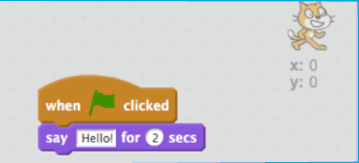Then go to **Looks** in the **code blocks palette** and choose the “say [Hello!] for [2] secs” block and drag it onto the **current sprite panel**, connecting it to the end of the other block, like this:

Now click the **Start Program**

Button and watch what happens!