Unity3D Tutorial – Materials and Particle Effects

0. About This Tutorial
- This is the second tutorial in a series of Unity3D tutorials for. To do this tutorial, you should be comfortable with basics of Unity3D user interface, have internet access, and have some experience drawing simple shapes in a drawing computer program.  - This tutorial teaches basics of how to use Materials and Textures, but is primarily focused on using the Unity3D Shuriken particle system engine. | 

1. Starting Point
- You can chose to do this tutorial in an existing project, or in a new project. If doing this in an existing project, skip this section, otherwise, within Unity3d, press , and select .
- to the , and create a (Right-Mouse Button in the File Chooser and select , or just press Ctrl + Shift +N or ⌘+Shift+N)
- Name the folder , then . Press to create the project.

2. Create a Simple Material
- Before creating a material, find an object in the scene to apply the material to! If you don't have one, create one in the , with , 3D Object, .
- To create the material, in the , select and .
- Name the material something like “mat_green”.  - Notice material options in the . The options belong to the material's Shader.  - Click the color picker () to the right of Albedo to change colors.  - Albedo is a scientific word that means “light bouncing off of something”  - Click inside the gradient to change the color. To change the square: Click the rainbow on the right, drag the , or type a raw RGB value in the text boxes.  - Close the window after picking a color.  - Drag-and-drop () the material onto a GameObject in the , or even in the .  - Create more colors by creating more Materials! | 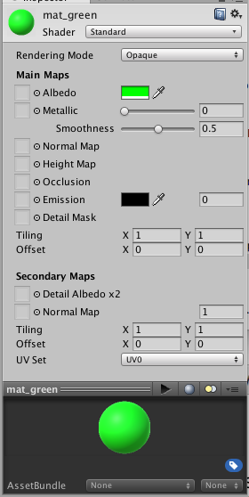

3. Texture and Shader Basics
- A Material can put a picture on a GameObject if the Material has a Texture. Click the tiny-circle-with-the-dot-in-it next to Albedo, and select a texture. Every Unity3D project should have at least 1 texture (the default particle texture).
    - The tiny-circle-with-the-dot-in-it is Unity's “select another resource” icon.
- You may notice that setting a Material's texture changes all GameObjects using that material.
- A Shader changes how objects light themselves. Click the drop-down box to see shader options. Don't worry about them all, just know they are there. Shaders are a big topic!
  - Game Developers should know something about shaders:
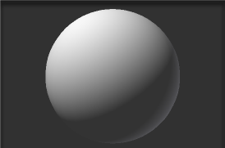 | Diffuse – Also called Flat Shading. This is a basic idea that applies to many different kinds of shaders. Diffuse lighting makes something look correct in light, but not particularly special.
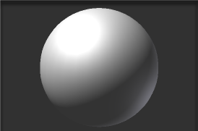 | Specular – Specular is the term for the white circle of shininess on a reflective material. Objects with specular look more wet than objects with only Diffuse lighting. The smaller that white reflection, the shinier and wetter something looks.
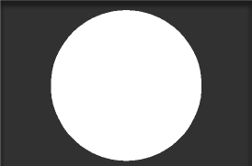 | Unlit – An Unlit shader tells the 3D graphics system not to apply lighting calculations to this object. Unlit objects will look very artificial, and stand out in a game that is using other shaders.
 | Particles/Additive – Many particle effects use this shader. It acts intelligently with transparency, and generates good-looking color blending, without costing the computer much processing power.
 | Sprites – These shaders intelligently handle transparency. Use these if you want to display images-with-transparency onto objects, especially as pieces of user interface that interact within a game area.
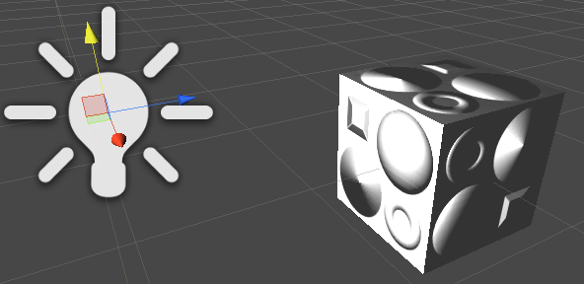
  The standard shader allows Normal Maps or Bump Maps, to show detail on a surface when lit. Normal Maps are an important part of very high-quality 3D art development for games.  ← White cube and lighting, using Normal Map →  http://codegiraffe.com/utut/normalmap.png → | 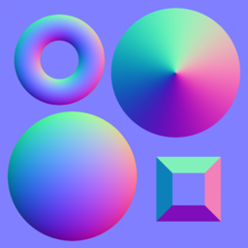
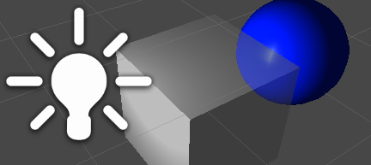 | The standard shader in Unity has a Transparent Rendering Mode, which allows textures to be partially see-through. The Alpha Transparency can be set in the Material's color (the alpha transparency bar at the bottom of the color picker).  ← Partially-transparent white cube in front of a specular blue sphere
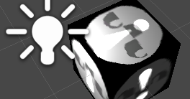 | Emission – The standard shader can apply a light, or a light stencil effect, directly onto textures. These light effects can help accent details, and make a texture look lit regardless of actual lighting.

4. Creating Simple Textures with PiskelApp for Unity3D
- Unity3D can use almost any image type as a texture. Lets make a very simple image using PiskelApp, a free animated-sprite-editor on the internet, found at http://piskelapp.com/p/create .
- Press  (on the right) to set the size of the starting image to 128 x 128. Notably, 128 is a power of 2, which is easier for a computer to use than any other kind of number (some graphics hardware requires images to be sized by powers of 2).  - Colors are changed with the rectangles at the lower-left. 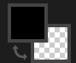  - Use the (P)encil tool () and paint (B)ucket () to draw something with your mouse. I drew a silly face, and left the edges transparent.  - Name the graphic with Save (), and download it as a .png with Export ().  - Don't spend time to make good art right now, make fast art! Game Developers call this Placeholder Art, it is meant to be replaced later, by an artist taking their time. | 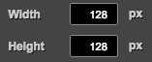  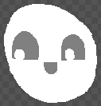  Sample Placeholder Art
- To import the image into Unity3D, save your image in the Assets folder of your Unity3D project. Or, you can also simply drag-and-drop the image into the folder of your project (either in Unity3D, or in the file system). To see the Assets folder in the file system, press the Right-Mouse Button on , then or . or, use , , and then find the image using the file chooser.  - You can bring any image into Unity3D, by following the previous step.  - Image assets can be put onto objects by drag-and-dropping them. Doing that will automatically create a Material in a Materials sub-folder, which is created in the same folder as the image. | 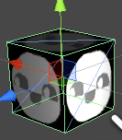

Don't Forget to Save Your Scene!

5. Simple Particle Effects
- Create a new Particle System in the by clicking and .  - The Particle System Component describes how the particle effect works, and can be changed by editing its values directly.  - Hover your mouse over the text label next to each value for a description of what the value is for.  - The Particle System has many sub-components (like Emission, Shape, Size over Lifetime). Click on the sub-components of the Particle System to expand them. Click the white circle to toggle them on and off.  - You can rename the Particle System to anything. For this demonstration, name it “Absorb from Environment”.  - Copy the Emission and Shape sub-components to match the example on the right. →  - Enable and expand Size over Lifetime, and click in the gray rectangle. Clicking the rectangle activates the Curve Editor.  - You may need to expand the Particle System Curves editor by dragging it taller: hover your mouse over the Particle System Curves title, near the bottom of the inspector, and drag it upward.  - Notice that the shape of the spline determines the size of particles at different parts of the particle's life. | 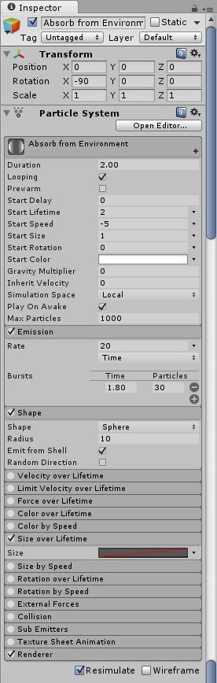
  - The curve editor modifies a spline, a special kind of curved line. Drag spline points, or adjust the slope with a handle that appears after selecting a point. | 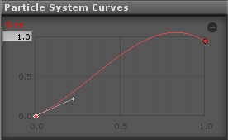
  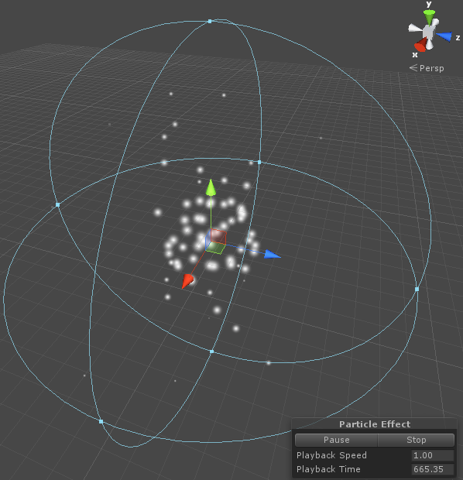 | - With these values (the sample to the right), this Particle System creates a sphere area that pulls white energy of some kind towards a center point.  - Don't forget to save your work!  - Experiment with different numbers to see what happens to the Particle System.

6. Particles Using Materials
- Get the image Star02.png  from https://goo.gl/LCw5Oo  - Add this image to your Unity .  - Create a new Material, and set it's shader to Particles/Additive  - Particles/Additive tells a shader to treat black as transparent, and white as maximum color, with shades of gray being partially transparent. When combined with different colors, and many particles, this allows very pretty color-blending effects for a material!  - Create a new Particle System in the by clicking and and name it twinkle.  - Please keep this particle effect simple! It is designed to be a subtle accent. Small effects like this can give nice hints to players.  - Rotation over Lifetime should be enabled. Change the Angular Velocity value to accepting two values by pressing the-tiny-down-arrow and selecting . Use -90 and 90.  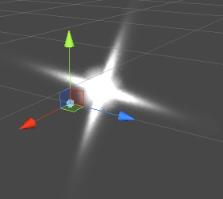 | 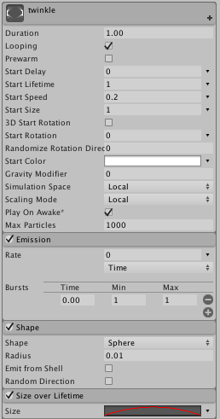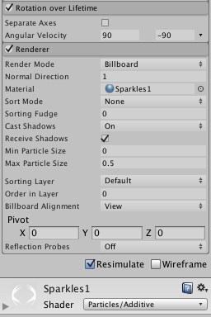
  - Name the new material Sparkles1
  - Use 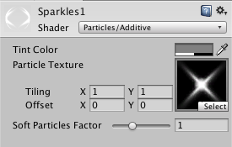to choose Start02.png as the texture for the material, or drag-and-drop Start02.png into the box.
  - Size over Lifetime should be enabled, and should use a parabola-like curve (here →).  - Renderer should use the Material: Sparkles1 (press to find it). | 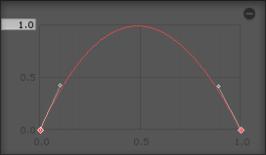

7. Particles Using Sprite Materials
- Create an image to act as a sprite, using your favorite image editor.  - This particle effect is designed to be an iconic alert! A simple, iconic image would work well. For example: https://goo.gl/iqyuL0   - After creating the iconic image, Import it into Unity3D.  - Create a new material called Exclaim.  - The image must be set first, in the Standard shader, because some versions of Unity don't support changing the Albedo texture in Sprites shaders.  - Make a new Particle System, using values to the right →, and name it exclaim.  - Un-check the Shape.  - Particle Systems without a shape will simply shoot particles in the Transform's forward direction. This can also be very helpful for projectile effects!  - Size over Lifetime should be enabled, and should use a parabola-like curve with a flat finish (here →).  - Renderer should use the Material: Exclaim (press to find it, or drag the material into the Renderer's material). | 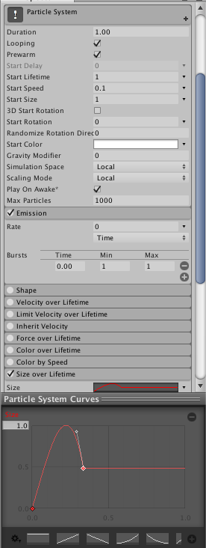
  - Change the Albedo Main Map to the image for this particle effect by setting it with the tiny-circle-with-the-dot-in-it.  - After the image is set, change the Shader from Standard to Sprites/Default. | 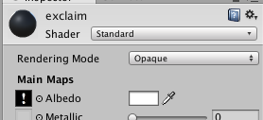  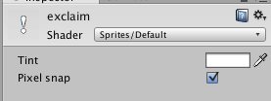

8. Particles With Blending Colors
- This particle works well with a partially transparent blob, like fairydust.tif, which can be found here: https://goo.gl/owdkHy  - Create a material using the transparent blob-like image: 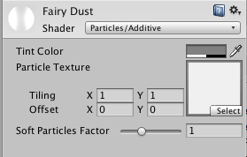 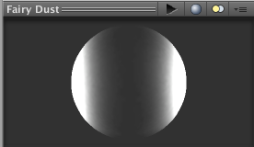  - Make a new Particle System, using the values to the right, and name it “faerie fire”.  - Color over Lifetime should be enabled. There should be 4 color markers that can be selected, dragged, and modified using a color picker.  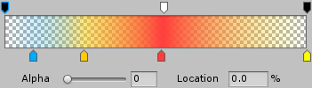  - Create additional markers as pictured above by simply clicking in an empty area above or below the color gradient. Remove markers by pulling them off of the gradient editor.  - Select the markers at the top to change the Alpha Transparency. The markers at the top-left and top-right should use an Alpha of 0, so that the particles fade in and out. Create a new marker at the top, and give it full Alpha. | 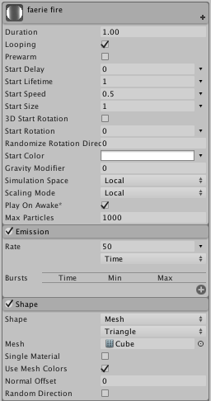  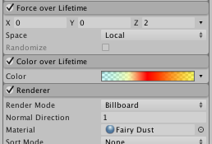
  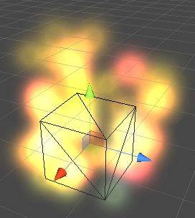 | - Note: Be careful with the Material Editor that appears below the Particle Editor in the Inspector! It provides global access to the Material! That means modifying this material will modify this particle effect, and every other object using this material!

9. More Particle Effects
  - Try making these Particle Systems for practice! Note: these were created with Unity version 4!
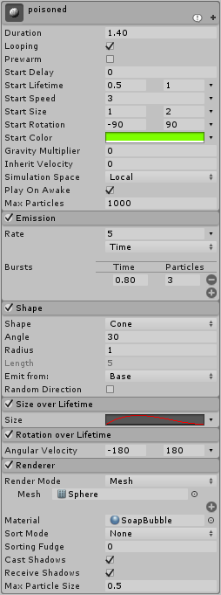  The graphic for the SoapBubble material can be found here: https://goo.gl/9XZfs7  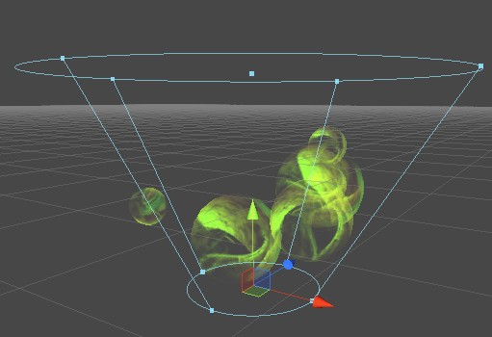 | 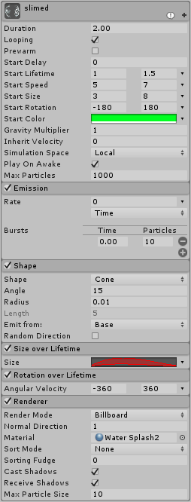  For the slimed particle effect, use 2 curves in Size over Lifetime: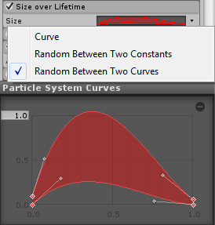 | 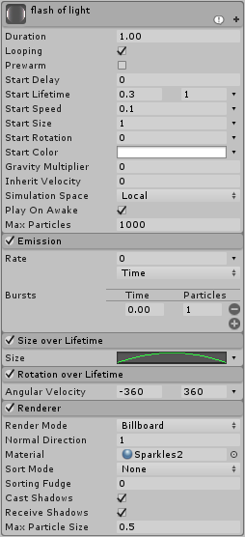  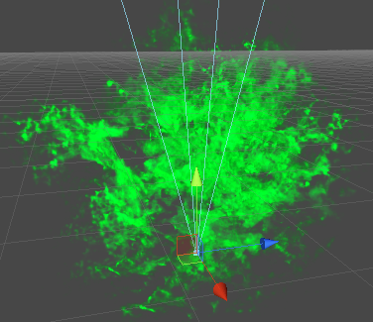  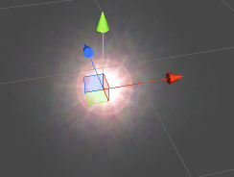

10. Particles With Sub Emitters
- Start by creating the simple Particle System to the right →.  - To the right of Birth, in the Sub Emitters sub-component, press the button to add a new birth particle effect.  - Notice that the fireworks Particle System now has a trail for each particle. Also notice in the that the fireworks Particle System now has SubEmitter as a child element. Rename that SubEmitter Particle System to fireworkTrail.  - Select fireworkTrail in the .  - Using the button to the right of Death, set the Sub Emitter of fireworkTrail to twinkle. Unity3D will ask if it should re-parent twinkle. Press to keep things simple for now. Notice how the fireworkTrail twinkles away now.  - Select fireworks again. Press the button to add a new Death particle effect in Sub Emitters. Notice that the fireworks particles now explode. Also notice in the that the fireworks has another SubEmitter child element. Rename it to fireworkExplode.  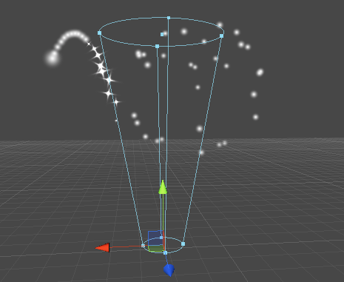  - Try adding sub-emitters to fireworkExplode! | 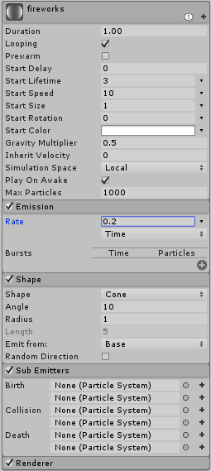  The fireworks Particle System should have two Sub Emitters.  