Unity3D Tutorial - Beginner Basics

0. About This Tutorial
- Unity3D can be an intimidating Game Development tool for Windows and Mac OS. This tutorial will help a beginner feel more comfortable using Unity3D to make 3D games.
- To run Unity3D well, a computer needs a 3D graphics card, and 2GB or more of RAM.
- To understand this tutorial, you must be comfortable running computer programs in Windows or Mac OS, and using a mouse and keyboard. Knowing programming is not required, but helpful!
- By the end of this tutorial, a beginner should be able to make and play a simple Scene in Unity3D, with a FPSController, and simple obstacles. More enthusiastic users should be able to create a platform-based 3D maze game, complete with win condition.
- This tutorial should explain enough for a beginner to feel comfortable with Unity3D.

1. Installing Unity3D
- Head to http://unity3d.com/unity/download and download the free version. Run the installer. It's a large install so be patient!
- While downloading, make sure you have an e-mail account. You need it to finish installation!
- During install, press , and to the license, which says you are 13 or older, won't do anything illegal with Unity, and respect copyright (note: I am not a lawyer, this is not legal advice).
- For slower computers, un-check to reduce the install, and speed up the first load time.
- On Windows computers, un-check Microsoft Visual Studio Community to drastically reduce the instal time. However, if you want the absolute best C# editor, install it, or re-run the installer later.
- Press , , and wait for the progress bar .
- Finally, after Unity finishes installing press .
- Unity3D should start up on it's own. If it doesn't start automatically, start Unity3D with the shortcut that might be on the desktop, Applications Folder (Mac OS), in the Start-menu, or the Windows dashboard.
- If you have a Unity Account, sign in with that, otherwise, create one, then sign in.
- Select PERSONAL EDITION for the free version, and agree to the license, saying you will buy the pro version when your games make $100,000 in revenue (I am not a lawyer, this is not legal advice).
- Press OK at the bottom of the survey, and Start Using Unity !

2. Start a Project
- If you un-checked earlier, just select New project . Otherwise, after the Example Project finishes loading, press , and select .
- Browse … to the , and create a (Right-Mouse Button in the File Chooser and select , or press Ctrl+Shift+N in Windows, or ⌘+Shift+N in Mac OS). Name the new folder Unity3D.
- Name your project something like tutorial1. Make this a 3D project.
    - Note: if you accidentally make your project 2D, you can simply click the button to see a 3D view. A 2D project won't have sky, or 3D shadows, so following this tutorial in 2D mode will look different.
- Name the folder , then . Press Create project to create the project.

3. Pick a User Interface Layout
- Choose a User Interface layout using the UI drop-down menu () on the upper-right.
- Below is an example of the Tall User Interface (or UI for short):

- Make sure you can find , , , and tabs.
- If you lose any UI, check , or reset the layout with the UI drop-down menu.

4. Use the Scene User Interface
- Find your view. It looks something like this:
  - The view is used while play-testing your game. If you accidentally click that, click again.
  - You can toggle (turn on and off) the sky box with button. The Grid can be toggled as one of the Gizmos, along with many other icons in the scene view.
- Turn the camera by holding the Right-Mouse Button and moving the mouse. Turning with the mouse like this is called Mouselook.
- While holding the Right-Mouse Button, move the camera in the using W, A, S, and D. If you have ever played Minecraft, or another First Person Shooter with a mouse-and-keyboard, this should be familiar. If you aren't comfortable with 3D games, this will take some getting used to!
- Notice the 3D Scene Gizmo at the Upper Right of the . You'll notice it move when you Mouselook. It's diagramming the XYZ Axis. | 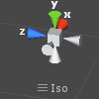
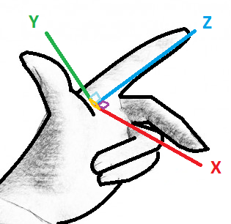 | - You can imagine the XYZ Axis in real life using a hand gesture, like this:  - The Z axis (Depth) is forward, along your pointer finger  - The Y axis (Height) is up, along your thumb  - The X axis (Width) is to the side, along your middle finger  - If you've studied Algebra or Geometry, you may have seen an XY Grid, also called a Cartesian Plane or Euclidean space. The XYZ Axis is like that, but with a Z dimension too! Not only Width and Height, but also Depth!
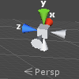 | - If you Click on the cube in the center of the 3D Scene Gizmo, you will toggle how the camera draws 3D, between Perspective and Isometric.  - Perspective is how we see in real life: far-away-things are smaller than close-by things.  - Isometric, also called orthographic, means distance does not change size, so it is useful for lining up objects that are far apart.
- The will help you organize your game, in 3D space.

5. Use the Hierarchy User Interface
- The will help you organize your scene as a list of Game Objects.
  - Everything currently in the game Scene will be listed here!
  - You can add a new element to the scene with .
  - Quickly Double-Click on a listed element to adjust the view, showing it.
  - Slowly Double-Click on a listed element to rename it!
- Press and a 3D Object → Cube. It should appear in the , and the .
- If you cannot see the new Cube, Quickly Double-Click on its name in the .
- Other simple Game Objects you should experiment with creating: Sphere, Capsule, Cylinder, Plane. Don't be afraid to try other things too! You can Undo (Ctrl+Z or ⌘+Z) almost anything, including adding a new object. To Delete an extra object, select it and press Delete, or press the Right-Mouse Button over the object in the and select from the menu.
- You can also find the same create menu through .
- Move around using WASD and Mouselook (hold down the Right-Mouse Button), to see where the Cube and Directional Light are .
- If you don't see the Translate Gizmo (as pictured to the right), select the Cube, and press , in the upper-left of the Unity3D UI (User Interface).
- Try to move the Cube with the Translate Gizmo (colored Arrows and Planes in the ). Drag the Arrows with your mouse, or Drag the Planes between the lines of the arrows.
- Select the Directional Light, then rotate it with the Rotation Gizmo. Drag your mouse along the colored circles! You should notice the lighting on the cube change. If not, press , at the top of the , to toggle lights. If you create more cubes in the scene, you may notice shadows moving as you rotate the light!

6. Use the Inspector User Interface
- Select an object in the or and you'll see its details in the .
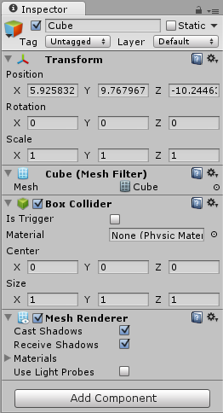 | - You can rename an object with the text field at the top.  - Hide this object if you un-check next to the name.  - All Game Objects have a , which can be changed with the input fields. The Transform consists of:  - Position in XYZ space  - Rotation, which is how it is turned, on the XYZ axis  - Scale, which is how it is stretched across the XYZ axis  - You can also use other Gizmos and the mouse to change the Position , Rotation , and Scale . The buttons that enable those Gizmos are at the top-left of the Unity User Interface, in a panel that looks like .  - You might see these Components somewhere in your scene:  - : makes the cube model, or Mesh  - : makes the cube collide-able like a box  - : allows Game Object to render (show)  - : set a light, with color, brightness, and more  - : will render a view to the screen  - : allows lens-flares to be rendered  - : allows custom GUIs to be rendered  - : allows sounds to be heard in-game  - Much of Unity development is creating and editing your own Components, which are added to Game Objects.
- Select your Cube. You can click on it in the , or in the .
- Set the Cube's Position to . You can change each number by selecting the text-box with the number in it, and typing in a new number.
- Set the Cube's Scale to .
- Rename your Cube to ground (and press Enter after renaming it!)
- Double-click on ground in the to auto-adjust the view.
- A Point Light, will create light even if the directional light is facing away. Create a Point Light. Set your Point Light's Position to .
  - Select the Main Camera to see Camera Preview in the .
  - Move around in the with WASD and Mouselook (while holding the Right-Mouse Button), then with the Main Camera still selected, from the menu, select , or just press Ctrl+Shift+F or ⌘+Shift+F.
  - You should notice the Camera Preview, and the changed.
  - This Align With View can change any selected .

7. Use the Project User Interface
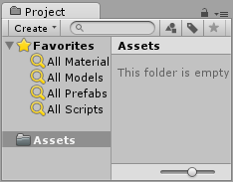 | - is a list of Assets (Game Objects, pictures, sound, scripts, ...) that could be in your . It's different from the , which is a list of Game Objects that are in your .  - You can Import new assets with the menu item.  - The Assets folder in mirrors the actual file system! To see it in the file system, press the Right-Mouse Button on , then or .  - Use the slider at the bottom to change icon size.
- To import a Character Controller from the Standard Assets Library, select the menu, then and Characters.
- You can press . but to make the project smaller and faster, click the arrow to be for FirstPersonController, RollerBall, and ThirdPersonController. Then, un-check the RollerBall, and ThirdPersonController. DO Keep FirstPersonController checked.
- The folder in now has an arrow . Click the arrow to toggle folder listing.
- In the , navigate Assets → Standard Assets → Characters → FirstPersonController → Prefabs.
- Select the FPSController, which looks like a cube in the , but wireframe Capsule in the .
- Drag-and-drop the First Person Controller into the .
  - There are now 2 Main Cameras in your Game! The Scene started with one, and FPSController came with one as well (named FirstPersonCharacter)!
  - Delete the Main Camera that was in the Scene first, the one not inside the First Person Controller. Select it and press Delete, or press the Right-Mouse Button over the Main Camera and select Delete.
  - This is not required, but may help with debugging scripts later!
- Set the Position of the First Person Controller to
- Rename the FPSController to something like “player”, to help keep things simple for later.
- Save your Scene by selecting , and (Ctrl+S or ⌘+S). Name it something like “tutorial”, and be sure to save it in the Assets folder, or in a folder inside of it.  - Save often, especially before you try something new that you have never done before! | 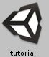

8. Play-Test
- Press the Play button (in the middle, near the top, with one of these buttons )
- The view is now active, and the rest of the UI changed color very slightly.
- To move the FPSController (that was renamed to player), move the mouse (Mouselook), and use the WASD keys for movement, just like in the . You can use Space Bar to jump!
- If you fall, you can stop and restart the game by pressing .
- If your game seems broken, set the player's Position to . Also, make sure you have a ground cube at Position and the ground cube's Scale of . The player might be partially in the ground cube.
- While the game is playing, select the player in the , then Click back into the
to give mouse and keyboard focus back to the game. Notice that when you move the player, the shows the new state of the player's .
- You can change the details of any Game Object while the game is running with the . BUT! Any changes you make while in Play Mode can't be saved!
- You should adjust your Unity settings to more clearly show when the game is running, so you don't accidentally make changes that can't be saved. Go to , , , and change the 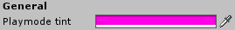 to something obvious. Like, hot pink.
- Click on the colored rectangle, and select a color using the color chooser.

9. “Iterate” On Your Game
  - Iterate means to do something over-and-over again. Game Developers use that word to describe working on a game. Most of real Game Development is the same few things over and over:
      - Come up with an idea to try
      - Use tools (like Unity3D) to try it out
      - Test it out, to see if it works like expected
      - If it doesn't work, or there's more to do (there almost always is), go back to the first step!
  - This is also called the Iterative Process, and it is also similar to the Scientific Method.
  - Try to add more Game Objects and move them around to create a more interesting Scene:
- Try to use several cubes and lights to build a maze. You can Scale the cubes into walls, and even additional ground platforms!
- Add lighting. Don't be afraid to edit objects in the . Unity can Undo (Ctrl+Z or ⌘+Z) and Redo (Ctrl+Y or ⌘+Y) any of your changes. Also, don't forget to save often (Ctrl+S or ⌘+S)!
- Play-test your game after making some changes, to see if it is more fun!
  - You could try to make a simple maze, like this (6 Cubes, 1 Directional Light, and a FPSController):
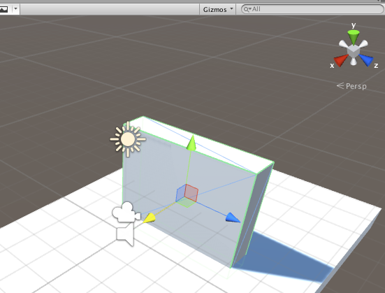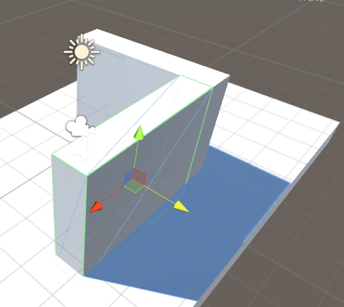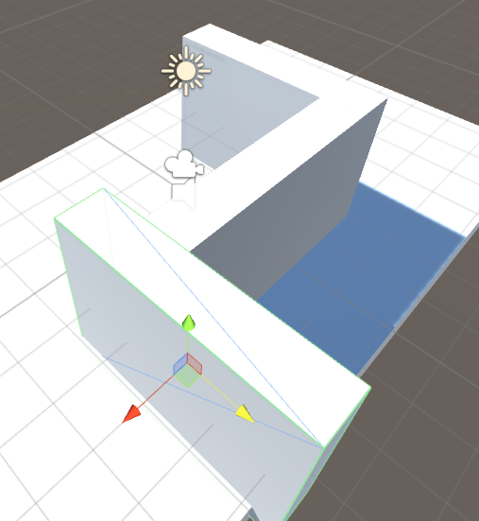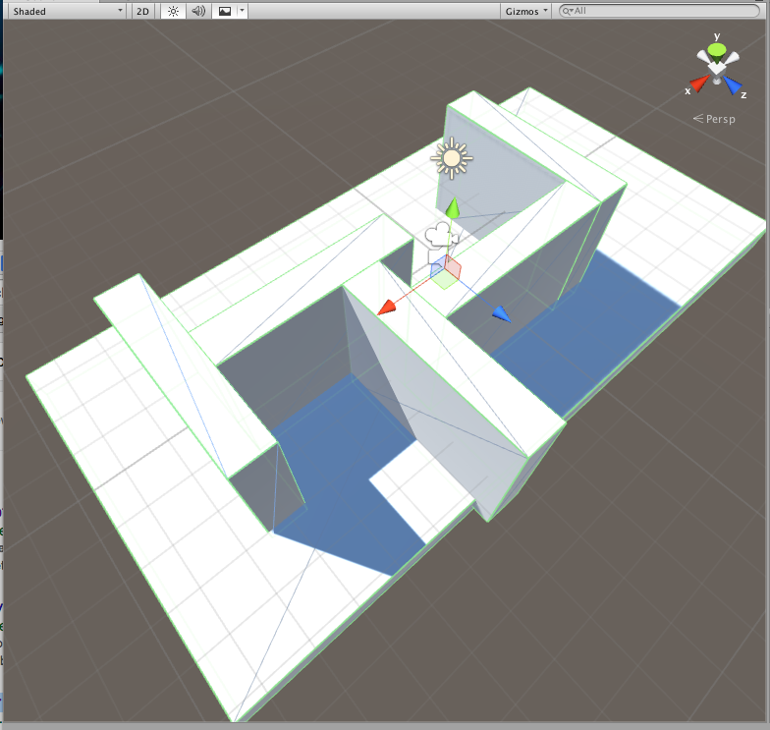 | - To Duplicate a Game Object, press the Right-Mouse Button over it in the and select , or select it and press Ctrl+D or ⌘+D.  - For more digital (or snap-to-grid) control while adjusting Game Objects with the Position , Rotation , and Scale Gizmos, hold Ctrl or ⌘, while Dragging the mouse.  - The (p)osition and (s)cale of the 6 cubes in the example ← on the left:  - p(0,-2,0) s(20,1,10)  - p(-3,0,0) s(1,4,5)  - p(0,0,2) s(5,4,1)  - p(3,0,3) s(1,4,5)  - p(4,0,0) s(5,4,1)  - p(7,0,0) s(1,4,5)

10. Add a Script Component: Restart After Falling
- To bring the player back to the beginning if the player falls off of a platform, we will need a script.
- There's a LOT to learn about scripting, which is a way of saying simple programming. During this part of the tutorial it may be helpful to have someone who knows about programming around to help you!
- Press the Right-Mouse Button over the Assets folder, in the . Then select , and . C# is pronounced “See Sharp”. | 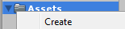
- Name the script Fall, with a capital 'F'. You can also rename it with the Right-Mouse Button menu.
- Double-click, or press Enter on the Fall script in the . Then, wait a minute or two! The script editor, MonoDevelop, takes some time to load. | 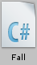
- Add to the Fall script in MonoDevelop, so that it looks like this:
  - If MonoDevelop opens multiple times, just close the extra instances.
  - Unity3D and MonoDevelop support several scripting languages, including:
    - C#: the strictest option. Strict means it requires more code, but that helps MonoDevelop offer better auto-complete. C# Supports entire .NET 2.0 library. This is the most common choice.
    - JavaScript: or UnityScript, which has fairly simple syntax, very close to web JavaScript.
    - Boo: closely related to Python. Least common and least supported by Unity communities.
- The lines with the green next to the line number are the ones you will need to type.
- Copy this script *exactly*. Every capital letter is capital, and every lowercase letter is lowercase.
- The curly braces { } are on the keyboard near the Enter key, above and to the right of your right pinky.
- Save the file in MonoDevelop (with Ctrl+S, ⌘+S, or select the menu, then ).
- You can check to see if your script is correct in Unity by checking the bottom bar of the User Interface:
this example error is a simple case of misspelling: “transfrom” instead of “transform”
- If there is an error, read the error message and use it to help you discover what is wrong, to solve the problem. This is where having someone who knows about programming will be very helpful!
- If there are no errors, drag-and-drop the Fall script from the onto player (which is the renamed FPSController).
- You should notice a component in player. Scroll down in the to find it.
If you accidentally added the script more than once, remove extras by pressing the Right-Mouse Button over the extra script, and select .
- You can change how the Fall script works by changing Lowest Allowed in the .
- Test out the script by jumping from your game area! If it does not work, think about what might fix it, and try it out, or ask a friend to help you Debug your problem. Debugging, or Troubleshooting, which means fixing-computer-problems, is a very important and powerful skill for a Game Developer to develop for themselves. Think of these problems as challenges to improve your skills with!

11. More Scripting Examples
  - Here are some more scripts you can try to figure out and play with (each script will need its own file):
ClickColor.cs  using UnityEngine;  using System.Collections;  public class ClickColor : MonoBehaviour {  Color originalColor;  public Color color = Color.red;  void Start () {  originalColor = renderer.material.color;  }  void OnMouseDown () {  if(renderer.material.color == originalColor) {  renderer.material.color = color;  } else {  renderer.material.color = originalColor;  }  }  }  TouchSensitive.cs  using UnityEngine;  using System.Collections;  // put this on the player  public class TouchSensitive : MonoBehaviour {  void OnControllerColliderHit(  ControllerColliderHit hit) {  Damage dmg = hit.gameObject.  GetComponent<Damage>();  if(dmg != null) {  dmg.DoDamage(this.gameObject);  }  }  }  Damage.cs  using UnityEngine;  using System.Collections;  // put this on something that damages the player  public class Damage : MonoBehaviour {  public void DoDamage(GameObject go) {  Fall f = go.GetComponent<Fall>();  if(f != null) {  go.transform.position =  new Vector3(0, f.lowestAllowed, 0);  }  }  } | FoundIt.cs  using UnityEngine;  using System.Collections;  public class FoundIt : MonoBehaviour {  public GameObject player;  public float distance = 2;  public string message = "You Win!";  public static GameObject FindGObj(System.Type t) {  object[] f;  f = UnityEngine.Object.FindObjectsOfType(t);  if(f != null && f.Length > 0) {  return ((CharacterController)f[0])  .gameObject;  }  return null;  }  void Start() {  if(player == null) {  player = FindGObj(  typeof(CharacterController));  }  }  void OnGUI() {  if(player == null) {  print("No player looking for "+name+"!");  Destroy(this);  return;  }  float calculatedDistance = Vector3.Distance(  transform.position,  player.transform.position);  if(calculatedDistance < distance) {  GUILayout.Label(message);  }  }  }
  - These scripts can create color-changing objects, goal objects, and penalty objects that restart the player!
  - Someone who feels comfortable with Programming may want to check out the Monobehaviour documentation at http://docs.unity3d.com/Documentation/ScriptReference/MonoBehaviour.html.

12. What Else Can Unity3D Do?
  - There is still SO MUCH that Unity3D can do to create games! You can use scripting to implement any kind of gameplay you can think of, but scripting is only one part of it! You should also know about:
    - Materials, to change the color and texture of objects
    - Particle Effects, to make explosions water effects, and things that look like magic!
    - Rigidbody Physics, to allow objects to interact with each other in interesting ways
    - 3D Models and Animations, which you can import from tools like Blender, 3DS Max, or Maya
    - Music and Sound Effects, which can add a lot to your game
    - And so much more! Terrain editors, Web and Mobile development, Shaders, Lighting, Novel Game Controllers, Networking, Graphical User Interface (GUI), the Unity Asset Store, …
- Find the Unity3D User Guide is at: http://docs.unity3d.com/Documentation/Manual/UserGuide.html

