Edit a web page
1 Go into the my-first-website folder and open the about-me.html file.
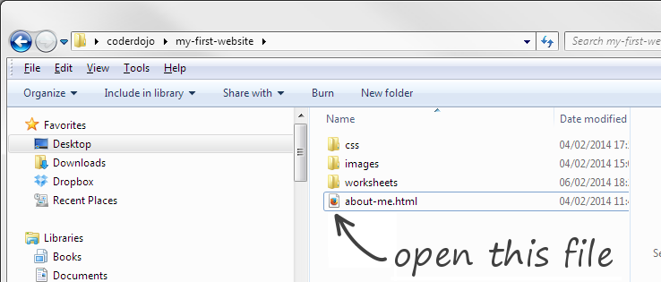
It opens in your web browser.
2 Now open the same file in a plain text editor such as Notepad.
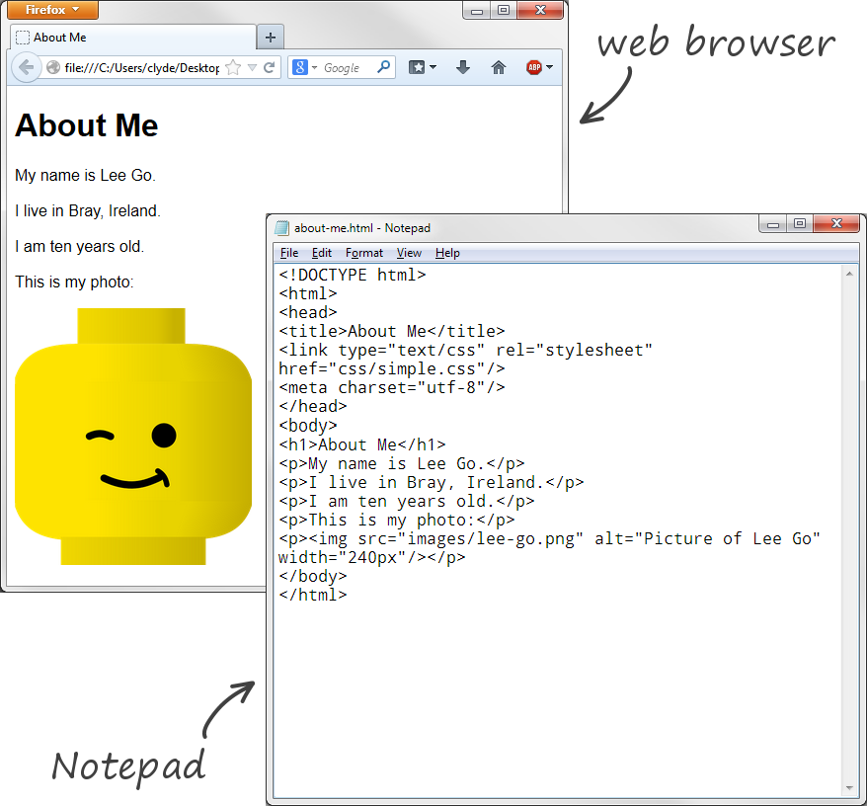
3 Arrange the Browser window and the text editor window so that they are alongside one another on your screen.
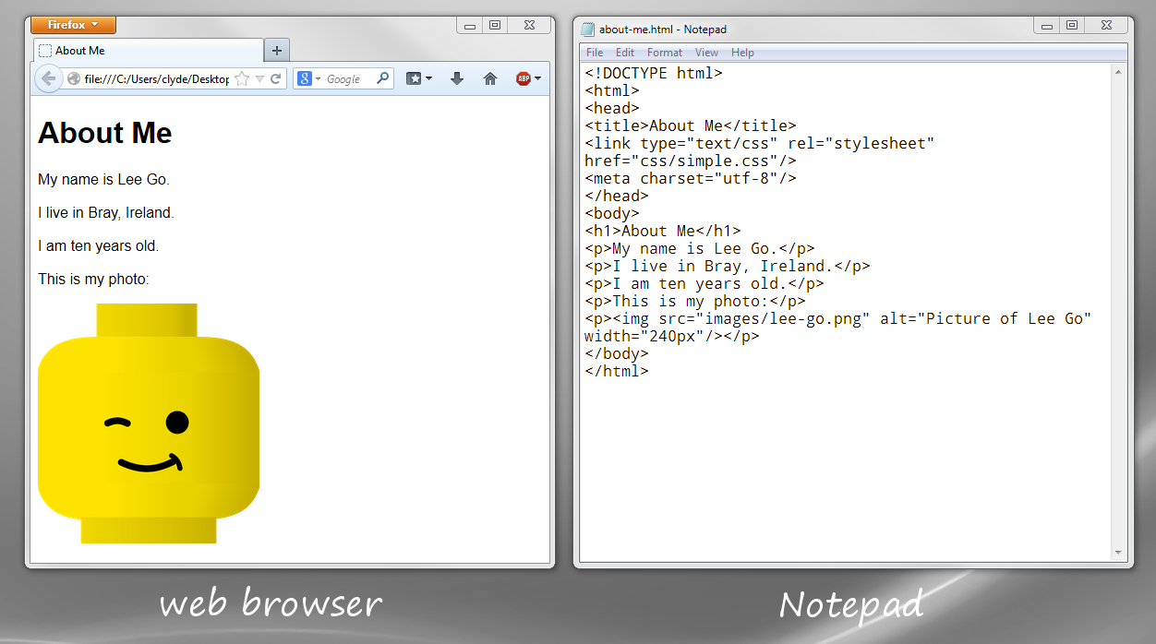
4 Change the text in the page so that it’s about you — not Lee Go.
5 After you have changed some text, save the file in Notepad and then refresh the web page in your browser window. To do this click the Refresh symbol.
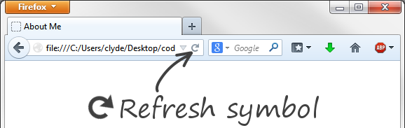
* What happens?
6 Now put in a new paragraph of text. This needs to go between the <p> and </p> tags.
Like this:
<p>I am learning how to make a website at CoderDojo.</p>
<p> is the start tag for a paragraph element, </p> is the end tag.
7 Again, Save and Refresh.
You can see now that a web page is just text typed into a text file. How the text appears on the web page is controlled by the tags.
* What happens if you use h1 or h2 elements instead of p?
* What happens if you put some words inside strong? Like this:
<p>My name is <strong>Lee Go</strong></p>

