Make a new web page
1 Go into the my-first-website folder and copy the about-me.html file.
To copy the file, select it, then hold down the Z and c keys at the same time.
2 Paste the copy of the file into the same folder.
To paste the file, hold down the Z and v keys at the same time.
After you have pasted the file you should see this —
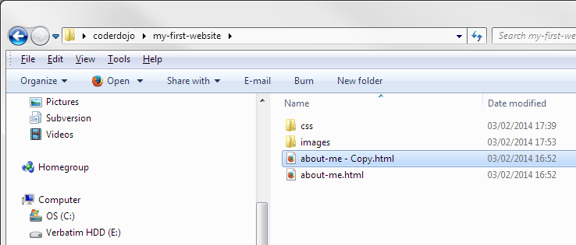
Now you have a copy of the about-me.html file in the same folder. It is called about-me - Copy.html
You’ll make this copied file into a new page which will list your favourite games. So you’ll need to change its name to games.html
3 Click the file to select it and press "
The about-me - Copy part of the filename is highlighted.
4 Change the name to games.html
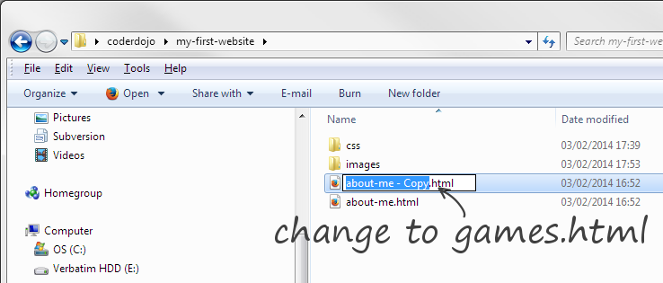
When you have renamed the file it should look like this —
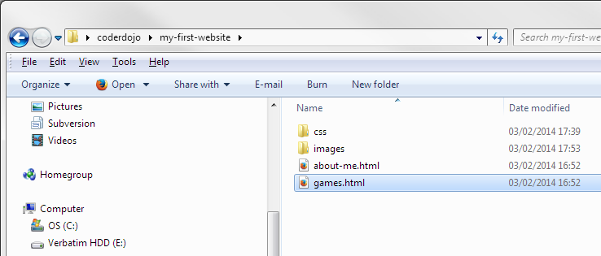
You now have a new web page named games.html. But at the moment it’s just the same as the about-me.html page.
5 You’ll need to open it and edit the text so that the page is now about your favourite games. Use the example below for ideas. Can you figure out how to download a picture (like the Minecraft logo) for your top game and display it in the page?
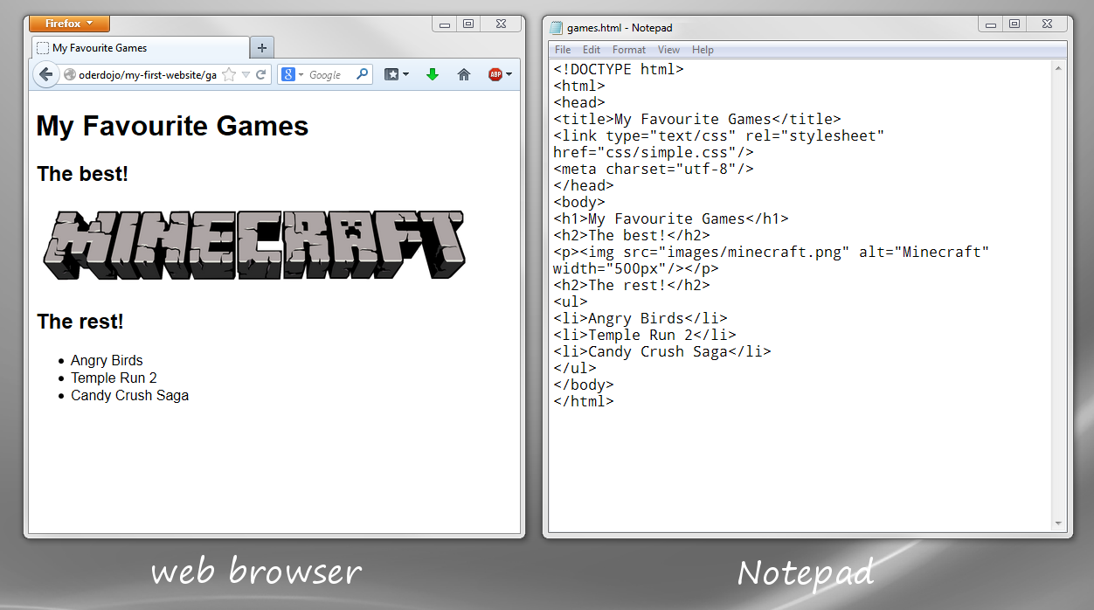
Save the file every so often as you’re working on it. To save press the Z and s keys at the same time. That way you won’t loose your work if your laptop battery gives out suddenly!
Every time you save the file, refresh R the web page to see the effect of your most recent changes.
* Can you see that we’ve added a list to the page? The list has several li elements inside a ul element.
* What happens if you put the li elements inside an ol instead of a ul element?

