Link the pages
We’re going to add links to all the pages we’ve created. This will allow us to navigate from one page to another no matter where we are in the site. Right now, the only links we have are on the index.html Home page.
To do this we’ll open up the index.html file, copy the HTML code for the links and then paste it into the other files (about-me.html, games.html, family.html and so on). We’ll also add a link back to the Home page.
1 Open index.html in Notepad and select the HTML code for the links.
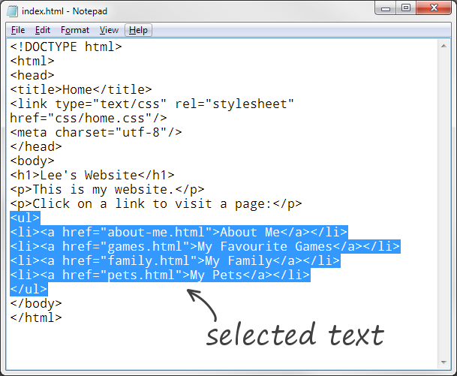
To select the code for the links —
• click just before the ul opening tag
• keep the mouse or touchpad button pressed down and then drag down, highlighting the text as you go
• take your finger off the button when you get to the ul closing tag

2 When the links are selected, check that you’ve included ALL of the start and end tags for the ul element —
Spot the difference!
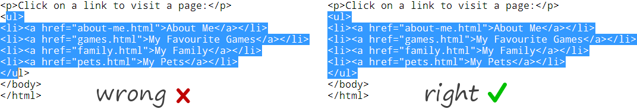
3 Copy the links into the Clipboard memory by pressing Z c
4 Open one of the web pages you made earlier in Notepad (in the example below, we’ll use the About Me page (about-me.html).

5 Click just before the h1 opening tag and paste the links by pressing Z v

You should end up with this —
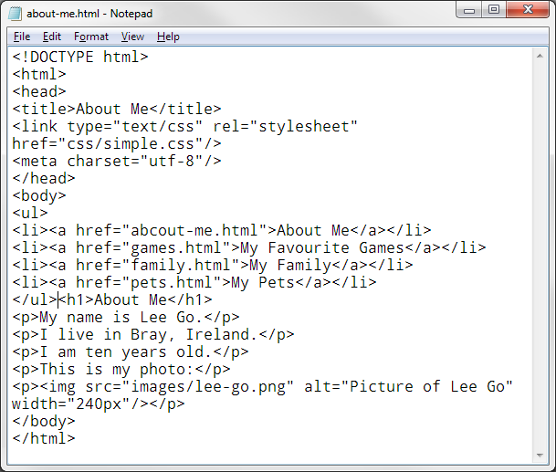
Can you see where the links have been pasted?
If you want to, you can press the Return key …
~
… to push the h1 element down to the next line and make your code look a little neater (although the browser doesn’t care!)
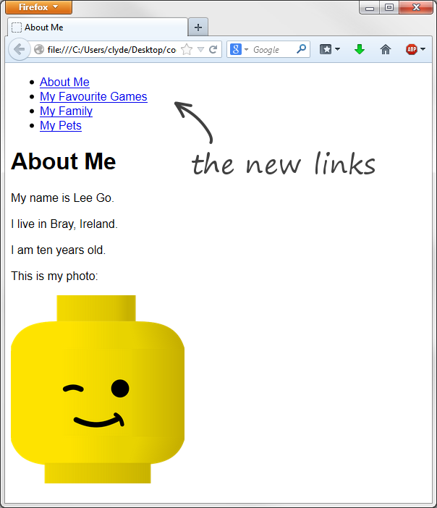
6 Press Z s to save the file and then open it in your browser.
You can see that the links appear above the h1 element.
They look a bit strange however. It would be better if they ran across the top in a row like the top menu bar you see on most web sites.
We’ll do that on the next Card.
Before we do though, can you do two things?
* Add a link to the Home page above the About Me link.
* Then copy the full set of links to all the other pages (except the Home page as it already has them).
Put the links in the same place before the h1 element.

