Style the top menu
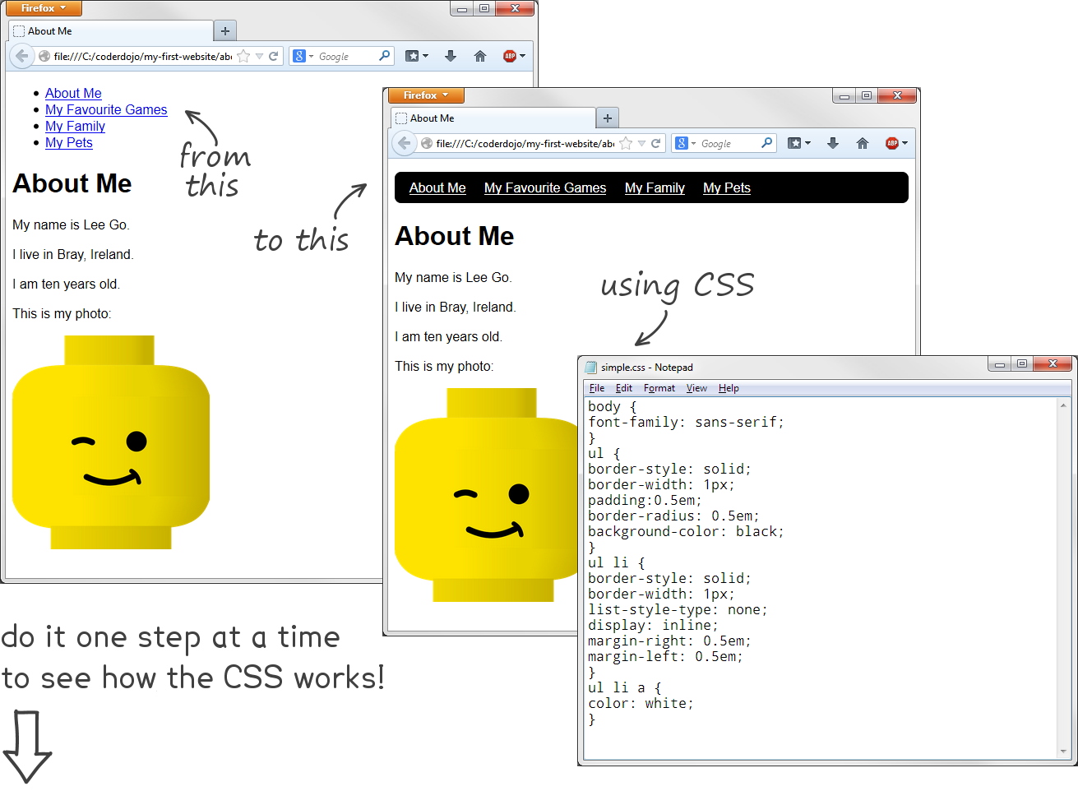
1 | 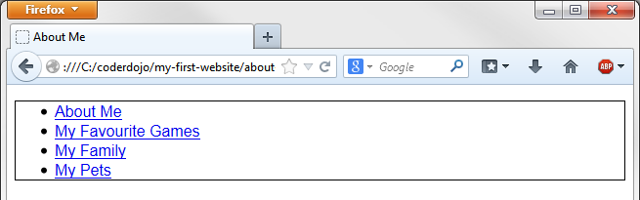 | body {  font-family: sans-serif;  }  ul {  border-style: solid;  border-width: 1px;  }
2 |  | ul {  border-style: solid;  border-width: 1px;  }  ul li {  border-style: solid;  border-width: 1px;  border-color: red;  }
3 | 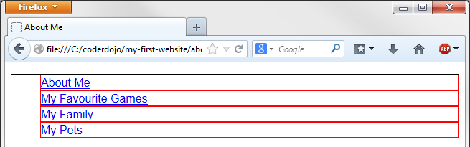 | ul li {  border-style: solid;  border-width: 1px;  border-color: red;  list-style-type: none;  }
4 | 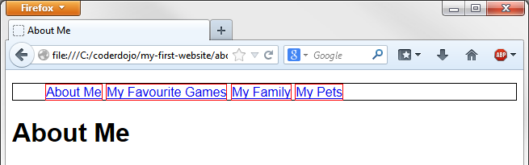 | ul li {  border-style: solid;  border-width: 1px;  border-color: red;  list-style-type: none;  display: inline;  }
5 | 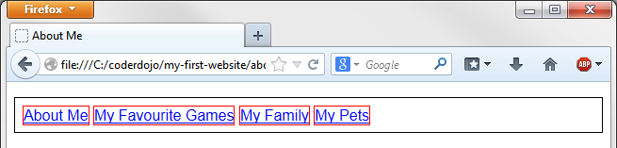 | ul {  border-style: solid;  border-width: 1px;  padding: 0.5em;  }
6 | 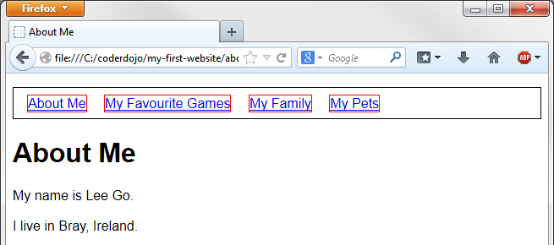 | ul li {  border-style: solid;  border-width: 1px;  border-color: red;  list-style-type: none;  display: inline;  margin-right: 0.5em;  margin-left: 0.5em;  }
7 | 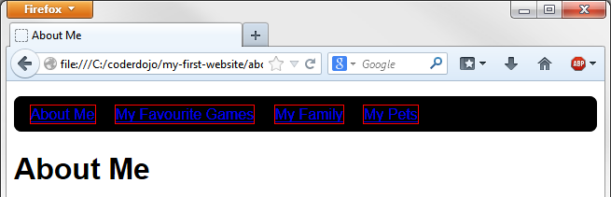 | ul {  border-style: solid;  border-width: 1px;  padding: 0.5em;  border-radius: 0.5em;  background-color: black;  }
8 | 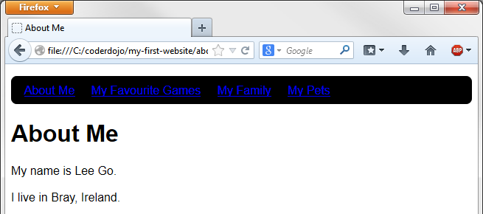 | ul li {  border-style: solid;  border-width: 1px;  border-color: red;  list-style-type: none;  display: inline;  margin-right: 0.5em;  margin-left: 0.5em;  }
9 | 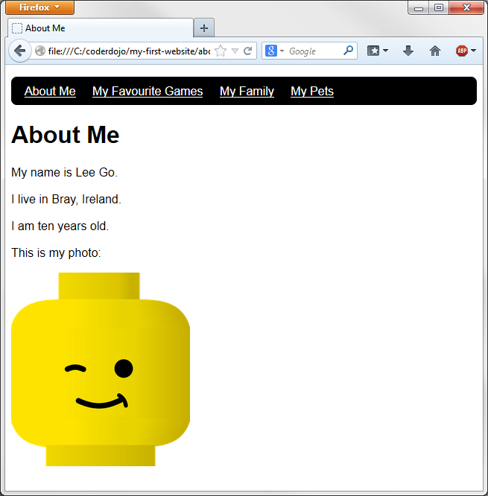 | body {  font-family: sans-serif;  }  ul {  border-style: solid;  border-width: 1px;  padding: 0.5em;  border-radius: 0.5em;  background-color: black;  }  ul li {  list-style-type: none;  display: inline;  margin-right: 0.5em;  margin-left: 0.5em;  }  ul li a {  color: white;  }

