Style the menu links
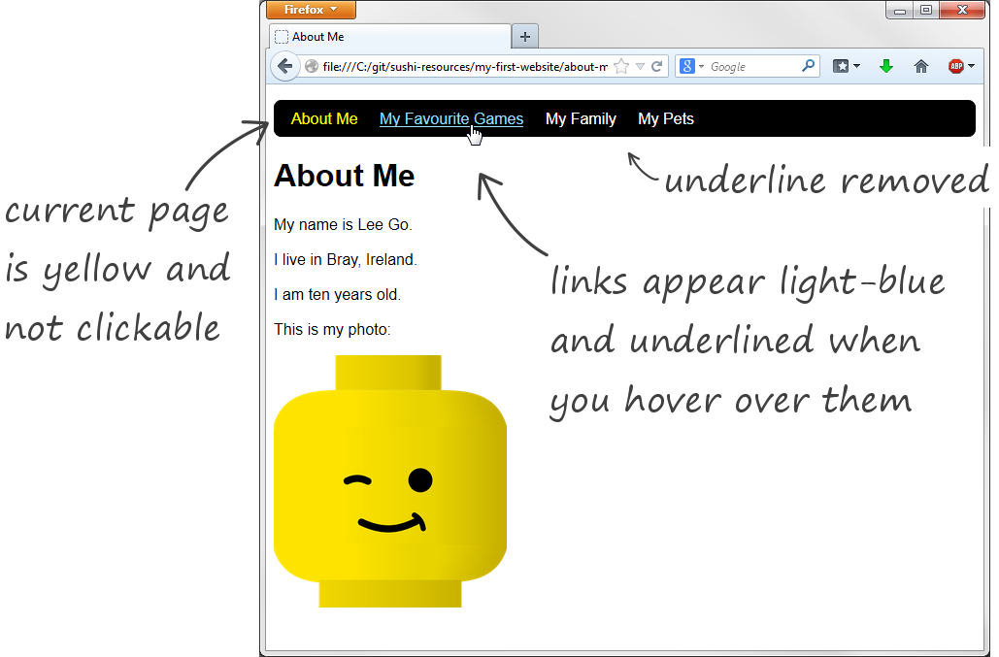
To style to your links like those above you’ll need to edit the HTML files and the CSS file.
1 In each of your HTML files remove the one link from the menu that leads to same page. For example, in the about-me.html page you will remove the <a href="about-me.html"> link, in the games.html page you will remove the <a href="games.html"> link —
file | menu code before editing |  | menu code after editing
about-me.html | <ul>  <li><a href="about-me.html">About Me</a></li>  <li><a href="games.html">My Favourite Games</a></li>  <li><a href="family.html">My Family</a></li>  <li><a href="pets.html">My Pets</a></li>  </ul> | to | <ul>  <li>About Me</li>  <li><a href="games.html">My Favourite Games</a></li>  <li><a href="family.html">My Family</a></li>  <li><a href="pets.html">My Pets</a></li>  </ul>
games.html | <ul>  <li><a href="about-me.html">About Me</a></li>  <li><a href="games.html">My Favourite Games</a></li>  <li><a href="family.html">My Family</a></li>  <li><a href="pets.html">My Pets</a></li>  </ul> | to | <ul>  <li><a href="about-me.html">About Me</a></li>  <li>My Favourite Games</li>  <li><a href="family.html">My Family</a></li>  <li><a href="pets.html">My Pets</a></li>  </ul>
Do this for all the files in your site (for example family.html and pets.html). Notice that after you make this change the menu entry is no longer clickable.
2 Add a class attribute with a value of selected to the same li elements —
file | menu code before editing |  | menu code after editing
about-me.html | <ul>  <li>About Me</li>  <li><a href="games.html">My Favourite Games</a></li>  <li><a href="family.html">My Family</a></li>  <li><a href="pets.html">My Pets</a></li>  </ul> | to | <ul>  <li class="selected">About Me</li>  <li><a href="games.html">My Favourite Games</a></li>  <li><a href="family.html">My Family</a></li>  <li><a href="pets.html">My Pets</a></li>  </ul>
games.html | <ul>  <li><a href="about-me.html">About Me</a></li>  <li>My Favourite Games</li>  <li><a href="family.html">My Family</a></li>  <li><a href="pets.html">My Pets</a></li>  </ul> | to | <ul>  <li><a href="about-me.html">About Me</a></li>  <li class="selected">My Favourite Games</li>  <li><a href="family.html">My Family</a></li>  <li><a href="pets.html">My Pets</a></li>  </ul>
This doesn’t do anything on its own (refresh in the browser and the menu still looks the same). BUT, adding the class attribute allows you to pick out the link in the CSS file and colour it yellow. Here’s how —
file | menu code before editing |  | menu code after editing
simple.css | ul li a {  color: white;  } | to | ul li a {  color: white;  }  ul li.selected {  color: yellow;  }
3 Refresh and you’ll see the selected link change to yellow. What you’ve done is added a new rule which applies only to li elements with a class attribute of selected. Notice the syntax in the CSS file — instead of specifying li in the rule, you specify li.selected
4 Remove the underline from the menu links:
file | menu code before editing |  | menu code after editing
simple.css | ul li a {  color: white;  } | to | ul li a {  color: white;  text-decoration: none;  }
5 Make the links light-blue and show the underline when you hover over them by adding a new rule to the CSS. This rule defines what will happen when you hover over an a element.
ul li a:hover {
color: #99DDFF;
text-decoration: underline;
}
Note that #99DDFF is the code for the light-blue colour.

