Identify the menu
If we have an unordered list within our page it will be formatted in the same way as the menu — unless we can distinguish between them.
The web page shown below is NOT what we want —
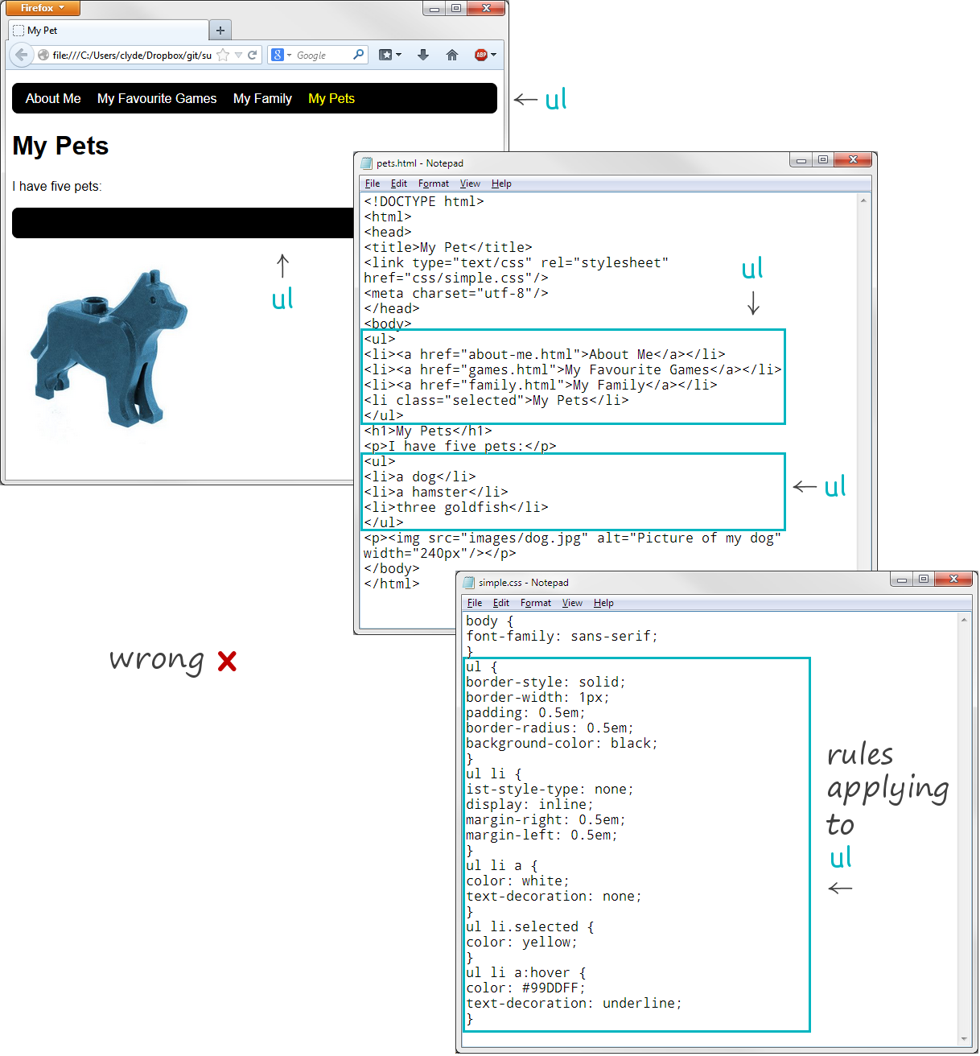
We need to identify the menu by giving it a class attribute.
<ul class="menu"> … </ul>
Once we have done this we can modify the CSS stylesheet so that the menu formatting rules are only applied to the ul elements which have a class attribute with a value of menu.
Here’s how —
