Getting responsive
Responsive websites are sites which work on all types of devices — desktop PCs, laptops, tablets, mobile phones. Responsive websites do this by rearranging the elements on a web page to suit the amount of screen which is available.
In order to do this, responsive sites use the CSS float property. We’ll use the float property in this challenge.
First we’ll add a new block of text on our Pets page which contains our top tips. We’ll put these tips inside an aside element. We’ll also put the information about our pets inside an article element.
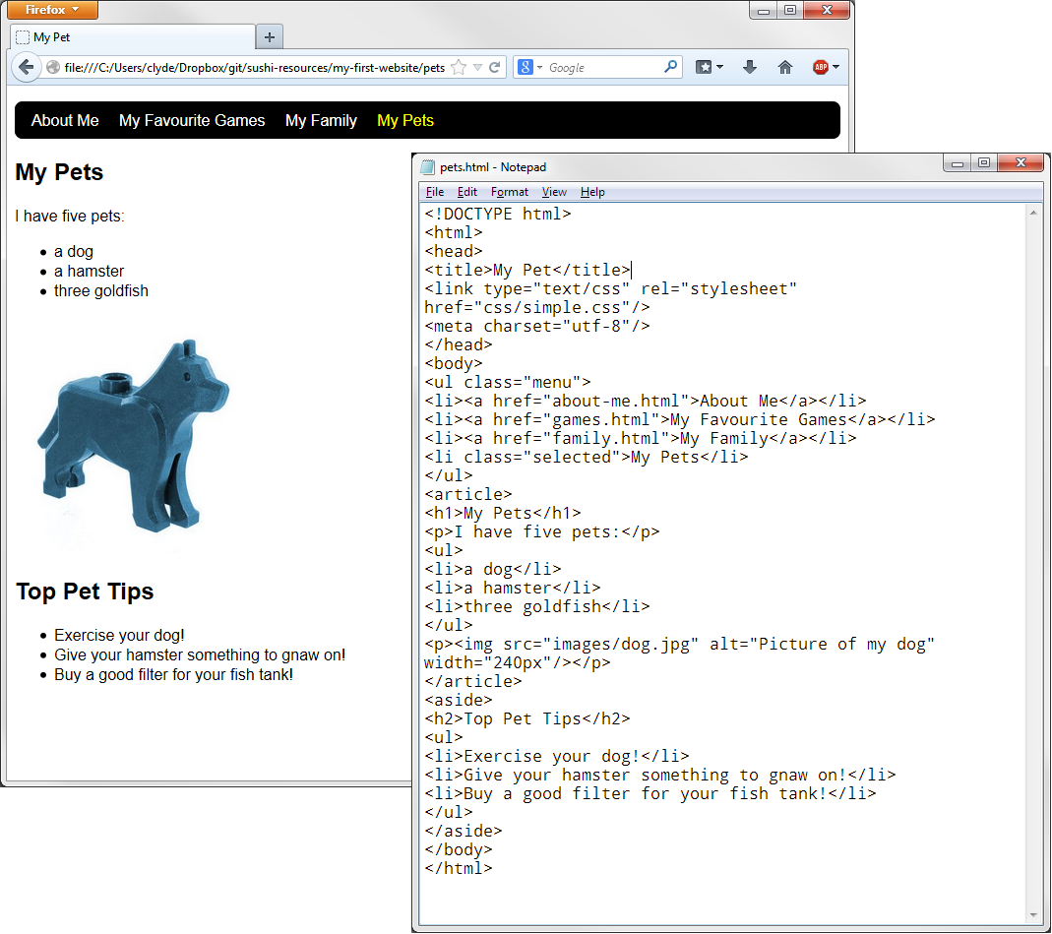

Then add the following selectors to your CSS file. Note the float: left property!
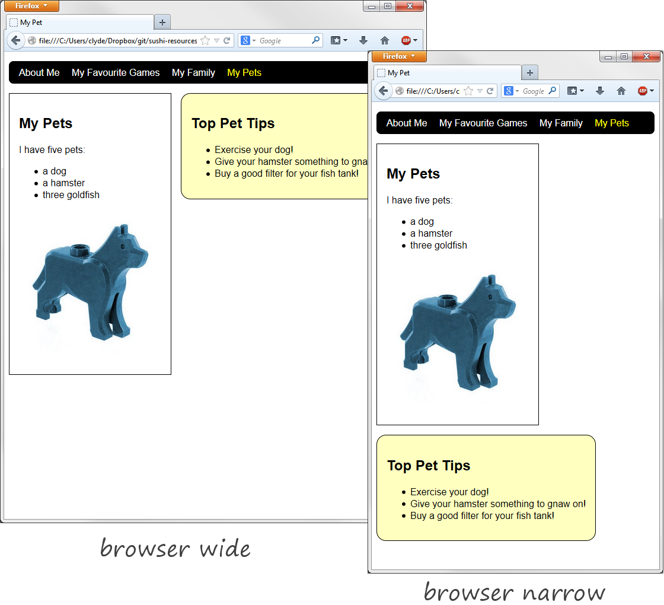
article {
float: left;
border-style: solid;
border-width: 1px;
margin-right: 1em;
margin-bottom: 1em;
padding: 1em;
}
aside {
float: left;
border-style: solid;
border-width: 1px;
padding: 1em;
border-radius: 1em;
background-color: #FFFFC0;
}

Challenge!
Can you modify the styling of the page so that it looks like this?
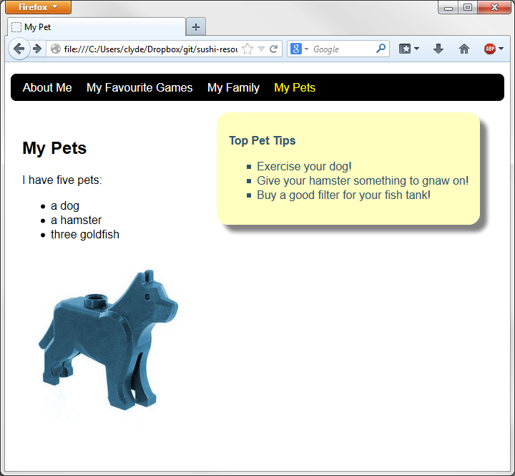
Hints:
box-shadow: 10px 10px 5px gray;
color: #2F5670;
list-style-type: square;
font-size: 1em;

