Add a table
We’re going to change our My Favourite Games page so that it shows a table listing our top five games and showing marks out of ten for each of the games.
Here’s how it will look —
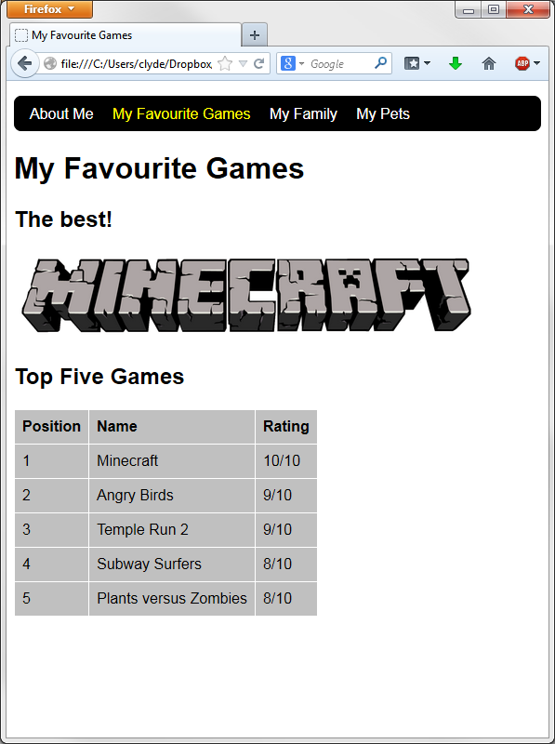
1. Start by adding the following selectors to your simple.css file
table, th, td
{
border: 1px solid white;
border-collapse: collapse;
}
tr
{
background-color: silver;
}
th, td
{
vertical-align: top;
padding: 0.5em;
text-align: left;
}

2. Add the table to your games.html page. Here is some code to get you started —
<h2>Top Five Games</h2>
<table>
<tr>
<th>Position</th><th>Name</th><th>Rating</th>
</tr>
<tr>
<td>1</td><td>Minecraft</td><td>10/10</td>
</tr>
[you’ll need to add the rest of the rows!]
</table>
Can you do the rest? Add more than five if you like. Make them your own favourite games.

Challenges!
1. Can you add a column showing icons for each of the games?
Tip — you can use the Search Tools button in Google Images search to search for images of a particular size. The ones below are all 128x128 pixels square.
2. Can you make the name of the game into a link to the game download site?
