Make a crossword
We’re going to make a crossword using HTML table markup and some CSS techniques.
Here’s the crossword and the clues —
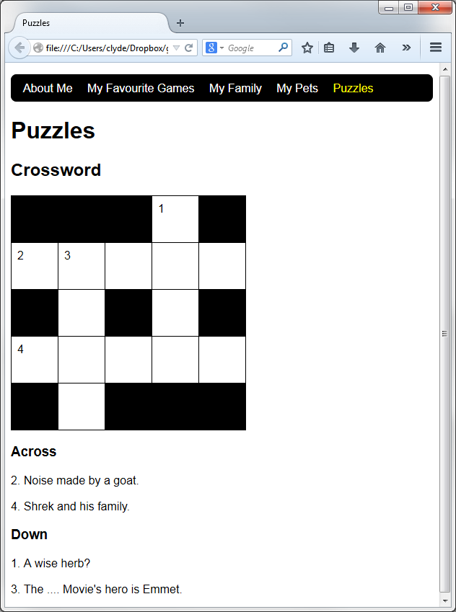
1. Start by adding the following selectors to your simple.css file
table.crossword,
.crossword td
{
border: 1px solid black;
border-collapse: collapse;
}
.crossword td
{
width: 3em;
height: 3em;
vertical-align: top;
background-color: white;
}
.crossword .black
{
background-color: black;
}

2. Create a new Puzzles page (call it puzzles.html).
3. Add links to your top menu and to your home page.
4. Add the crossword. Here is some code to get you started —
<table class="crossword">
<tr>
<td class="black" colspan="3"></td><td>1</td><td class="black"></td>
</tr>
<tr>
<td>2</td><td>3</td><td></td><td></td><td></td>
</tr>
[you’ll need to add the rest of the rows!]
</table>
Can you do the rest? (Also, can you complete the crossword?)

Suduko challenge!
Can you create a table showing the following Suduko puzzle and its solution?
Any ideas about how you might create the thicker lines which outline the groups of nine cells?
What about the black and red numbers?
Clue! You can combine classes by separating them with spaces like this —
<td class="border-thick-top border-thick-left answer">9</td>
