**Before:**

VGG16

ResNet50

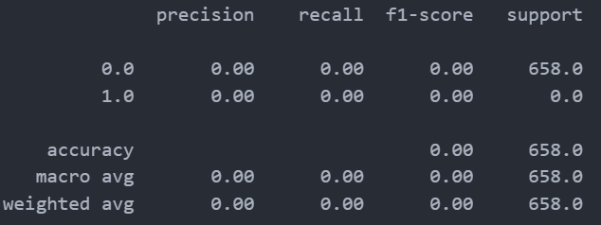

EfficientNetV2B3

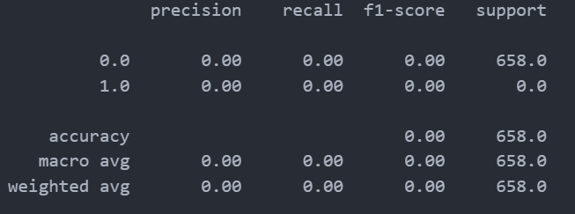

**After:**

VGG16

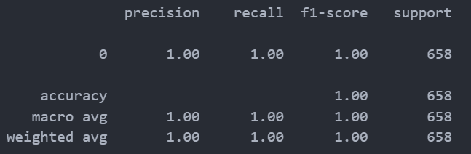

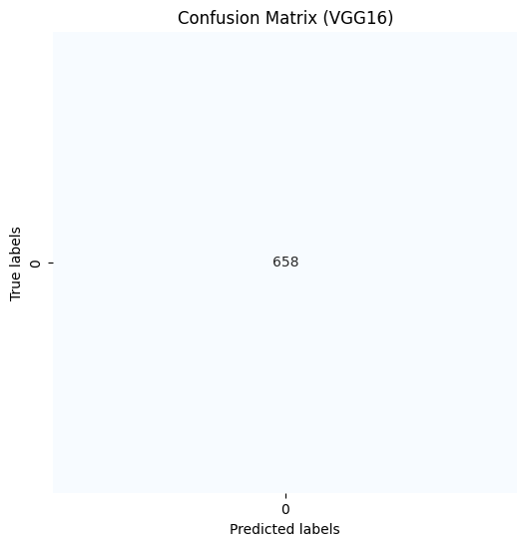

ResNet50



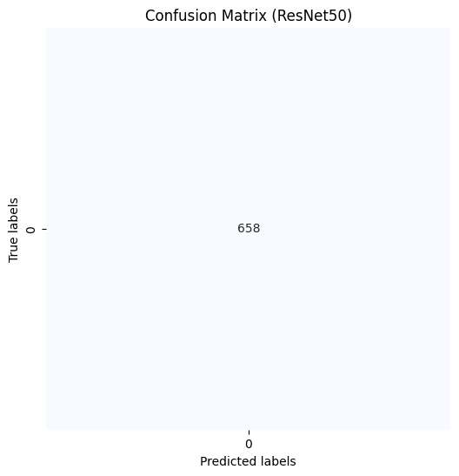

EfficientNetV2B3



