WhatsApp Image 2024-10-20 at 7.30.56 PM (1).jpeg

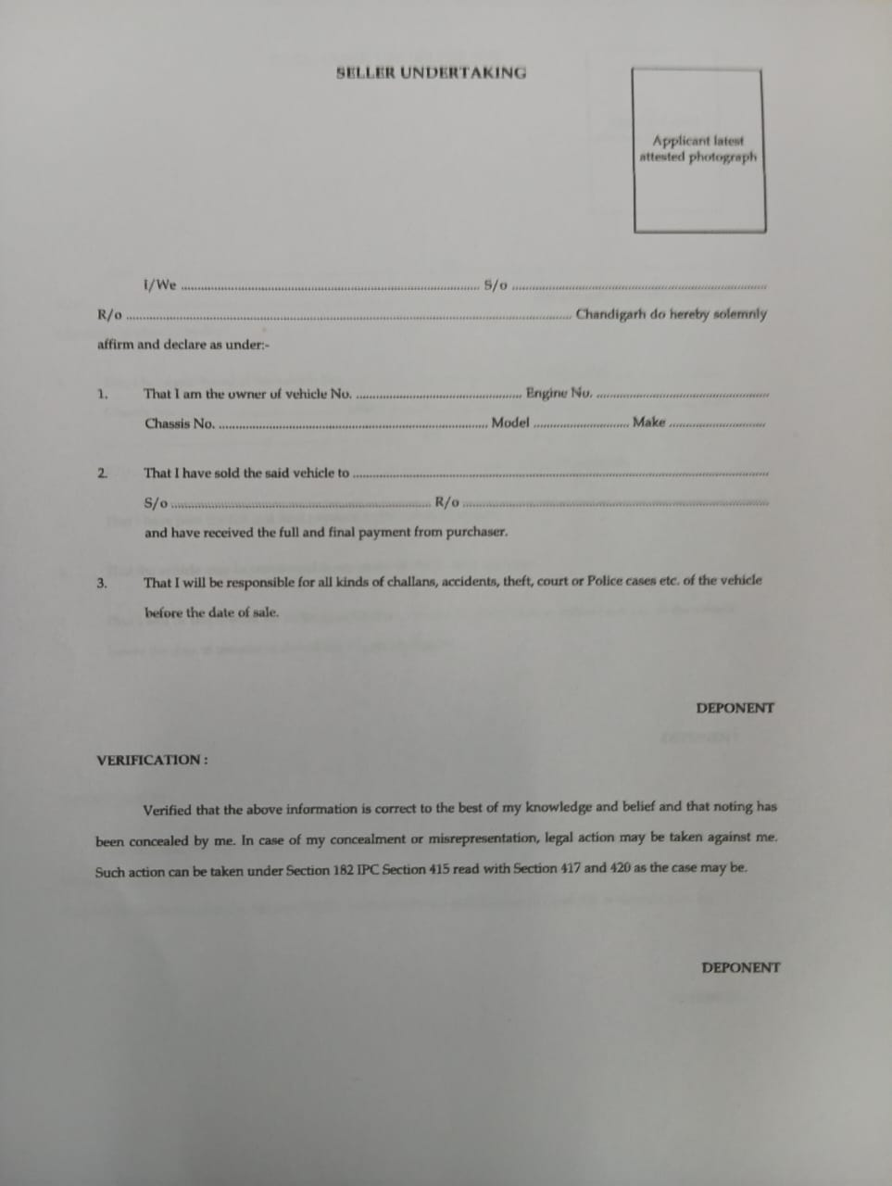

WhatsApp Image 2024-10-20 at 7.30.56 PM.jpeg

