In this lesson we will see a react feature that is dangerouslysetinnerHTML
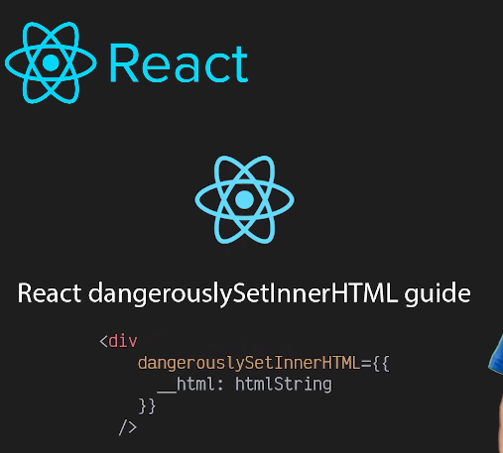
In nay container(or component) if you want to input HTML then you have to use dangerouslysetInner if you try to directly render HTML then tag as it is will be rendered which is not a good experience for the user. We will see with the help of dangerously innerhtml we can put html content in huntingcoder which has simple p and heading plain text was there. So that it looks beautiful and the option of formatting will increase (who knows) Out blog is HTML Now if you put html uibside string in json file. We want to write such that it retain formatting We search for HTML editor and then we din this site https://html-online.com/ and then copy the html content shownin in the first page and at first we paste it in the address bar so that we can remove the new line and then we search Json and aby any ransom site escape the jaon that is replace “ by /” and many more and then again remove the new lines by pasing in the address bar.
Now our output look like below
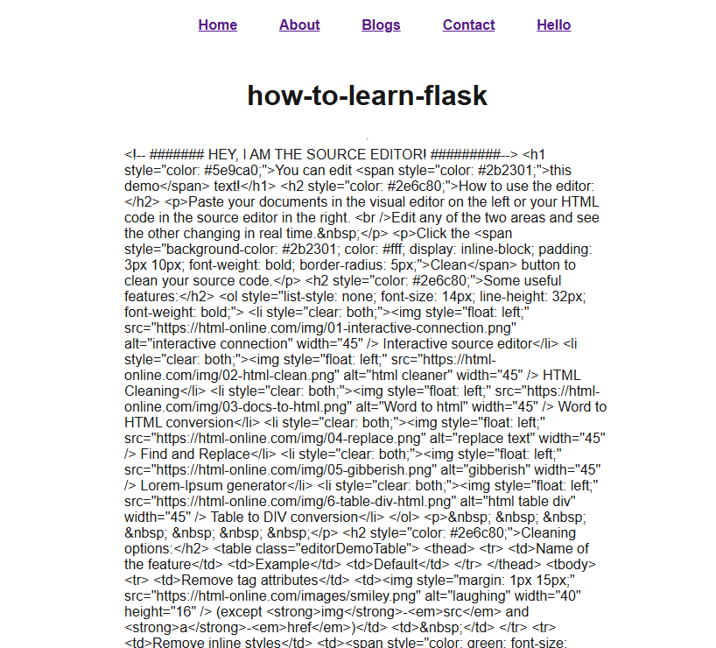
Now what happened there that is html did not get parsed it showed html as it is and the reason is safety It(Nextjs or react) wants to keep you safe you say this html safe and this should be parsed you need to tell Nextjs that you want to parse html there is a tool or setting (who knows) and it is a part of react not a part of nextjs as it is a feature of react Do we will do something like below
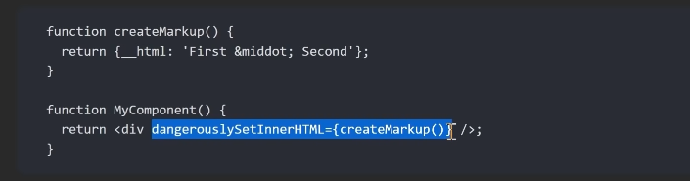
The element where you used dangerouslyinnerHTML should not have space in the content as it is considered a content other wise you will get this error
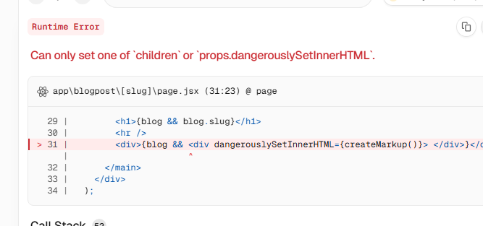
Now our slug folder page.jsx look like below
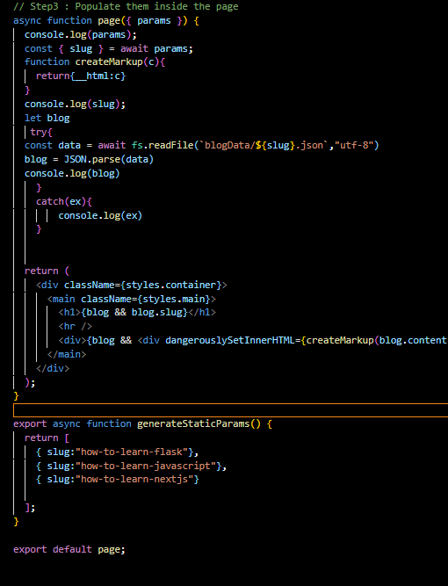
So we can so this thing Now we can see it is getting rendered as shown below
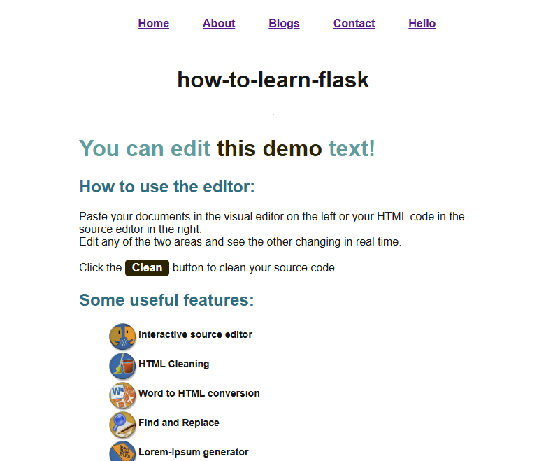
Now you might have understood that how we can use html string content in our blog
Teacher advice to use Html editor that it is a good utility so you can use them to write content for your blog.
In the blog we made a contact page in which anyone waiting to contact us can fill out a form After filing a form when a user will submit the form we will definitely have to make an API to collect the data. We are going to make that api in this lesson. We will see make it using Next.js API route. We will see how to handle post request because this will be our first time handling it Seom noownards I will not give too much explanation
So for now our post request handler look like below
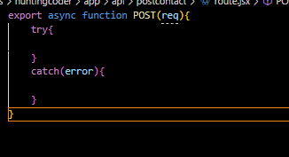
Ols version used to look like below
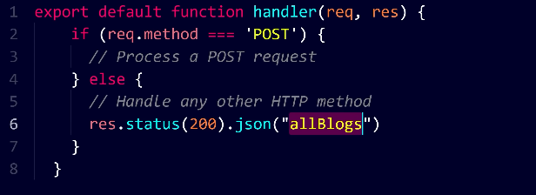
We used method key to handle different type of request in old method
In older version teacher try to send req but could not send because
You didn’t see useful data because req is a complex object, not plain JSON, so sending it directly with res.json(req) doesn’t work as expected.

What req contains (old Next.js / Node.js)
In older API routes:
export default function handler(req, res)
req is a huge object containing:
- headers
- method
- query
- body
- internal properties (circular references)

Why res.json(req) doesn’t show data
When you do:
res.status(200).json(req)
Problem:
req is NOT a plain object
→ contains functions, circular refs
→ cannot be serialized properly
So:
Response is empty / weird / error

What you should send instead
You must send specific parts of req.
Example:
export default function handler(req, res) {
if (req.method === "POST") {
res.status(200).json({
method: req.method,
body: req.body,
query: req.query,
});
}
}
Now it works because:
Plain JSON → can be serialized

Key concept
Thing | Can be sent as JSON?
req (whole object) | ❌ No
req.body | ✅ Yes
req.query | ✅ Yes
req.method | ✅ Yes

Modern Next.js difference
Now you use:
export async function POST(req)
And:
const body = await req.json();
Here:
You extract only usable data

One-line answer
You didn’t see req in the response because it’s a complex object that cannot be directly converted to JSON—you need to send specific fields like req.body.
In older version we used to get body like we did in node js but in modern it look like below
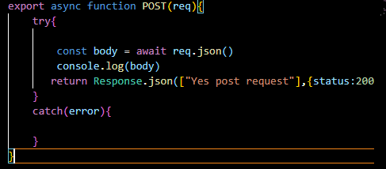
Now we code like this below
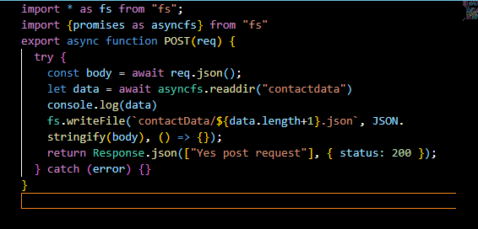
The problem with the file making strategy is that if suppose oint fail is failed to wiriteen an empyty fie is created problem can happen (maybe if we associate a number to a user who tries to contact (who knows))
Writing in file system is not a good idea but for simplicity we are doing this.
This error we may face if we son’t set the value of the input fields
In older version we used to put the state value in between the textarea element(who knows may be I am wrong here) and on state update method we used e.target.innerText
But now in Textare we can use e.target,value as value attribute is used in the Textfield
The API may not give json response but instead uit may text reponse who knows and we can parse it by text method in response we are fetching as shown below
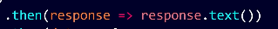
Our hunting coder design is not good
Teacher will tell us how different component should be kept separate.
Shortcut for margin:auto will be m:auto in VSCode
In name of logic we forgot to style outpages are not responsive which teacher will talk about in upcoming lesson we will see how to keep styling of the component different from one another.
Infinite scrolling is a feature that you see in any blog that looks very professional Previously pagination was used you did see going from one page to another page like 1,2,3 number come at the bottom of the page.
Suppose you have 50 blogs and you want to show 5 blogs on each pages so 10 pages will be formed . In the similar way pagination can be showed by infinite scroll like facebook news feed you keep scrolling and new thing appears we will implement things in out blogs page.
If you want to make blog manually then you can use intersection observer api.
The Intersection Observer API is a web API that allows developers to asynchronously observe changes in the visibility of a target element relative to an ancestor element or the viewport. It is commonly used for features like lazy-loading images and implementing infinite scrolling on websites but we don’t do here just to save our time. And we will use the libraries which id already made for us
Sometimes it happens that we will not good components means you won’t get good packages for doing any work(who knows)
npm install --save react-infinite-scroll-component
So we run the above command I context of yarn by using below command
yarn add react-infinite-scroll-component
Now we will import it and use it and see what are the functions inside it.
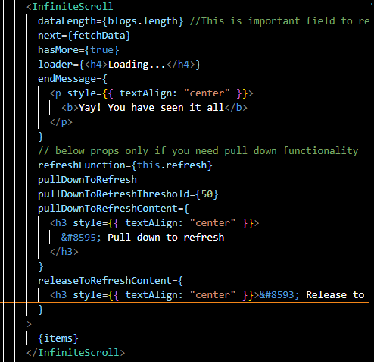
Data length of the data that to be shown , next is the function that will be called when we scroll and reach the bottom and more data is needed to be loaded.
The props below the endMessage are used when you want pull down functionality(who knows)
You can use InfiniteScroll only in client side so we need to use it in client component so we will change the blogs from SSG to client component.
Whenever we use any library onw important thing is that how to use it how the library is defined is it idefined like that you have to use the map it is defined like this if we keep single item we need to see all this things
Note:-
Sometime it happens in react that one component is show two times so reload to remove the bug
We will update blogs with more blogs
Out blog is almost over except for responsiveness we will make our blog responsive and will write media queries how we can we run media queries in the css model and we will give our website a unique look
Previously if you used to deliver the website and if you gave responsiveness it was an addon if you gave it then it was a favor you can say bit in todays time if you are delivering a website then responsiveness is a must
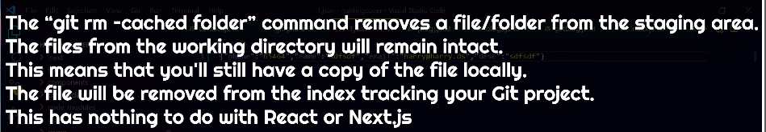
I think this command remove the folder from being tracked. (maybe for now until next commit)
We will deploy everything
We will hosts the website made in next js we will see our hunting coder live for everyone we will host it so everyone can read our blog
Teacher will use digital Ocean platform you can use anything basic are same. If you want to upload a static site
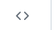
In github commit history click on above to access the code in that commit
In digital Ocean we will make a VPS.
There is an app platform which I don’t know about
IN digital ocean we make new user(who knows)
In digital ocean we create an app.
Often the hosting happens by taking files form the github pages
In case your project is nested you can configure the source directory and the whole build process will be build there
It will ask you to make database in there services. (who knows)
There is some concept of container which we may study about.
It is very simple an it wil automatically detect your application
I think if you build it and use it like a node ap hten it will be good(wjp knows)
‘ can create error in jsx in Nextjs or maybe in React.(maybe it is an outdated problem)
The routes for posting the form may not be work and show errors as we are in docker (who knows)
It is good for small scale setup Teacher wanted to show it that you can make it like that and if it become profitable then you can scale it (who knows)
Now as you commit then Digital ocean will build it automatically for you.(maybe if auto deploy option was selected in the setting(who knows))
At the time Teacher lesson recorded that is Digital Ocean give you 8GB Ram on built time and there is no other method to increase it. as an advanced user you may face such problems. The big apps work fine here (maybe very large app don’t work properly(who knows))
In digital ocean you cannot access files and folder directly so we may not be able to submit our form because it is inside the docker and there are many complications
Now we will see how Google analytics and search console(who knowa) like very important services added in our blog especially if next js is present
Nextjs don’t have index.html like we did see in React.
In networking, a padlock refers to the security lock icon shown in the browser address bar 🔒.
Meaning
The padlock indicates that the connection between your browser and the website is secure and encrypted.
What it means technically
It means the website is using HTTPS (HTTP Secure) with SSL/TLS encryption.
The digital ocean automatically gives you a padlock which is also called SSLV(who knows) and this is a good feature of the digital ocean. You can see this I other service providers Different types of services are provided by all hosting providers choose one hosting provider and start your work according to what is your budget and application complexity and severity of the application. So if we want that the domain we have need to be pointed to the server then we need to add domain to the digital ocean.
When you add domain then it will ask you should they manage it or we should do it
Of you chose the former then you will see that from the dashboard that how things are happening and if you chose later then you need to point it to a Digital ocean(who knows). By former we bring the domain in the digital ocean(who knows).
Now it follows the domain technique I already know.
In former we add the domain in digital ocean (who knows).
Now we want to see out huntingcoder.com on google search console
So we went to Google search console so we add a property there
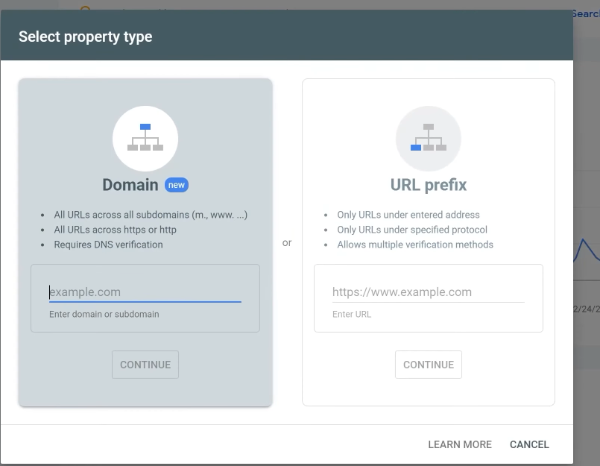
We get the option of adding property by domain or url prefix when we enter domain ad then you need to verify it so it give us some text which we will paste in the DNS records to give the proof for ownership of domain. After this you can get to go to properties
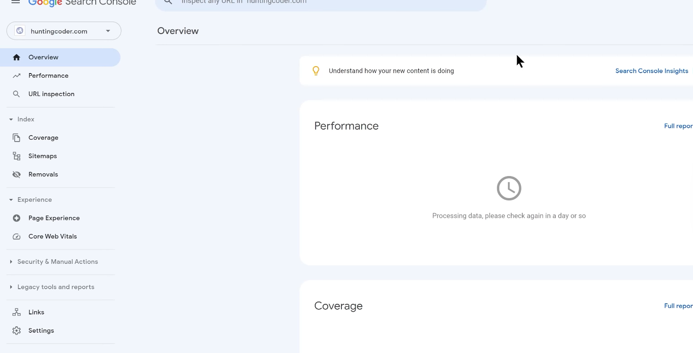
Now you can see all the things of the domain over here. I think it collect data how many times your link was clicked when shown by the browser.
Now we will make an ecomerce store and we will make pages like Product page, Cart page and checkout page and how to integrate payment gateway to the website . How orders will come and how admin panel will be made . From domain buying to end to end integration teacher will teach us We name it codeswear it will be an ecommerce store where we will list our product So we type the command
yarn create next-app <appname>
Teacher will us through this project that how to handle customer if they come in the app and if your website is scaled then how you need to deploy it
We will use global css for tailwind css and we will see how to apply it
Now we will see how to setup up tailwind with Nextjs, what extension to use it optimally and will make a black slate of codeswear (who knows)
A blank slate of a website means starting the website from scratch with no existing design, content, or structure.
We will search tailwind css with nextjs so by this we will go to official documentation
Now in out project folder type this cammand
npm install tailwindcss @tailwindcss/postcss postcss
or
yarn add tailwindcss @tailwindcss/postcss postcss
Now the method teacher is using is autdated so we will use modern method by following documentation
https://tailwindcss.com/docs/installation/framework-guides/nextjs
So now by installing the tailwind most of the configuration happens by itself (maybe)
Like Bootstrap Tailwind also have predefined class .So we have tailwind css is installed and we can use our utility class and can create our design
One side note is that Teacher is using tailwind extensions as shown below
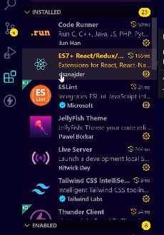
The Tailwind CSS intelligence give us suggestion. If you don’t get suggestion then you can type ctrl + space
There are some pages which you will find in almost all Ecommerce website that is Product page , Home page, Checkout page, page when you generate an order , login and signUp. We will create their blank slate here and then we will start codeswear development
Whatever you by [slug] is actually dynamic page routes
There are many things which we think we need to o on the spot like Forget Password
You can even launch this ecommerce site
Navbar and footer are important for our website and it will be present in all of the pages
We will use app for that purposes(maybe ol version of layout.jsx)
Now there is site that is Tailblocks that will give you tailblocks snippet here you get minimalistic design Here you get Ecommerece design
Its link is like this https://tailblocks.cc/
In tailwiond code you might need ot replace
stroke-linecap by strokeLineCap
stroke-linejoin by strokeLineJoin
stroke-width by StrokeWidth
Previously we could use anchor tag inside the Link component but not now but if you still want to use them then you need to add a Boolean attribute that is legacyBehaviour
Why not using / gives us error in Image or maybe in Nextjs general
Coder, this happens because Next.js (especially with next/image) requires absolute paths for static files.
If you write:
<Image src="home.jpg" />
Next.js throws an error because it cannot resolve a relative path for optimization.
But when you write:
<Image src="/home.jpg" />
Next.js knows the file is in the public folder and can process it.
Short answer:
Next.js shows an error because next/image only accepts absolute paths (/file.jpg) or external URLs, not relative paths like file.jpg.
Maybe we can use justify between to push the element inside a div with flex property to the extreme end and(we try there should be equivalent space between them)(who knows)
We can add media quary in Tailwind by md:property name such that when the screen is in medium size then this property will be applied
You can get predefined icons from react that is from react-icons package
https://react-icons.github.io/react-icons/
You can follow above link and you can explore the icons present in react icons package and it will tell you how to add it to you site
Another tip is that to import an icon we add the first two letters of the icon name in the slug while using import statement for example to import AI Outline Cart we use slug ai as shown below
import { AiOutlineShoppingCart } from "react-icons/ai";
By text-xl property we can increase or decrease a size in Tailwind
We find below in the third section of content group as shown below
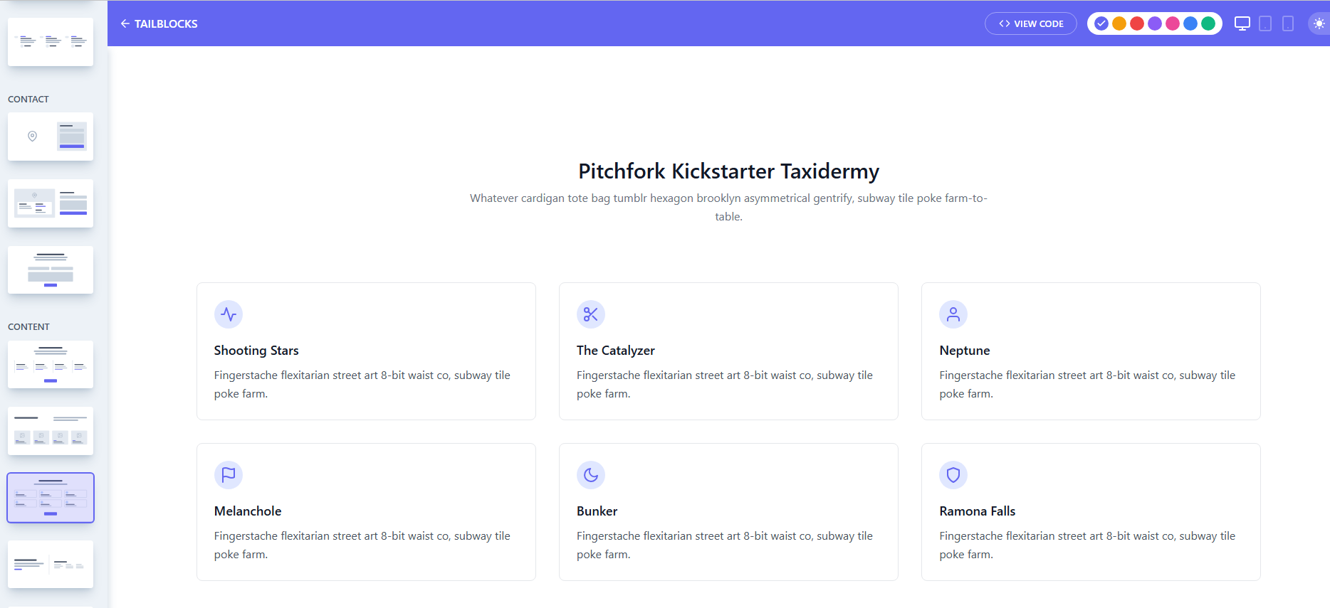
We go to its view code
Now we can see the cards in the ecommerce first tab
We can do a permanent word wrap in all files by going to settings and then search word wrap and then you can go to marked below and make it on
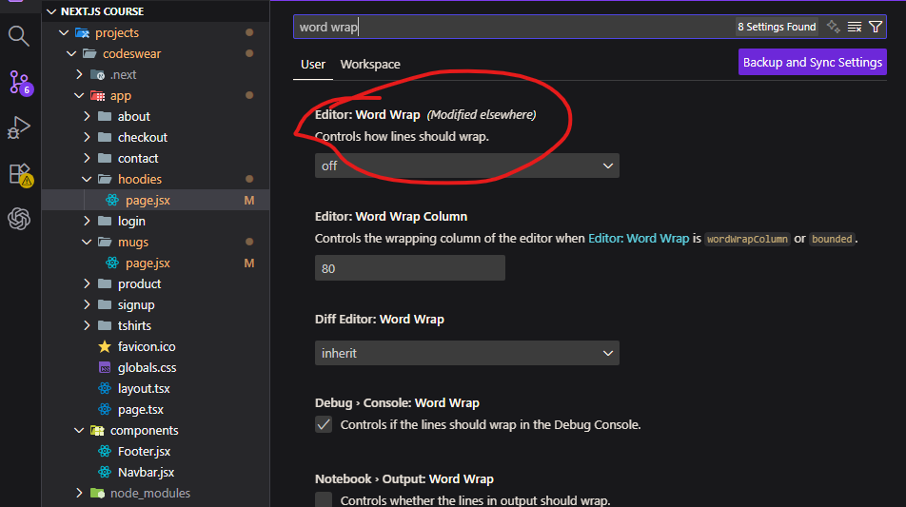
Teacher suggest us that we make design of cart such that when we hover over the cart button then we will be shown cart items and checkout buttons it will increase the conversion , design is good and user experience is good how to make this card sidebar by keeping it responsive we are not going to keep making it responsive by repeatedly changing design because we are using tailwind css. Since we are using tailwind css we will keep mobile first as the screen increase the sidebar of cart will automatically adapt
By overflow-x:hidden you can make sure there is no horizontal scrollbar maybe in body in case you add it to body.
Often times we are asked is out pincode servicable or notig no then you cannot receiver the order.
We will make a mock api that will show all the apis that are serviceable
We will store the items in cart object as an object and its key will be its id and the item will have properties
In react state are not updated immediately there is no such guarantee it is just a request and js will update cart accordingly and there is no guarantee when it will be updated so believe it that cart is not updated but you believe it will happen do update method is request its not an order. React fulfil this request accordingly and it will take time but it take time by time we mean in millisecond but it will not be that fast that immediately changes happen and next function can use the updated version
We can place the button of checkout inside link so that we can use it as a link
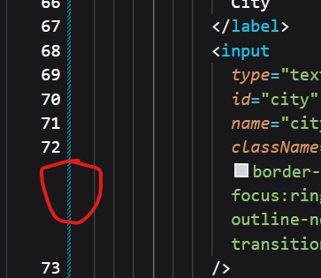
By clicking on marked above you can use the git to see all the code after the latest commit as shown below
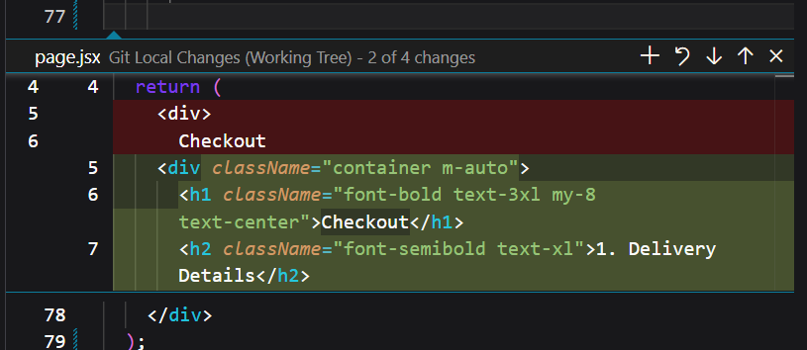
We will now make orders page where the user will be redirected when the order will be placed. We will tell the user how they can track their order. How his order item look (who knows) we can show it all. Herer we will confirm the order and then we will tell user your order is placed and then we will tell the user that what were the items in the cart and how did we confirm the order there(who knows).
Note:-
JSX is js not html.
To make codewear we are going to use Mongoose is a connector to a Mongodb (who knows ) it will help js to connect to mongodb and we can use its built in functionality you don’t have to read and write and update to the mongodb (like maybe the complex we do for it in mongodb(who knows)). Mongoose will manage many things for us for example creating fields like createdAT and updatedAt
If we make timestamp property (who knows)true it automatically create for us, How these all things are done what is the syntax. How does it manage
Mongoose is a library of js through which we connect to mongodb
I think we are going to directly contact to mongos by frontEnd
Ow we will install Mongoose by npm and we will make some modals(maybe not) through which you will store the data (who knows) but before that we need to install mongodb
Download and install community server as enterprise level will be paid once you install it then your mongdb compass will be installed which is a product of mongodb
Now in mongodb compass you click on connect to the localhost ehere the server is running
We will make all the data base in mongodb compass.
So first we will understand how table is made in mongoose what is mongoose it is written as shown below
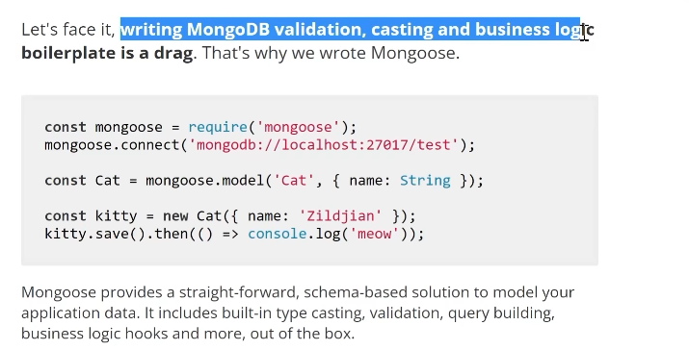
They made it so that you can design schema properly
So first install it as shown below
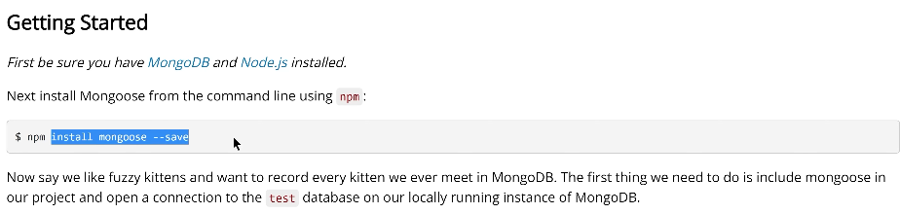
And after this get connection to the mongodb and your wok will be sone now you can make schemas
Consider model a table however mongo don’t have tables mongoose has collection and document but the teacher tell that if you are from a Database background and you used a relational database management system.
So we will make three modals that is Order, Product and User.
Now we will define how to define mongo schema (who knows)
Teacher says we will make a middleware for connection
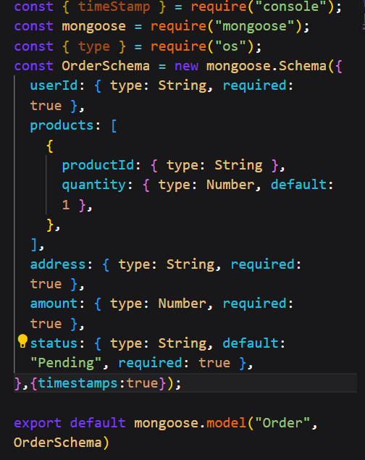
So by the scheme (who knows maybe by making schema object and passing it to the )we created a model.
For admin we will create separate UI(who knows how we will manage admin authentication)
So we will create middleware to connect to database and from there we will use these models in our API
Now we will learn how to make three APIs that is getProduct, updateProduct and addProducts now they do as the name suggests and off course update API will not be public otherwise anybody can use it and update our store so we will make it and then decide who get what access(maybe referring to user).
Now we are going to start middleware development which will facilitate the connection to mongodb now it seems confusing at first.
Facilitate means:
👉 to make something easier, smoother, or more possible
It may be confusing but it is as simple as creating middleware folder and inside that what we need to do you need to export a function inside a file that will do all the connection work
- We can make environment variable by making .env.local file and make a variable here and you can get it in our maybe server side by using process.env
- We need a connection string to connect to mongodb and we can get for mongodb compass by opening mongodb compass and then click on three dot as marked below(not visiblie because of not hover)
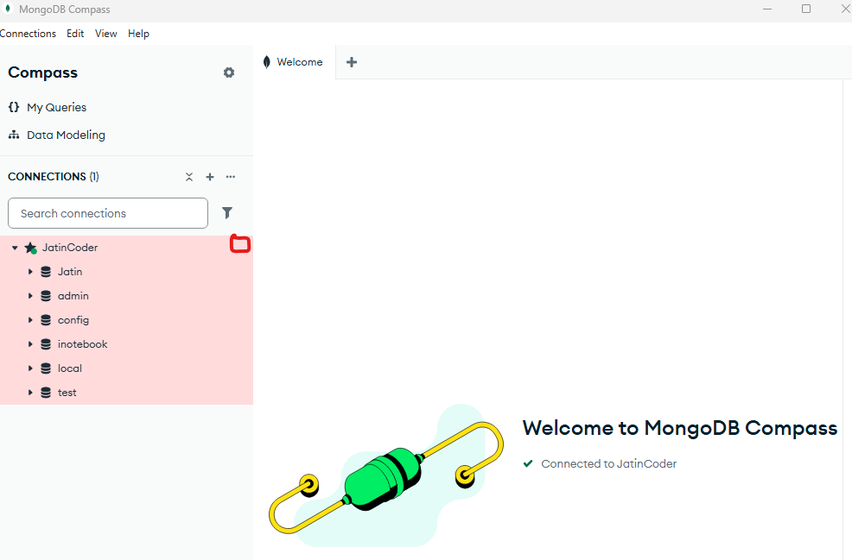
And then go to Edit connection to get the connection string and we will store it inside .env.local file.
Note:-
In modern Nextjs middleware cannot be used for database connectivity but you can use it for authentication and now edge runtime is used for middleware so there is a different syntax there and for database connectivity we can use helper function for the purpose database connectivity
We will use our helper function in our add Product and GetProduct API.
Note:-
We have observed that when there is not data in mongodb and we use find ot any operation on modal or maybe importing modal then it try to form data again on database(who knows). to fix that in model file write mongoose.models = {} in each model do make sure you doi this.
Always add the database in connection string of mongo Db.
We will make now updateProfuct api.
In older version the server side used to send HTML as well as data so that client side can add handler to the html but now the game is changed sever side component do all the work of mapping and generating html but in older version when data was end to the browser we need to make oit pardable we did it by JSON.parse(JSON.stringify(<object>))
Lesson 48 error could not solve 7:40(who knows)
what is passHref in simple words
🧠 passHref (simple explanation)
passHref tells <Link> to pass the href to its child element (like <a>)

🔍 Why it was needed
In older Next.js, this code:
<Link href="/login">
<a>Login</a>
</Link>
👉 sometimes the <a> did not automatically get href
So we used:
<Link href="/login" passHref>
<a>Login</a>
</Link>
✔ Now <a> properly gets:
<a href="/login">Login</a>

🧠 Super simple analogy
- <Link> = messenger
- <a> = receiver
- passHref = “give the link to the receiver”

⚠️ Modern Next.js
In modern **Next.js:
👉 You don’t need passHref anymore
👉 Because <Link> handles everything itself

🎯 One-line answer
passHref ensures the child element (like <a>) actually receives the link (href).
When we change color in our product page then we want our page to load as we don’t want the user to be confused as in one page application is very fast and strictly update everything and If any person click on the color he don’t want and click on add to cart then he might buy wrong color product. So he should know he is in new page.
There is a configuration in debugging that can help that is called preserve log it may be found in every browser it preserve the log that was before reload So to do it go to marked below in console
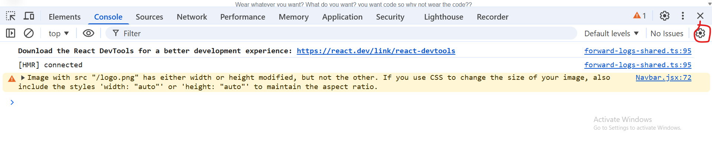
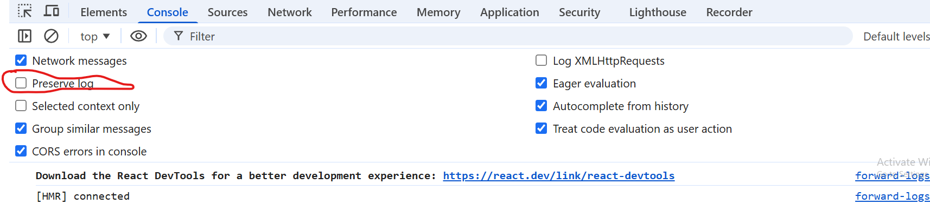
Now we go to marked above and then check the preserve log.
In a select element we have an attribute that is value that tells what is selected in the select list by default as select match its value attribute value to the value of option element so we can use it instead of using selected Boolean attribute on a particular option we want to show by default shown below
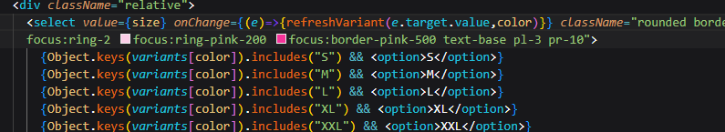
Discovery:-
We think that inside react elements that space is also counted as an element.(maybe) for example you take <p> <a>demo</a></p>. This be treated as an element.(who knows)
We usually add an item to cart and then we checkout but sometime we want that we buy onr ptofict immediately and for that you are given buy now button .If you click on buy Now then it will be in your cart and you will be checkout (who knows(maybe wrong)) so that you can enter your details instantly and checkout Now what teacher is saying when someone click on Buy now then all cart will be cleared and the items you carted will be removed from cart and only then item you want to buy now will be shown in the cart and we will be checked out(who knows)
There is a method to move to a next page in nextjs like you did in react by navigate you can do so in nextJs by router object that you can get by useRouter hooks which you import from “next/navigation” and you navigate to another page that is by push method of router object and in push method we pass the relative path(maybe)
overflow-y-scroll
By this class we can add scroll to an element vertically.
Many times in ecommerce we need to give alert to the user that their pincode is not serviceable
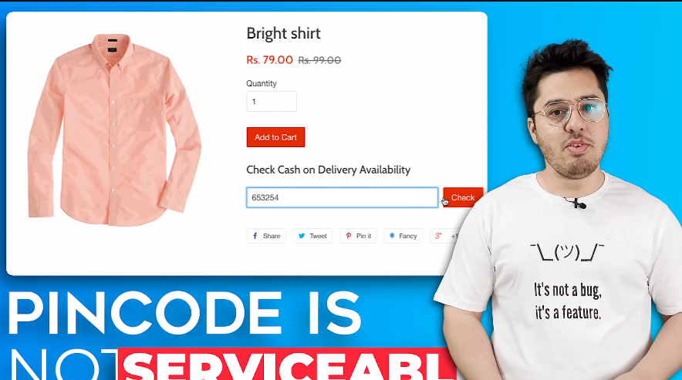
.We need to tell them that their login credentials are correct
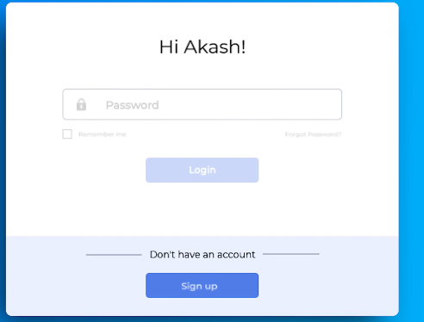
and their cart value is changed because some prices of item is changed
To do all this we are going to use a library called React Toastify and if you use React or Nextjs
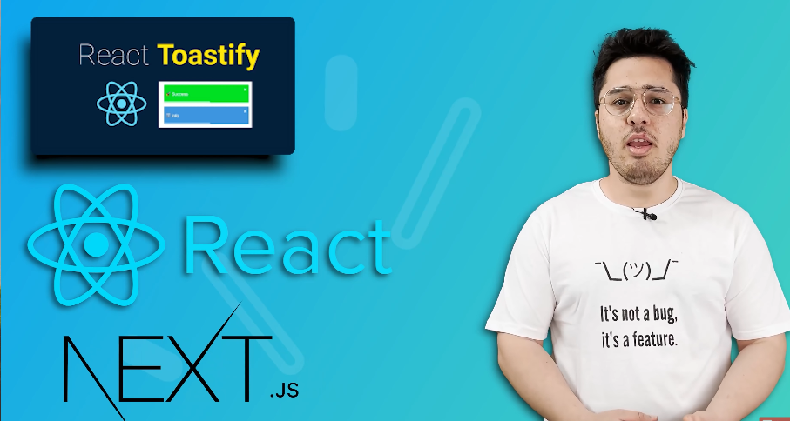
then this library is very helpful as it is very simple setup and you will feel fun
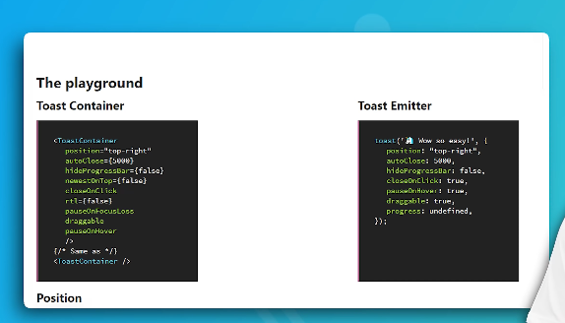
Because there are two lines of code one you add container and then invoke that container and all the work this library handles it itself.
We will see React Toastify documentation and use it. and we will see a link by going to which we can create our own toast
To use it we need to import it as shown below
And here toast it is a container invoker method be calling it we invoke Toast component
We get error as shown below
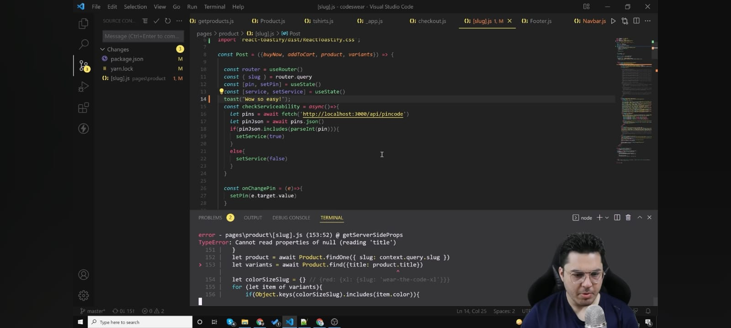
We get this error because image also demands from server by url and server takes slug and did not find any product by this title as the img property that was used in the src was some random string we set for demo
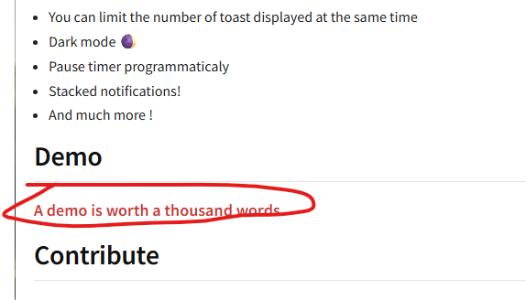
Now you can click on demo in the documentation and you will reach below
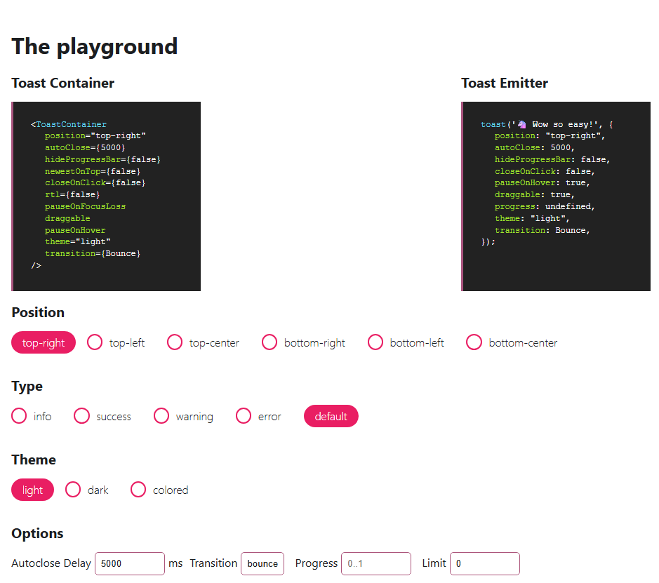
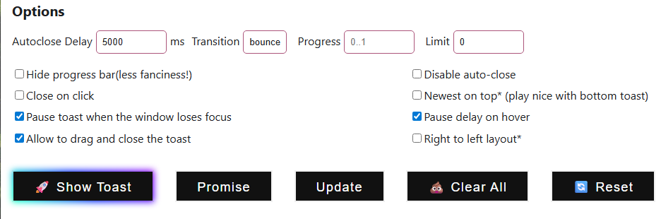
You can there is two things that is ToastContainer which tells how our toast will be shown , whjat will be the position and after what duration the toast should be closed and we have Toast Emmitor that invoke that component You can see oabove options of types and position is given . Choose your option and then your code will reflect that. To see the demo we click on Show toast
You can see the output in top tight as that position was chosen for it
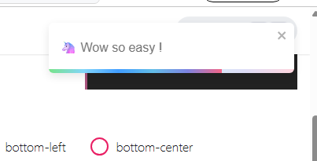
So we now copy and paste the code here to apply them. There are other methods inside our toast that is success and error and many more to show different situation in the toast.(who knows)
You can see different combination of toast in the demo of documentation
By promise it shows how it will look in promise who knows and in update we reset the ongoing popup
We can change its font. In the upcoming lesson we will connect the hoodies, stickers and cups with data bases and fill content in it.

We think that whatever files stored in the models is Schema actually and we make models of hem when we import that schema in a file that makes the model that is Schema Object(who knows) and sometimes we don’t need object just Schema class and its static methods(who knows).
It is recommended to import css of toastify that come with it as the classes used by Toast might find by mistake definition in Tailwind css.
As Teacher did mistake as he signed up them some element get bugger as shown below
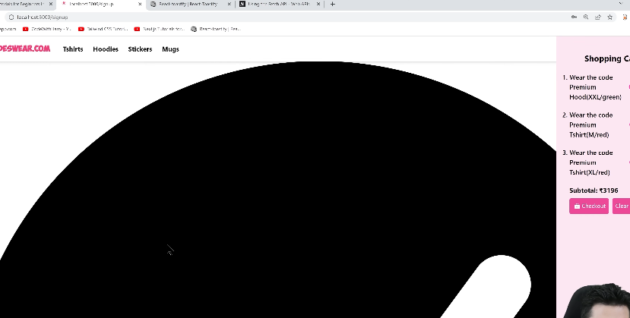
In the express you could have send two responses one after the other but server will give error in second response as it will say header could not be sent when they were already sent to the client early.(maybe header are sent before response(maybe) that was supposed to be only one) but in Modern nextjs it does not happen as the responses are returned and the flow is stopped in the function.
In authentication we encrypt password and when we match our password after we get authenticated we get token for personalization of services. It is not easy to hack a database of plain password but if it get hacked then all the data will be taken from database. Anybody can access any account.
User experience is bad if your site is not smooth and secure.
Now there is a dependency that we need that is crypto-js for encryption.
When we encrypt a password with a secret key and one benefit we get by this is that
You can see above we encrypted the password with a secret keys which is a secret string actually
We encrypted password because we don’t want that even if our database got hacked then still someone cannot access any account. When we encrypt our password then we encrypt it with a secret which we don’t tell anybody obviously it will not be that simple it will be a very complex string the benefit of that is that you can build the encrypted password from simple string but cannot vice versa or we can say it is almost impossible to do so we basically need very high GPUs which many hackers cannot afford. These are special type of function that’s why they are used
Note:-
Every time we generate an encrypted from of a same string and even with same secret key we get different results because of salt and we think it is a string that influences the formation of encrypted string and its string is decided by the algorithm and while decrypting (how can it be possible) this string(or salt) may be decoded from the string. Evert algorithm has its own working
IN the working of AES we don’t need to match encrypted string we need to match decrypted string.
There are lots of algorithm available here in crypto js. You don’t have to know all algorithm. You just need to know how to deal with a particular algorithm.
In this lesson we will learn about what is JWT. What are the benefits of using JWT Token. What are the three parts of Json and how data is taken from it and it s tampering does not become possible what we do for it
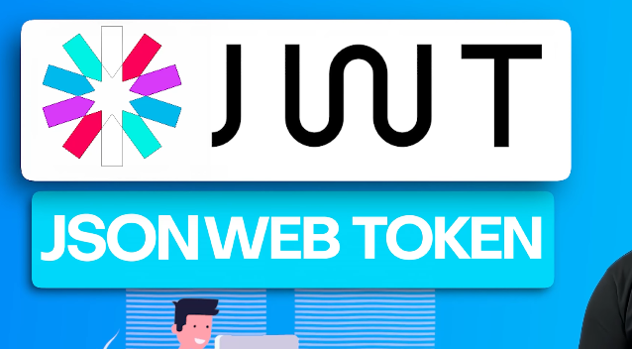
Now ig we go to JWT website you see below
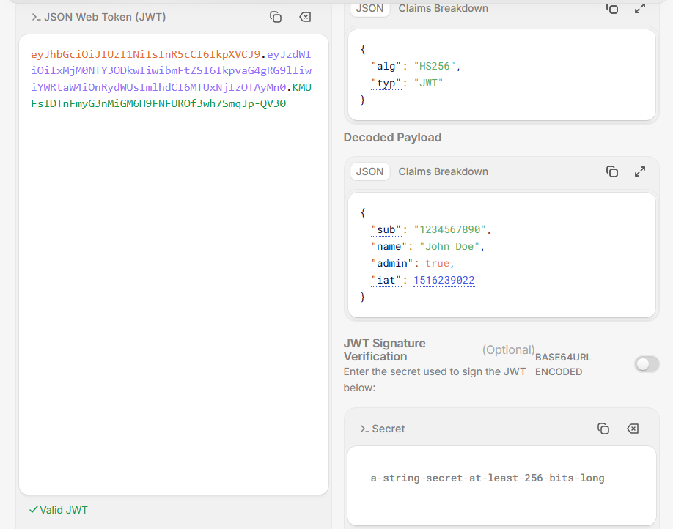
We are talking about token on the left The traditional approach of login is that you will authrnticate user id and password and then in server your session info will be saved and the seesion in server is alive iuntil then you will be logged in. If your session is ended by server then you will be logged out.
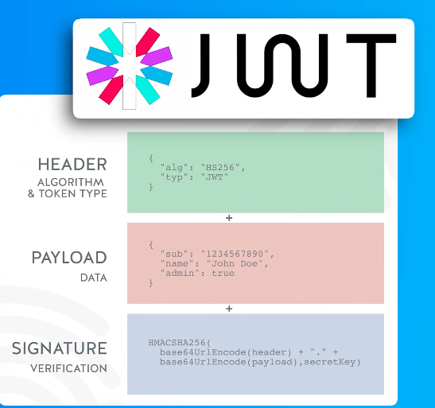
What happens in jwt is that it is divided into three parts first is header , second part is Payload data(which is our data ) and another is signature. Why JWT makes sense teacher tell it. See header it is the algorithm it means for the security this algorithm is used. By algorithm we mean for its security and to make JWT token what algorithm is used (maybe for encryption) and then next part is data that is payload is the actual data sent and the third part is signature Now we saw that in JWT encoder of website we see when we bring changes in the secret key then third part is modified. This secret is only known by the server. We can take JWT token and can check that is the payload data is actually tampered or not. By tamper we mean has the client change the payload data the client could not change it because we have signed it with our secret key. By using this secret we can know is this JWt tampered. And by this secret we can sign a given data so that whoever we give this data to he will not be able to change this jwt wihtou knowing this secret
So we add it jsonwebtokens by yarn
So what we did we import jsonwebtokens
And then we do something like below
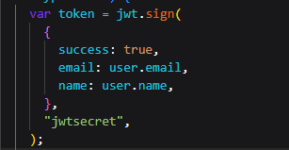
And whne we get tokens and we paster in token decoder we get below
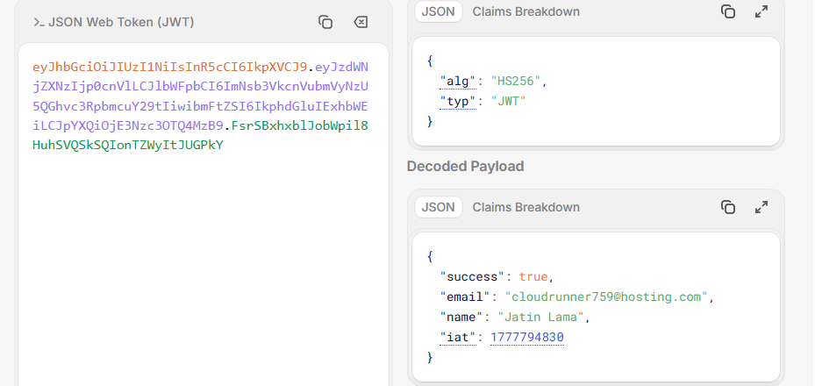
You can see one more attribute is added that is Iat it tells when this token was issued. So you can see above that this is the data JWT is taking. There is another parameter that we pass to the sign method that is an object literal having properties like expiresIn that tells when that token will be expired( who knows).
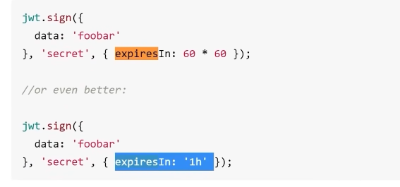
So now our code look like above.
We can even do it for one day by using “1d” as a value of expires In
We are doing it so that it get logout after some time.
There was a predefined file called _document.js which was used as a wrapper to the application that is basically Boilerplate surrounding the app content(or pages) and Boiler plate often contains Html ,Head and Body It was used to work like a HTML wrapper around the page It was like below
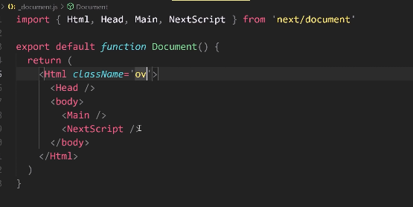
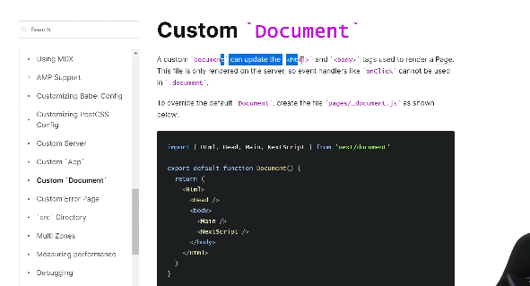
But now it is not used instead our layout.tsx is used. With _document.js we can make a skeleton of custom document (maybe pages (who knows))
The _documents.js was used inside pages router but layout.tsx was inside app router.
You can use router.query inside the array of the useEffect that you want to run as it track the url . so as url changes our useEffect runs.
Now in modern Nextjs router don’t have a query parameter you have usePathName hooks and you can use it to access pathname and can pass it to useEffect so that it can track
The issue is not with Tailwind or rendering—it's with how you're tracking route changes in Next.js App Router.
You're using:
useEffect(() => {
...
}, [router.query]);
👉 This does not work in modern Next.js (App Router).

❌ Problem
In next/navigation:
const router = useRouter()
👉 router does NOT have query anymore
So:
router.query // ❌ undefined
👉 Your useEffect dependency never changes → effect doesn’t rerun

✅ Correct way (App Router)
Use:
import { usePathname, useSearchParams } from "next/navigation";

🔧 Fix your code
Option 1: Detect route change
import { usePathname } from "next/navigation";

const pathname = usePathname();

useEffect(() => {
const token = localStorage.getItem("token");

if (token) {
setUser({ value: token });
setKey(Math.random());
}
}, [pathname]);

Option 2: Detect query params change
import { useSearchParams } from "next/navigation";

const searchParams = useSearchParams();

useEffect(() => {
const token = localStorage.getItem("token");

if (token) {
setUser({ value: token });
setKey(Math.random());
}
}, [searchParams]);

🧠 Why your current code fails
- router.query → only exists in Pages Router (next/router)
- You are using App Router (next/navigation)
- So dependency never updates → no re-render

⚠️ Bonus issue (important)
You don’t need this:
setKey(Math.random())
👉 This forces remount of Navbar (bad practice)
Instead just:
<Navbar user={user} />
React will re-render automatically when state changes.

✅ Clean version
"use client"
import React, { useEffect, useState } from "react";
import Navbar from "./Navbar";
import { usePathname } from "next/navigation";

function SuperNavBar() {
const pathname = usePathname();
const [user, setUser] = useState({ value: null });

useEffect(() => {
const token = localStorage.getItem("token");

if (token) {
setUser({ value: token });
}
}, [pathname]);

return <Navbar user={user} />;
}

export default SuperNavBar;

🎯 Key takeaway
router.query ❌ (old Next.js)
usePathname / useSearchParams ✅ (modern Next.js)

If you have visited any single page application then you must have seen if there is a navigation in a page and we are taken from one page to another then there is a very thin loading bar that goes on until that page loading happens Such things you might have seen in Youtube. Teacher will tell how this thing is done. He will tell us that how we are going to add top loafing bar in our site
If you see such thing in a site and it is react website then most probably that Top bar is made by react-top-loading-bar
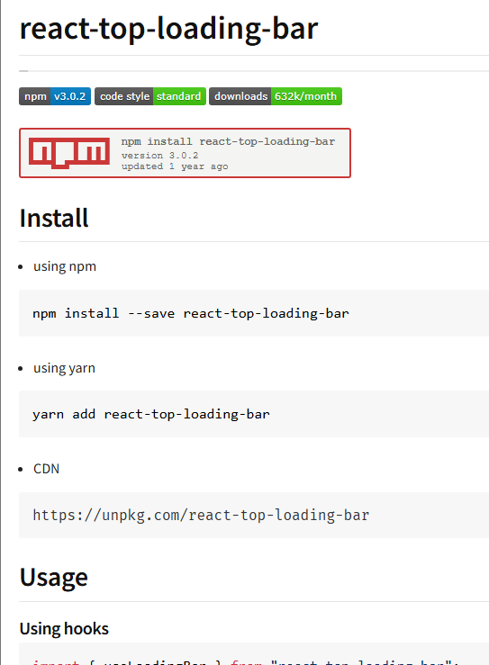
However there are other ways to do it. but we are going to see React top loafing bar. We install it by
yarn add react-top-loading-bar
Now we see next/router documentation
As our navigation will be complete in older Nextjs we use to listenof an event by router.events.on(“event name”,<event handler callback>) we used to listen for the event routerChangeComplete
But now in modern we can use it in the useEffect normally and set pathname as a trigger for the useEffect in our top component
We observed that when the loader reaches 100 percnt it fases out but it gase out after slightly long delay we can control it by waitingTime attribute.
There was also an event that was called routerchangeStart which was called when the router start routing but now no such thing exist so we need to do apply it in onClick on Link
Now there is another site that is tw-elements that we used for tables and the keyword is like
tailwind css table component
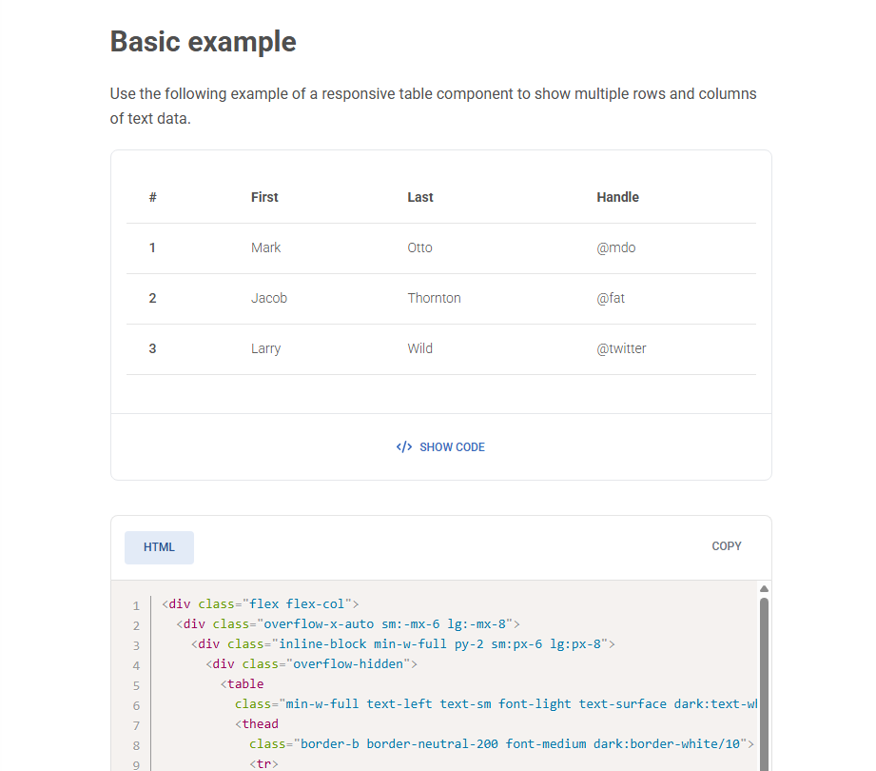
https://tw-elements.com/docs/standard/data/tables/ This is the url of the above site.
When we reach the site by the above keyword highlighted keyword then we see above and we copy the code.
We also use the url below
https://tailwindcss.com/docs/table-layout
To clear console click on the marked below
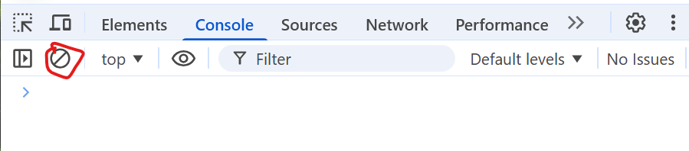
Teacher indirectly says that in blogs when you logout then you stays in the same page after reload but you are not logged in.
Teacher says In orders page there is a tracking link associated with a product to track the product.(who knows)
Teacher would want that user pay payment through payment gateway and we add order user and then redirect him to order page that we made.
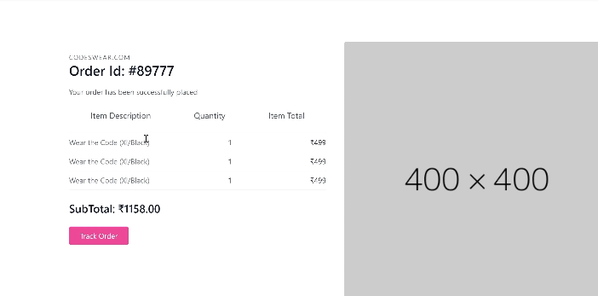
That this is your Order id and this is your Subtotal and these are your items and this is your tracking link(who knows maybe link to track the order).
Till now whatever secret thing we had we hard coded it. we hard coded JWT secret in the code. even out encryption secret keys we hardcoded them. So that means if we share out code base with anyone then our whole secret information will be in the hands of that person. We would not want that we will keep our thing like merchant Paytm key(who knows), passwords or any type encryption key or to be safe we would not want to give person information to anyone
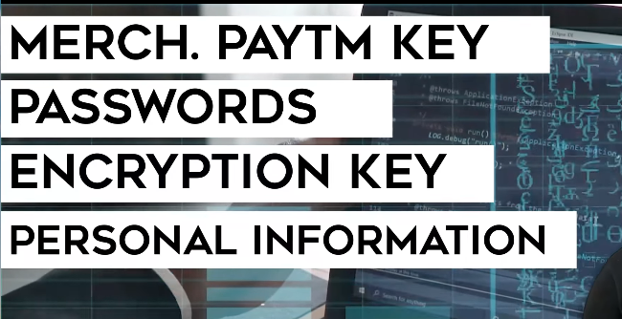
We can do this by environment variables we will learn how to add environment variables and how they are accessed.
We prepend a variable with NEXT_ to an environment variable(maybe we are wrong where) name so that they can be publicly be given in web browser(who knows) what is this we will understand it.
https://nextjs.org/docs/pages/guides/environment-variables
you can use documentation below and link above
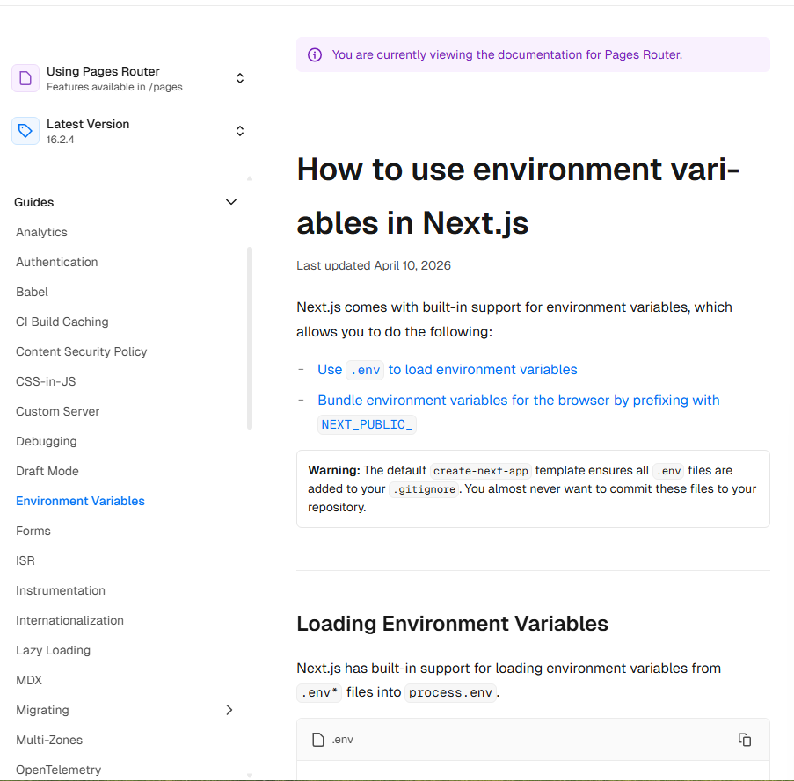

By reading above you will come to know how environment variables work in Nextjs. We make a .env.local file and put it in variables.
In our code bases we access them by process.env.<variable name>. and we thing is process is by default imported.
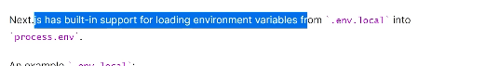
Now by this if we want to being changes in environment variable it will be reflected in the area in the code where the environment variable is used.
We can scroll and move around through the tabs in the VS Code.
We did a grave mistake we need to prefix the variable name with NEXT_PUBLIC_
About it is shown in oneliner below.
We need to do it so that we can expose it to the browser (who knows maybe server decides through this prefix to use that environment variables for the browser code(maybe we are wrong here)).
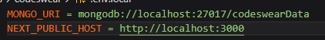
You can see above that MONGO_URI is an environment variable used by the server and NEXT_PUBLIC_HOST is used by the browser as maybe server exposed it to the browser(who knows).
All the html, CSS and JS files you can see in source tab of the console as shown below
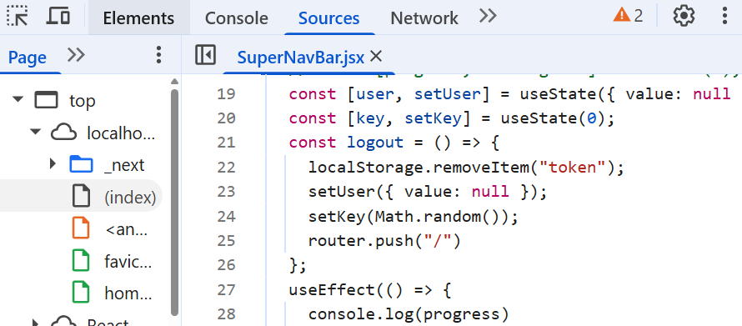
In older NextJs we needed to restart the server when we did some very strong changes related to the environment variable in the server (maybe we are wrong). But we don’t need to do now anymore as our modern server is strong now or maybe we are wrong here who knows.
Teacher will add paytm payment gateway you can choose any other payment gateway like Razorpay or instamojo Teacher will show us setup that tells how it works and what is the logic od adding payment gateway.
We will choose paytm but we will do payment through paytm but we will do it through Net Banking , Wallet or UPI and it will include all types of Bank. There are different ways to add different Gateways. If we talk about gateway then they will tell us some way to add their gateway. Similarly Paytm also do the same.
So we seacrh Paytm developer docs
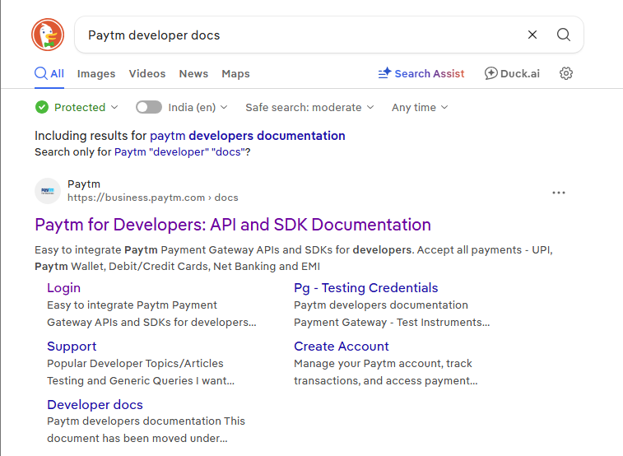
And then we open the first link as shown above.
And Here for payment gateway integration they provide us API. Teacher notices that since paytm introduces new flow how old code is depreciated(maybe its attributes or api link is changed that the gateway uses(who knows)) ). So we cannot make paytm payment gateway according to the flow(maybe technique).
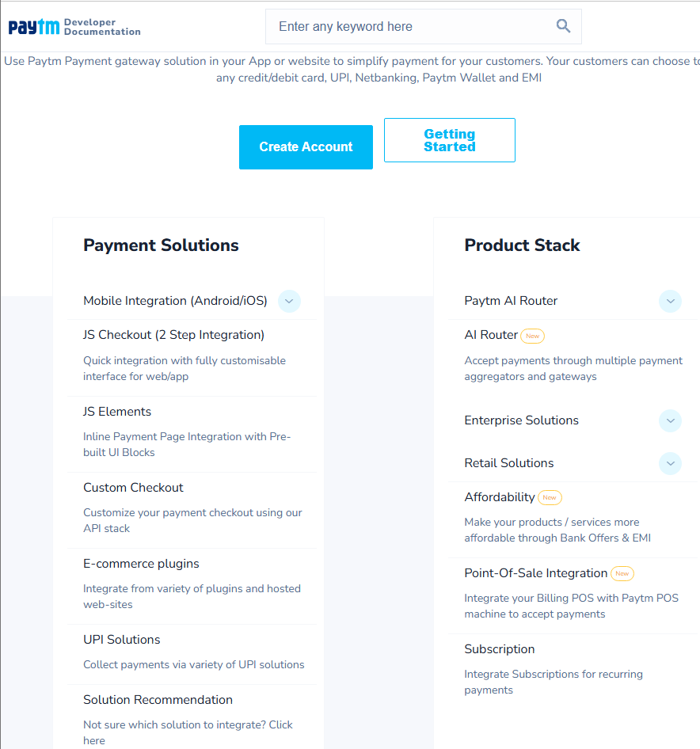
Now after clicking on Solution recommendation then we will be directed to page below
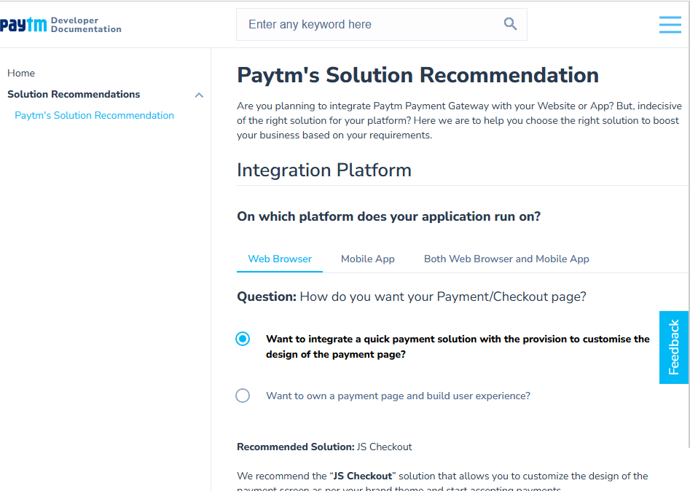
It will show at the bottom the pop u of redirecting close it ASAP other new page will be opened and even that page will not be opened properly.
Its link is
https://business.paytm.com/docs/recommendations?ref=solRecommendations
Keep the first option checked as shown above.
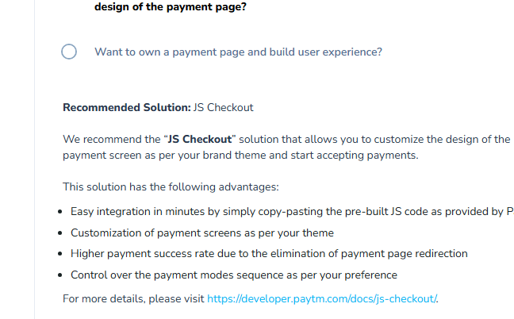
Now you can see above that Recommended solution is JS checkout you can click on link in the bottom as shown above
Now the link Is shown below
https://www.paytmpayments.com/docs/js-checkout/
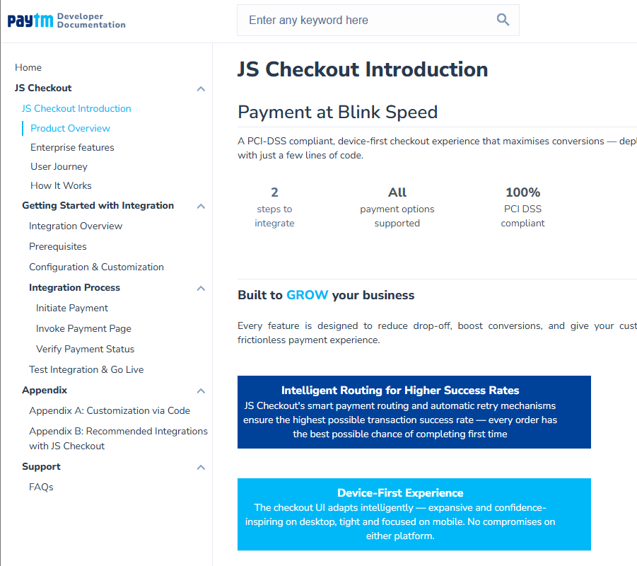
Now what is js checkout IT is an amazingly fast solution. It is provided by paytm. We will use checkout.js to accept paytm payments
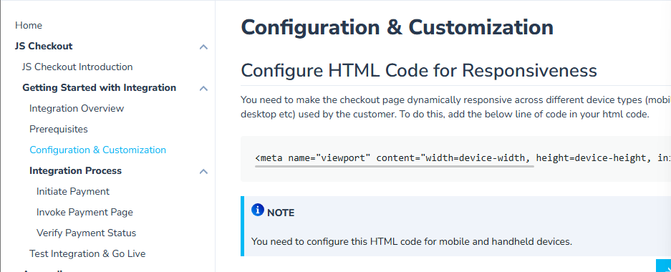
Now we will go to Configurations and Customization as shown above
It says to add meta
<meta name="viewport" content="width=device-width, height=device-height, initial-scale=1.0, maximum-scale=1.0"/> why need to add meta for payment gateway as we had heard that mets used to tell daata about data(short adn simple)
Short and simple 👇
🧠 Why this meta tag is needed (payment gateway)
<meta name="viewport" content="width=device-width, height=device-height, initial-scale=1.0, maximum-scale=1.0"/>
👉 It tells the browser how to display your page on mobile screens

🎯 Why payment gateways require it
- Payment pages must look proper on all devices
- Without it:
  - layout breaks ❌
  - buttons may be too small ❌
  - zoom issues ❌
- That can cause:
  - wrong clicks
  - failed payments

🔐 So they enforce it for
✔️ Better UX
✔️ Fewer payment errors
✔️ Consistent UI across devices

🧾 Simple understanding
It doesn’t describe your data — it controls how your page is shown on mobile

🚀 One-line answer
Payment gateways require the viewport meta tag to ensure the payment page displays correctly and safely on mobile devices.
but how page is shown should be tolf by CSS and meta tag is used for crawler so that ehy read the information
Good question—and your understanding is partly right but incomplete. Let’s fix it simply.

🧠 Key idea
CSS controls style
Meta viewport controls how the browser scales the page

🔴 Why CSS alone is NOT enough
Without viewport meta:
- Browser assumes a desktop width (~980px)
- Then shrinks the whole page to fit mobile
👉 Result:
- Text becomes tiny ❌
- Buttons hard to click ❌
- Layout looks broken ❌

✅ What viewport meta does
<meta name="viewport" content="width=device-width, initial-scale=1.0">
👉 It tells browser:
“Use the real device width, don’t shrink”

🎯 So difference is
Thing | Role
CSS | styling (colors, layout, flex, etc.)
viewport meta | scaling & zoom behavior

🔐 Why payment gateways insist on it
- Payments need precise clicks
- No zoom issues
- No misalignment
👉 So they enforce viewport for safe UX

⚠️ About your assumption
“meta tags are for crawlers”
👉 ❌ Not always
Meta tags are used for:
- SEO (description, robots) ✔️
- Browser behavior (viewport) ✔️
- Security (CSP) ✔️

🚀 One-line answer
CSS controls design, but viewport meta controls how the browser scales the page—without it, mobile layout breaks, which is why payment gateways require it.
just tell us when we load a page then the pixel size may very accoefing to device
Yes—exactly 👍
🧠 Simple answer
When a page loads, the pixel width used by the browser can vary depending on the device

🎯 Why?
- Mobile screens are smaller
- Desktop screens are larger
- Browsers may scale (zoom out) the page on mobile

🔴 Without viewport meta
👉 Browser assumes a fixed large width (like desktop)
👉 Then shrinks everything to fit mobile

✅ With viewport meta
<meta name="viewport" content="width=device-width">
👉 Browser uses:
- actual device width
- correct pixel scaling

🚀 One-line answer
Yes, page pixel size varies by device, and viewport meta ensures the browser uses the correct device width instead of shrinking the layout.
Now we paste that meta in our layout.tsx but it would added meta globally so what we did is we make server component and inside it wrap the client component that contains the UI of the checkout page and then inside the server component we add as shown below
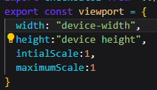
We would not read documentation deeply and apply all the points we just apply gateway and note down there so
So we add meta for viewport which we added so that the pages looks good (who knows)
And then add a script as shown below in our checkout page code
<script type="application/javascript" src="{HOST}/merchantpgpui/checkoutjs/merchants/{MID}.js" onload="onScriptLoad();" crossorigin="anonymous"></script>
<script>
function onScriptLoad(){
var config = {
"root": "",
"flow": "DEFAULT",
"data": {
"orderId": "", /* update order id */
"token": "", /* update token value */
"tokenType": "TXN_TOKEN",
"amount": "" /* update amount */
},
"handler": {
"notifyMerchant": function(eventName,data){
console.log("notifyMerchant handler function called");
console.log("eventName => ",eventName);
console.log("data => ",data);
}
}
};
if(window.Paytm && window.Paytm.CheckoutJS){
window.Paytm.CheckoutJS.onLoad(function excecuteAfterCompleteLoad() {
// initialze configuration using init method
window.Paytm.CheckoutJS.init(config).then(function onSuccess() {
// after successfully updating configuration, invoke JS Checkout
window.Paytm.CheckoutJS.invoke();
}).catch(function onError(error){
console.log("error => ",error);
});
});
}
}
</script>
Now we will add our Merchant id and HOST (that will be different that is for production it is different and for staging (or development (according to Teacher))is different (who knows)) to the script
Now it says once script is loaded then you can run the code onload which is below the script as shown above
This code is as such that when page loads then your transaction start but we will start the transaction manually
When you make a merchant account they make you merchant Id By merchant mean you can take the money then you would have to link it with Bank account and also maybe do KYC(and maybe it is done when we are dealing with liv mode) and maybe we get MID when we do kyc or activate account.
We write the code after our script in a click event handler and for Order id we choose Math.random(). Soon Teacher will tell what are transaction token are.
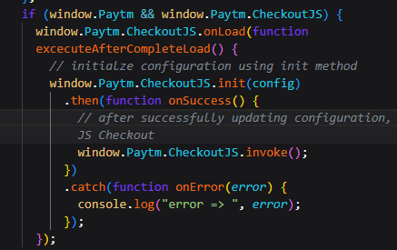
Now about code is written such that when checoutJS loads then the function passed to it will rum but since we are using click handler we don’t need onload so we remove it and keep jut init fucntoin call.
Yes—that’s the right idea, just word it like this 👍
🧠 Correct understanding
✔️ onLoad ensures don’t run this function until the script is fully ready

🔴 Slight correction
It’s not just “script executed”
It’s script + its internal async setup completed

🎯 Simple meaning
Wait until Paytm is fully ready → then run my code

🧾 Final one-line answer
onLoad ensures the function runs only after the script and its internal asynchronous setup are fully completed.

You’ve got the concept now 👍
Onload was used as this code was weiten in context of script rather than even hang;er and we believer until we click the button ot checkoutjs from script will be loaded.
So lets see how Paytm payment world so first of all you initiate the transaction by using initiate transaction API you can see it is written in doc as shown below
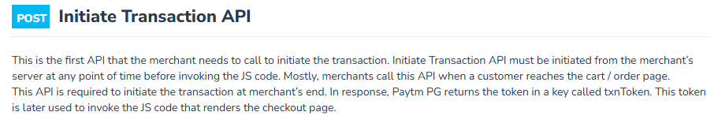
They say that by using initiate transaction api we get transaction token so we make an API in the backend that fetch tokens and we add fetch in starting of Checkout page so that we can get tokens when we click on Pay button. After we get transaction token we set it to the token variable that we set to token parameter of config(the code that we pasted first pasted in the click handler).
There is a package that we need to install that is paytmchecksum
what this callBackUtl do here (hoer and simple).
Think of callbackUrl as “where Paytm should send the result after payment is done.”
Simple flow:
- User clicks Pay → goes to Paytm payment page
- User completes (or fails) the payment
- Paytm redirects + sends response to your callbackUrl

In your code:
callbackUrl: "https://<callback URL to be used by merchant>"
👉 This URL is your backend endpoint (API route) where:
- Paytm sends transaction status
- You verify payment
- You update your database/order status

Example:
callbackUrl: "https://yourdomain.com/api/paytm/callback"
Then in your backend:
app.post("/api/paytm/callback", (req, res) => {
const paymentData = req.body;

// verify checksum (very important)
// check if txn is SUCCESS

if (paymentData.STATUS === "TXN_SUCCESS") {
// mark order as paid
} else {
// mark order as failed
}
});

In one line:
👉 callbackUrl = “Paytm tells your server what happened to the payment here.”

Important (don’t skip this):
- Always verify checksum/signature (security)
- Never trust raw response blindly
- This is where your order confirmation logic happens

If you want, I can show you the full working Paytm integration (Node + React) step-by-step for your ecommerce project.
but it is sinde the token generator api how cna it be calle d after payment
Good catch—that confusion is very common. The key point is:
👉 callbackUrl is NOT used during token generation.
It’s just passed forward to Paytm and stored for later use.

What actually happens step-by-step
1. Your backend (token generator API)
You call Paytm to create a transaction token:
paytmParams.body = {
requestType: "Payment",
mid: process.env.PAYTM_MID,
orderId: body.oid,
callbackUrl: "https://yourdomain.com/api/paytm/callback",
...
};
👉 At this moment:
- Nothing is “called” on callbackUrl
- You are just telling Paytm:
“After payment, send response here.”

2. Paytm stores this URL
Paytm internally saves:
- orderId
- mid
- callbackUrl

3. User goes to Paytm payment page
From frontend:
- You use the txnToken
- Redirect user to Paytm checkout

4. After payment is completed
Now Paytm uses that stored callbackUrl:
👉 It makes a POST request to your backend
https://yourdomain.com/api/paytm/callback
with:
- transaction status
- orderId
- checksum

So the answer to your question:
“how can it be called after payment if it's inside token API?”
👉 Because:
- You are not calling it
- Paytm calls it later, after payment

Think of it like this (very simple analogy):
You tell a delivery guy:
“After delivery, report back to this address.”
That address = callbackUrl
You gave it earlier, but it’s used later.

Important clarification
There are actually 2 things happening:
- Server-to-server call (important)
  - Paytm → your callbackUrl
  - Used for verification
- User redirect (optional UI flow)
  - User may also be redirected to a page (same or different URL)

Final one-liner
👉 callbackUrl is just registered during token creation, but triggered by Paytm after payment.

If you want, I can draw the full flow diagram (frontend → backend → Paytm → callback) so you never get confused again.
but wht will paytm get by callBakc Url
Short answer: Paytm doesn’t “get” anything from your callbackUrl—it uses it to deliver the payment result to you.

Why Paytm needs the callbackUrl
When you create the transaction, you give Paytm this URL so it knows:
👉 “Where should I send the final payment status for this order?”
After the user finishes paying, Paytm must:
- Notify your server whether the payment succeeded / failed
- Send transaction details tied to your orderId
That’s exactly what the callbackUrl is for.

What Paytm sends to your callbackUrl
Paytm makes a POST request to your backend with data like:
{
"ORDERID": "12345",
"STATUS": "TXN_SUCCESS",
"TXNAMOUNT": "1.00",
"TXNID": "202405061234",
"CHECKSUMHASH": "abcxyz..."
}

What YOU do with it
Your server receives that request:
app.post("/api/paytm/callback", (req, res) => {
const data = req.body;

// 1. Verify checksum (security)
// 2. Check STATUS

if (data.STATUS === "TXN_SUCCESS") {
// ✅ mark order as paid in DB
} else {
// ❌ mark order as failed
}
});

So your question:
“what will Paytm get by callbackUrl?”
👉 Nothing new.
👉 It already has all payment info.
It just uses the URL to send that info back to you.

Why this is necessary (very important)
Without callbackUrl:
- Your server would never know if payment succeeded
- You couldn’t safely:
  - confirm orders
  - update DB
  - deliver products

One-line clarity
👉 callbackUrl = Paytm’s way to report payment result back to your backend

If you’re building your ecommerce project, this endpoint is basically your “final authority”—everything (order success/failure) should depend on what you receive here, not the frontend.
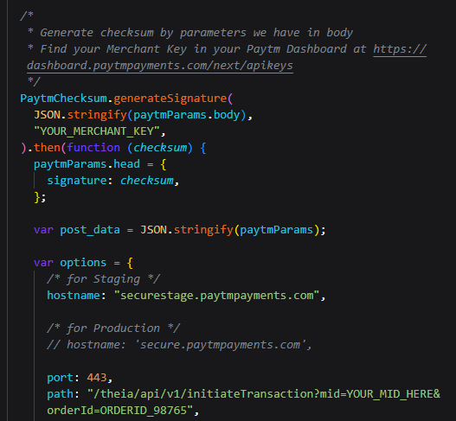
You can see the code below the token generation that is given by Paytm is given for staging (maybe for development purposes (who knows)). So we comment the hostname and uncomment the commented hostname.
Maybe because of url it was of staging but we want of production so we did so.
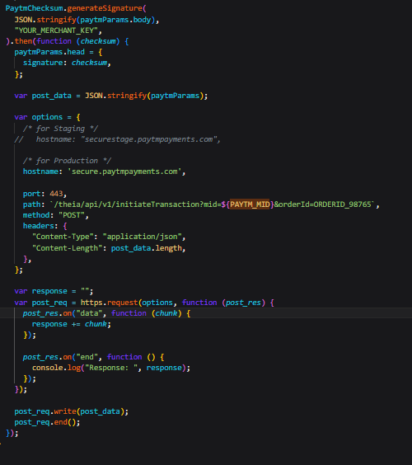
The code in the bottom of the token generation code is asynchronous in nature but we want that it should be tun block by block so that we can get our object containing key properly other wise we may get an undefined or any unpredictable value. You may argue that we can await everything but the problem is with https.request. The problem with this is that t is not returning any promise but a request object its outcome is handled by callback function as this code is very old when there was no promise and await and node js is backword compatible and many libraires depend on its behaviour and another reason is that it is streaming response so response are coming in chunks and problem with await is that it will await for only one chunk so that’s why we need to wrap the above code in Promise which we will await as we will wait for full code completion and then we can return the result .
But if you come to know there is a separate library for it to handle this behaviour especially made for Nextjs to nodes js then you can use them also(who knows).
We can use try catch to run reject(FYI).
Along with merchant ID we have merchant Key also so we also need ot savethat in out environment variblle.
We did a mistake that is not using proper url meant for stage but we did use for production and now orderid did not match. So beware .
Now our paytm payment gateway is working.
so what happens that when payment is sucessfull then paytm server redirect the browser to the callBack url with post telling the status
Yes—that’s essentially correct, just tighten it a bit:
✔️ After payment, Paytm redirects the user’s browser to your callbackUrl using a POST request that contains the transaction status.

🧠 Simple flow
1. User pays on Paytm
2. Payment completes
3. Paytm sends browser → your callbackUrl (POST)
4. POST contains status (success/failure + details)

🔴 Small but important addition
✔️ Paytm also expects your server to verify the response (checksum)
(not just trust the status blindly)

🎯 What you should do at callback
Receive POST → verify checksum → check status → redirect user

🚀 One-line answer
Yes, after payment Paytm redirects the browser to your callbackUrl via POST with transaction details, which your server must verify before proceeding.
In our callbackUtl code
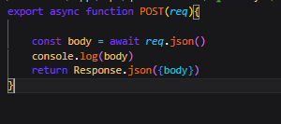
We are trying to get the body as a json but it is not because the form data is not send by detch but by action
export async function POST(req){ const body = await req.json() console.log(body) return Response.json({body}) } ⨯ SyntaxError: Unexpected token 'B', "BANKNAME=H"... is not valid JSON at JSON.parse (<anonymous>) We get error like this
Good—you’ve hit an important integration detail 👍
🔴 Why this error happens
SyntaxError: Unexpected token 'B', "BANKNAME=H"... is not valid JSON
❗ Paytm is NOT sending JSON
✔️ It sends form data (x-www-form-urlencoded)

🧠 What you tried
const body = await req.json() ❌
👉 This expects JSON like:
{ "key": "value" }

🔥 What Paytm actually sends
BANKNAME=HDFC&BANKTXNID=12345&STATUS=TXN_SUCCESS&...
👉 This is form-encoded data, not JSON

✅ Correct way (Next.js App Router)
Use:
export async function POST(req) {
const formData = await req.formData();

const data = Object.fromEntries(formData.entries());

console.log(data);

return Response.json({ data });
}

🎯 What this does
- formData() reads POST form data ✔️
- Object.fromEntries converts it to object ✔️

🔴 Example output
{
BANKNAME: "HDFC",
STATUS: "TXN_SUCCESS",
ORDERID: "123",
TXNAMOUNT: "100.00"
}

🚀 One-line answer
Paytm sends form-encoded data, not JSON, so you must use req.formData() instead of req.json().

If you want, next I can show you:
👉 how to verify checksum + detect success/failure correctly (very important step).
but form also send body like we senf in forms in browser
Yes—exactly right 👍
🧠 Simple explanation
✔️ Forms also send data in the request body
❗ But the format is different from JSON

🔴 Two types of body
1. JSON (what you expected)
{
"name": "coder",
"amount": 100
}
👉 Read with:
await req.json()

2. Form data (what Paytm sends)
name=coder&amount=100&status=TXN_SUCCESS
👉 Looks like:
- key=value&key=value
👉 Read with:
await req.formData()

🔥 Why your error happened
You did:
await req.json() ❌
But Paytm sent:
BANKNAME=HDFC&STATUS=TXN_SUCCESS ❌ (not JSON)
👉 So JSON parser crashed 💥

🎯 Simple analogy
Type | Like
JSON | object {}
Form data | URL ?a=1&b=2

🚀 One-line answer
Yes, forms send data in the body, but in key=value format—not JSON—so you must use req.formData() instead of req.json().
so the body is send in browser like parameter1=value&paramete2=value if we submit the fom without any fetch but by action
Yes—exactly correct 👍
🧠 What happens when you use a form (no fetch)
<form action="/api/test" method="POST">
<input name="param1" value="A" />
<input name="param2" value="B" />
</form>
👉 When user submits:
param1=A&param2=B
👉 This is sent in request body

🔴 Key point
✔️ Browser sends body as:
key=value&key=value
❗ Not JSON

🎯 Same as Paytm
Paytm is basically doing:
<form action="your-callback-url" method="POST">
<input name="STATUS" value="TXN_SUCCESS" />
<input name="ORDERID" value="123" />
</form>

<script>form.submit()</script>
👉 So you receive:
STATUS=TXN_SUCCESS&ORDERID=123

✅ That’s why you must use
await req.formData()

🚀 One-line answer
Yes, when a form is submitted using action, the browser sends body as key=value&key=value, not JSON.
So now we do something like below
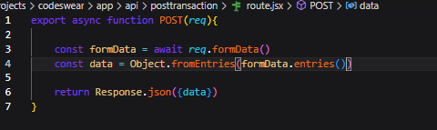
You can see the result of our callback url that we sent by post
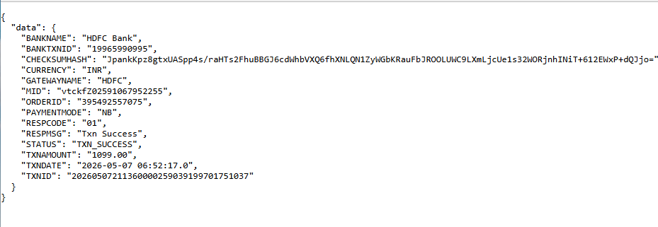
Now you can see our response as shown above.
Now we need ot check that payment is successful or not(maybe double checking ) then we can use one API that we could use So for that we use transaction Status API as shown below
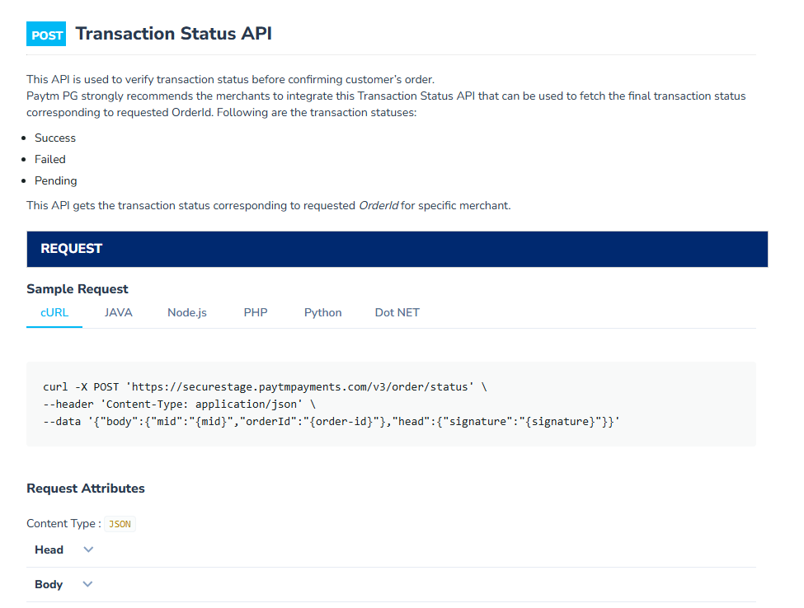
Th s Api needs merchant id and order id and in response it gives you the response as shown below
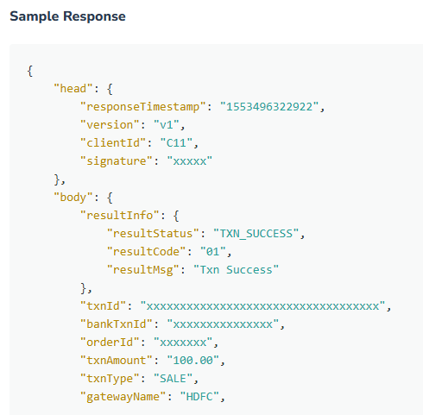
You can se above it is shown how much money was paid . Was payment successful or not and How it is done you get such money details. So paytm also says that when we will make you hit callback post url then doin’t consider it final(the data we get from post of callback url) what you should so is that corresponding to this Order id check that we have received money or not. If we have received money then you can confirm the order. Otherwise don’t confirm it.
We do something like below in the backend now
Order will have a track link which shipping provider will tell the status (who knows) However you want to do it.
Never make Merchant Key public but you can make Merchant Id public as you are fetching your js
https://securestage.paytmpayments.com/merchantpgpui/checkoutjs/undefined
why this linked woeked in fetching the kjs code((in simpler words)
Short and simple 👇
🧠 Why this URL still “worked”
.../checkoutjs/undefined
✔️ Because the server ignores that last part and still returns the main JS file

🔴 What should happen ideally
.../checkoutjs/merchants/YOUR_MID.js
👉 MID is used to customize script

🟢 What actually happened
- You sent undefined
- Server didn’t strictly validate it
- It still returned generic Paytm JS
👉 So script loaded ✔️

⚠️ But important
❌ This is NOT correct usage
❌ May break later (payments, config, features)

🎯 Simple analogy
Like going to /user/undefined and server still shows homepage

🚀 One-line answer
It worked because the server ignored undefined and returned a generic script, but it’s not correct and may fail later.

If you want, I can show you the correct script URL format for staging vs production.
so generic script was in checkout send point
Yes—that’s the idea 👍
🧠 Simple understanding
✔️ The checkoutjs endpoint can return a generic (default) script

🔴 What happened in your case
/checkoutjs/undefined
👉 Since MID was undefined:
- server couldn’t load merchant-specific config
- so it returned a default/common Paytm script

🎯 So:
✔️ Generic script = basic Paytm JS
❌ Not configured for your merchant

⚠️ Why you should NOT rely on it
- No proper merchant config ❌
- May fail in real transactions ❌
- Token/session issues ❌

🚀 One-line answer
Yes, the checkoutjs endpoint returned a generic script when MID was undefined, but it’s not properly configured for your merchant.

If you want, I can show you exact correct script URL format for your setup (staging + MID).
the url we put in src why it is not visible in network tab
Good question—this is a common confusion 👍
🧠 Short answer
❌ The URL you put in <Script> may not show clearly in Network
✔️ Because it can be loaded differently (cached / injected / renamed)

🔍 Why it’s not visible
1. ✅ Loaded via JavaScript (not normal request)
Paytm script can:
- internally load other scripts
- bundle requests
👉 so exact URL may not appear directly

2. ✅ Cached by browser
If already loaded once:
(no new network request)
👉 So you don’t see it again

3. ✅ Filter issue in DevTools
You may be seeing:
- only Fetch/XHR
- not JS
👉 Switch to:
All → JS

4. ✅ Different URL internally
You wrote:
/checkoutjs/merchants/MID.js
But Paytm may load:
/checkoutjs/v2/xyz.js
👉 So it looks different

5. ✅ Blocked / failed silently
If error:
ERR_BLOCKED_BY_CLIENT
👉 It may not show clearly

🧪 How to confirm
Open DevTools → Network → search:
checkoutjs

🚀 One-line answer
It may not appear because the script is cached, loaded internally by another script, or filtered out in DevTools.

If you want, I can show you exact way to force it to appear in Network tab (very useful trick).

