Teacher think that you can make id public and key private but we say that keep both private(who knows).
So you might get good idea that how to implement paytm payment gateway. If you go to Razorpay or instamozo then in their documentation. They will tell how to integrate them in your website or App.
Some payment gateway have pricing methods (who knows maybe paytm also have).
New Lesson
One user make some cart in out website and add their personal details and then checkout and do the payment then our order should come in our database and at the same tie we need or give user intimation that your order is successful you don’t worry we will fulfill your order. How we will do it in our code on our end.
We come to know that in Nextjs we can set a style according to Boolean attribute variable maybe for example dor disabled we can do so. That is disabled:bg-pink-300.
You can useStateSnippets(codeword that is showing in the suggestion) to make useState very fast
We observed that if a function is in a render it will only use that state value of the render(or we might say environment of that render stays for that function (who knows)) not of new render.
In old mongodb it was very merciful it used to ignore if no value passed for a field that has not required to true. But not anymore (who knows). If you have added required to true then you have to pass the value to the field even though default value was mentioned in the Schema.
The data client send to the server can be tempered from the local storage(maybe).
FYI if you remember Paytm give you checksum through which the data sent by the Paytm along with it a checksum of data is also sent. So by using our merchant key we can check that the data sent to us is valid or not. So through checksum we come to know is that valid or not.
If it sent by Paytm or not. It should not be like that someone sent aa random order ID set us Payment successful notification by hitting the callback url end point that we passed earlier and then we worry nobody can do it as we validate checksum and then we move forward otherwise we will return the user and throw error (maybe by status).
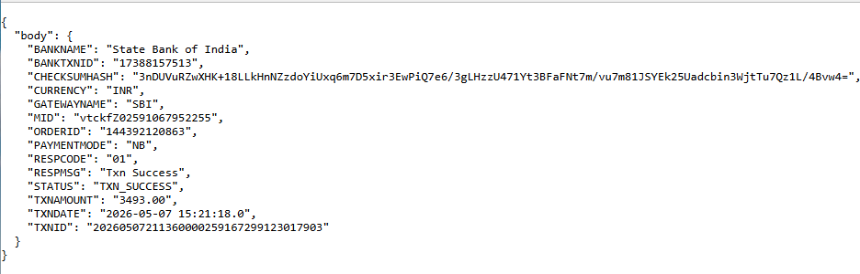
The urlCallback is sent this type of data.
Teacher says we get logical error that is no updation was happening in mongodb because some method does not return promise die which error may arise(who knows maybe we are wrong) according to teacher.
return Response.redirect("/order",302) why we get this error
Good—this is a common Next.js App Router issue 👍
🔴 Why this error happens
return Response.redirect("/order", 302)
❌ Fails because Response.redirect expects a full URL, not just a relative path

🧠 What’s happening
- In server (Node/Edge), there is no browser context
- So /order → ❌ unknown base URL

✅ Correct way (important)
✔️ Use absolute URL
return Response.redirect(`${process.env.NEXT_PUBLIC_HOST}/order`, 302);

🔥 Better (recommended by Next.js)
Use URL constructor:
return Response.redirect(new URL("/order", req.url), 302);
👉 This:
- builds full URL automatically ✔️
- works in all environments ✔️

🎯 Why this works
new URL("/order", req.url)
👉 Converts:
/order → http://localhost:3000/order

🚀 One-line answer
Response.redirect needs a full URL, so use new URL("/order", req.url) instead of just "/order".

If you want, I can show you when to use redirect() vs Response.redirect() (important distinction).
why it needs full url
Great question—this is the core concept 👍
🧠 Why Response.redirect() needs full URL
✔️ Because it runs on the server, not in the browser

🔴 Key difference
In browser:
window.location = "/order"
👉 Browser knows:
current site = https://example.com
👉 So it becomes:
https://example.com/order ✔️

On server (Next.js / Node):
Response.redirect("/order")
👉 Server does NOT know:
- current domain ❌
- hostname ❌
- protocol ❌
👉 So /order is incomplete

🧠 What server needs
https://example.com/order ✔️ (full URL)

✅ That’s why we do
new URL("/order", req.url)
👉 It builds:
http://localhost:3000/order ✔️

🔥 Simple analogy
- /order = “Go to room 5” ❌ (which building?)
- https://site.com/order = full address ✔️

🚀 One-line answer
Response.redirect() needs a full URL because the server doesn’t know the current domain, unlike the browser.
but why server don't knwo domain it can point to itself
Great question—this gets to how servers actually work 👍
🧠 Short answer
❌ Server doesn’t assume a domain because the same code can run on many domains
✔️ So it needs the full URL explicitly

🔴 Why server doesn’t “point to itself”
Your app might be accessed as:
https://myshop.com
https://www.myshop.com
https://staging.myshop.com
http://localhost:3000
👉 All hit the same server code

🧠 So what is “itself”?
❌ There is no single fixed “self”
✔️ Domain comes from the incoming request

🔥 That’s why req.url is used
new URL("/order", req.url)
👉 If request came from:
https://myshop.com/cart
👉 It builds:
https://myshop.com/order ✔️

⚠️ Important
Server:
- runs behind proxies/CDNs
- can serve multiple domains
- doesn’t hardcode hostname

🎯 Key idea
Browser knows current URL → server does NOT assume it

🚀 One-line answer
The server doesn’t assume a domain because the same code can serve multiple domains, so it relies on the incoming request (req.url) to determine the correct one.

If you want, I can show you how this behaves in Vercel / production vs localhost (very useful insight).
but in old NExtjs it was possible
Good point—you’re noticing a real difference 👍
🧠 Why it worked in old Next.js
✔️ Old Next.js hid this complexity for you

🔴 In Pages Router (old Next.js)
You used:
res.redirect("/order")
👉 It worked because:
- Next.js/Node automatically converted it
- Internally used request info (req.headers.host)
- Built full URL for you

🟢 In modern Next.js (App Router)
You use:
return Response.redirect(...)
👉 This is Web Standard API (Fetch API)
❗ It does NOT assume anything
❗ It requires full URL strictly

🔥 Key difference
Old Next.js | New Next.js
Node-based helper | Web standard API
Auto handled URL | You must provide full URL
res.redirect("/x") ✔️ | Response.redirect("/x") ❌

🎯 Why change happened
✔️ To support:
- Edge runtime
- Web standards
- platform independence

🚀 One-line answer
In old Next.js, res.redirect auto-built the full URL, but modern Next.js uses standard Response.redirect, which requires a full URL.
There is another property in the body of callback url that is STATUS and if the transaction was successful then its value will be TXN_SUCCESS.
We can use order id and transaction d to identify an order so that one cannot track any order by just any random number.(maybe by guess by which user information may get exposed by the hacker(who knows))
tell us in what scenerio the payment is pending(very short)
✔️ Payment is PENDING when the user has started payment but has not completed it yet (e.g., OTP not entered, UPI not approved, or bank response delayed).
no in terms of staging
Got it—in staging (test environment) 👍
✔️ Payment becomes PENDING when you don’t complete the test payment flow

🎯 Very short scenarios (staging)
- You don’t click “Success” on Paytm test page
- You close/refresh the page
- You don’t approve UPI / OTP
- You leave the payment incomplete

🧾 Meaning
✔️ Paytm is still “waiting” for user action → so STATUS = PENDING

🚀 One-line answer
In staging, payment is PENDING when you don’t complete the test payment (no success/failure action taken).
so by pending means user started the transaction but thwn in between like waiting for otp closed teh website (oneliner)
✔️ Yes—PENDING means the user started the transaction but didn’t complete it (e.g., closed the page while waiting for OTP/approval).
New Lesson
If you have visited any website then you might know that there is order page and then there is orders page in order page there is information of a particular order having an order id which have all the details of a particular order. And in orders page al the orders of a user are present there so the they can choose an order and track it (maybe opening a particular order page of order in orders page) and regarding that if we want to take resolution from customer help desk(who knows) then it can quote order id and take resolution.
✔️ Resolution = the issue/problem is fixed or settled
FindOneAndUpdate return the original unaltered document.
Note:-
WE can get the data from the token by verify method of jwt object
Now we thing modern Nextjs has a standard for id for mongodb otherwise findByid will throw an exception. but in older version there was no such findById accepted it.
For an ecommerce site fulfillment we need to keep the pincode servicable if it is not serviceable then we will not be able deliver there we would want that when someone enter their pin then there state and district automatically get filled if it get done then it will be a good experience for user. Because user would not want that he fills the pincode and then he have to fill State and then district then these all things should be automatic. Lets see how we can distribute pincode into state and district.
And we will also see how to check tampering of cart. (who knows) that nobody changes the cart in the memory and then buy things very cheap as cart data is in localhost.

By for in loop we can go through all the keys of an object

