So now that we have the program installed, we do unfortunately need to talk a little bit about settings before we dive in.

Teacher will try to be as quick as he can here, and hopefully this will be the driest part of the course.

If you see at teachers screen then you will notice that yours does not exactly the same

That’s okay

This is just because Teacher had blender installed on this machine previously and somewhere buried in some deep folder somewhere it remembers his settings.

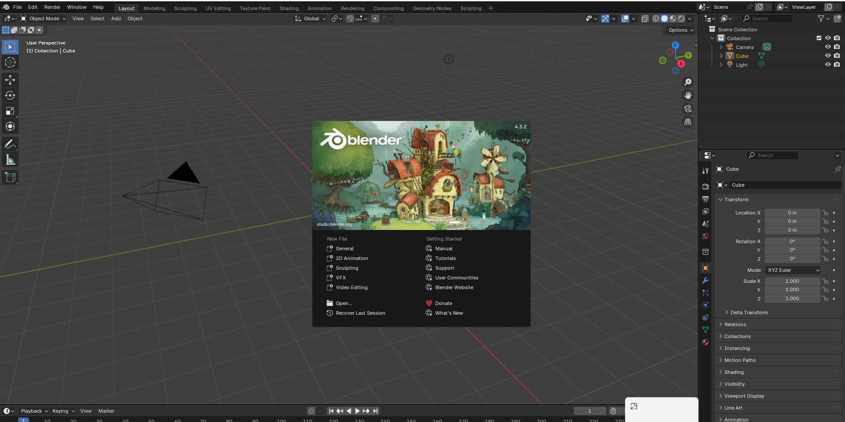

After we do first time set up, you'll get this screen every time you open blender.

But if you open it first time after installation( or of you are opening the blender for the first time in your pc no previous version was installed before ) then you see something like below.

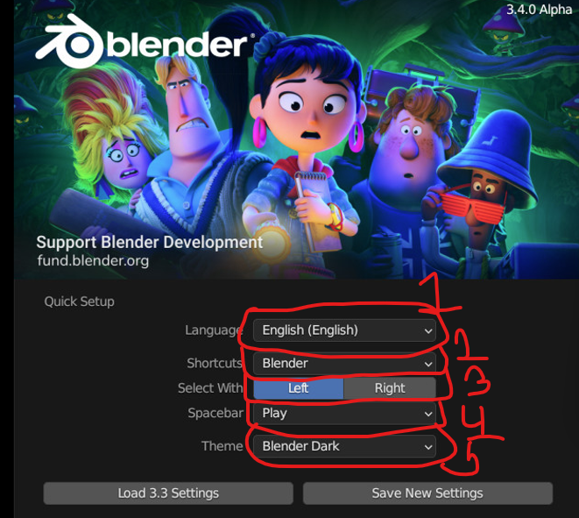

This is the quick setup screen, if you had a previous version of Blender installed onto the same machine as of the 3.0 update, you can come down here where it says load 3.3 settings and click that and it will load all of your preferences from the previous version.

**Note:-**

Maybe it does not show anymore now but for future it may show so I will still study it. Maybe I have seen it I don’t know why it is not showing after reinstalling blender but I think it may shown sometimes whenever we open a new project here

Presuming you wish to keep them the same.

If you are installing browser for the first time then the two option Load 3.3 Setting to Save new setting may not be given at all.

Marked 1

For language it is English

1:40

Marked 2

In shortcut whatever option we choose is the platform we are switching from and to the blender

So our blender has enabled support from another platform like Maya so that they don’t have to learn new key shortcuts whihch can be very difficult

I think by this the shortcut key you used to do for a work in different platform you can use that same key for that same work in blender

Teacher don’t think that Maya has any support for quickly enabling blender shortcut and last tie Techer tries to manually set up blender style shortcut in Maya Teacher was unable to because they do not allow certain function to be bound to another different keys in the default which is another good think about another source software like Blender it tends to be lot more configurable than company support software

However the tradeoff for that id often the open source is slightly less user friendly

But as mentioned by the teacher in the last lesson that Blender had a major update a few years ago and now it is much more user friendly than it used to be

Techer is assuming that somepne taking this course is not coming from another 3d modelling problem but is doing this for the first time so we are going to keep the default blender shortcuts   
Next up is select with that is marked 3

Now this is referring to when you want to select something whether you use the left or right mouse button

Right click was chosen as selection click in the version 2.42.5 Teacher don’t know why they did that but to change it we did not have the opening window you see now which is shown first time when in the blender opens(maybe) They sort of had to navigate down several submenu to find it

But if you are a person who do this and coming from very old version then they still have that option for you

But According to Teacher luckily Blender now defaults to select with the left click (who knows)

So the next setting is what function do we want to have bound to the spacebar on our keyboard.

Default is play which is geared to wards animation setup but he find it more useful to bind it to search because often times you need to use a specific operation that Blender has But maybe it’s not one you use over and over, so you will forget what menu its under Or and this happened to teacher quite a number of times you will need to use an operation and you did know where it was located, but you updated Blender to new version and they moved some of menu and things around

In this case it is extremely helpful to be able to just hit the spacebar and search for the function you need so click on search

Them (marked 5) This is really upto you

It's purely cosmetic.

All it will do is change the color of things like the background, the menus and outlines.

**Fun fact(or may be teacher myth (who knows)):-**

In darker program less Power is used because Monitors are emitting less light from your monitor.

You can change the theme later if you want

Click on Save new settings

So there’s couple more things that we need to go over regarding settings and preferences before we can really get started

So the first think that we need to discuss is the mouse and keyboard setup now

In order to use Blender or really any other 3d software

You need to have three button button just to clarify what teacher mean by that

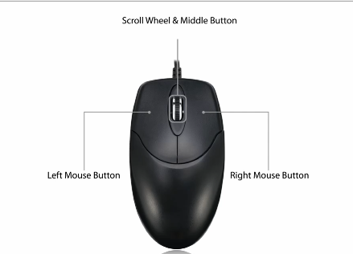

So three button that has the left click, right click and the middle mouse scroll wheel

The middle scroll wheel is very important and navigating around in 3D space really hinges on your ability to use this button So if you don’t have 3 button mouse you can get one

If you don’t have it then blender still have your back

Now if you go under edit and then to preference

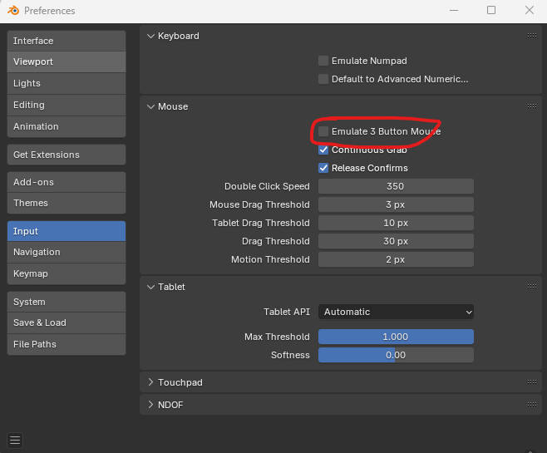

And now go to Input side tab

Now go to Mouse section and then to Emulate 3 button Mouse as marked above Check it to enable

Enabling this will allow you to use the same function that the scroll wheel provides by holding ALT and using the left mouse click

This might be an option if you are using something like a trackpad (who knows) you can still simulate that

Teacher don’t usually recommend it because it’s just much more difficult to use with the trackpad and laptop in general just aren't powerful enough to run programs like this at a high level.

**Note:-**

I think by this we will simulate the behaviour of middle click

You can get by in the beginning for sure on a laptop, and if you are just kind of trying this out to

see if you like it and are you have the laptop, you will be totally fine in the beginning.

But there comes a point pretty early on really where you will hit a performance wall and it will be trying too model something that is too complex for the machine and you’ll get frame drops and lags that make the program unusable, but cross that bridge if and when you come to it.(wtf)

So in the next setting Teacher want to discuss is the Numpad and the Number as shown below

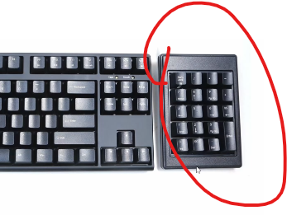

It Is very critical in Blender as we are going to see more in future lesson

But if your keyboard does not have Numpad then that’s still okay

Just make sure in that same input side tab

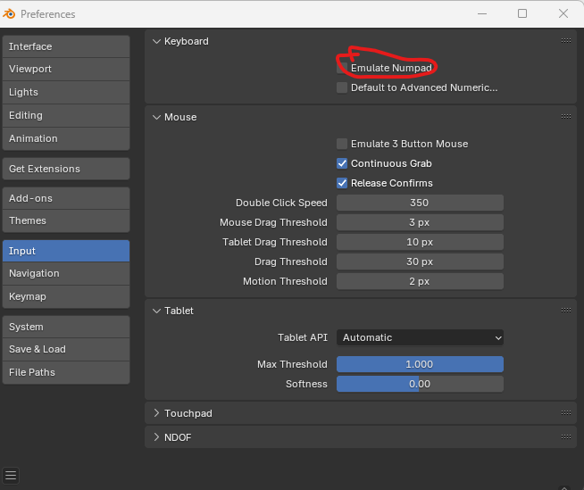

Then you are going to want to check the emulate Numpad as marked above

This will rebind all those functions that are normally on the numpad to that top row of number key

For teacher it is on because teacher don’t have numpad in its keyboard

Any of these keybinds (shortcut key to which a feature is bind) can be changed by navigating to the keymap side tab under the preference window

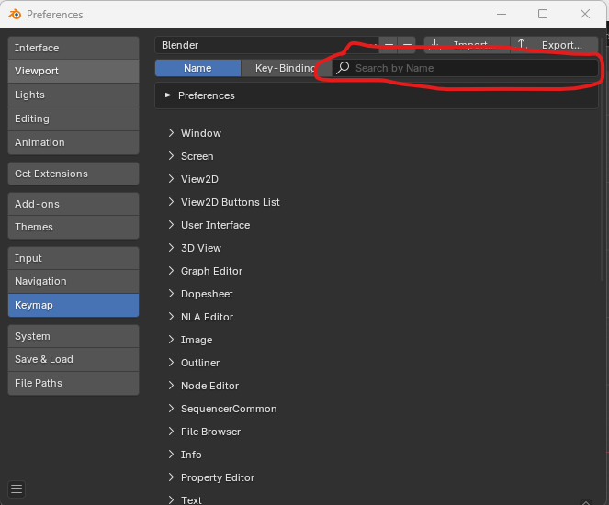

Select the category and simply changing the binding there

You can also search for the function by name or by the key that it is currently bound to and change it that way

We are not going to be changing any of these

We just leave them all of at the default Teacher just want to show you where you could do that if you needed to

The last thing The teacher want to discuss are adds ons.

Add ons are essentially plugins for Blender than can extend the program functionality

Blender comes with a whole slew of add ons that are installed into the program, but not enabled by default.

So for that go to addons side tab

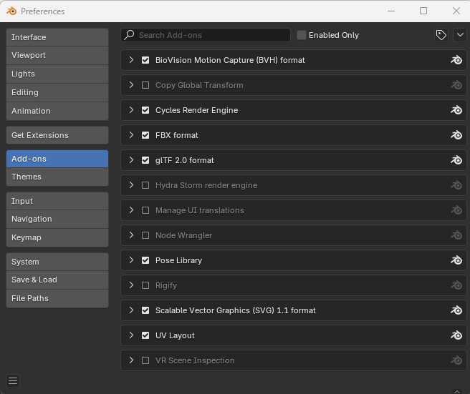

So all of these are add ons that come with Blender to enable any of these add ons click the checkmark next to it and to diable uncheck it

It is showing addons less in number as compared to Teacher may be because the add ons tht were on teacher time are now pat of the blender by default and they cannot be disabled now

(who knows)

A lot of these are enabled by default, such as these import export options as shown below(from Teacher addons list )

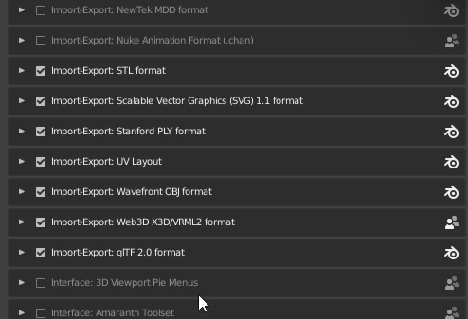

10:35

(ATT)

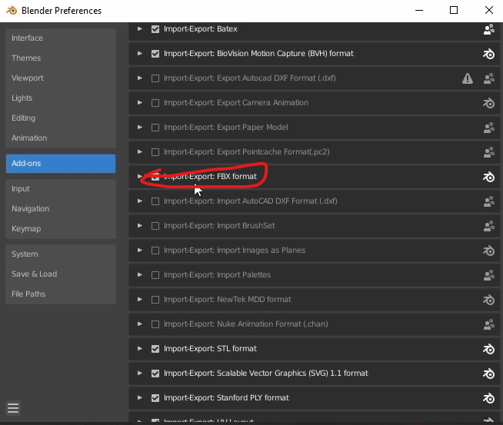

For example that the above marked one

this import export format is there by default, and this allows you to export your models

into this file format, which is standard for sharing across other programs such as Unreal Engine Unity,

Any of these add ons that are enabled to begin with, teacher would leave on because if you disable something

by default down the line, maybe you're trying to, for example, export and fix and the menu option

just won't be there.

And when you Google it, you probably won't find very many answers because nobody has really had this

problem because it's on by default.

But in addition to the ones that are on by default, there’s a few that Teacher highly recommend you enable that is **Mesh LoopTools** (TT(Teachers Time))

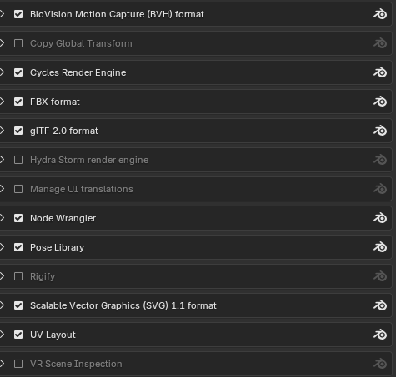

And second is **Node: Node Wrangler** In my time it is Node Wrangler

We will cover more of these in future lessons (TT)

For now just make sure these check boxes are enabled

Another is UV TextTools(TT) but this one does

not come packaged with Blender. we are gonna have to download it

So but its going really very simple We won’t be using it right away, but we will eventually and we are going to want some more tools when we come to the texture portion of the course And this is a good way to demonstrate just how to add plugins that are not included in Blender

So it proves that we can add extra plugins by downloading and including it in Blender

As the teacher said in in previous lesson that Blender is an open source which means among any other things that anyone is able to write plugins for it

The code is not proprietary so no company control that plugins are written for it

There are a lot of really great plugins available online that extend blender functionality in some pretty substantial ways.

That being said, of course, because it's totally open there, there's no real support or helpdesk of any kind.

Should you have any issue with one of these outside plugins

And as always be carefull of what you download off of the Internet, make sure the source is legitimate

So inorder to get this UI text tool add on we are going to open a browser and we are just going to Google blender texttools

So the first page you will see is a Github page

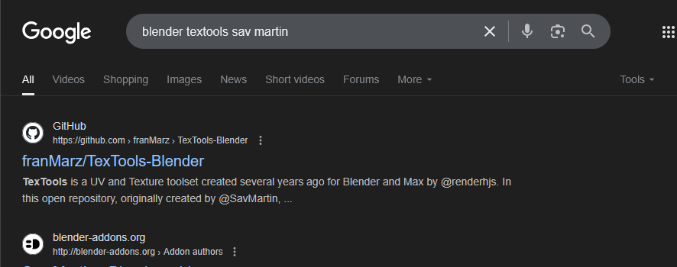

Open the first link

And what GitHub is, if you've never seen it before, is basically it's just an online location where

people can upload source code for applications and plugins such as this one.

You don’t need to login or sign up or anything to access these files

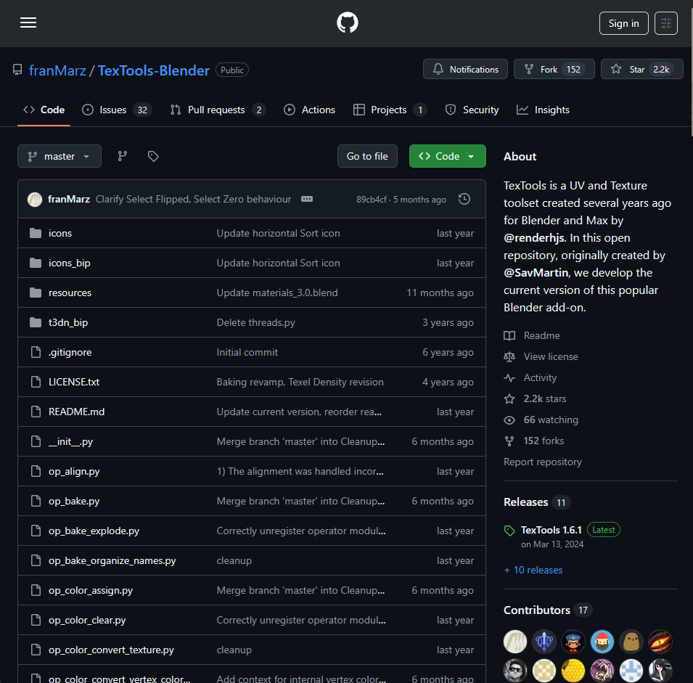

Now we go to bottom

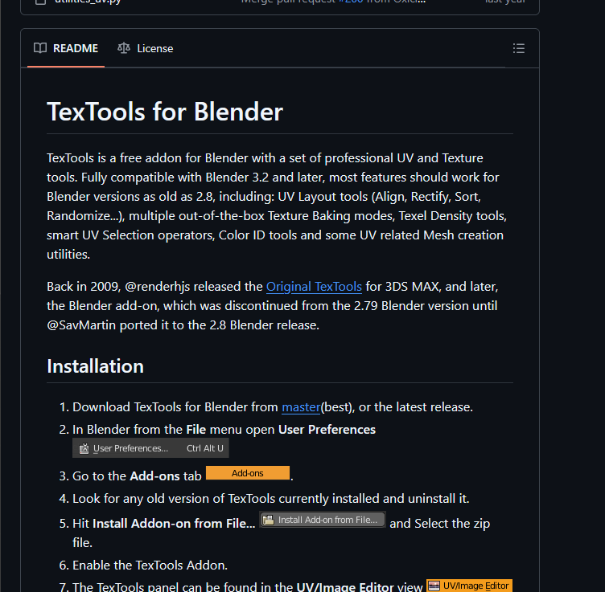

there's a little read me file which just explains a little bit more about the functionality

of of text tools.

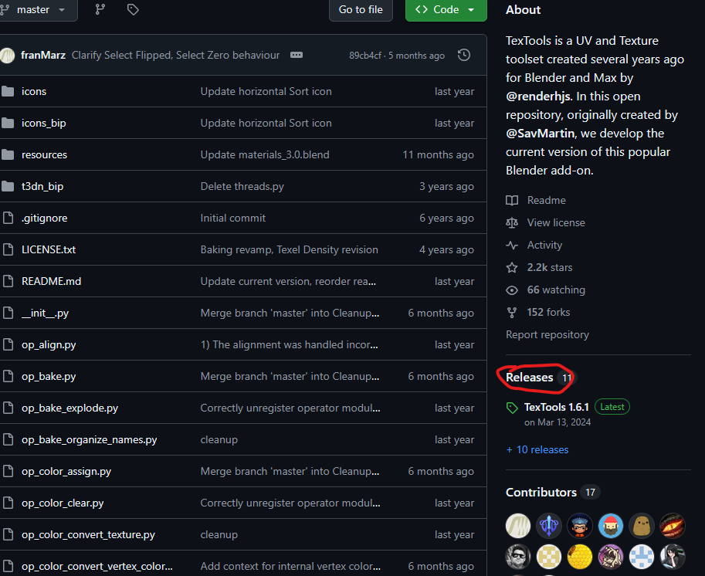

Now we again go to top and then click on releases as marked above

Underneath there is a link that says TextTools 1.6.1

Now, depending on when you were watching this, this version may be different, but that's okay.

Just click whatever version says latest.

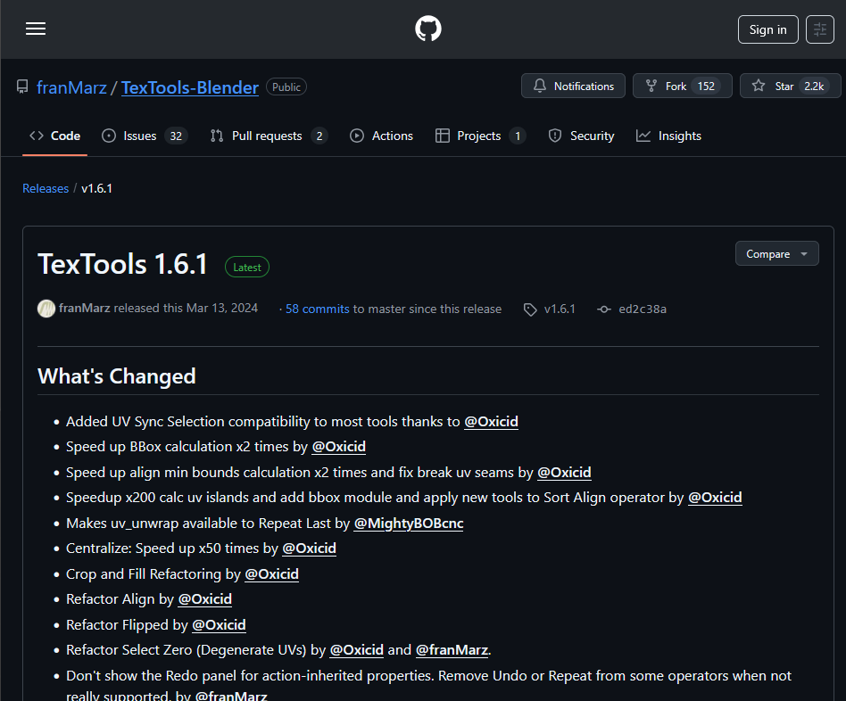

Now you will be reached above

And this is just basically a list of everything that's been updated since the last version of text tools.

So scroll down the bottom here where it says assets

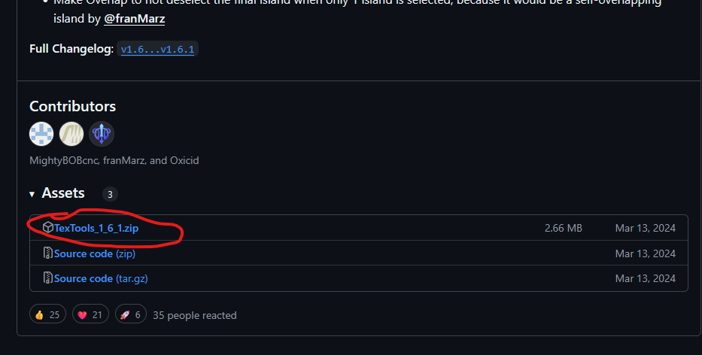

Now we will click on the marked above to download the zip file and once it is downloaded we want to go to the file location( where the file is downloaded ) we are actually not going to unzip this

You can certainly leave it in the downloads folder if you wish because once blender has a copy of these files we won’t need this file anymore you could delete this zip file and then the plugin will still work

However, if you ever need to reinstall Blender for whatever reason, you would need to locate these

original files again and redownload them if they were deleted.

But there is no gurantee that the author of the plugin won’t have taken them down which would leave you without access to those plugins

So Teacher believe as of Blender 3.0, you do not have to reinstall add ons when you update, but I could be misremembering that either way.

So for our setup we will go to Blender install location

And before blender main folder teacher has added a folder named as Add-ons which Is basically backup for all plugins

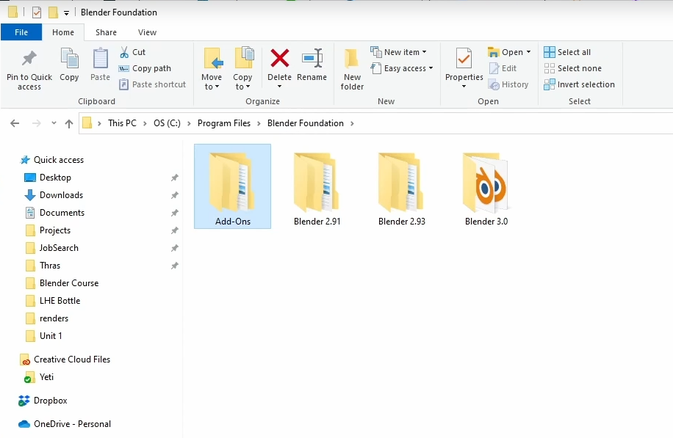

So back in Blender all you have to do to get any downloaded addon working is by

in the same preference window we are just in so go to addons side menu

go to top

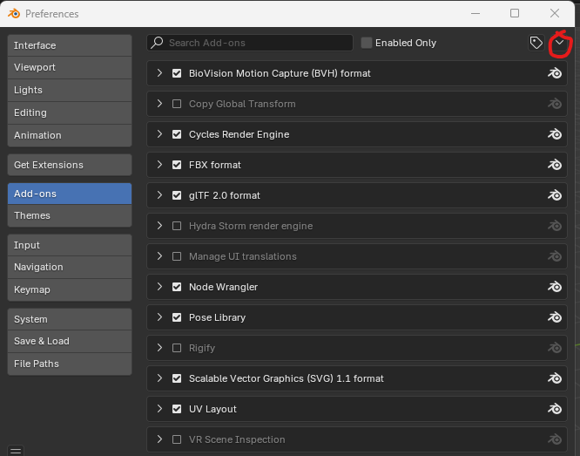

and then click on the marked above

and then in submenu go to Insert from disk

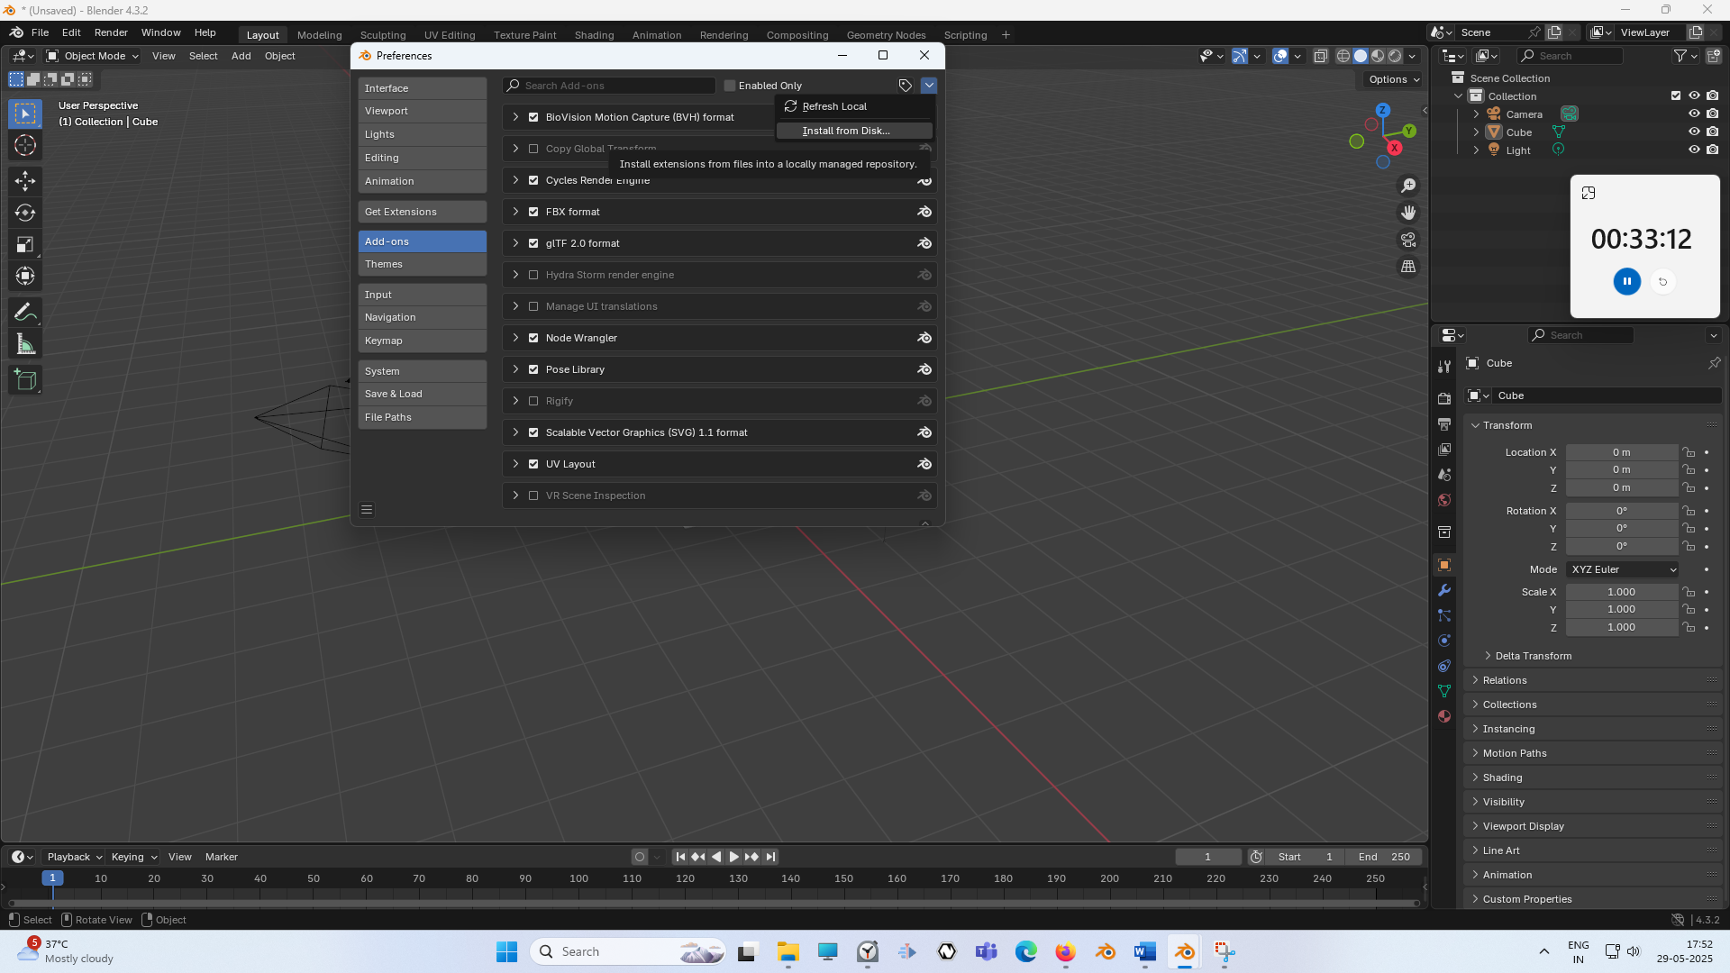

And now a file explorer will be opened and we need to navigate where my addon zip file is downloaded

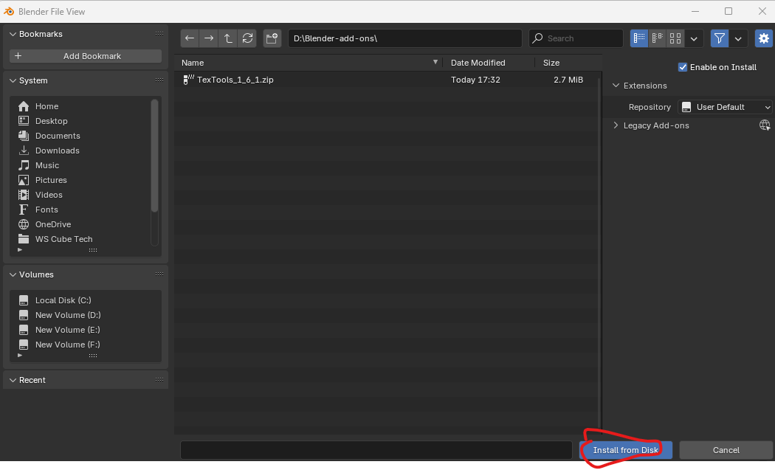Now select the addonzip file you want and then click on install from Disk as shown above

Now you can see the Text tool in the add on list as marked below

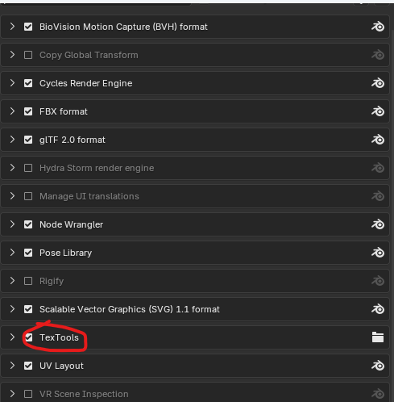

Previously it was named UV Texttools (Maybe) but now it is named as TextTools

Now scroll and check whether the UI Texttools is check if not then check to enable it

We are not going to use it in future lessons and teacher just wanted to show you how to add ons into Blender

Now that we have the program up and running, we have all of our preferences set.

And Now we are going to jump in and we are going to do it in next lesson