So now we have all the setup complete, we are ready to go in and start looking at the program

Now everytime you start a blemnder you will get this splash screen as marked below

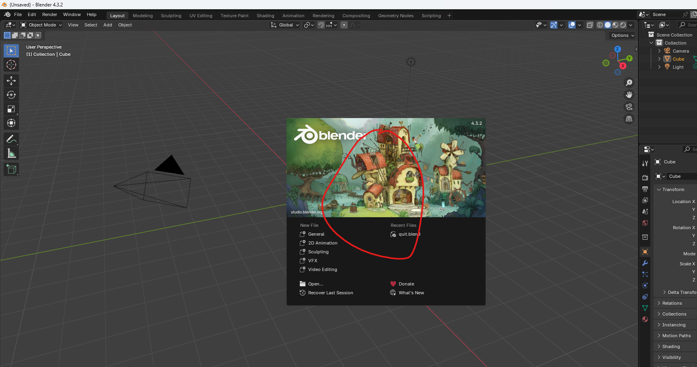

And if you have ever used Photoshop or something like that you will be familiar with this sort of start ( who know I think he I talking about the top window of every untitled project photoshop that shoes option of new project, open project ) 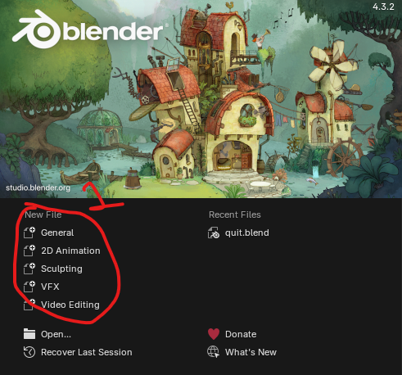

Now the left side is How you create a new file and the right side will have any recently opened files that you may have

You will have marked 1 for the template for the project that you want to create

Teacher always choose general because it will have every workspace the we need loaded into it by default ( maybe general is used for all the purposes and maybe workspace can be divided into many subtypes each serving a particular purpose ) and we will cover what workspaces are in just a moment here

0:35

So you can create a new file from some of these templates if you want to check them out or if you just click off the splash window

Bender already has a new general Blender file loaded up

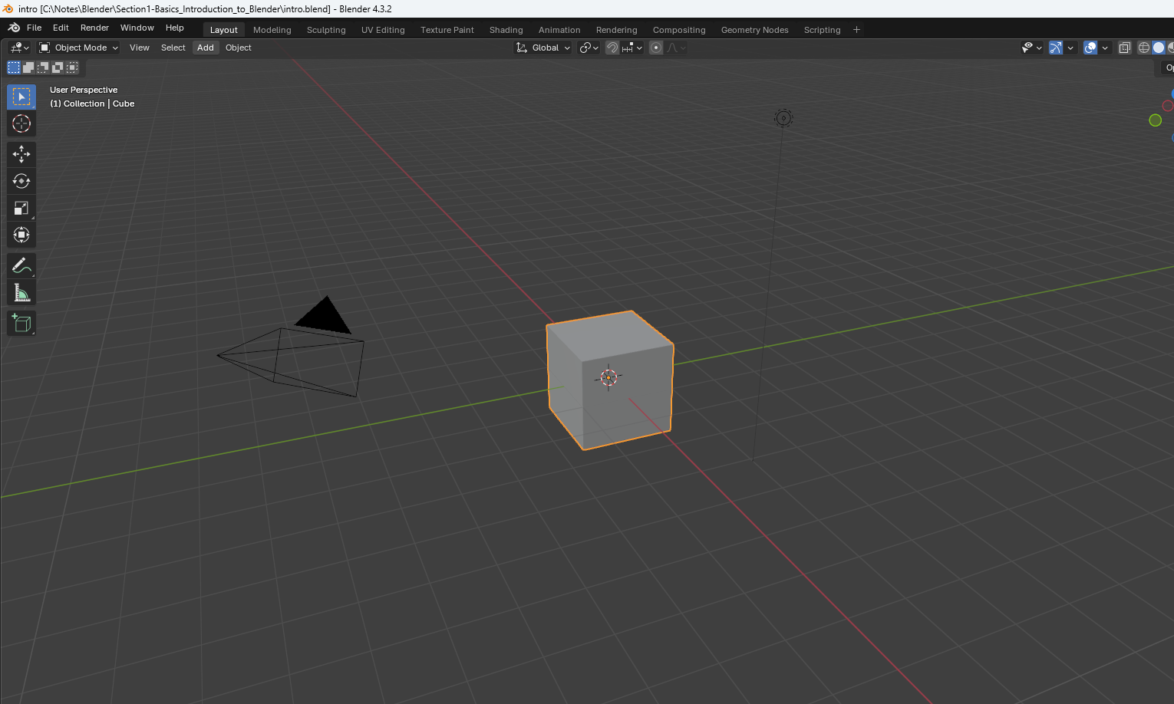

Now teacher knows that UI can be overwhelming if you are not used to it. Blender is a program that has lot of capabilities, so along with that comes sort of a busy screen.

We will not be using this right away. This is after all a basic course

Now teacher is going to go over this interface a bit quickly as an overview at first and we will comeback and revisits these things when they will be more relevant

This will be just to familiarize yourself with some of these menus and things truly understand what is happening on the screen

We actually need to know a little bit of math And don't be afraid.

Teacher is going to keep this all very high level concepts stuff.

So lets break down this thing little. It is a 3D modelling Software.

What does that mean

We all know that we perceive reality in the three dimension which means that any object in the universe universe can have its position be described mathematically using a set of coordinates using an X, Y and Z axis

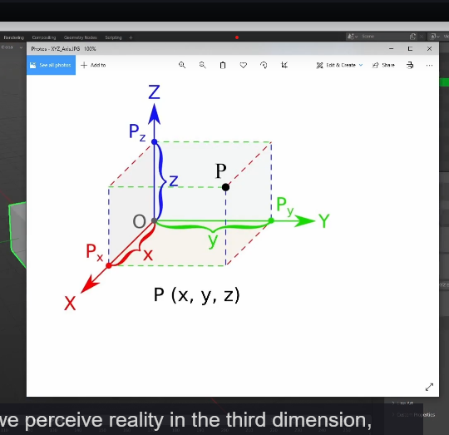

Blender X represents where the object is in the left and right direction

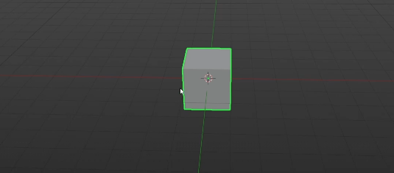

Y represents the forward and backward direction and z represents the up and down which we can see here drawn as the red, green and blue lines.

So what is 3d related to Computer graphics

The things we make in Blender, although they are 3d, they still need to be rendered or drawn onto a 2d screen in order for us to visualize it on the monitor here

So what a 3d modelling software does it give us the ability to create 3d objects that can be rendered onto a 2d screen in a way that allows us to perceive them as 3d by using the principle of perspective

Yes we are talking about the below

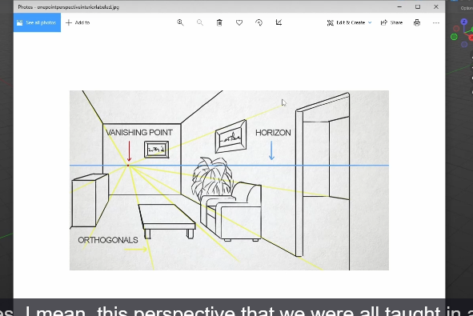

And yes, Teacher mean, this perspective that we were all taught in an opening art class, which teacher is not going to be covering in this, because this is a blender course, not an art fundamentals course.

There are tons of great free resources online.

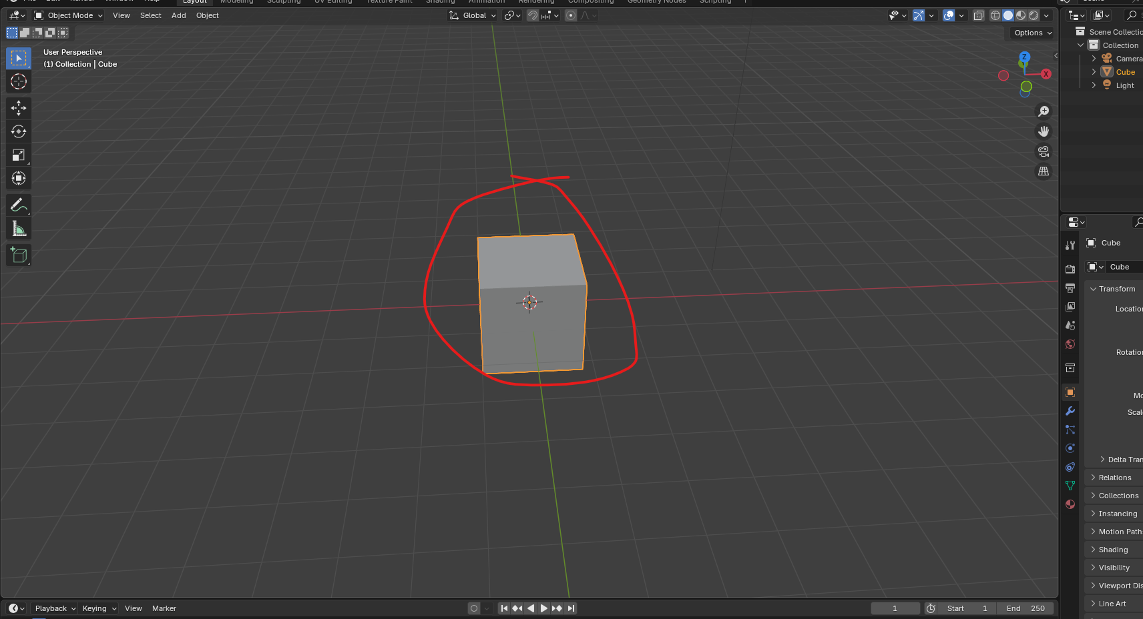

The marked view you are seeing is a 3d viewport which Is exactly what it is sounds like

It is a 3D view of the objects in our scene. The scene is simply how we describe the container for these objects and the space around it as represented. Y these grid lines

Here, the scene is essentially the blender file that we will create when we save this.

So Teacher may use the word scene and file here interchangeably. Every new Blender scene start with three objects in it that is a default Cube, a Camera and a light

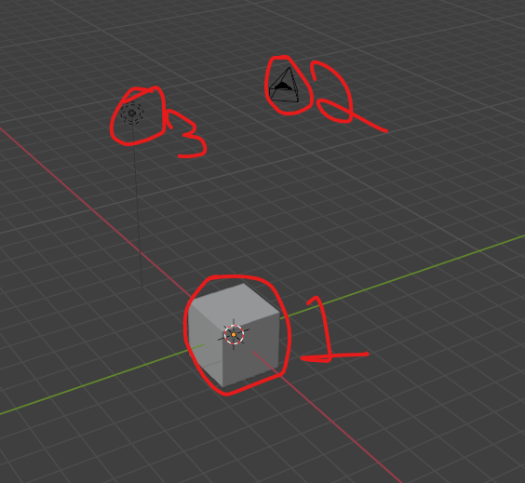

The marked 1 is cube and marked 2 is camera and marked 3 is light

We are going to get more into these objects types in future types in future lessons

Now there is a **popup panel** in the 3d viewport that you can access by hitting N on the keyboard

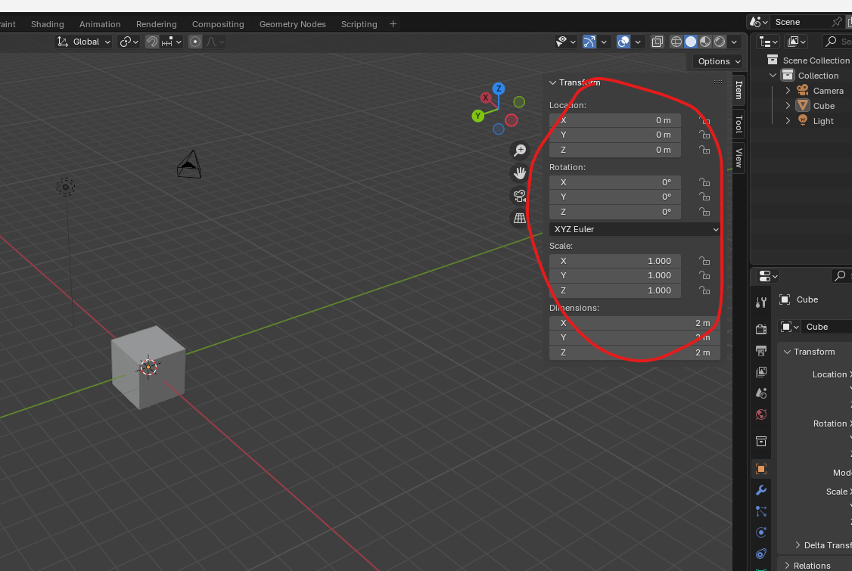

Or you can also open it by clicking on arrow pointing left as marked below

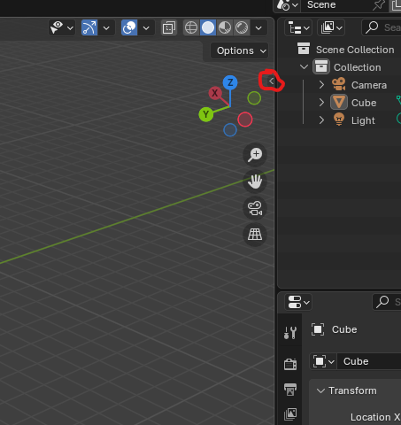

And you can close it by

The popup will be as marked above to pull up the sidebar or panel It can be easily accessed

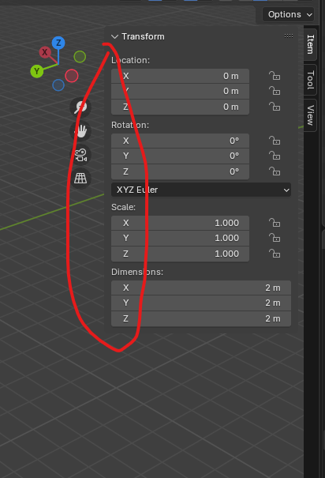

Now drag it from the edge and scale by dragging against the right side panels until it bome of 0 size in breadth

This will show you some information on the location, rotation and scale of the selected object under the item panel as msrked below

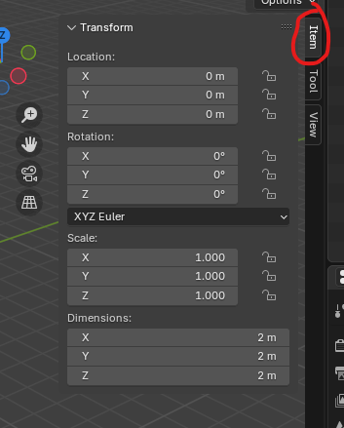

The tool tab’s active tool panel contains some options for your pointer( that is move ,scale, selection )

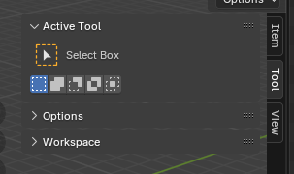

Which will also be shown on the top left of the screen as marked below for the selected pointer

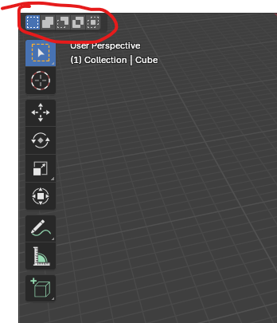

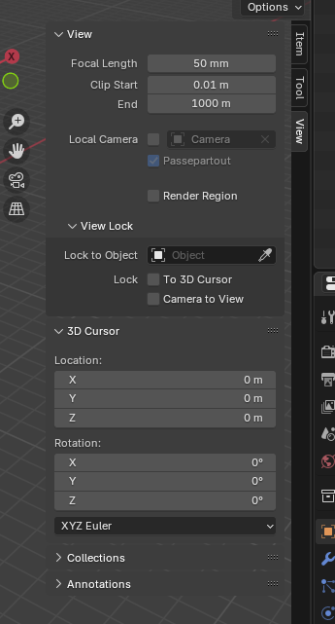

View tab has a few settings for the 3d viewport which we are not going to change at the moment

but we're going to. Go over it more later when it's more applicable.

These sidebar could contain tabs which exist because of the addons you enable.

The below shown tabs

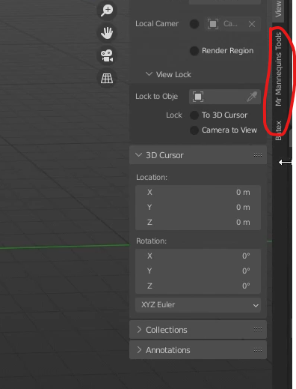

The above marked are the few here that Teacher use regularly, but we do not need them for this course.

Betex is a batch fbx exporter(I don’t know) and Mr. Manikins is this awesome plugin that loads in unreal engines default character models which is really just handy as a scale tool when you're building scenes for Unreal.  
You'll notice that the text tools add on. We downloaded and installed and the previous lesson is not here.

This is just it does not utilize the 3d viewport for any of its functionality so it lives inside another editor (maybe as a tab or a panel inside a tab (who knows) but by editor we mean modelling, UV, Sculpting )

If you press **t** key then it toggle on or off the toolbar on the right side as marked below

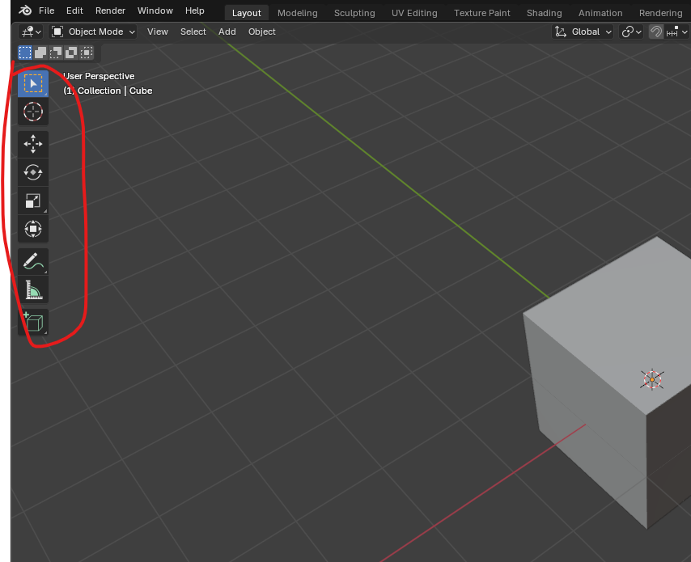

6:00