I have already bought my domain So
Tutorial link is
https://www.youtube.com/watch?v=kTfuZzuwczg

I will go to infinity free website
https://www.infinityfree.com/

Teacher has already tought how to host in 000webhost
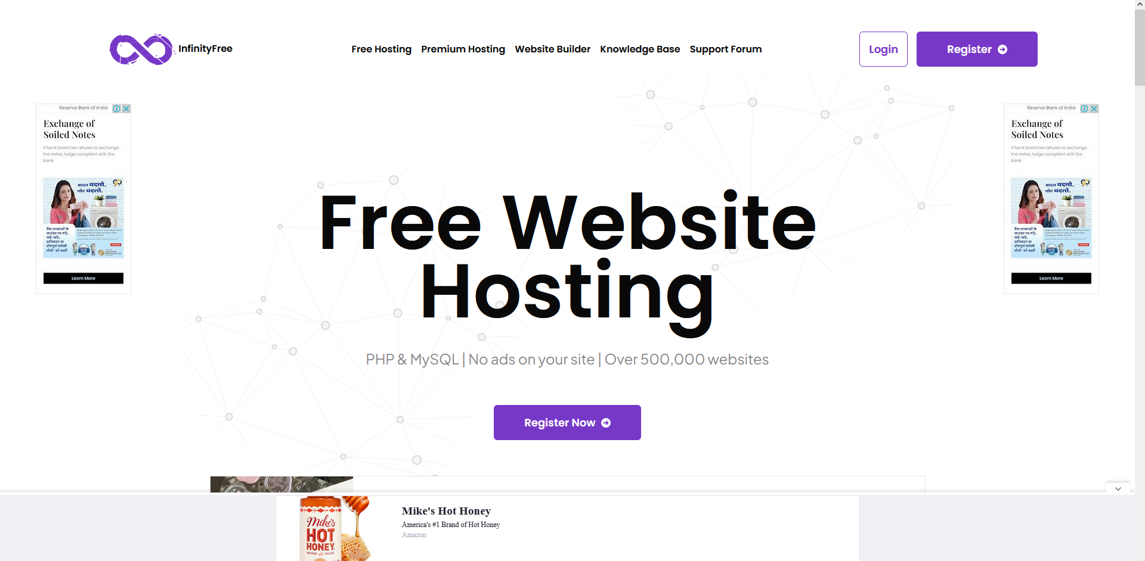
If you don't have an id here click on Register here
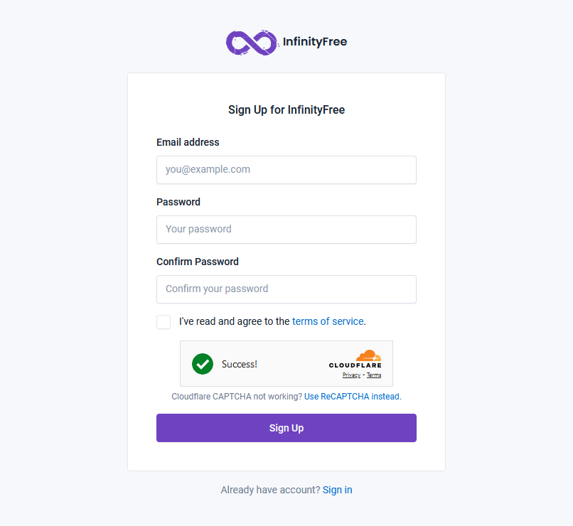
Now in new page you will see above interface you can create an account from above
In email address enter your email
aand rest is self explanatory
click on signup button
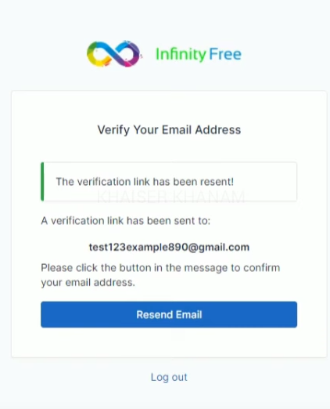
A verifiction link will be sent to your email you used in your signup
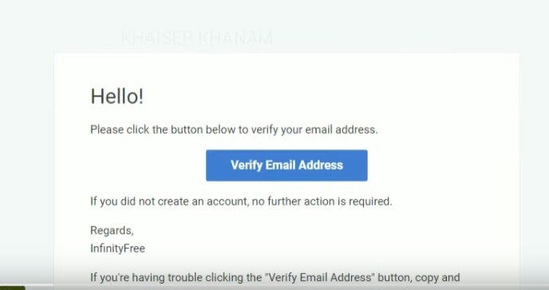
in your email click on verify email as shown above now you will be directed to our logged in account
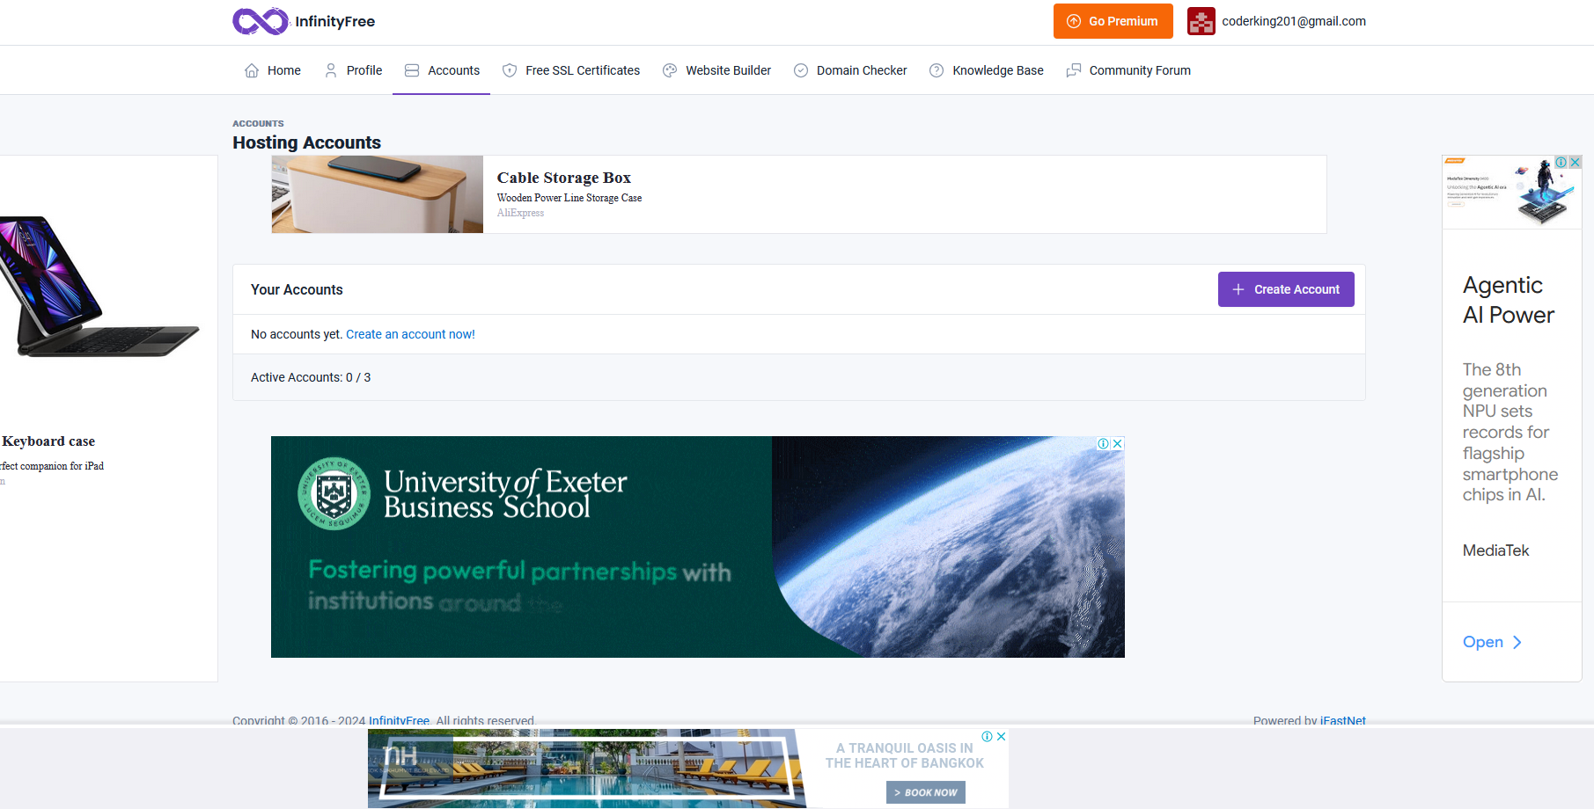
In above dashboard you can see Active account 0/3 means you can create 3 website here and you have not create none now
click on create account button
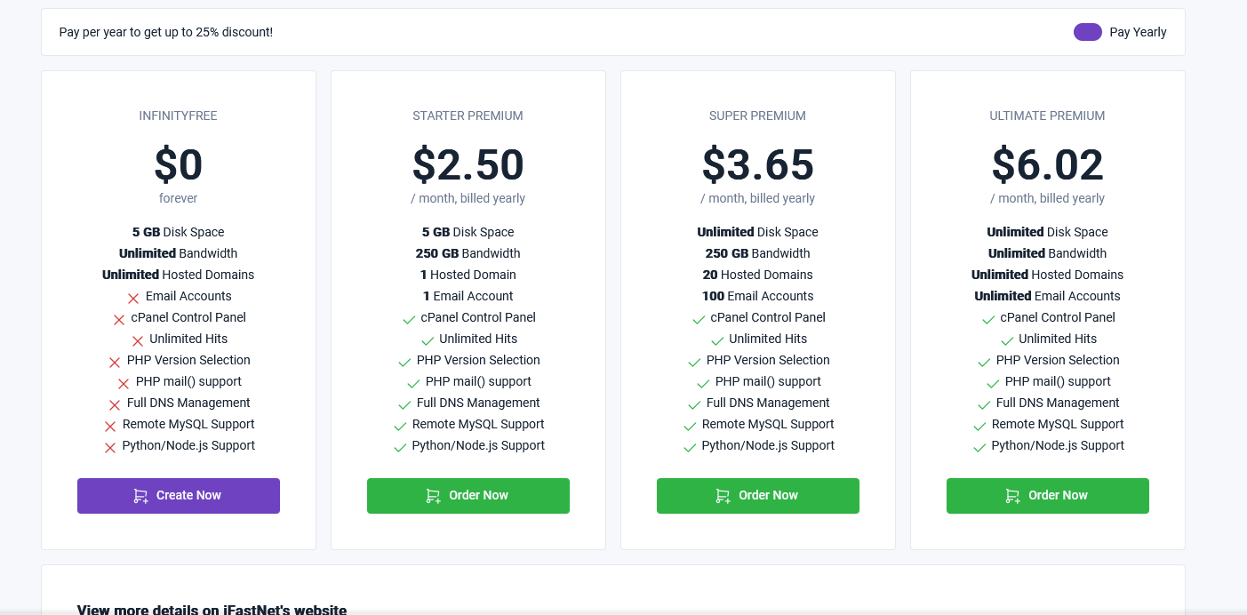
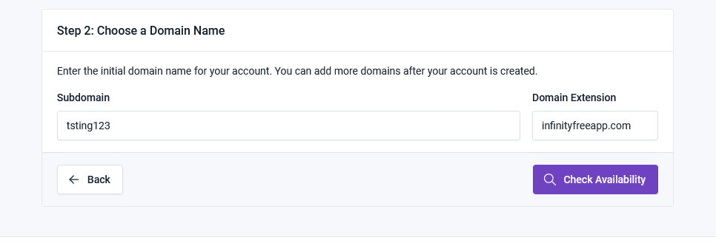
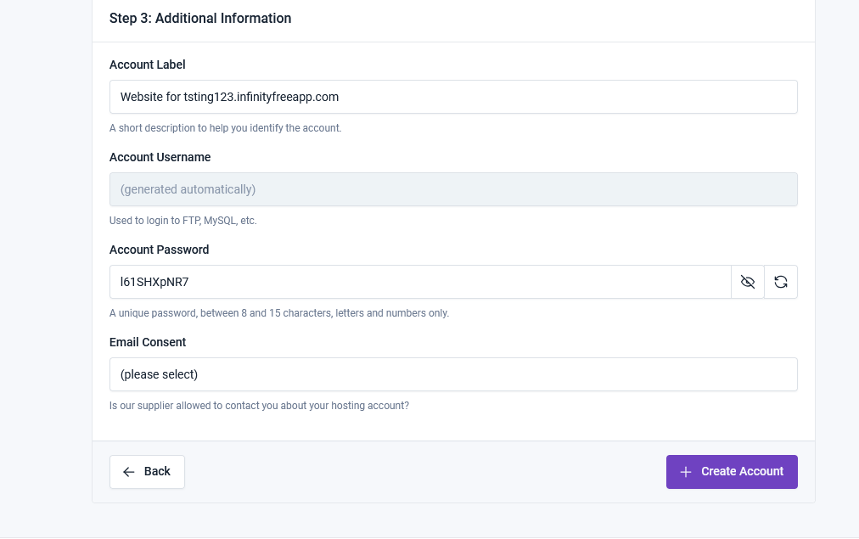
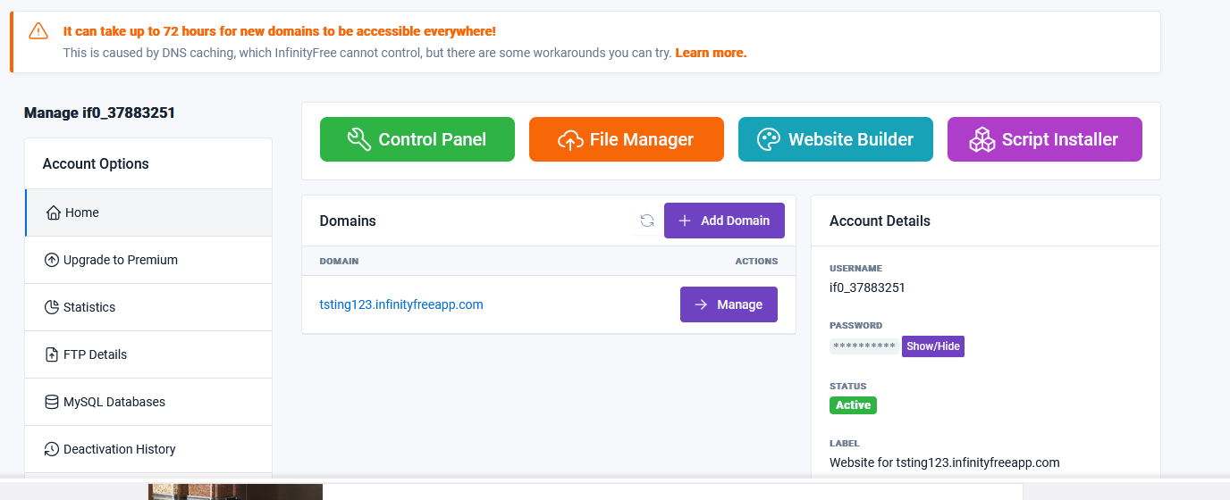

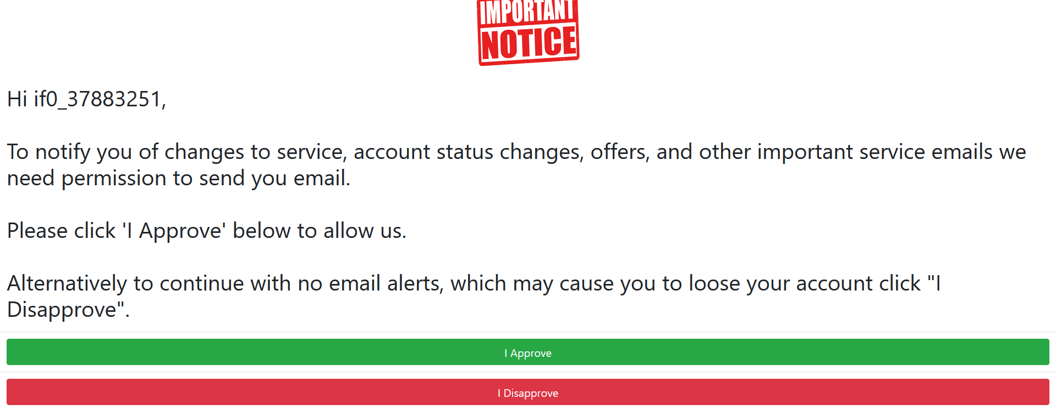
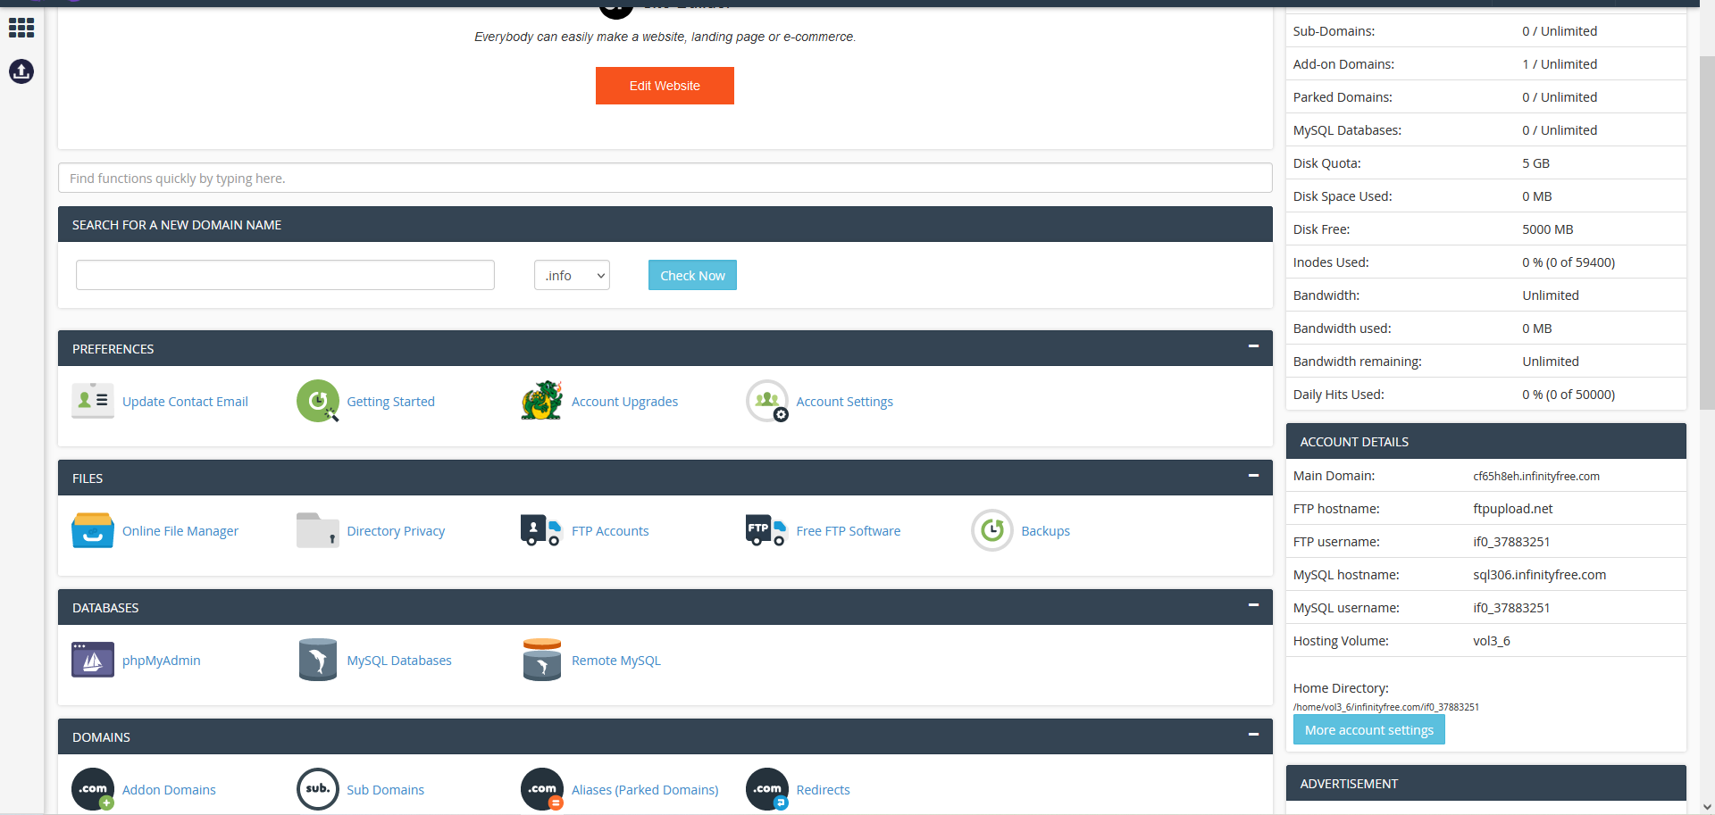

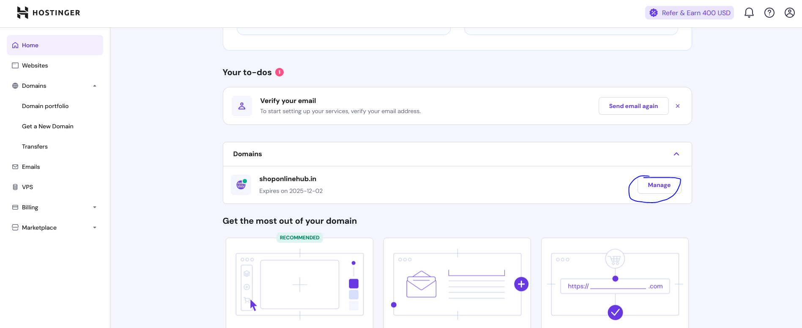

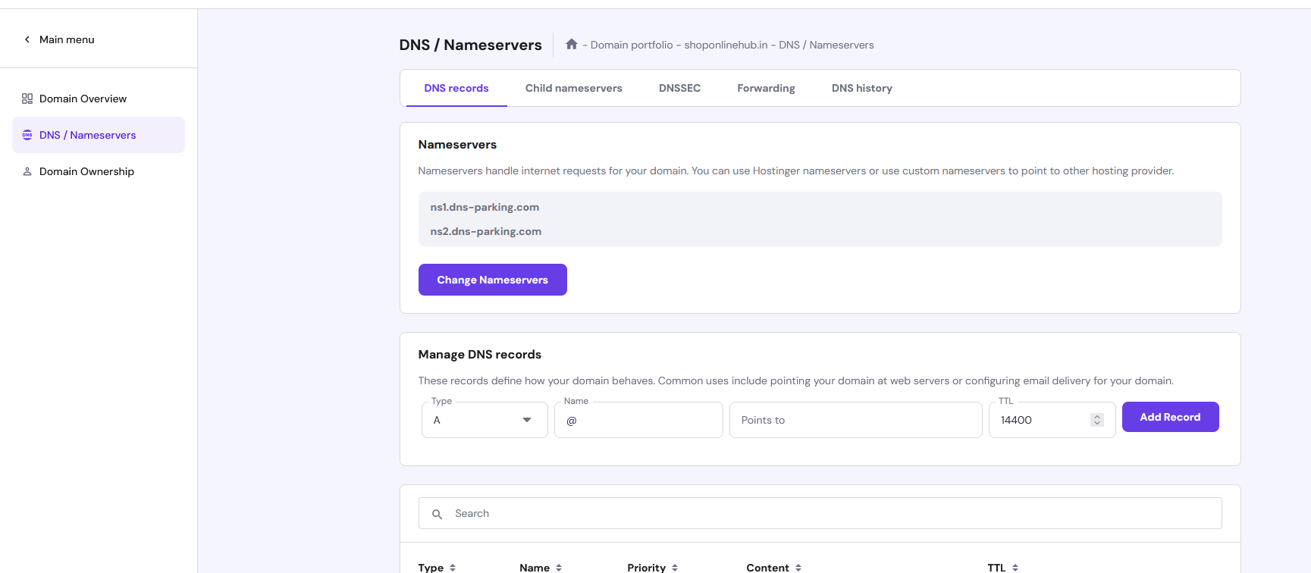

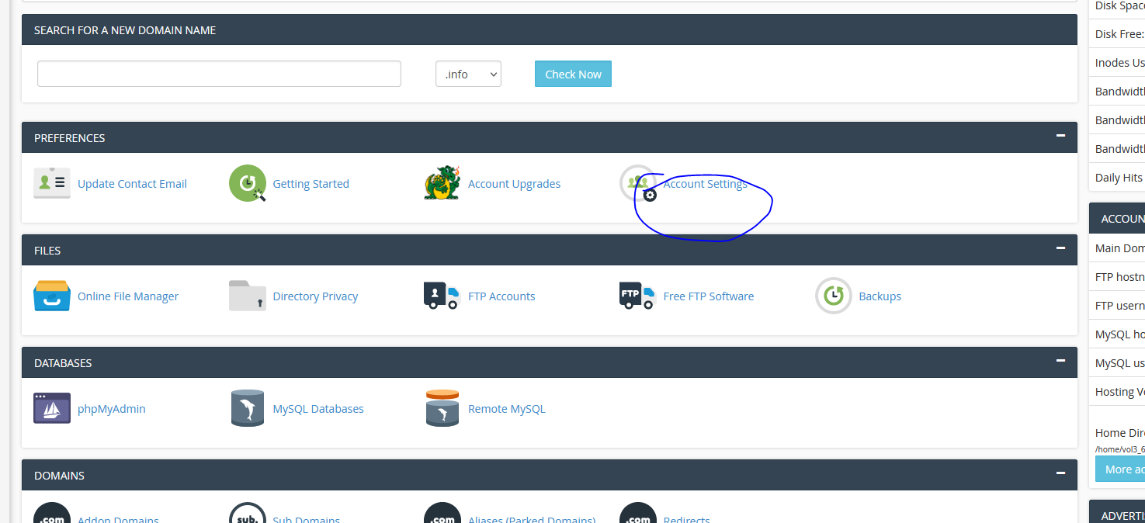

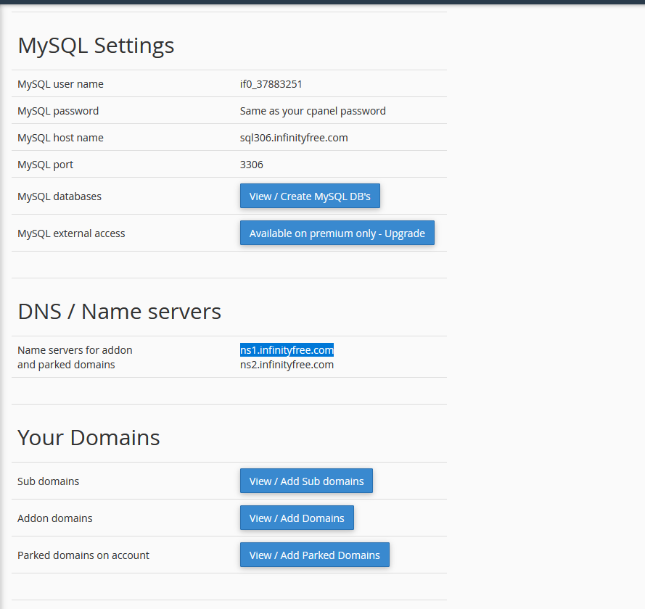
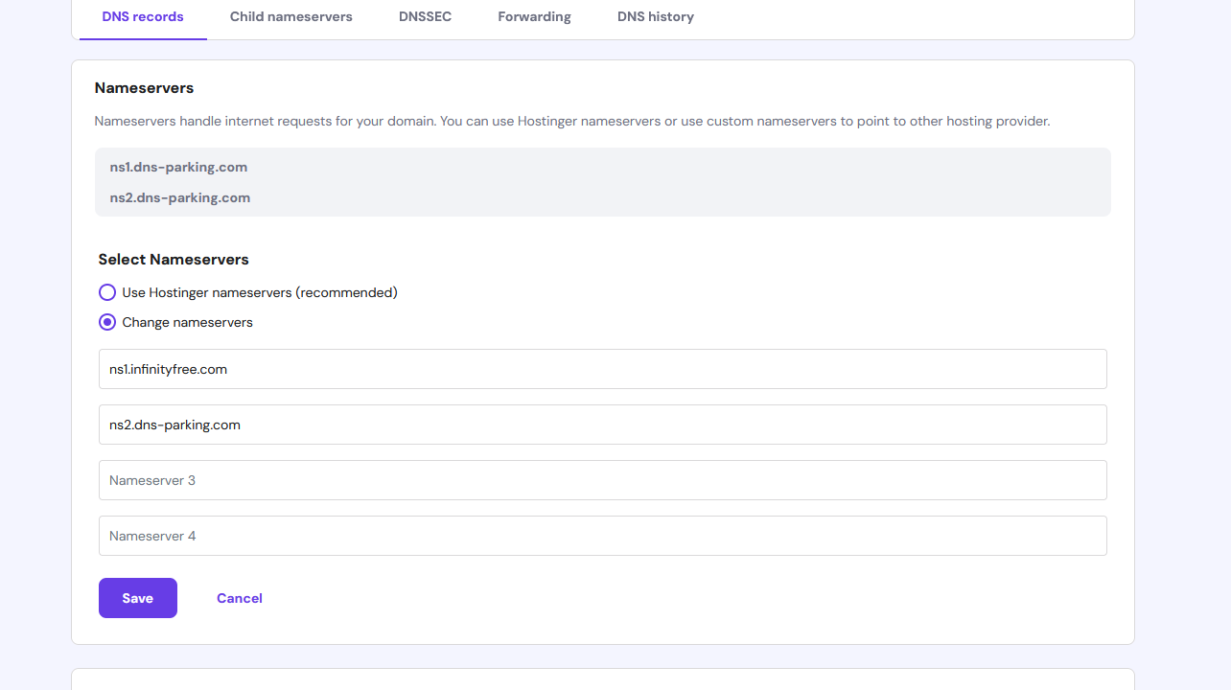
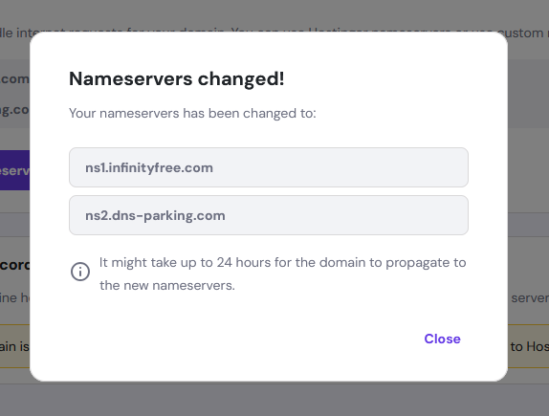

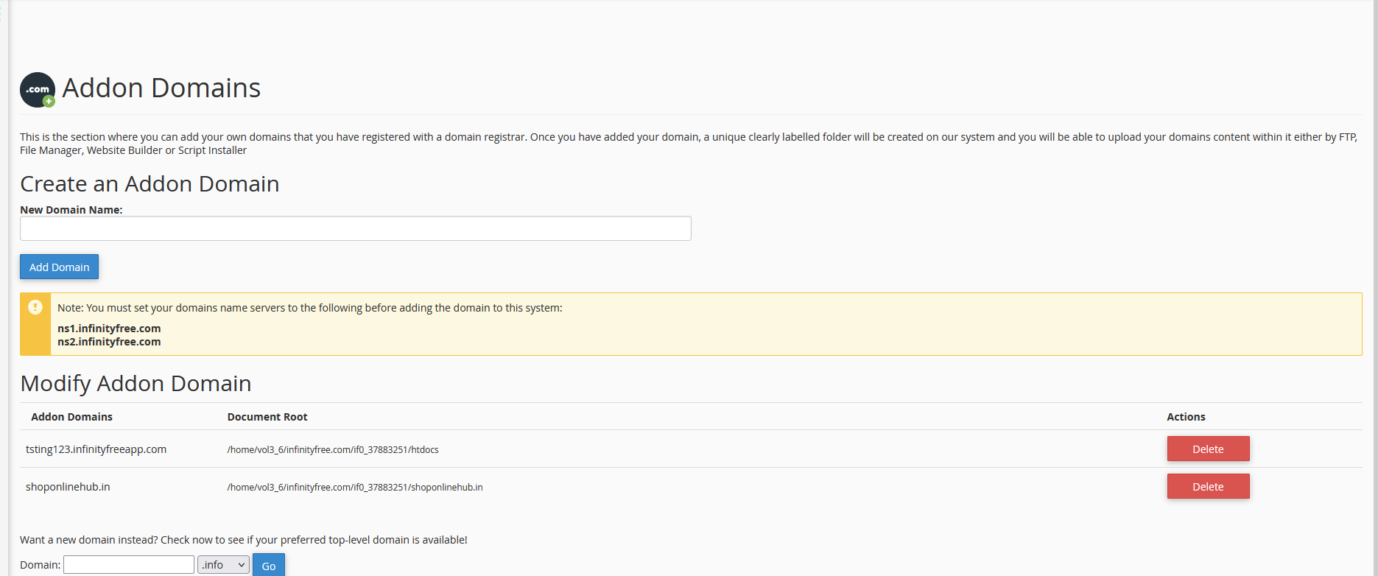

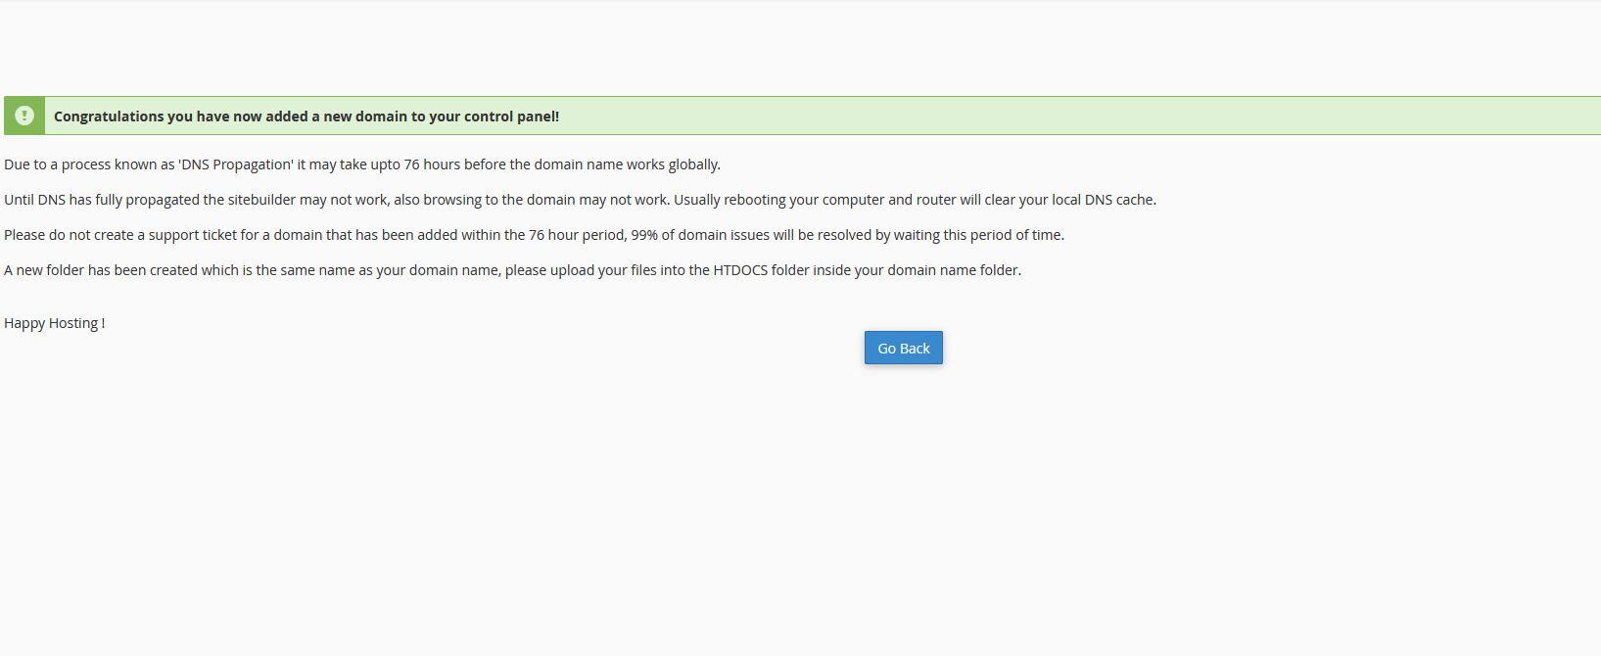
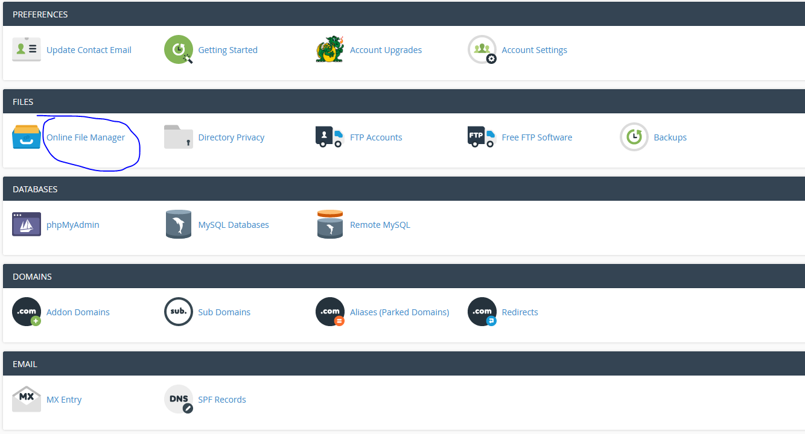
To connect a domain you purchased from Hostinger to your website hosted on InfinityFree, you'll need to update the domain's nameservers to point to InfinityFree's nameservers. Here's a step-by-step guide on how to do this:

Step 1: Get the InfinityFree Nameservers
- Log in to your InfinityFree account.
- Go to the 'Control Panel' for your hosting account.
- Find the nameservers assigned to your account. These are typically:
  - ns1.byet.org
  - ns2.byet.org
You can also find these in the InfinityFree control panel under the "Account Settings" or "Nameservers" section.

Step 2: Update the Nameservers on Hostinger
- Log in to your Hostinger account.
- Go to the 'Domains' section and click on 'Manage' next to the domain you want to connect.
- Find the 'DNS settings' or 'Nameservers' section. This may be under the "Advanced" or "DNS Zone Editor" section.
- Choose to use custom nameservers.
- Enter the InfinityFree nameservers (typically ns1.byet.org and ns2.byet.org).
- Save the changes.

Step 3: Wait for DNS Propagation
- After updating the nameservers, it can take anywhere from a few minutes to 48 hours for the changes to fully propagate across the internet.
- You can check the status using tools like DNS Checker to see if the nameserver update has been propagated globally.

Step 4: Add Your Domain to InfinityFree
- Log in to InfinityFree and go to the Control Panel.
- Under the Addon Domains section, add the domain you purchased from Hostinger.
  - Enter the domain name and make sure the document root is correct (the folder where your website files will be stored).
- Complete the setup to link your domain to your InfinityFree account.

Step 5: Upload Your Website Files
- You can now upload your website files via File Manager in InfinityFree's control panel or use FTP to upload them to the appropriate folder.
After DNS propagation is complete, your domain will point to your InfinityFree hosting, and your website will be live with the new domain!

what is name server

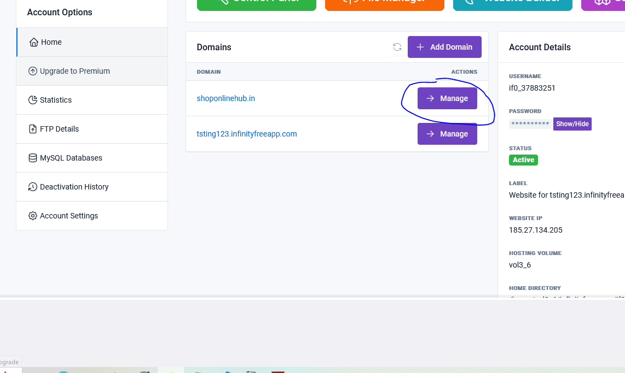

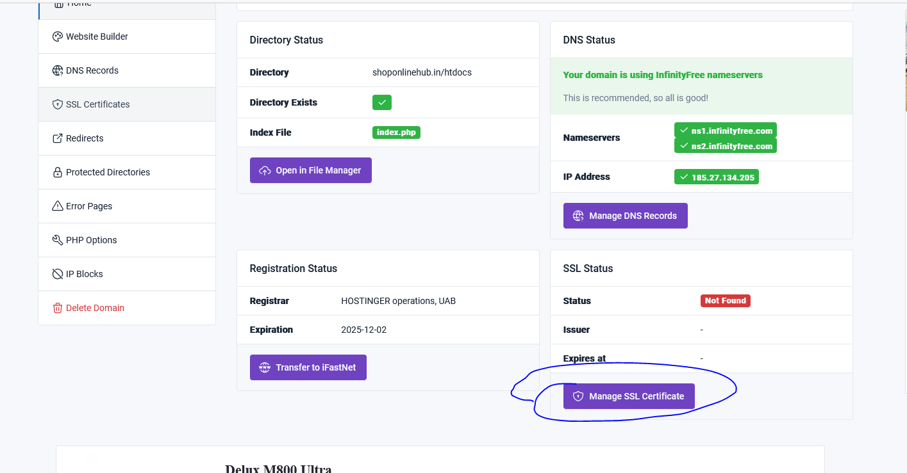

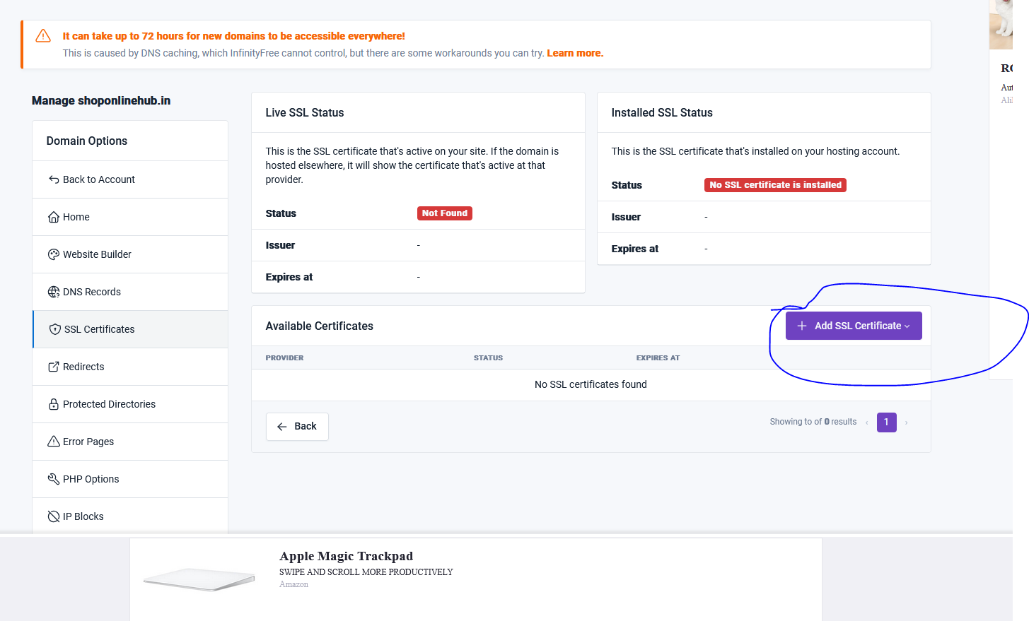

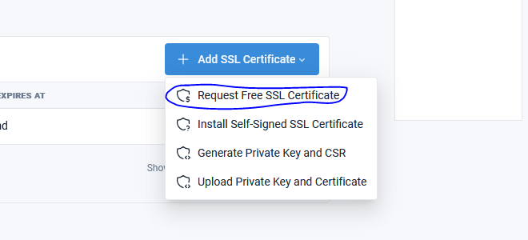

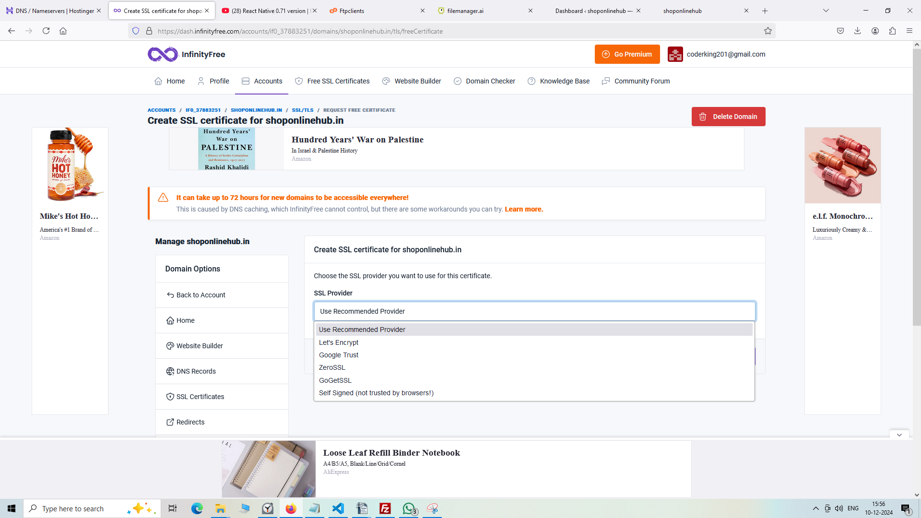

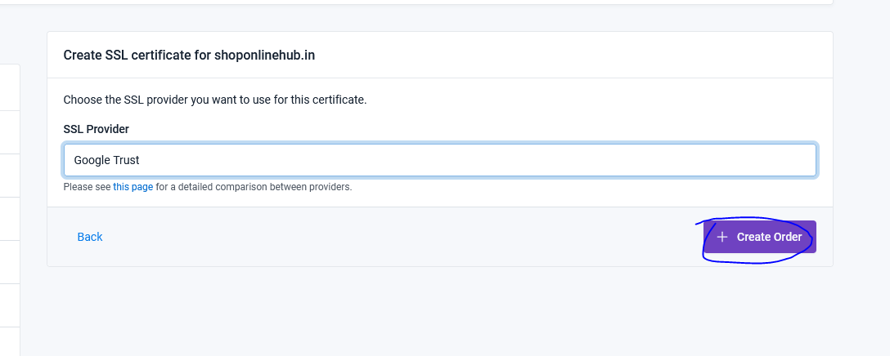

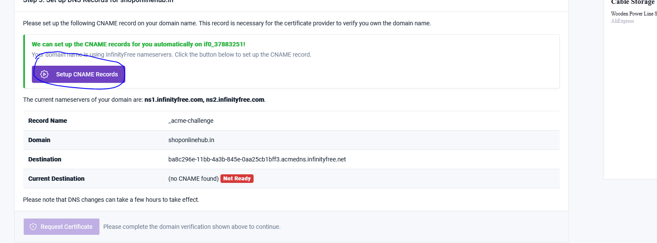

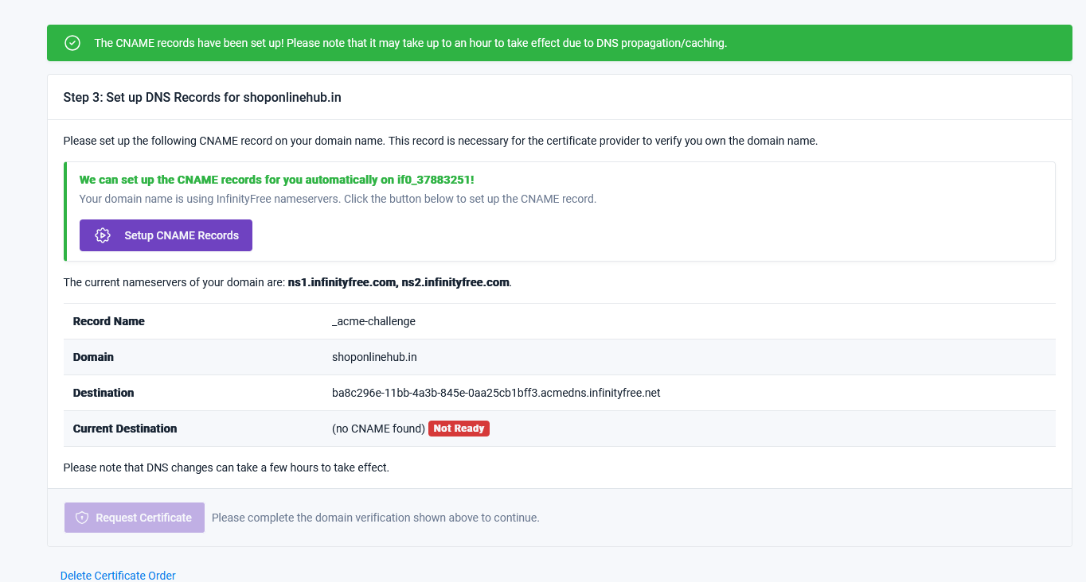
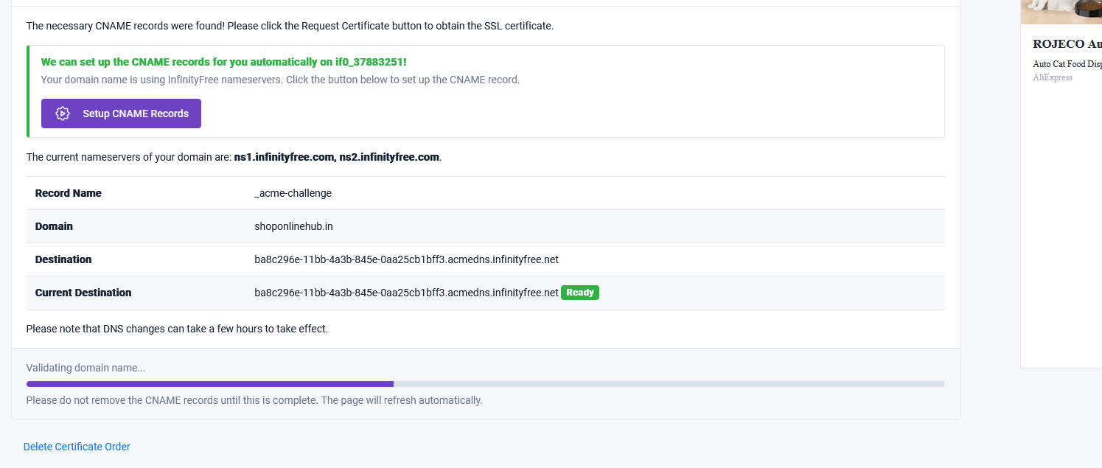

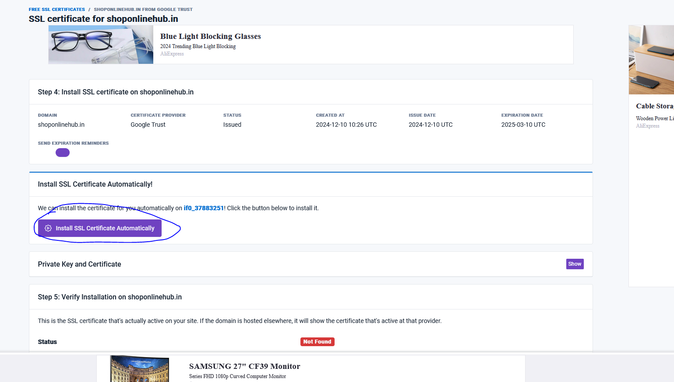

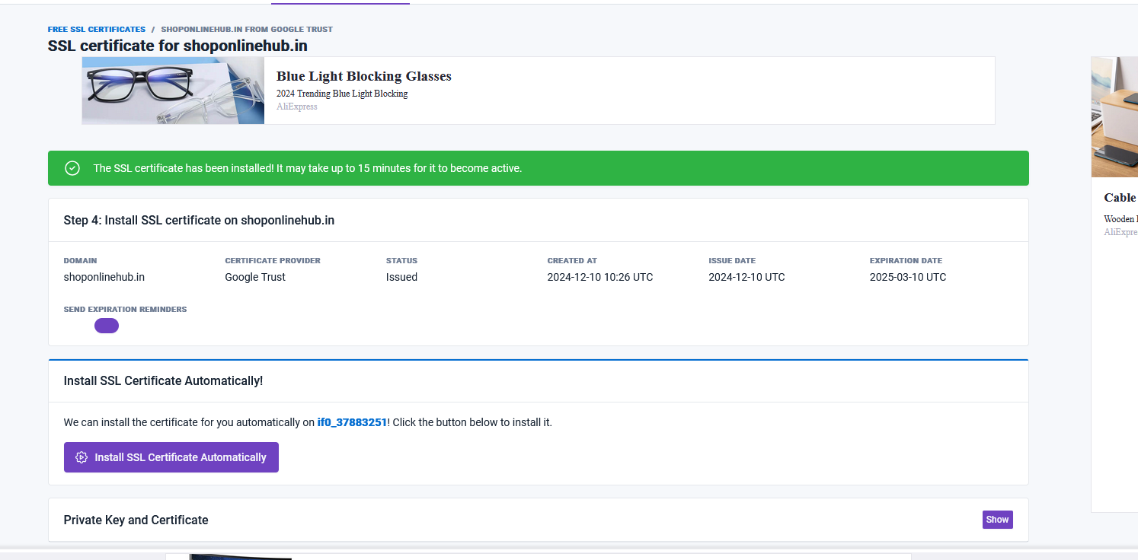

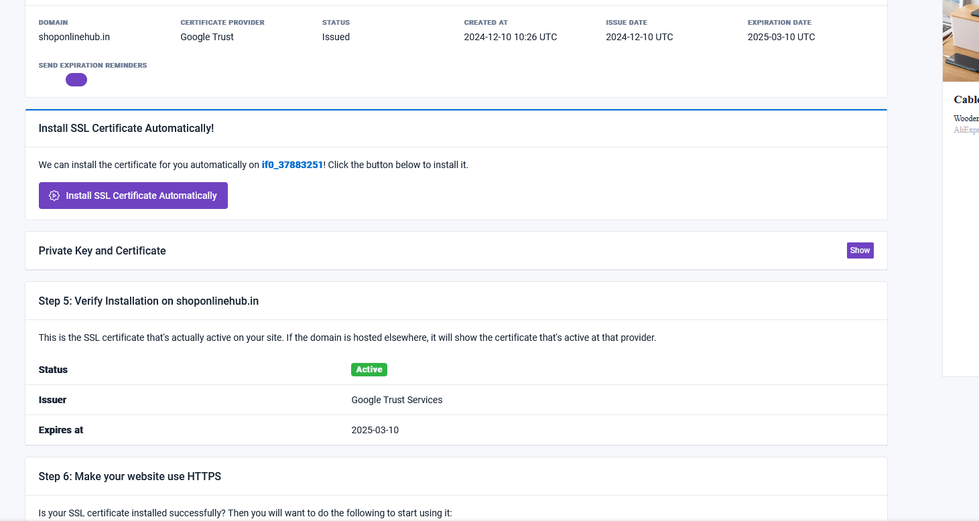

Here are a few free web hosting providers that support both PHP and Node.js:
- Glitch
  - PHP Support: No (but provides Node.js hosting)
  - Node.js Support: Yes
  - Description: Glitch is a platform mainly for Node.js projects, but it's highly flexible. It offers free hosting with live collaboration features. For Node.js, it's a great choice, but it does not natively support PHP.
- Vercel
  - PHP Support: No (primarily supports serverless functions in JavaScript, TypeScript, and Go)
  - Node.js Support: Yes
  - Description: Vercel is excellent for Node.js applications with serverless deployments and simple front-end hosting, but it does not have native PHP support.
- Render
  - PHP Support: Yes
  - Node.js Support: Yes
  - Description: Render offers free hosting for both Node.js and PHP applications. It supports databases, custom domains, and SSL for free on their hobby tier. A great choice if you want both PHP and Node.js on the same platform.
- InfinityFree
  - PHP Support: Yes
  - Node.js Support: No
  - Description: InfinityFree offers free hosting with unlimited bandwidth and storage, but it focuses mainly on PHP and MySQL. It doesn’t support Node.js natively.
- 000WebHost
  - PHP Support: Yes
  - Node.js Support: No
  - Description: 000WebHost is another free host focused on PHP with MySQL support. It’s a solid choice for small PHP websites, but it does not support Node.js.
- Heroku
  - PHP Support: Yes (via buildpacks)
  - Node.js Support: Yes
  - Description: Heroku allows you to deploy both PHP and Node.js apps. While it offers a free tier, it comes with limitations, such as automatic sleep after 30 minutes of inactivity. However, it's a great option for both PHP and Node.js hosting.

Recommendations:
- Render is the best option if you need both PHP and Node.js on the same platform.
- Heroku is also a solid choice if you're looking for more flexibility in deploying apps, including PHP and Node.js, with a robust free-tier offering.

