In this text file We will see how to host a website from your own country
that's right no paid hosting services are required , no complex setup process is required
you can actually can make your website go live from your home computer free of cost
and obviously since this website will be hosted by your local computer so your local computer must be turned on and connected to the Internet all day if you want to make your website be live all day
You might think that we may need a static ip address(I don't know) in order to make this work but you don't need a static IP address It workd if your are behind a LAN
We know most of the Isp's especially in India they disable or they do not permit their customer to host web server from their internet connection most isp's do to but unless you subscribe to a bussiness plan.
But what teacher is going to work on any internet connection even with a mobile data
you don't need to have static IP address in order to make this work
So free it step by step.
First thing you need is a web server which is basically a software which you have to install in your computer so it can host the website and it give response to the client which send request to it
There are many webs servers available one of them is
Apache
We are going to use this server
We also need a DBMS
We are going to use wordpress to make our website
We will be using MYSQL as DBMS
and ni order to install Apache and MySQL
You cna just install XAMP
XAMPP is basically a PHP develpoment environment which means it bascally come with all the required tools in order to develop and publish a website basically
You can go to
https://www.apachefriends.org/
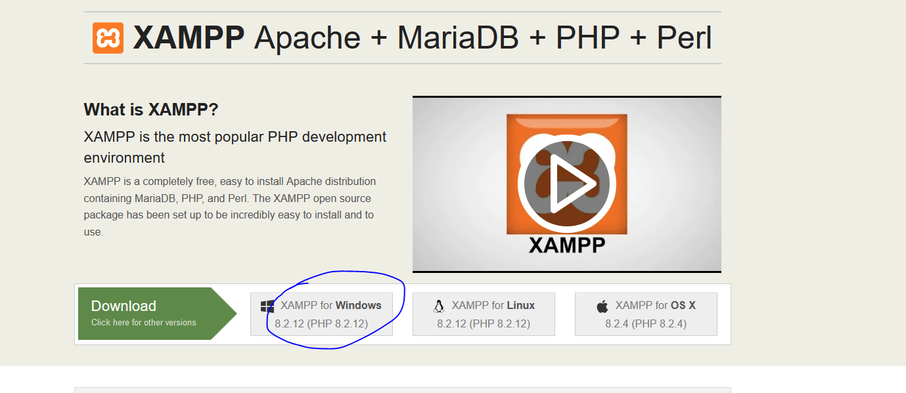
You will reach by the url Now you can go to marked above to download it for windows.
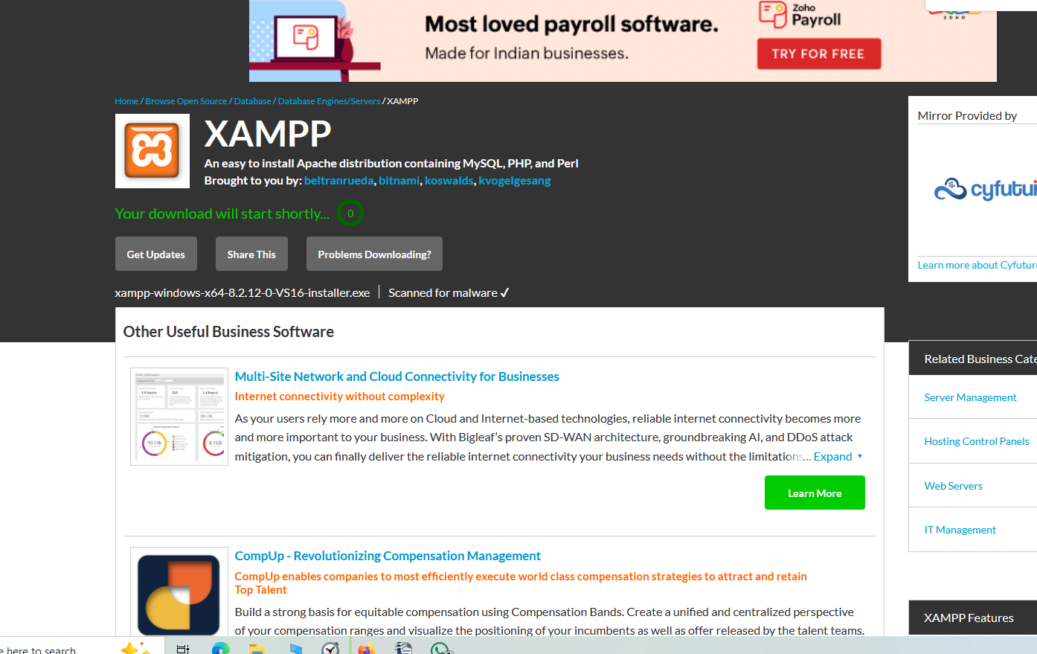
It will show you countdown and then download the XAMPP installer immediately
and then you make a new folder for it in your local disk
I named it "Xampp installer" and put it in Local Disk C
Now we will open it
and it will give you a warning to beware of antivirus in your system as it may interfere with installation we click on Yes to continue
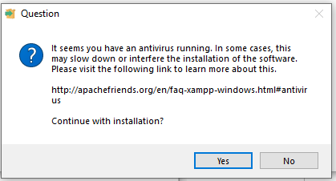
Now XAMPP installer wizrd will be opened like below
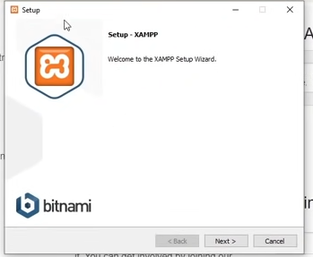
Now click on next
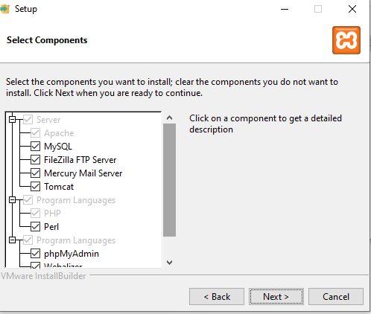
Now leave all as it is Now click on Next button
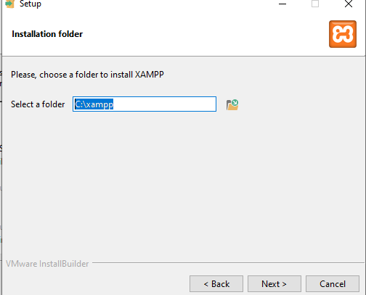
Now you will be asked location where you want to store your installation you can add your own but remember where you have installed it now click on next button
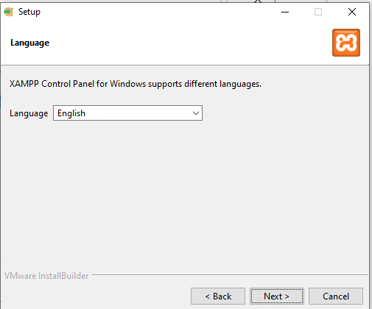
Choose teh languaheb we keep it english
and then click on next button
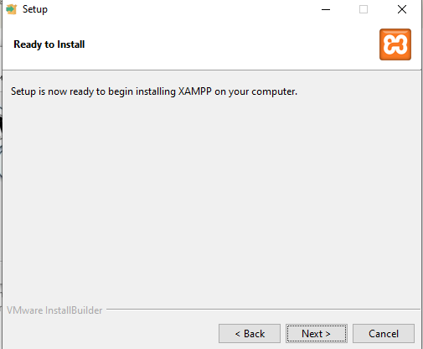
No again click on next button
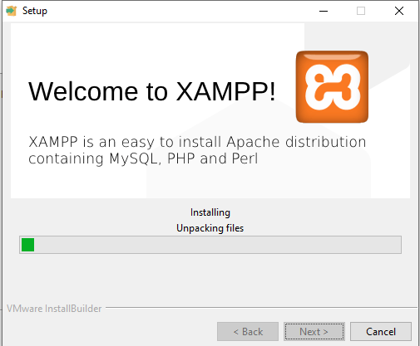
Now it will start installing
while installation
we see a prompt
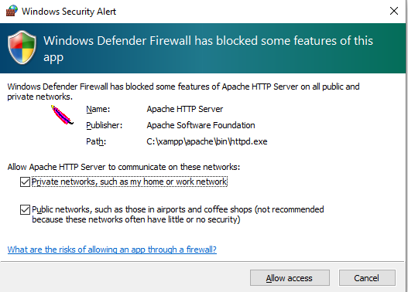
click on allow access button
Now while the installation take place in mean time you can go to wordpress
5:00
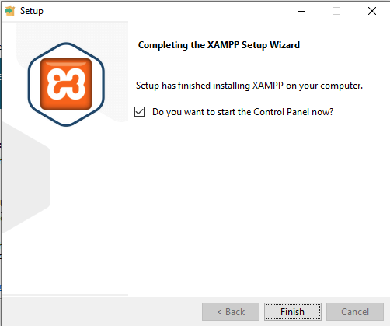
Now click on finish button
Now XAMPP control panel will be opened like below
