You can create a react app in the folder you are currently in by replacing the folder name with in any react app creation command and the folder in which you are making should follow naming convention.

String method

Slice ,substr, startsWith, lastindexOf , indexOf, endsWith

Numerical method

toString , toPrecision , value of etc.

to switch to script mode we use “use strict” in the beginning of the code.

It is used to avoid bugs in our scripts

Use htmlFor instead of for.

Use className instead of class.

Use tabIndex instead of tabindex

It is mandatory that tag or componeent should be closed in jsx even if it is an empty tag by /

React use webpack for live server

And use babel for compilation of component to js

Will research about Prop type and require prop types later

$0 in the browser is used to access elements that is selected in the inspector inside the console.

**Font size => page Specific(who knows)**

**${} => template lateral**

Use **text-light** class to make text white in Bootstrap

In react we use {} when we want to write js in between the tags.

To make the hosting of static websites in git easy we use package gh-pages

When a website Layout got shifted because of above layout shift then it is cumulative layout shift. Avoid it for good SEO.

Copy may not work in http requested website (I don’t now why it is working in my site may it is changed but According to Teacher some js api does not work on http requested site.)

This React course has some reference to the deployment as they are very important.

**Certbot for HTTP in nginx**

**Nginx**

**.accordion-button::after{**

**filter:invert(1)**

**}**

Will study about it

**Content Delivery Management (CDM)** refers to the process of managing and optimizing the delivery of digital content such as text, images, and applications across websites and online platforms.

**shift + alt + down** copy the current line text and then paste it in the line below

**Network Throttling => I think by this you modify the speed of the internet in the browser**

The temporary [**reduction**](https://duckduckgo.com/?q=reduction+definition&ia=definition) of [**bandwidth**](https://duckduckgo.com/?q=bandwidth+definition&ia=definition) through a communications network by controlling the [**package**](https://duckduckgo.com/?q=package+definition&ia=definition) flow rate. Used to minimise congestion. Also known as bandwidth throttling.(who knows)

**I think in routing if same component with different props is being route then you need to give each component a key to uniquely identify that component and that component can be remounted in different route and I also think that path follows exact now in route.**

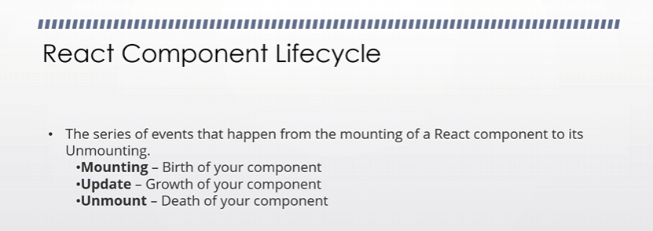

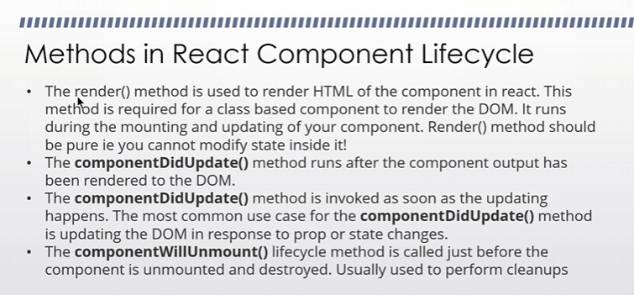

**Pure function**

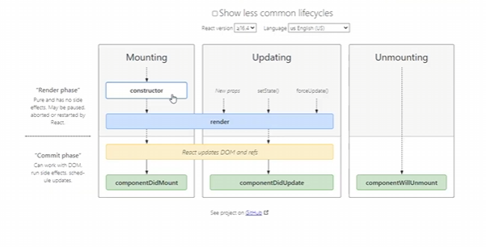

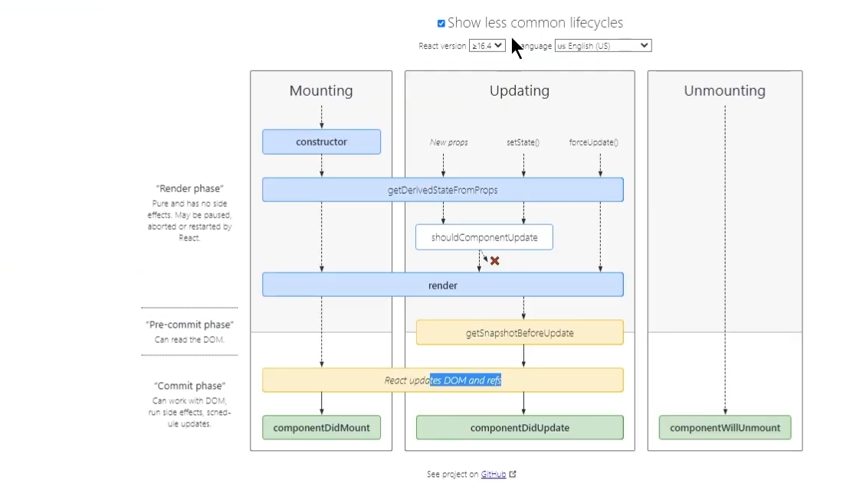

**React lifecycle diagram**