You can create a react app in the folder you are currently in by replacing the folder name with in any react app creation command and the folder in which you are making should follow naming convention.
String method
Slice ,substr, startsWith, lastindexOf , indexOf, endsWith
Numerical method
toString , toPrecision , value of etc.
to switch to script mode we use “use strict” in the beginning of the code.
It is used to avoid bugs in our scripts
Use htmlFor instead of for.
Use className instead of class.
Use tabIndex instead of tabindex
It is mandatory that tag or componeent should be closed in jsx even if it is an empty tag by /
React use webpack for live server
And use babel for compilation of component to js
Will research about Prop type and require prop types later
$0 in the browser is used to access elements that is selected in the inspector inside the console.
Font size => page Specific(who knows)
${} => template lateral
Use text-light class to make text white in Bootstrap
In react we use {} when we want to write js in between the tags.
To make the hosting of static websites in git easy we use package gh-pages
When a website Layout got shifted because of above layout shift then it is cumulative layout shift. Avoid it for good SEO.
Copy may not work in http requested website (I don’t now why it is working in my site may it is changed but According to Teacher some js api does not work on http requested site.)
This React course has some reference to the deployment as they are very important.
Certbot for HTTP in nginx
Nginx
.accordion-button::after{
filter:invert(1)
}
Will study about it
Content Delivery Management (CDM) refers to the process of managing and optimizing the delivery of digital content such as text, images, and applications across websites and online platforms.
shift + alt + down copy the current line text and then paste it in the line below
Network Throttling => I think by this you modify the speed of the internet in the browser
The temporary reduction of bandwidth through a communications network by controlling the package flow rate. Used to minimise congestion. Also known as bandwidth throttling.(who knows)
I think in routing if same component with different props is being route then you need to give each component a key to uniquely identify that component and that component can be remounted in different route and I also think that path follows exact now in route.
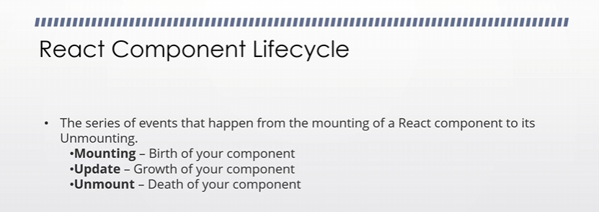
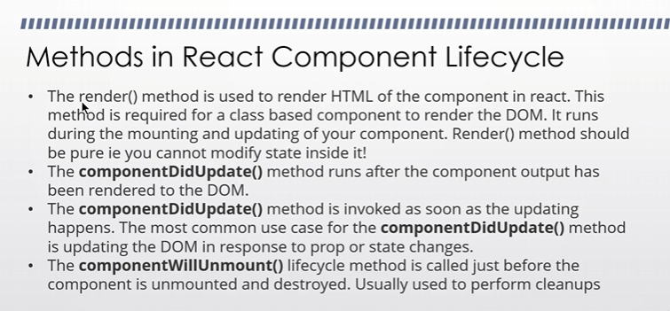
Pure function
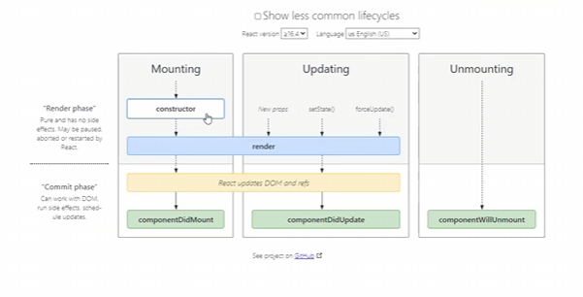
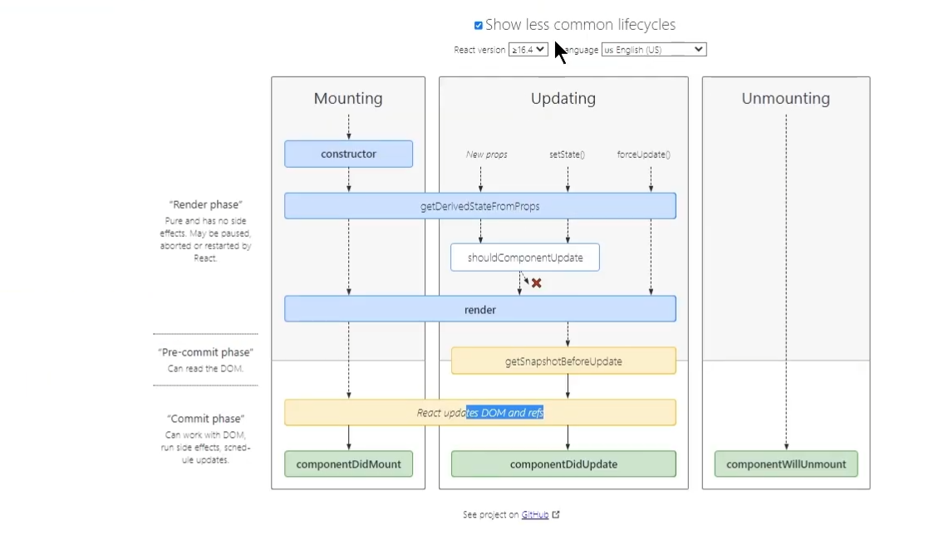
React lifecycle diagram
Intersection observer
How to use other external things in the react app.
react infinite scroll
npm i react-infinite-scroll-component
react top loading bar
In VS Code we can change the occurance of selectd text and use multiple cursor and its shortcut key is ctrl + f2
We can store a local data in our react app in .env.local (added in gitignore and I think it is an environment variable)
The environment variable start with START_APP you can get access to it in your react application
Read about custom environment variable
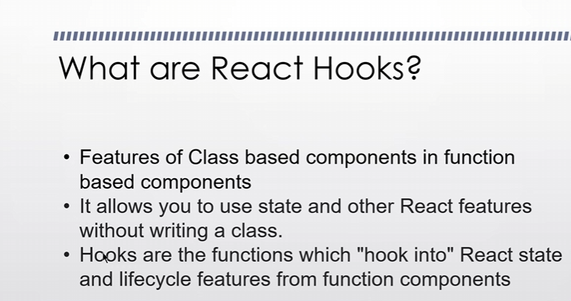
You can make your own custom hook in React.
You can make Hybrid React app including some files of class based component and some files of function based component.
You can add a comment on a next line where there is warning happening
//eslint-disable-next-line
And it will hide that warning
It keeps the console free from warning (According to the teacher)

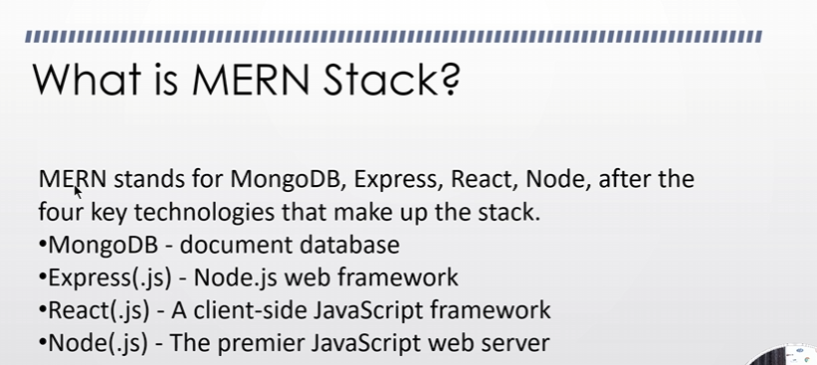
MongoDb Compass
Mongoose is an abstract layer on top of mongodb which help us in connecting us with nodejs
With the help of this we can make models (here (who knows))
Thunderclient is an alternative of postman
We are not using ES6 modules but we are using common js modules in Inotebook backend (who knows)
what is ES6 modules(simples and short)
ES6 modules are a way in JavaScript to split code into separate files called modules. Each module can export variables, functions, or classes, which can then be imported and reused in other files. This makes code easier to organize, maintain, and reuse.
Key points:
- Use export to make parts of a module available to other files.
- Use import to bring those parts into another file.
- Modules help avoid conflicts by keeping variables and functions private unless exported.
- ES6 modules are loaded asynchronously and support better tools and optimization.
In short, ES6 modules let you break your code into smaller, reusable pieces that communicate through explicit imports and exports, improving clarity and maintainability.freecodecamp+3​
what about commonjs modules
CommonJS modules are an older JavaScript module system mainly used in Node.js for server-side development. They use require() to import modules and module.exports to export functions, objects, or values. The loading is synchronous, meaning code execution waits for the module to load.
In contrast to ES6 modules, which use import and export with asynchronous loading and static analysis, CommonJS is simpler but less optimized for modern applications. CommonJS is best for backend Node.js apps and tooling environments where synchronous loading is acceptable.
Summary of CommonJS modules:
- Use require() to import modules.
- Use module.exports to export from a module.
- Modules load synchronously.
- Mostly used in Node.js for server-side code.
- No native support in browsers (requires bundlers).
Both CommonJS and ES6 modules serve to organize code but differ in syntax, loading, and environments of use.
Press Alt + Z to toggle WordWrap in VSStudio
Our model name start with capital first letter.
So here is the mongoose drill first we make a schema by Schema class
And we export it to model
Schema files are inside the models folder (who knows)
Teacher says models are made by Schema. By mongoose.model
Fo linking routes we use app.use
If we don’t send anything in response then the loading keep happening
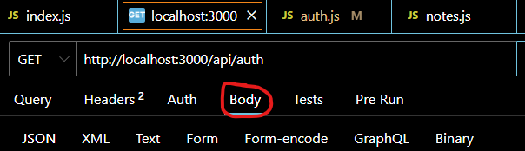
Request body
To Send a body make sure send a data in the body and make the header content type as application/json
Teacher says never to store password in plain text(who knows)
We will use express validation package for validation purposes
I think in mongoose anything new you mentioned that does not exist in mongo db it will be added in mongodb (for example if you mentioned new database in connection string or anything new and it might show when you add something new(who knows))
React App usually runs on the 3000 port
Making collection is not free in Thunderclient but for demo we do this
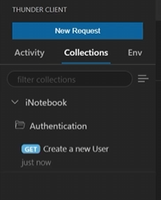
According to teacher when an error occur then we sent it to Logger or SQS
In Thunder client you can export the collection and then import it in another computer and you can use the response in another computer or in another folder structure (who knows)
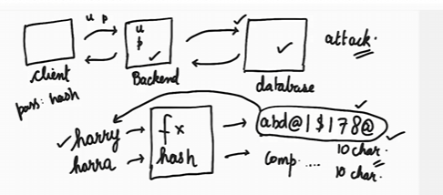
There are different types of hashing algorithm
Always avoid comsmon password as hacker can search their hash in rainbow table
To protect us from it we use SALT
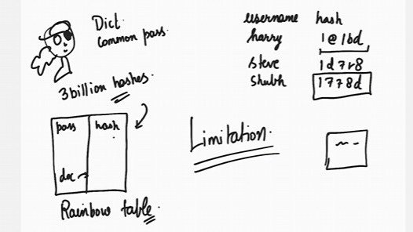
Bcryptjs is a node by which you can apply may be hasf function and also generate SALT by genSalt
Theer si another thing that is Pepper that is hardcoded in backend and iut is added after salt.
There are two types of token that is generated when a user is logged in that is Session Token and JSON Web Token.
We will use JWT(JSON Web Token) token
Jwt.io tells what is web token properly
When a token is assigned on registration of the user then it is signed by the server by a string
JSON web token => Algorithm encode Payload encode. Signature
Note:-
If an attribute is indexed then you can get that element very easily by using that attribute that is indexed in our code it is by id.
You can do updation by post but for updation put is used.
There are three ways to get the data
Either by body in post
And by query in ?
And params in /:<parameter>
We can install concurrently that will lets us run multiple command at once
There is a thing called React Bootstrap and you can install it.
It is better for SEO and many things (According to Teacher)
We don’t need to use large segment sphere as it can reduce performance and this debug is used while testing and not with performance.
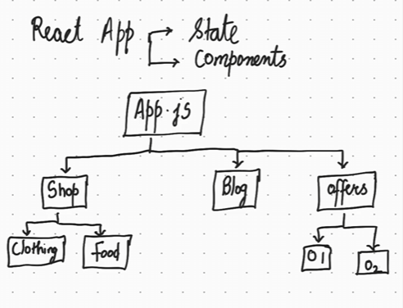
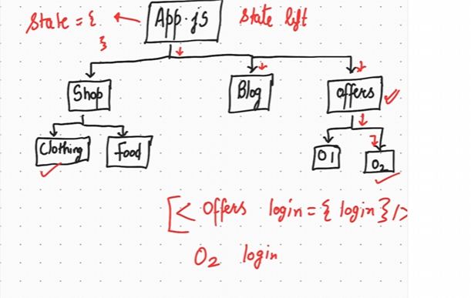
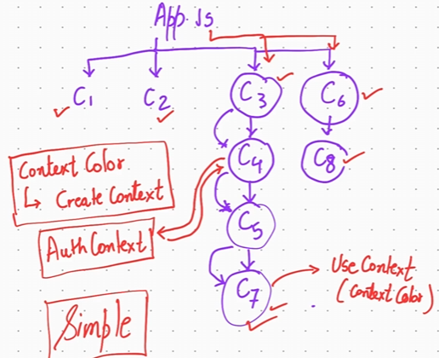
If a component need something then he need to contact the context or context API(who knows).
Context saves the state of the app(maybe)
Make state file as a jsx file not js file.
To know that location you are in your react app we use useLocation Hook and it comes under React router.
Teacher used Fontawesome for deigning a button. It gives us some great icons.

