**Final Report**

The Database 'registrar.mdb' was imported and all the information was displayed in the sheet 'Database' in query-style format. The data imported from this was then used to chart and graph crucial information.

There are many courses available to choose from. Figure 1 displays a table of courses available.

**Figure 1: Current Courses Available**

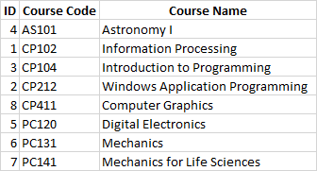

Amongst the available courses, AS101 is chosen to display class averages. Figure 2 shows a chart that displays the average grade for each assessment as well as the overall class average for this course.

**Figure 2: AS101 Course Average Breakdown**

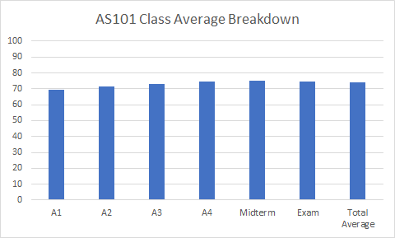

For the same course, AS101 the average, minimum, maximum and standard deviance is found for the final exam taken. It is then displayed by Figure 3 in a chart format

**Figure 3: AS101 Final Examination Report**

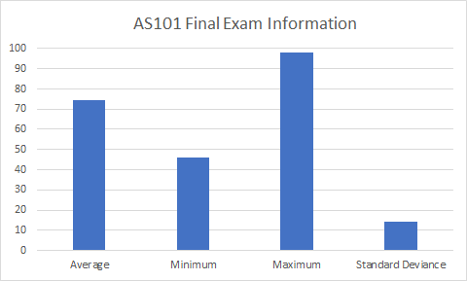

The user chose to display course enrollment information by displaying the first name, last name, and student ID for this course. Figure 4 displays a table for the course AS101 where the information is shown.

**Figure 4: Course Enrollment for AS101**

