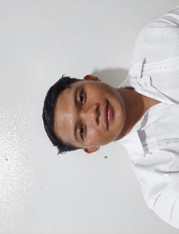

**JOHNSEN A. SOPETA**

**DETAILS______________**

Azucena, Barili, Cebu.

johnsensopeta555@gmail.com

09661344660

Single

Filipino

Roman Catholic



**PROFILE**

Motivated and detail-oriented IT professional with a passion for web development seeking an internship position to apply and enhance my skills in actual job environment. Eager to contribute to a dynamic team and gain hands-on experience in the field of web development or any IT related jobs that will help me to become armored with skills in IT fields.

**SKILLS______________________________**

Fundamental knowledge in Java, python, php, Javascript languages

Web development using HTML, CSS, JavaScript and python for backend and MySQL for database

Ms Words

Basic of networking

Computer formatting and maintenance

Powerpoint

Fundamental Networking

Web based design

Basic Arduino Programming



**COLLEGIATE:** Cebu Technological University Barili.

(2023-Present)

**PRIMARY:** Barili Central School.

(2013-2014)

**SECONDARY:** Patupat National National High School.

(2019-2020)

**Seminars and Trainings**

* ICT Proficiency and Cybersecurity

**Languages____________**

Cebu Technological University, February 16, 2023

English

Filipino

Bisaya

**CHARACTER REFERENCES**

* Charles Magne A. Pasaje

MSIT ASST. PROF II DEPT OF TECHNOLOGY – CTU-BARILI CAMPUS

09205180493

* Dariel P. Pabroa

Instructor, DOT

09089489289

* Benjamin Auza Bere III

DOT Chairman

09089489289