My web design project Review

LuckyMagazine : LuckyMagazine is a modern landing page design based on newspaper. The design is very elegant and modern, and also very easy to customize with 1170px grid. Morakf template has beautiful and unique design that will be best suited for your online web presence. It has 100% responsive design and tested on all major handheld devices.

Language : Html5 , JavaScript, JQuery , CSS3 , Boostrap4.

Let’s go view my project:-

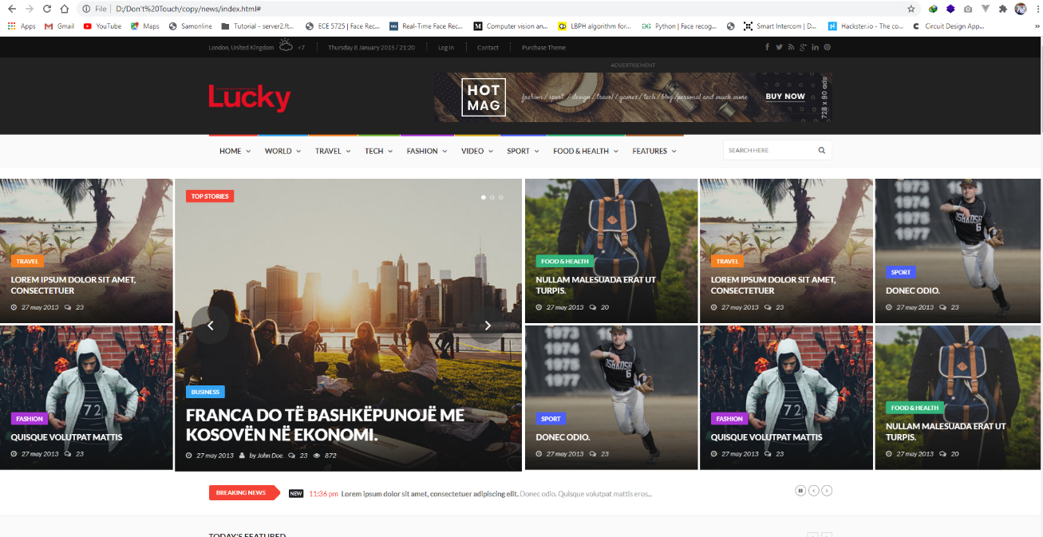

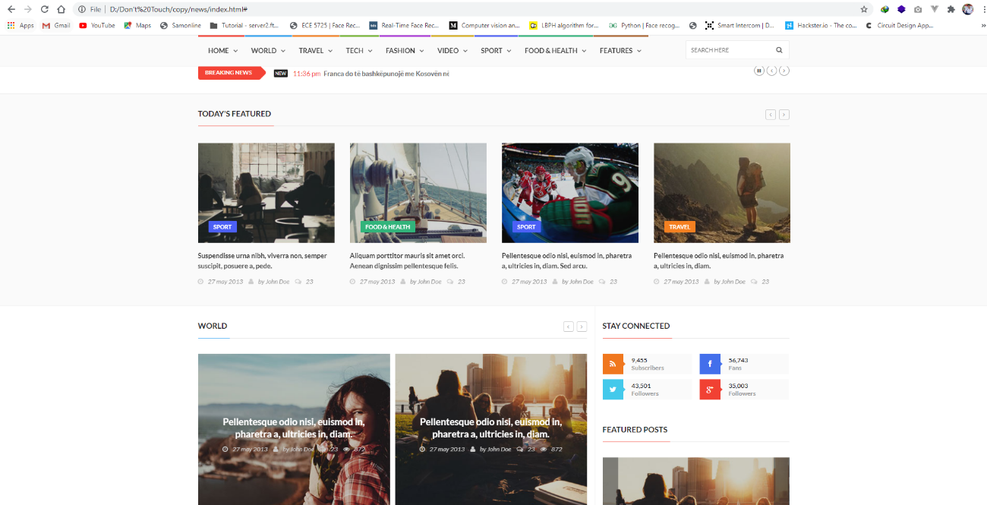

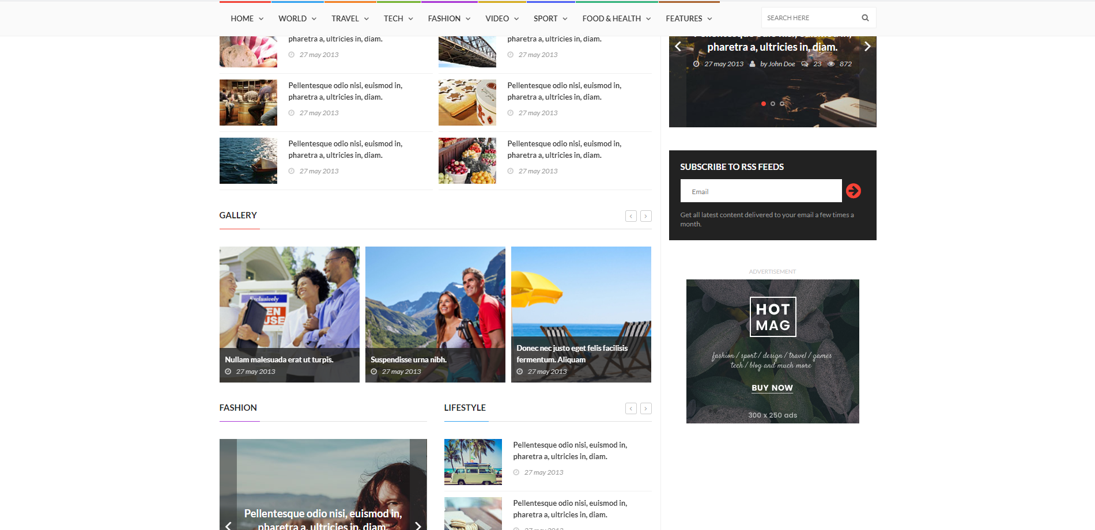

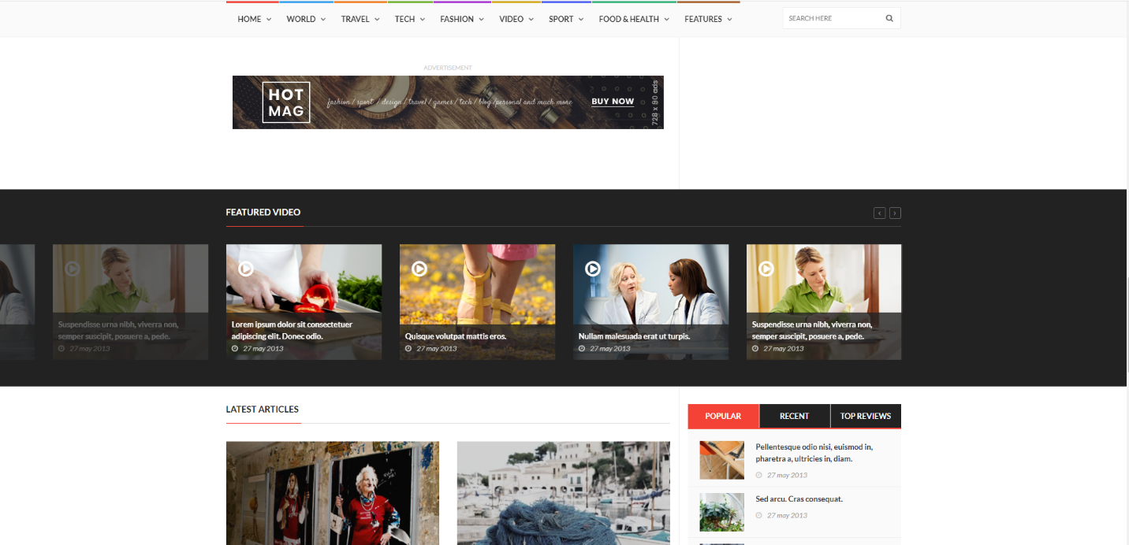

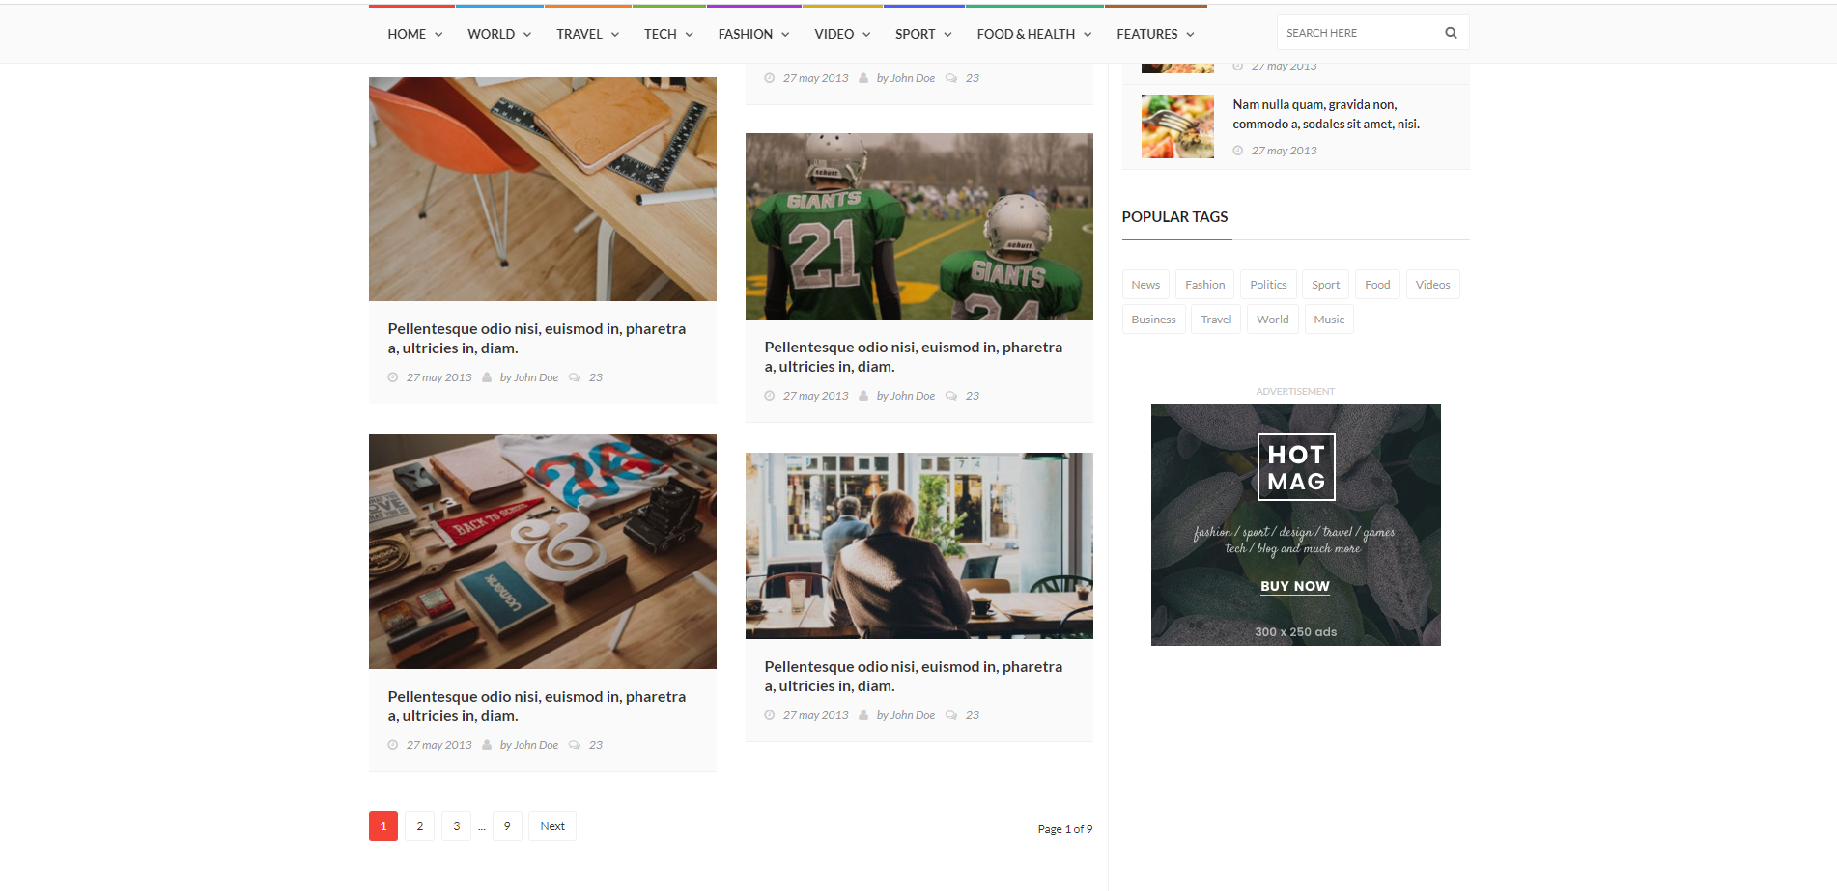

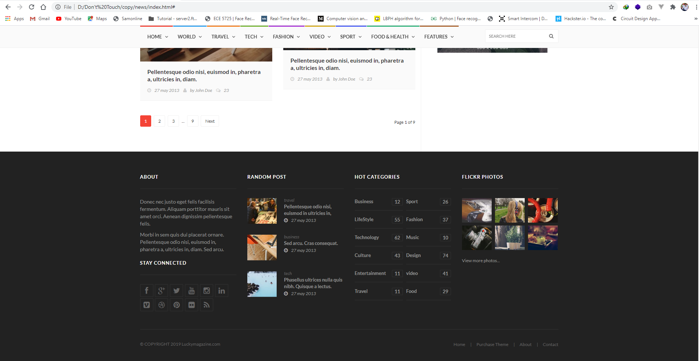

SourceCode: https://github.com/CoderMoniruzzaman/luckymagazine-template