CSIS 2260 - Lab #1
Introduction to Linux and Personal Web Page
Name: ________________________________________________ Student No.: ______________

Objectives: To learn about the basic features of a distribution of Linux operating system, Ubuntu. Learn about user account creation and basic commands for files and directories management.

Document Required: The document Introduction to UNIX Commands and Scripting

About Ubuntu: Ubuntu is a free and open-source operating system. Open-source means that is has been created by a collective of thousands of volunteers and that the source code is freely available and constantly being improved upon and examined for bugs.

The Linux command line is one of the most powerful tools available for computer systems administration and maintenance. The command line is also known as the terminal, shell, console, command prompt, and command line interface (CLI)

A. Connecting to the Ubuntu Server [207.216.57.60] using ssh
1. Start the WindowsPowerShell or search for CMD:
Type ssh firstinitiallastname@207.216.57.60

e.g. Joe Black will use ssh jblack@207.216.57.60

Password is fall2024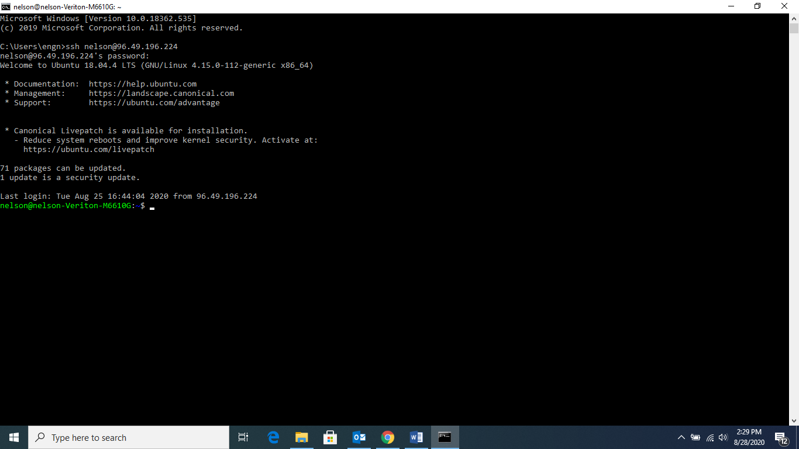

What is ssh?_________________________________________________________ [_____/2]

B. Working with UNIX commands

Learn to use the command line for small tasks. Refer to Section 0 of Introduction to UNIX Commands and Scripting on how you can get help on using the commands.

1. Change your password [_____/1]
Type passwd

What is your new password?

2. Create a new user firstname2260 with password hello. [_____/1]
First, try to type in the following command:
adduser firstname2260

What is the message appears on screen?

3. Describe the function of the command sudo (Hints: use the command man). [_____/2]

Now try the following command:
sudo adduser firstname2260

4. Refer to Introduction to UNIX Commands and Scripting for the rest of this lab. You are required to complete Sections 0, 1 and 2.1-2.3 (page 1-6) .[_____/2]

Exercise 1a
Make another directory inside the unixstuff directory called backups

Exercise 1b
What do you think ls ~ would list?

What do you think ls ~/.. would list?

Exercise 2a
Create a backup of your sample.txt file by copying it to a file called sample.bak

Exercise 2b
Create a directory called tempstuff using mkdir, then remove it using the rmdir command.

C. Review Exercise [_____/4]
- Create a folder csislab under your home directory.
- Go to the folder csislab.
- Under csislab, create the file test.txt by typing
man ls > test.txt
- Make a copy of the file test.txt and call it test1.txt.
- Create a subfolder temp under csislab.
- Make a backup copy of the file test.txt and call it test.bak
- Move the file test.bak to the temp.

- Remove the subfolder temp.
Take screen prints to show the instructor that the subfolder temp has been removed. Write down the command(s) that you used to remove the subfolder temp.

D. Personal Web Page [_____/8]

Make sure you are in your /home/firstinitiallastname e.g. neng for Nelson Eng, type pwd - see below
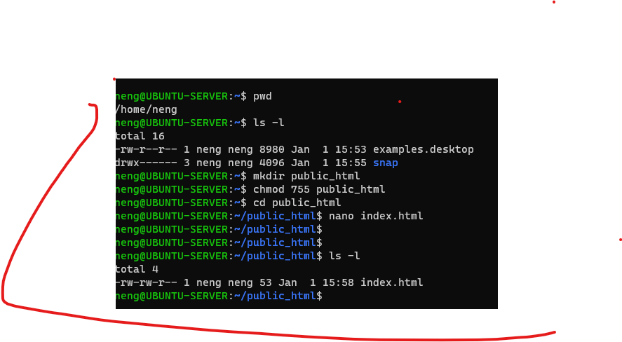

mkdir public_html
chmod 755 public_html

cd public_html

use EDITOR
nano index.html
</html>
</body>
This is CSIS2260 or ???? <br>
</body>
</html>
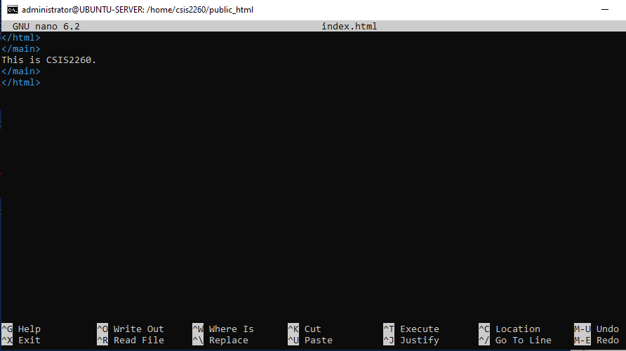
Ctrl O, then Ctrl X
Use browser (Chrome or Edge) to view web page

replace csis2260 below with your firstinitaillastname

http://207.216.57.60/~csis2260

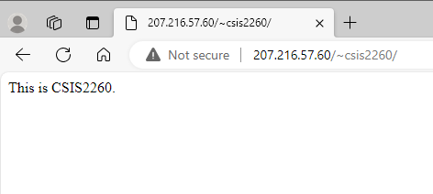
take screen shot and paste here
Submission
Save as FirstName_Student#_Lab1v12 and submit in Blackboard

