**CSIS2270 - Lab #3**

20

***Network Configuration and Network Services***

**Name: ________________________________________________ Student No.: ______________**

**Introduction:** File Transfer Protocol (ftp) is a widely used protocol to move files between devices. Applications have been built based on the FTP protocol for data communications. In this lab, you will set up a ftp server for file transfer.

**Objectives:**

1. To setup a simple network
2. To get familiar with network configuration commands
3. To get familiar with basic networking troubleshooting techniques and commands
4. To get familiar with ftp network service.

**Equipment Required:**

1. One Home Router-PT.
2. Two PC-PT
3. One Server-PT
4. Straight network cables.
5. **Router Configuration [_____/6]**

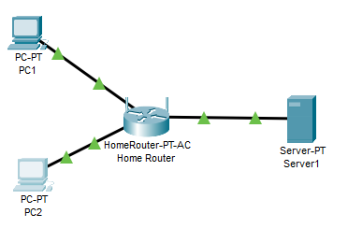

1. Refer to the diagram above and connect the PCs to the router (the same way you did in the previous lab2). Turn off the firewall on both PCs ( click on the PC in the workplace, then click on Desktop in the top bar , find the IPv4 Firewall icon and click it, then from the opened window select the “off” radio button, repeat these steps for both PCs and the Server) .
2. Set the PCs and the server to DHCP mode ( the same way you did in previous lab2)

1. Use “ ipconfig” command in the command prompt   
   What is the ip address of PC 1? 192.168.0.100

What is the ip address of PC 2? 192.168.0.101

What is the ip address of the server? 192.168.0.102  
 What is the ip address of Home Router? 192.168.0.1

1. From one of the PCs , login to the Home Router ( the same way you did in previous lab 2)
2. Configure router A as follow:

IP address: 210.100.10.1

Subnet mask: 255.255.255.0

DHCP start IP address: 210.100.10.50

1. Disabled the wireless networks.
2. Save settings
3. Enter the command ***ipconfig /release*** on the PCs and Server
4. Enter the command ***ipconfig /renew*** on PC’s and Server
5. What is the IP address of PC 1? ____ . _____ . _____ . ______

What is the gateway address of PC 1? ____ . _____ . _____ . ______

What is the IP address of PC 2? ____ . _____ . _____ . ______

What is the gateway address of PC 2? ____ . _____ . _____ . ______

1. **Connectivity Test [_____/4]**
2. Connectivity test: in the command prompt use the command  
    (C:\> **ping** *ip address* of the destination device)
3. Ping to the local router:

From PC 1 to Home Router. Is it successful? _______

From PC 2 to Home Router. Is it successful? _______

1. Ping to the local PC.

From PC 1 to PC 2. Is it successful? _______

From PC 2 to PC 1. Is it successful? _______

1. **FTP service [_____/10]**

FTP (File Transfer Protocol) is the protocol and network service used for transferring files between two devices. It runs on top of the TCP/IP stack to provide reliable data transfer between devices. The device that uploads or downloads a file is referred to as the **FTP client**, the device that stores the files or provides the files is referred to as **FTP server** ( in real case, it is necessary to set up a FTP server and turn on the FTP service on the server before the FTP service can be provided). Note that many FTP servers allow any user to upload and download files by using the user id ***anonymous*** with no password.

After you verified the connectivity between all the devices in this network, now you will practice the FTP service. For this purpose, you will use PC1 and PC2 as the FTP clients (using the FTP client built in the PC-PT) and Server1 as the FTP server(using the FTP server configured in the Server-PT)). In this experiment you will create a text file and save it in PC1 then upload it to the server and PC2 will download this file. To make sure you understood the principles of this service you are required to repeat the same steps but in the reverse direction (PC2 🡪Server🡪PC1).

(Please note that PC-PT and Server-PT refer to Packet Tracer simulated devices not real devices. A real FTP service configuration and use will be considered in future lab)

1. Preparing the FTP server: click on Server1 and click on Services in the top menu bar, then select FTP and check the “On” radio button

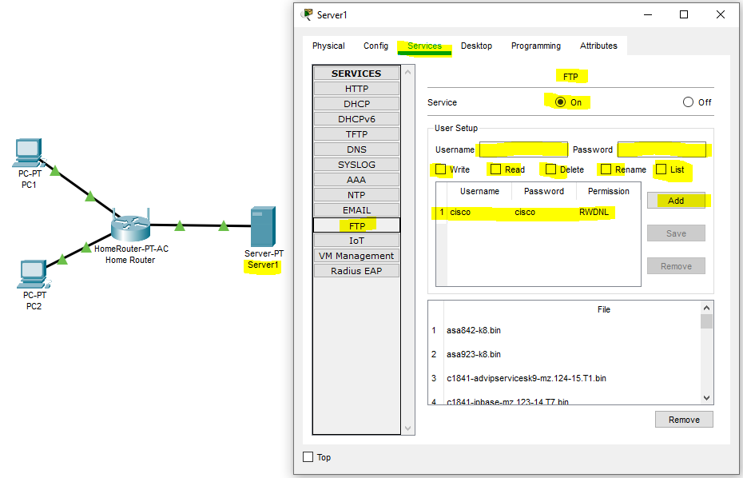

1. By default, the FTP server is configured to accepts client users with “cisco” username and “cisco” password with “RWDNL” permissions (Read, Write, Delete, Rename, List). Create a new client user configuration by typing “**student**” in the user name space and “**lab3**” in the password space. Check the **Write**, **Read** and **List** permissions then click Add.

FTP client in PC-PT can be used to read, write, delete and rename files present in the FTP server in Server-PT. On the other hand, FTP server in Server-PT can be used to read and write configuration files as well as IOS images. Additionally, the FTP server also supports file operations such rename, delete and listing directory.

1. Testing the FTP service
   1. Create a text file on PC1. Click on PC1in the workspace, then Desktop from the top menu bar, then click on Text Editor icon.

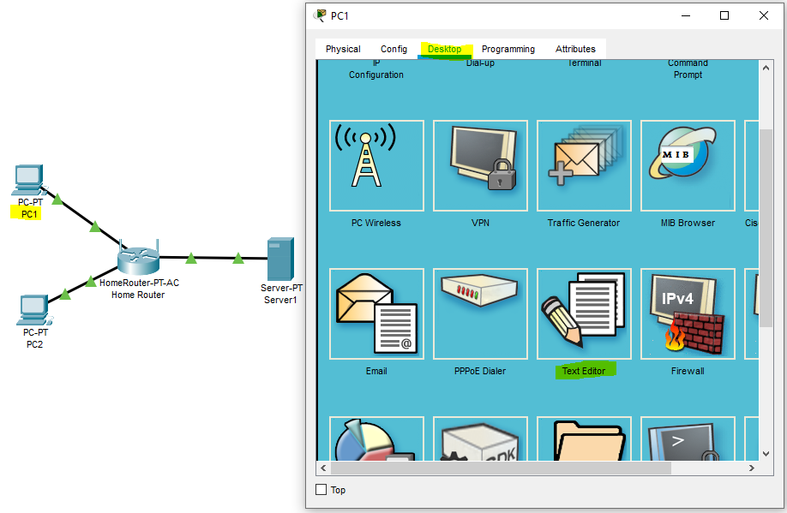

* 1. Type some text and save the file as **lab3.txt**

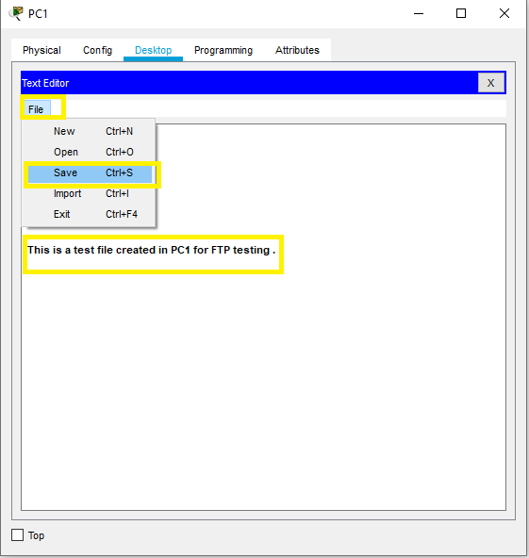

* 1. 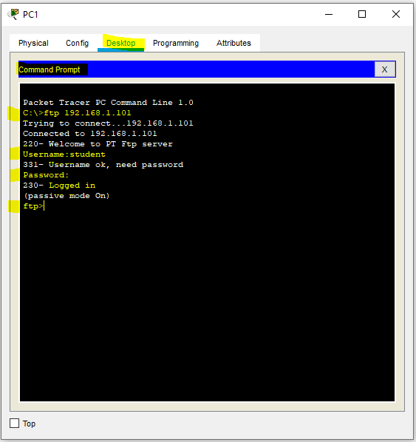Now from command prompt of PC1 log into the FTP server using the command   
      (C:\> **ftp** *ip address* of the FTP server) , username “student” , password “lab3” , password will not be visible. Once logged in , the command prompt will change to **ftp>**

* 1. Type “?” in the command line to check the available commands. List them below  
     -  
     -  
     -
  2. To upload the text file which you created earlier type the following command  
      (ftp> **put** *file name*) 🡪 ftp> **put** lab3.txt 🡪 hit enter key on your keyboard then you will be notified about the file transfer success as   
      Writing file lab3.txt to 192.168.1.101:

File transfer in progress...

[Transfer complete - 59 bytes]

59 bytes copied in 0.023 secs (2565 bytes/sec)

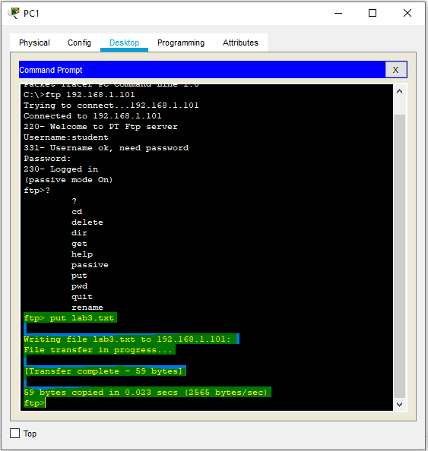

* 1. Type the command “ quit “ to close the connection with the ftp server and return to the command prompt: ftp> **quit** 🡪enter 🡪 c:\>
  2. To check that the file actually received in the FTP server, click on the Server1 in the workspace, click on Services, then select FTP, scroll through the File window and you must see lab3.txt file there. List below some few other files you can see in the FTP server   
     -  
     -  
     -

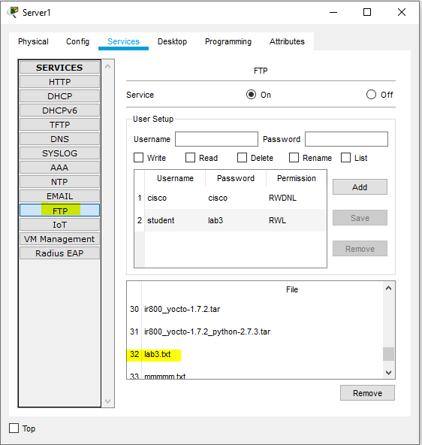

* 1. To download the lab3.txt file from the FTP server to PC2, click on PC2 in the workspace, and click on Desktop from the top menu bar and click on the command prompt.
  2. Type the command **“dir”** to make sure thatlab3.txt file is **not** there. Can you see any files there? If yes, what are they? ___________
  3. Log in the FTP server by the same way you did with PC1 using the same username and password.
  4. Use the command ( ftp> dir) , can you see the lab3.txt file ? _____
  5. In the ftp command line type the command (ftp> **get** *filename*) to download the file from the FTP server 🡪 ftp> **get** lab3.txt 🡪 enter
  6. Close the connection with the FTP server as you did earlier and return to the command prompt of PC2. Type the command C:\> **dir** . Can you see the lab3.txt file ? ________

Save the Packet Tracer file as described in the submission instructions.

**Lab Submission instructions:**

1. Save your report file as yourFirstname_yourID_Lab3.docx.  
    (example: Nelson_1234_Lab3.docx)
2. Save your Packet Tracer file as yourFirstname_yourID_Lab3.pkt   
    (example: Nelson_1234_Lab3.pkt)
3. Put both files ( .pkt and .docx) in one folder and name it as   
    yourFirstname_yourID_Lab3
4. Compress the folder into a zip file
5. Send the compressed zip file to your instructor not later 6:15 pm of the same day where the lab took place through a *Blackboard message* **strictly** (do not send labs by email please. Any lab submitted by email will be ignored).
6. Late submissions will not be marked and the student will lose the mark of that lab.
7. Students who don’t save lab files with proper names as indicated in 1,2,3 above, will lose 50% of the lab’s mark.