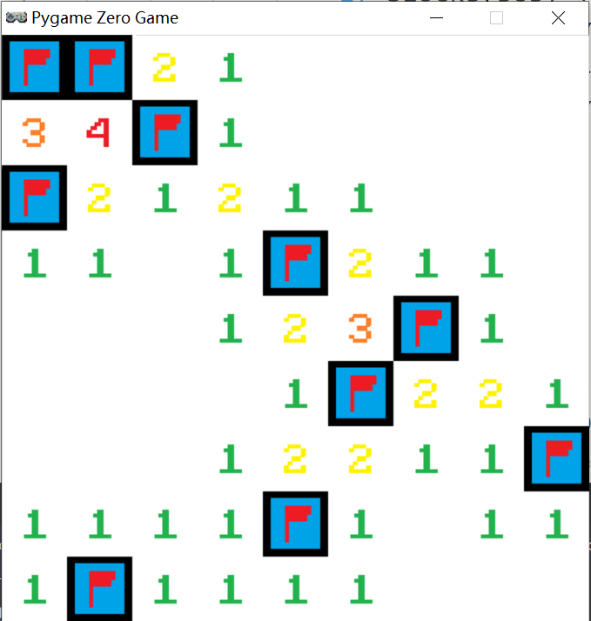
↑This is a screenshot of Orangesoft MineSweeper.
Thanks for using it!
Good luck for you!

