 |  | LEIC, Análise e Modelação de Sistemas, 2016-2017  Projecto – Relatório para a 2ª Entrega (E1)
Nº Grupo | Turno (Alameda/Taguspark, dia semana, e hora) |  | Professor
Aluno: |  |  | Esforço em Nº horas, por cada aluno, e por cada entrega:
Nº | Nome |  | E1 | E2 | E3 | Total
81191 | Patrick Santos Fernandes
81796 | António Pedro Lourenço
81861 | Afonso Tinoco de Faria Cecílio dos Santos
Total:

Assumptions:

- In the partner and client registration, for simplicity, cases of invalid input (whether personal data or NIB) are omitted.
- In the partner and client registration it is assumed that the token returned is always correct.
- In the partner and client registrations it is assumed a token time-out corresponds to an error in the processes.
- When searching for tours, the MyTGuide system only proceeds if the user asks for a reservation or if the search times out (there is no explicit end-of-search message).
- In the tour reservation, when waiting for the tour confirmation from the partner, the MyTGuide system only proceeds if the partner confirms the trip or if the confirmations times out (there is no explicit cancellation message)
- When asking for feedback, the MyTGuide system only proceeds if the user rates the trip or if the feedback times out (there is no explicit no-feedback message).
- When the partner doesn't return the hotspot and the DAP technician is evaluating if he is going to apply a penalty, it is assumed that even if he asks the DAP Coordinator for a decision, he is the one who enters the decision in the MyTGuide System.
- It is assumed that each 24h if the hotspot is not returned, the DAP evaluates whether to (further) apply a penalty and not only once.
- It is assumed that the hotspot return process always goes by the DAP Coordinator even if the hotspot is returned on time.
- In the tour reservation process, it is assumed that a time-out in the trip confirmation corresponds to an error in the process.

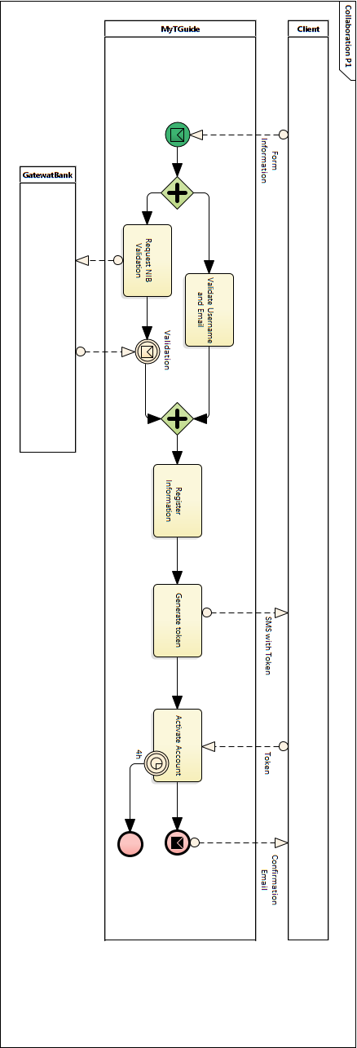
BPMN Collaboration Model for processes P1, P2, P3, P4:

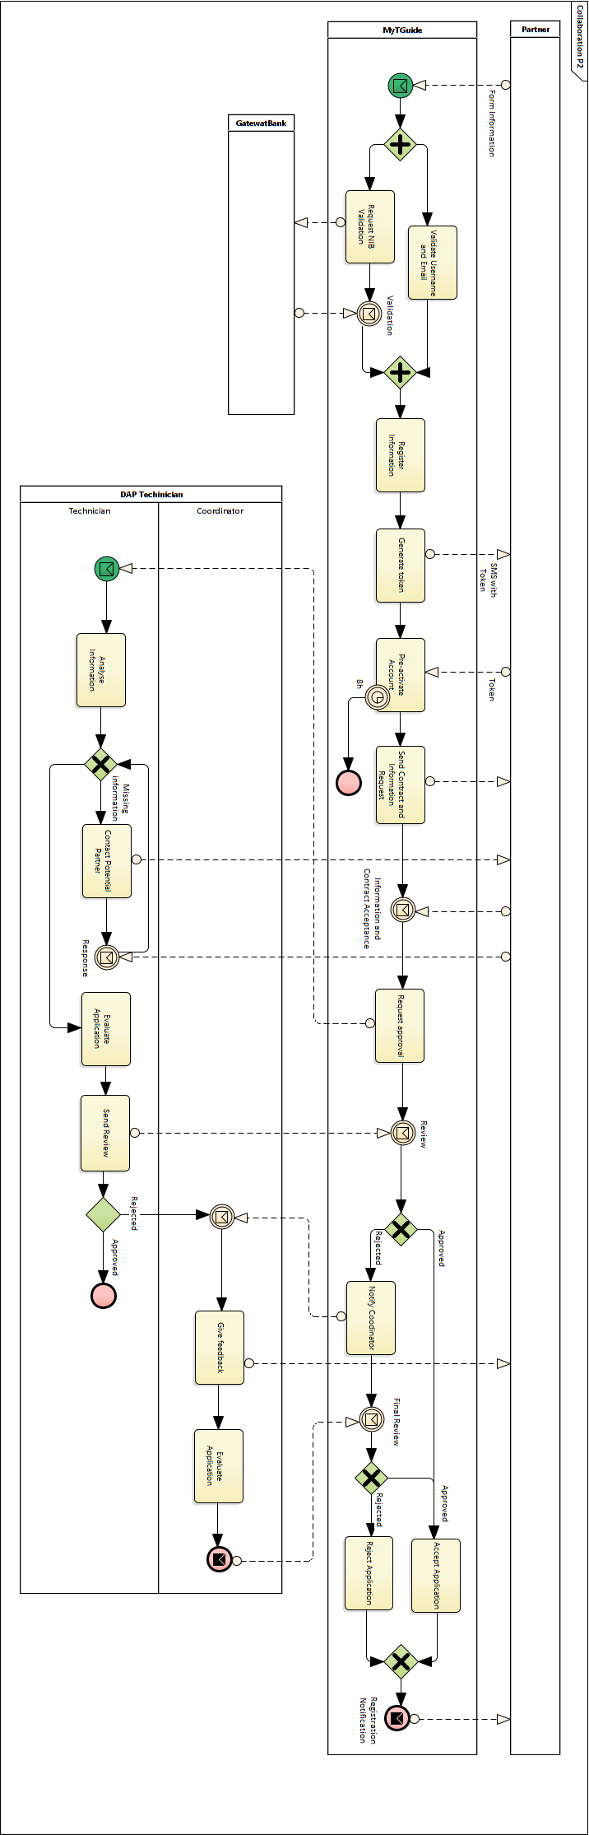

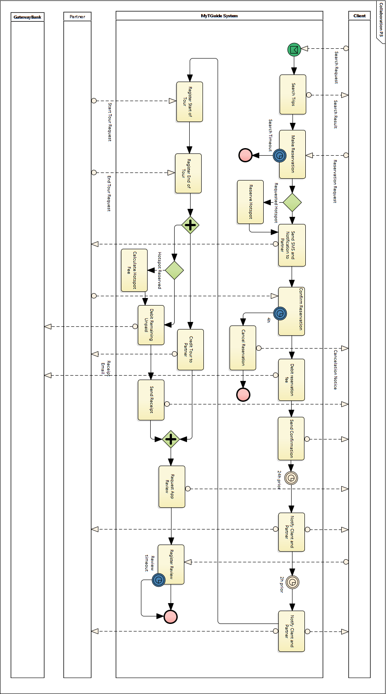

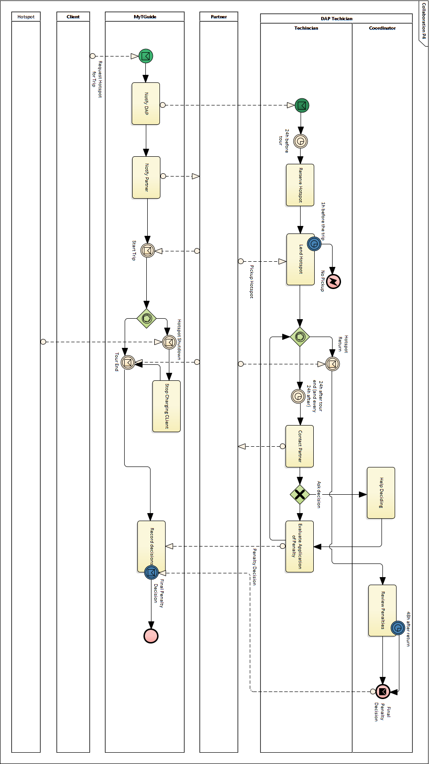

BPMN Choreography Model for P3 process:
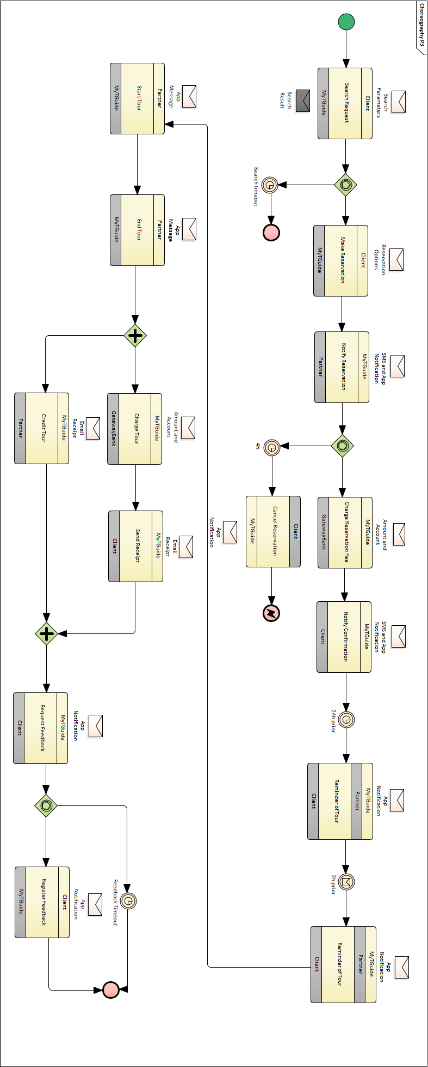

MyTGuide system use cases’s UML Model and descriptive table:

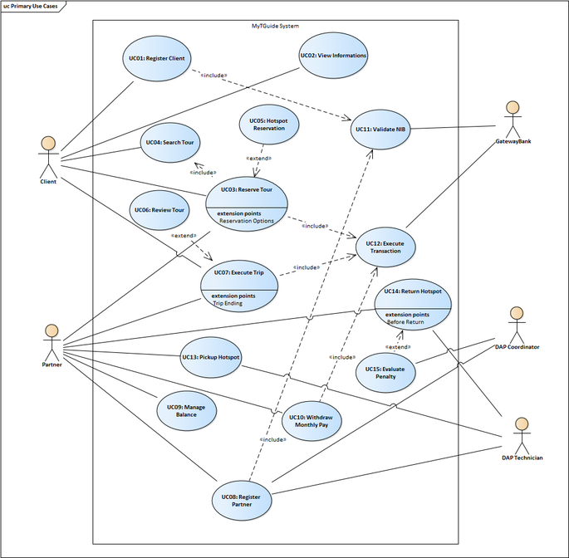

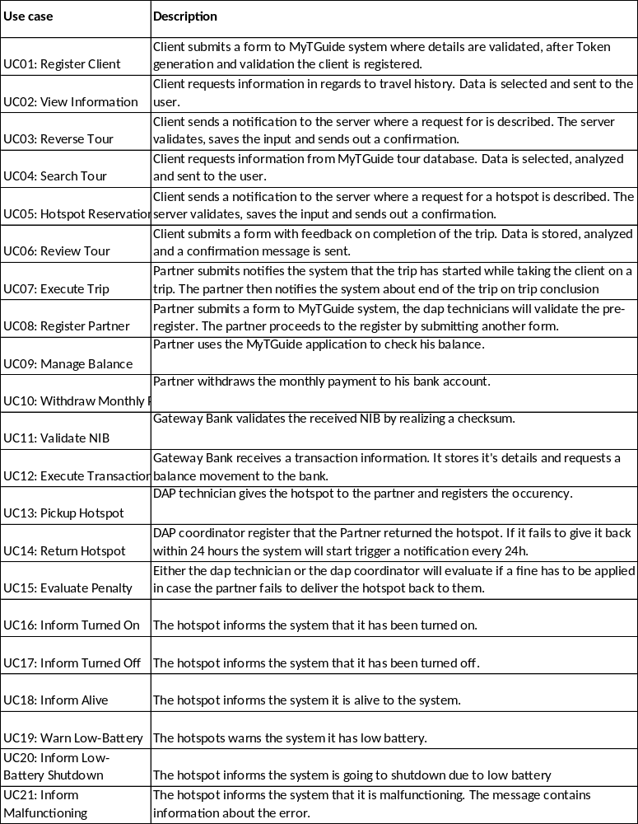
Based on the use case models from the previous question, define a template with a textual description well-structured for the use case of your project with the maximum amount of iterations:

Section | Content
Identifier | UC03
Name | Reserve Tour
Description | The user searches for a tour. Then he proceeds to supply the data to make a reservation including whether he want to rent a hotspot or not. The MyTGuide, sends a notification to the Partner requesting for validation. After the partner validates the app, the MyTGuide registers the reservation and sends a notification to the clients.
Main Actor | Client
Other Actors | Partner, Gateway Bank
Preconditions | Client is registered and confirmed  Partner is registered and confirmed
Main scenario
  1 | The Client searches for tours on the app by several criteria (i.e. location, date, mean of transportation and guide name).
  2 | The Client selects the make reservation option on the app on a specific tour.
  3 | The Client fills the data of the tour (number of visitors and agreement to pay a tax) on the MyTGuide app.
  4 | The MyTGuide validates the data and sends a notification to the partner to review the reservation.
  5 | The Partner confirms the reservation on the MyTGuide app.
  6 | The MyTGuide request that the GatewayBank debits the reservation deposit on the user Bank account.
  7 | The MyTGuide sends an email to the Client confirming the reservation.
Alternative Scenarios
  3a | 3a1 | The client selects the reserve hotspot option in the app
   | 3a2 | The MyTGuide validates the data and sends a notification to the partner to review the reservation with information about the hotspot required
   | 3a3 | The Partner confirms the reservation on the MyTGuide app.
   | - | Proceed with step 5
Postconditions | A reservation is made to the given tour to the given user  The Client will receive notification of a confirmation  The Client will receive reminders of the trip  The user will be billed for the tour reservation fee.
Exception Scenarios
  5a | - | The partner fails to confirm within 4h
   | 5a1 | The MyTGuide cancels the reservation
   | 5a2 | The MyTGuide sends a notification to the user
Exception Postconditions | 5a The Client will receive notification of cancelation

